Request for Proposals (RFP)
Application Package

McKinney-Vento Homeless Assistance Act
Education for Homeless Children and Youths
2020–21 Discretionary Subgrant
Round Two
REVISED on October 29, 2020

The Education for Homeless Children and Youths Program is a subgrant funded by the United States Department of Education, authorized by the McKinney-Vento Homeless Assistance Act, Title VII, Subtitle B (42 U.S.C. 11431 et seq.), as amended by the Every Student Succeeds Act (ESSA), and administered by the South Carolina Department of Education.
.

Deadline for Receipt of Applications: October 30, 2020, at 4:30 p.m. November 2, 2020, at 4:30 p.m.

Technical Assistance Webinar for Applicants: October 5, 2020, at 2:30 p.m.

For questions about the Education for Homeless Children and Youths Program, contact:
Linda Mirabal-Pace, 803-734-6010, lpace@ed.sc.gov

Issued by:
South Carolina Department of Education
Office of Federal and State Accountability
1429 Senate Street, Suite 501-B
Columbia, SC 29201

TABLE OF CONTENTS
PART I: General Information 2
A. Introduction and Purpose 2
B. Eligible Applicants 3
C. Timeline of Subgranting Process 3
D. Technical Assistance Sessions for Applicants 3
E. Statutory, Federal Regulations, and State-Level Requirements 3
F. Authorized Activities 7
G. Unauthorized Activities 9
H. Program Accountability and Monitoring 9
I. Fiscal Operations 13
J. Supplement, Not Supplant 13
K. Review and Selection Process 13
L. Appeals Process 15

PART II: Application Overview, Content, and Instructions 16
A. Application Overview 16
B. Application Narrative Format 17
C. Online Application Submission 17
D. Project Abstract 17
E. Application Narrative Content 17
1. Needs Assessment 18
2. Goals and Objectives 19
3. Activities 20
4. Management and Collaboration 21
5. Evaluation and Dissemination 23
F. Application Budget 23
G. Appendices 26
H. Deadline and Submission Procedures 28
I. Screenshots of Online Application Submission Forms 28

Appendix A: Definitions of terms used 36

Appendix B: Selection Criteria and Reviewers’ Scoring Rubric 36

Appendix C: Required SCDE Forms 49
Certification Signature Page 49
Assurances and Terms and Conditions for Federal Subawards 50
Program-Specific Assurances 54
Pre-Award Audit Questionnaire 57
Instructions for GEPA Statement of Compliance 58
Examples of Measurable Outcomes for Activities Authorized by McKinney-Vento Act 59
Grant Design Chart 61
Timeline of Objectives, Activities, and Measurable Outcomes Template 62
Goals, Objectives, and Outcomes Worksheet 63
Budget Narrative Template 64

PART I: General Information

Introduction and Purpose

The reauthorized McKinney-Vento Homeless Assistance Act (42 USC § 11431 et seq.) ensures educational rights and protections for children and youths experiencing homelessness. The McKinney-Vento Education for Homeless Children and Youths Program (McKinney-Vento) is designed to address the problems that homeless children and youths have faced in enrolling, attending, and succeeding in school. Under this program, state educational agencies must ensure that each homeless child and youth has equal access to the same free, appropriate public education, including a public preschool education, as other children and youths.

Homeless children and youths should have access to educational and other services that they need to enable them to meet the same challenging state student academic achievement standards to which all students are held. In addition, homeless students may not be separated from the mainstream school environment based on their housing status. State and local educational agencies (LEAs) are required to review and undertake steps to revise laws, regulations, practices, or policies that may act as a barrier to the identification, enrollment, attendance, or success in school of homeless children and youths. McKinney-Vento also requires that LEAs designate an appropriate staff person as the LEA McKinney-Vento Liaison who is able to carry out the duties described in the Act.

The U.S. Department of Education (USED) allocates federal funds for McKinney-Vento on a formula basis to the South Carolina Department of Education (SCDE) for state-level activities to coordinate, manage, and monitor all LEA McKinney-Vento programs and the competitive McKinney-Vento subgrant process.

The SCDE will award McKinney-Vento competitive subgrants to LEAs to improve the identification, enrollment, attendance, and success in school of homeless children and youths. McKinney-Vento funds can be used to provide activities for and services to homeless children and youths, including preschool-aged homeless children, that enable them to enroll in, attend, and succeed in school or preschool programs.

Approximately $515,000.00 will be available for new subgrants in the one-year funding period. The SCDE anticipates awarding approximately 15 subgrants. Because McKinney-Vento funding is limited, applicants will be eligible to apply for subgrants based on the LEA’s reported count of homeless students in the 2019–20 count in PowerSchool. The following tiers should be used as a guideline for requesting funds.

Tier | Number of Homeless Students | Maximum Funding Levels
1 | 50–150 | $20,000
2 | 151–250 | $30,000
3 | 251–500 | $45,000
4 | 501–750 | $60,000
5 | More than 750 | $85,000
Competitive subgrants will be awarded to LEAs that have developed programs that go above and beyond the requirements of the law and document effective collaboration with service providers to ensure that homeless children and youths receive needed services. Award amounts will be determined based on demonstrated need for assistance, the quality of applications received, and total funding requested. Final budgets may be negotiated based on demonstrated needs.

The grant budget period is November 2, 2020, through June 30, 2021.

The subgrantee may obligate funds upon receipt of the grant award notice. However, no funds will be disbursed until after December 1, 2020. Subgrant payments are made on a cost-reimbursement basis so applicants should have at least three months of operating funds at their disposal to implement the program to compensate for any delays in receiving reimbursement payments.

Eligible Applicants

All South Carolina public LEAs are eligible to apply.

Timeline of Subgranting Process

Date | Activity/Action
October 5, 2020 | Pre-application Online technical assistance webinar for applicants
October 30, 2020 | Deadline for receipt of application
November 2, 2020 | Deadline for receipt of application
December 2020 | Notification of awards
December 2020 | New subgrantee technical assistance session
November 2, 2020 | Funding period begins; projects can begin
June 30, 2021 | Year one Funding period ends; projects must end
October 1, 2021 | Year one analysis report due to the SCDE

Technical Assistance Sessions for Applicants

The Office of Federal and State Accountability (OFSA) will offer a pre-application technical assistance webinar via Adobe Connect on October 5, 2020 from 2:30 p.m.–4:00 p.m. No password is required to join the session. Participants should enter their full names when logging in to the session. Participants will be able to log in 30 minutes prior to the start of the session to test their equipment’s audio settings and to download/print handouts. While participation is not mandatory in order to submit an application, it is highly recommended.

Statutory, Federal Regulations, and State-Level Requirements

Applicants must propose projects that adhere to the following McKinney-Vento program requirements from statute, federal guidance, and the state.

Statutory Requirements
Application Contents⎯A subgrant application proposing a McKinney-Vento project must include all of the following:
- an assessment of the educational and related needs of homeless children and youths in the area served by such agency (which may be undertaken as part of a needs assessments for other disadvantaged groups);
- a description of the services and programs for which assistance is sought to address the educational and related needs identified in the assessment that the LEA would provide;
- an assurance that the LEA meets the maintenance-of-effort requirement;
- an assurance that the LEA would use subgrant funds in compliance with section
§ 11432(g)(3)–(7) of the McKinney-Vento Act;
- a description of policies and procedures that the LEA would undertake to ensure that its activities would not isolate or stigmatize homeless children and youths;
- an assurance that the LEA will collect and promptly provide data requested by the state coordinator pursuant to paragraphs (1) and (3) of § 11432(f);
- an assurance that the LEA will meet the requirements of § 11432(g)(3); and
- a statement that the LEA will comply with all of the Program-Specific Assurances (see pages 54-56.

Civil Rights and General Education Provisions Act (GEPA) Statement⎯Section 504 of the Rehabilitation Act obligates applicants to ensure that their proposed McKinney-Vento projects are accessible to persons with disabilities, and Title VI of the Civil Rights Act of 1964 obligates applicants to ensure non-discrimination against students based on race, color, sex, and national origin. To comply with Section 427 of the General Education Provisions Act (GEPA), each subgrant application must contain an appropriate GEPA statement of compliance as described on page 58 of this application package.

Collaboration with Other Local and State Agencies⎯Projects are required to collaborate with other local and state agencies that serve homeless children and youths. The McKinney-Vento program is intended to combine the resources and expertise from a variety of educational programs and services to meet the needs of children, youth, and families who are experiencing homelessness. Title I programs are a required partner under Title I of the ESEA, Section 1112 (20 U.S.C. § 6312). Title I staff (and other LEA program staff) and the McKinney-Vento liaison must mutually aid each other to identify and address specific needs of homeless students within the LEA. Additionally, LEAs must set-aside Title I Part A funds to directly address needs exacerbated by or due to housing status. Such set-asides must be an actual dollar amount; in-kind contributions do not qualify. The set-asides must be clearly identifiable as provided specifically for the LEA’s homeless students in addition to other services the students may receive through Title I programs. Other education programs that must be involved as a part of the education of homeless students due to federal and state law and regulations include, but are not limited to, special education, transportation, vocational education, and the National School Lunch and Breakfast Program.

Maintenance of Effort⎯LEAs are responsible for maintaining effort and for documenting Maintenance of Effort (MOE). The McKinney-Vento Act requires that LEAs assure that their combined fiscal effort per student, or the aggregate expenditures of that LEA and the state with respect to the provision of free public education by such agency for the fiscal year preceding the fiscal year for which the determination is made, was not less than 90 percent of such combined fiscal effort or aggregate expenditures for the second fiscal year preceding the fiscal year for which the determination is made (§ 11433(b)(3) of the McKinney-Vento Act).

Note: The McKinney-Vento Non-Regulatory Guidance states that, unlike other programs authorized by the ESEA, the McKinney-Vento Act does not include provisions allowing the SCDE to reduce the amount of a subgrant in the event an LEA fails to meet fiscal effort requirements. Thus, if an LEA fails to meet this requirement, the LEA cannot receive its subgrant funds during the grant period of availability until the next funding period for which it demonstrates maintenance of fiscal effort, according to the SCDE’s procedures.

Prohibition Against Segregating Homeless Students⎯To the maximum extent practical, services shall be provided through programs and mechanisms that integrate children and youth experiencing homelessness with their housed peers. Activities undertaken must not isolate or stigmatize homeless children and youths.

Services to Homeless Children and Youths⎯Services may be provided through programs on school grounds or at other facilities (e.g., shelters and nonprofit community social service centers). Where services are provided through programs on school grounds, such services also may be made available to children or youth who are determined by the LEA to be at risk of failing or dropping out of school, except that priority for such services shall be given to homeless children and homeless youths.

Applicable Federal Regulations
Applicants should review the following federal regulations, accessible at the electronic Code of Federal Regulations (e-CFR) Web site, which are applicable to the McKinney-Vento subgrant program. Applicants are reminded that, if funded, their programs must comply with these regulations.
- McKinney-Vento Homeless Assistance Act, Subtitle VII-B (42 U.S.C. § 11431 et seq.)
- 2 CFR Part 25—Universal Identifier and System of Award Management
- 2 CFR Part 170—Reporting Subaward and Executive Compensation Information
- 2 CFR Part 175—Award Term for Trafficking in Persons
- 2 CFR Part 180—OMB Guidelines to Agencies on Governmentwide Debarment and Suspension (Nonprocurement), as adopted at 2 CFR Part 3485
- 2 CFR Part 200—Uniform Administrative Requirements, Cost Principles, and Audit Requirements for Federal Awards, as adopted in 2 CFR 3474 (Note: 2 CFR Part 200.210(a)(1)) requires that a grant recipient’s name match their registered name in the Data Universal Numbering System (DUNS), for their DUNS number.)
- 34 CFR Part 75—Direct Grant Programs
- 34 CFR Part 76—State-Administered Programs (except for 76.650–76.662—Participation of Students Enrolled in Private Schools)
- 34 CFR Part 77—Definitions that Apply to Department Regulations
- 34 CFR Part 81—General Education Provisions Act Enforcement
- 34 CFR Part 82—New Restrictions on Lobbying
- 34 CFR Part 84—Governmentwide Requirements for Drug-Free Workplace (Financial Assistance Grants)
- 34 CFR Part 86—Drug and Alcohol Prevention
- 34 CFR Part 99—Family Educational Rights and Privacy.
- 34 CFR Part 200—Title I—Improving the Academic Achievement of the Disadvantaged, as applicable

Additional information on select federal governmentwide regulations is presented below:

Universal Identifier and System of Award Management—2 CFR Part 25
All grant applicants must obtain a unique identifier; currently this is the Dun and Bradstreet (D&B) Data Universal Numbering System (DUNS) number as a universal identifier for federal financial assistance. Visit the D&B DUNS Web site to request a DUNS number. Note that the federal government plans to transition from using DUNS to a new unique identifier for grantees and subgrantees, the System for Award Management Managed Identifier (SAMMI), by December 2020.

The subgrant applicant must also be registered in the federal Systems for Award Management (SAM) prior to submitting an application, maintain their SAM registration throughout the application and award process, and include a valid DUNS number in the online application. To register in SAM, you will need to create a login.gov account (see Help) and have your entity’s DUNS number, Tax ID Number (TIN), and taxpayer name (as it appears on your last tax return). You must also submit a notarized letter on your entity’s letterhead formally appointing an Entity Administrator; instructions and a template are available here. Registration can take time so begin your login.gov and SAM registrations well in advance of the application deadline. If you do not receive confirmation that your SAM registration is complete, please contact SAM.gov. For assistance, see the Federal Service Desk. For detailed information, see the USED’s SAM.gov tip sheet.

Please note that applicant organizations must be registered in the SAM prior to submitting an application, maintain the SAM registration throughout the application and award process, and include a valid DUNS number in their application. The SCDE will not make a subaward of federal funds to an applicant until the applicant has complied with the requirements described in 2 CFR 25 to provide a valid unique identifier number and maintain an active SAM registration with current information.

Reporting Subaward and Executive Compensation Information—2 CFR Part 170
The Federal Funding Accountability and Transparency Act (FFATA) of 2006 (Public Law 109–282), as amended by Section 6202 of Public Law 110–252, requires primary grantees of federal grants and cooperative agreements to report information on subgrantee obligations and executive compensation. FFATA promotes open government by enhancing the federal government’s accountability for its stewardship of public resources. This is accomplished by making government information, particularly information on federal spending, accessible to the general public.

Primary grantees, like the SCDE, are required to report actions that obligate $25,000 or more in federal grant funds to first-tier subgrantees. This information must be reported in the governmentwide FFATA Subaward Reporting System (FSRS). In order to access FSRS a current SAM registration is required. A primary grantee and first-tier subgrantees must also report total compensation for each of its five most-highly compensated executives. Every primary and first-tier subgrantee must obtain a DUNS number prior to being eligible to receive a grant or subgrant award. Additional information will be provided to subgrant recipients upon award.

Applicants should also review the Assurances and Terms and Conditions for Federal Subawards (on pages 50–53) and the Program-Specific Assurances (on pages 54–56) to ensure that, if awarded a subgrant, they are capable of full compliance, especially with all the referenced federal regulations and state laws, in order to enter into an agreement with the SCDE for this program. For example, in compliance with 2 CFR Part 200.112, applicants must disclose in writing any potential conflict of interest to the SCDE in accordance with the USED’s conflict of interest policy. A signed Certification Signature Page (see page 49) is required with the grant application and legally binds the applicant to the agency’s Assurances and Terms and Conditions and all Program-Specific Assurances.

State-Level McKinney-Vento Program Requirements

PowerSchool⎯All LEAs must use PowerSchool to submit data for the federal CSPR. Upon identification as homeless, the liaison or designated person must enter the student’s homeless status in PowerSchool by identifying the primary nighttime residence at the time of identification. The LEA must also indicate if the student is an unaccompanied homeless youth. In addition, subgrantees must report outcome-based data for evaluation purposes, including measures for academic performance. Each subgrantee is required to designate a person to be responsible for submitting all program data by deadlines set by the SCDE. However, the project coordinator is ultimately responsible for all elements and the timely submission of all reports.

Mandatory Meetings:
- Subgrantees must attend and participate in two annual program meetings in Columbia, South Carolina, conducted by the SCDE’s OFSA. More information on these meetings will be provided at the new subgrantee meeting (date to be determined).
- The subgrantee liaison must attend the National Association for the Education of Homeless Children and Youth (NAEHCY) Conference each year of the subgrant.
- The subgrantee liaison must attend the South Carolina Annual McKinney-Vento Conference for each year of the subgrant.

Authorized Activities

LEAs must use McKinney-Vento subgrant funds to assist homeless children and youths with enrolling, attending, and succeeding in school. Funds may be used for the following specific activities, as outlined in § 11433(d), are authorized for this program.
- The provision of tutoring, supplemental instruction, and enriched educational services that are linked to the achievement of the same challenging state academic standards as the state establishes for other children and youths.
- The provision of expedited evaluations of the strengths and needs of homeless children and youths, including needs and eligibility for programs and services (such as educational programs for gifted and talented students, children with disabilities, and English learners, services provided under Title I of the Elementary and Secondary Education Act of 1965 or similar state or local programs, programs in career and technical education, and school nutrition programs).
- Professional development and other activities for educators and specialized instructional support personnel that are designed to heighten the understanding and sensitivity of such personnel to the needs of homeless children and youths, the rights of such children and youths under this part, and the specific educational needs of runaway and homeless youths.
- The provision of referral services to homeless children and youths for medical, dental, mental, and other health services.
- The provision of assistance to defray the excess cost of transportation for students under § 11432(g)(4)(A), not otherwise provided through federal, state, or local funding, where necessary to enable students to attend the school selected under § 11432(g)(3). This cost cannot exceed 20 percent of the total award amount.
- The provision of developmentally appropriate early childhood education programs, not otherwise provided through federal, state, or local funding, for preschool-aged homeless children.
- The provision of services and assistance to attract, engage, and retain homeless children and youths, particularly homeless children and youths who are not enrolled in school, in public school programs and services provided to nonhomeless children and youths.
- The provision for homeless children and youths of before- and after-school, mentoring, and summer programs in which a teacher or other qualified individual provides tutoring, homework assistance, and supervision of educational activities.
- If necessary, the payment of fees and other costs associated with tracking, obtaining, and transferring records necessary to enroll homeless children and youths in school, including birth certificates, immunization or other required health records, academic records, guardianship records, and evaluations for special programs or services.
- The provision of education and training to the parents and guardians of homeless children and youths about the rights of, and resources available to, such children and youths, and other activities designed to increase the meaningful involvement of parents and guardians of homeless children or youths in the education of such children or youths.
- The development of coordination between schools and agencies providing services to homeless children and youths, as described in § 11432(g)(5).
- The provision of specialized instructional support services (including violence prevention counseling) and referrals for such services.
- Activities to address the particular needs of homeless children and youths that may arise from domestic violence and parental mental health or substance abuse problems.
- The adaptation of space and purchase of supplies for any nonschool facilities made available under subsection (a)(2) to provide services under this subsection.
- The provision of school supplies, including those supplies to be distributed at shelters or temporary housing facilities, or other appropriate locations.
- The provision of other extraordinary or emergency assistance needed to enable homeless children and youths to attend school and participate fully in school activities.

Applicants are allowed to use subgrant funds for travel to the mandatory one-day meetings in Columbia.

Applicants may budget subgrant funds for up to five days of travel for the annual NAEHCY conference. Information about the conference is available at the NAEHCY website.

All uses of subgrant funds, including meeting or conference travel expenses, must be detailed in the budget narrative.

Unauthorized Activities

McKinney-Vento subgrant funds must not be used for
- rent or utilities;
- motel or temporary housing;
- costs associated with non-educational field trips (such as amusement or fun parks);
- costs associated with very high priced educational field trips;
- gift cards or other incentives for students or project staff;
- providing or supporting religious activities;
- purchase of promotional items;
- purchase of any types of vehicles to transport students; or
- purchase, construction, or renovation of a building.

Program Accountability and Monitoring

The SCDE is responsible for monitoring McKinney-Vento program implementation to improve the identification, enrollment, attendance, and success in school of homeless children and youths in accordance with the following program accountability requirements:
- Each subrecipient receiving funds through this RFP meets the eligibility requirements for the subgrant described herein, and the applicant has provided all required assurances that it will comply with all program implementation and reporting requirements established through this RFP.
- Each subrecipient receiving funds through this RFP appropriately uses these funds as described in this application package.
- Each subrecipient implements activities funded through this application within the timeline in which the funds provided are to be used.

In compliance with 2 CFR Part 200.205, the SCDE will conduct a pre-award risk assessment of potential subgrantees before a grant award is issued. As a part of this process, each applicant should complete the pre-award audit questionnaire (link on page 57) to submit with their application as described on page 27. The SCDE’s Office of Auditing Services will evaluate this questionnaire and may conduct a further evaluation of the applicant’s financial system, internal controls, and policies and procedures. Visit the Office of Auditing Services to access the review process and procedures.

Applicants awarded subgrant funds must satisfy periodic reporting and accountability requirements throughout the term of the subgrant. These requirements address: (1) program accountability; (2) performance reporting; (3) annual budget; (4) monitoring; (5) program evaluation; and (6) technical assistance.

    - Program Accountability
Each subgrantee is responsible for carrying out its responsibilities in accordance with the 2015 reauthorized McKinney-Vento Homeless Assistance Act; all applicable statutes, regulations, and programmatic guidance; and its approved subgrant application and work plan. Subgrantees are also required to submit periodic reports to the SCDE to report on the use of subgrant funds and the progress of subgrant activities.

    - Performance Reporting
Performance reporting requirements include those for both programmatic reporting and fiscal reporting. The subgrantee is responsible for ensuring that all required performance reports are accurate, complete, and submitted on time.

Programmatic Reporting Requirements
Subgrantees must submit an Annual Analysis Report to the SCDE. Subgrantees are responsible for ensuring that all reports are accurate, complete, and submitted on time. Progress toward achieving subgrant goals and objectives will be monitored through the annual performance report process.

To allow for the collection of end-of-year assessment and graduation data, the comprehensive Annual Analysis Report must be submitted so that it is received by the SCDE by October 1 of the year following the subgrant. This report must address project success toward each goal and activity stated in the application.

The following data elements are required to be reported in the Annual Analysis Report for the full academic year of the subgrant (November 2 through June 30):

- Total children in age cohorts birth through 2 and 3 through 5 (not kindergarten), not in PowerSchool, by subgroup, served by your McKinney-Vento funds;
- Total out-of-school youths or youths not enrolled in your LEA who were served by your McKinney-Vento funds, by subgroup;
- Total students identified as homeless by grade level;
- Number of schools attended by grade level;
- Chronic absenteeism of students identified as homeless by grade level;
- Promotion, retention, and dropout rates of students identified as homeless by grade level;
- Discipline incident reports of students identified as homeless by grade level;
- Adjusted cohort graduation rate for students identified as homeless;
- Statewide assessment for English Language—participation and assessment results by grade level for the subgroups of homeless, economically disadvantaged students, and all students;
- Statewide assessment for mathematics—participation and assessment results by grade level for the subgroups of homeless, economically disadvantaged students, and all students; and
- Statewide high school assessments—participation and assessment results by grade level for the subgroups of homeless, economically disadvantaged students, and all students.

If a subgrantee fails to submit the Annual Analysis Report by the required deadline, the SCDE may consider the subgrantee a high risk and apply special conditions to subsequent awards, or disqualify the subgrantee from future funding opportunities.

Fiscal Reporting Requirements
All expenditure reports must be submitted through the SCDE’s grants accounting processing system (GAPS). GAPS training will be provided to subgrantees during the subgrantee award meeting. Submission of expenditure reports will be accepted monthly but is required at least quarterly throughout the grant award period. Subgrantees must submit a final fiscal report to the SCDE that covers the duration of the grant award.

    - Annual Budget
An annual budget of projected expenditures to be funded by the subgrant must be submitted with the application. Approved budgets must be uploaded into GAPS by subgrantees after the receipt of the grant award notification and prior to submitting any reimbursement requests

    - Monitoring
The SCDE will monitor subgrantees by reviewing the Annual Analysis Report. All information in monitoring reports is subject to verification.

The SCDE may conduct programmatic and financial monitoring site visits. Subgrantees must agree to site visits conducted by SCDE or federal program representatives. The purpose of site visits is to validate information provided in fiscal and program reports and to gather more detailed information on implementation efforts and challenges from interviews and observations for monitoring and evaluation purposes.

Following the award period, subgrantees will be monitored on site or by desk monitoring by the SCDE, conducted by the McKinney-Vento state coordinator. Monitoring will focus on the progress of each subgrantee in meeting the objectives stated in their approved subgrant application and general McKinney-Vento compliance. Monitoring will address the number and quality of services being provided to eligible participants and will include a review of documented activities in the areas of identification, policy and procedures, enrollment, fiscal management, and collaboration.

The SCDE may require additional information from the subgrantee, verify information with the authorizing agency, or require the submission of additional documentation including, but not limited to, invoices, receipts, and personnel time and effort reports. Prior to a site visit, the subgrantee may be required to submit additional relevant information that will allow the SCDE to conduct a useful, efficient, and effective visit. The SCDE may require electronic submission of documents instead of a paper-copy submission.

SCDE staff will verify the contents of documentation submitted. Subgrantee may be asked to revise reports when
- non-allowable expenses are found;
- reports are confusing or difficult to understand; or
- there are unexplained discrepancies between the proposed use of subgrant funds, as provided in the annual budget, and actual expenditures found in the submitted documentation.

    - Program Evaluation
Subgrantee Project Monitoring and Evaluation
Subgrantees are required to conduct ongoing self-monitoring and evaluation to ensure project goals are achieved. While hiring an external monitoring and evaluation contractor is not required, it is also not prohibited. Progress toward meeting project goals is to be reported through the annual progress review process.

The Annual Analysis Report is due by October 1, 2021. This report must address project success toward each goal and activity stated in the application. If a subgrantee fails to conduct the final project evaluation report by the required deadline, or if any of the performance requirements in section I.2 are not completed, the SCDE may consider the subgrantee a high risk and may elect to apply special conditions to subsequent awards, or disqualify the subgrantee from future funding opportunities.

    - Technical Assistance to Subgrantees
Subgrantees are required to participate in all technical assistance that the SCDE may conduct for the McKinney-Vento subgrant. Delivery of such technical assistance may include in-person meetings, webinars, and conference calls.

Fiscal Operations

Subgrantees must use subgrant funds for allowable subgrant expenditures during the subgrant period. McKinney-Vento grant funds are disbursed on a reimbursement basis. The SCDE will de-obligate any unspent funds remaining at the end of the subgrant period for reallocation to other subgrantees.

Any modification from the approved project application and budget must be approved in advance by the SCDE. Indirect costs are allowed and LEAs must use their restricted indirect cost rate. Matching or in-kind funds are not required; however, matching and in-kind funds are an indicator of potential long-term sustainability of a McKinney-Vento project.

Allowable Costs
Subgrant funds must be used in accordance with statutory and regulatory requirements for allowable activities as presented in Section F. Subgrant funds may be used for the development and implementation of educational and related services for homeless school-age children and youths. These services are to be made available during school hours; before and after school; and on holidays, weekends, and/or vacations. Services must be designed to expand upon or improve services provided to homeless students as part of the school's regular academic program.

Unallowable Costs
A subgrantee may not use McKinney-Vento subgrant funds for any costs that provide for any unauthorized activities that are described in Section G (see page 9).

Supplement, Not Supplant

McKinney-Vento subgrant funds must supplement, not supplant, existing services and may not be used to supplant federal, state, local, or non-federal funds. Projects may not use subgrant funds to pay for existing levels of services funded from any other sources. Section 723(a)(3) of the McKinney-Vento Homeless Assistance Act states that subgrantees must use funds to expand or improve services provided as part of a school’s regular academic program and that funds must not be used to replace services provided under the regular academic program. All students, including homeless and other disadvantaged students, must be provided at least the same level and quality of education and services with state and local funds as all other students receive from state and local funds. McKinney-Vento funds must be used to expand or to improve upon those programs and services. Subgrant funds may not be used for purchases that do not directly support the approved work plan.

Review and Selection Process

Only those grant applications that are received by the deadline and deemed complete will be forwarded for review and funding consideration. All required materials including forms and appendices must be submitted for the application to be considered complete and eligible for review. Program staff will conduct an initial review of applications for completeness and compliance with the RFP instructions. No incomplete applications will be forwarded to the selected reviewers or considered for funding.

Three reviewers from diverse backgrounds without a vested interest in any applicant being funded will evaluate each application based on the quality of the proposed activities and the capability of the applicant to implement the proposed project. The review team will be comprised of experienced grant readers from various professions and entities.

Reviewers will use the scoring rubric on pages 36–48 to read and score each application independently. After the three reviewers have individually rated each application, the scores will be averaged. An application can earn up to 100 points for an average score. Applications that fail to earn an average score in the adequate/meets range or higher will not be eligible for funding.

Applications will be rank ordered by averaged scores. Subject to the SCDE’s final approval, the availability of federal funds, subgrant awards will be made starting with applications that earned an average score in adequate/meets range or higher. If funds remain following these awards, the SCDE will consider funding remaining applications that earned an average score within the adequate/meets range until all funds are allocated.

Before final award decisions are made, applicants who previously received McKinney-Vento funding will be subject to a review of historical data (including financial data for evidence of timely submission and accuracy of budgets, expenditure reports, amendment requests, and supporting documents) to confirm compliance and performance during the previous grant periods. The SCDE will also consider progress in achieving the objectives as set forth in the previously funded applications and reported in the annual progress reports; the effectiveness of the funded project in meeting the purposes of the McKinney-Vento program as reported in the annual progress reports; and the reported ability to sustain work supported by previous funding. The SCDE reserves the right to not grant an award if the data review reveals that the applicant did not adhere to the previous grant’s guidelines or meet the project’s goals and objectives.

Prior to making awards, the SCDE’s Office of Auditing Services will conduct a pre-award risk assessment. Based upon the results of this assessment, special conditions may be applied to the award that may include, but are not limited to, requirements for more frequent programmatic or financial reporting, increased monitoring of subgrant activities, and the provision of additional technical assistance. The SCDE reserves the right to interview applicants recommended for funding, request additional documentation, and make a site visit as appropriate to ensure compliance with federal and state requirements.

The SCDE reserves the right to negotiate final budgets and to disqualify costs associated with any line items that are unallowable, unallocable, unreasonable, or inconsistent with the program’s goals or the proposed project’s activities and strategies.

Subgrant awards are not final until a subgrant award notification is fully executed. Notification of funding will be sent in December 2020 to the authorized official listed on the Certification Signature Page. After the notification of awards, copies of the reviewers’ comments and score sheets will be sent to the contact person identified in the online application.

Appeals Process

An applicant who has submitted a proposal that the SCDE does not fund has 30 calendar days after receiving notification that the proposal is not funded to request a review of the process. Scores may not be appealed; the SCDE will not rescore applications. An unfunded applicant may inquire as to whether or not the application process was followed. The request for review must be directed to the State Superintendent of Education and must state the reasons for the request. The SCDE will conduct a hearing in accordance with the provisions of 34 CFR Part 76.401.

PART II: Application Overview, Content, and Instructions

Read all guidelines and criteria carefully before preparing your application. Adhere to font, format, page limit, and organizational requirements. Only applications that include all sections and appendices and fully adhere to these guidelines will be reviewed and considered for funding. Incomplete applications will not be reviewed.

Application Overview

Applicants are encouraged to prepare all of the following elements of the application before beginning the online submission process. Do not wait until the last minute to submit an application. Use the following overview as a checklist to ensure that the application is complete with items labeled accordingly and presented in the order outlined below. Verify that all narrative components and appendices are included prior to uploading attachments.

The McKinney-Vento online application is organized into the following sections (also see the screenshots on pages 29-34):
- Online Forms
- Applicant Information
- McKinney-Vento LEA Liaison Contact Information
- Other Contact Information
  - Project Coordinator Information
  - Financial Director Information
  - Superintendent Information
  - Authorized Official Information (if different from superintendent)
- Program Information
- Funding Information
- Budget Summary
- Proposal Attachments
- Project/Program Summary/Abstract
- Application Narrative
  - Table of Contents
  - Needs Assessment
  - Goals and Objectives
  - Activities and Strategies
  - Management and Collaboration
  - Evaluation and Dissemination
- Budget Narrative
- Appendices
  - Certification Signature Page (see page 49)
  - GEPA Statement (see page 58 for guidance)
  - Timeline of Objectives, Activities, and Measurable Outcomes
- Pre-award Audit Questionnaire

Application Narrative Format

Length of Narrative: | Maximum of 20 pages, excluding table of contents.
Required Font/Size: | Times New Roman or Arial/11 or 12.
Margins: | 1” on all sides.
Page Numbers: | All pages must be numbered in the bottom right-hand corner.
Spacing: | All pages of the narrative must be double-spaced; charts and tables may be single-spaced.
Final File Format: | PDF document.

Each section must be clearly identified. Sections may not be combined. Reviewers will not consider information requested in one section that is provided in another section. Incomplete proposals will not be considered.

Online Application Submission

Applications must be submitted using the online application form. The online submission is organized into two sections—Online Forms and Proposal Attachments.

Provide the primary applicant’s nine-digit DUNS number and Taxpayer Identification Number (TIN) in the application form. Applicants should contact their organization’s finance office if they need assistance with these items. (See pages 5–7 for more information.)

Use the following instructions to compile and complete all proposal attachments prior to submitting your application. Verify that all components of the narrative and appendices are included prior to uploading attachments. Follow the directions in each section for saving the documents and refer to the screenshot on page 33 for upload locations.

Project Abstract

In one-page, describe the proposed project, including brief descriptions of
- the documented need for the project based on the needs assessment,
- each of the main components (e.g., tutoring, training, school supplies),
- proposed goals and objectives for the project,
- the number of students to be served, and
- the amount of funding requested.

The abstract does not count against the page limitation. When completed, save the abstract as a single PDF document to be uploaded as an attachment in the online application (see pages 32–33).

Application Narrative Content

Use the following directions to write the application narrative and organize it into sections following the sequence presented below. Include a table of contents as the first page of the narrative (not included in the page limit). Do not combine sections. Required components must be located in their designated sections in order to be scored.

When complete, save the entire narrative as a single PDF document to be uploaded into the online application where indicated in the proposal attachments section.

Needs Assessment (maximum of 20 points available)

The needs assessment is a key element of a proposal that makes a clear, concise, and well-supported statement of the need or problem to be addressed. The needs statement reflects the mission of the LEA and fits with the purpose of the funding opportunity. This statement must include an analysis of the educational challenges and related needs of homeless children and youths served by the LEA. The needs assessment may be undertaken as part of the needs assessments for other groups or the LEA.

Projects, activities, and services to be provided through the subgrant should tie to the results of the needs assessment. To make a convincing case that students need the project, the applicant should conduct a needs assessment to identify the major educational and non-educational needs of homeless children and youths in the LEA and tailor the application to meet these needs. The information provided should be both factual and directly related to the problem addressed by the proposal.

Areas to document in the needs statement include:

- The LEA’s trends in homeless identification over the past two years (including data submitted in the Project Information section of the online application form; refer to the screenshots on page 31). Include an analysis of the trends in identification (e.g., possible explanations for increases or decreases), and a description of how identification rates in the LEA compare with the national rate and expected rates of identification based on poverty data, as indicated below.
    - National data report that 2.94% of students enrolled in public schools are experiencing homelessness.
    - It is estimated that 10 percent of children living in poverty experience homelessness in a year. Therefore, if the number of students living at or below the poverty level is 1,000, it is expected that approximately 100 students will experience homelessness during the year.

- Identification of the current academic and social/emotional functioning of McKinney-Vento students and the major needs of such students in the LEA as validated by needs assessment data and/or data from PowerSchool or other sources. This section must include an analysis of the data on the number of homeless children and youths by primary nighttime residence, absenteeism, discipline referrals, dropout rate, level of academic proficiency, and any gaps between McKinney-Vento students, other subgroups such as students living in poverty, and/or the total student population. Include a description of the major barriers, both within the LEA and outside, that limit the identification, immediate enrollment, attendance (including prompt provision of transportation), and success in school of homeless children and youths.

- The effectiveness of existing programming and resources, within the LEA and externally, to assist McKinney-Vento students (e.g., existing LEA support including percentage of time that the liaison and others devote to homeless education; support from McKinney-Vento subgrant-funded programming and programming targeted for homeless students through Title I Part A and other funding; and support from community, state, or national organizations (Coalition of Care, United Way, Department of Social Services, business partners, community and faith-based agencies)). Include available data and/or feedback on the effectiveness of the program(s). Explain how the data on program effectiveness was collected and analyzed. Describe how the data demonstrates improvement (or not) on the part of students served (improved attendance, improved academic skills, increased participation in statewide assessments, improved performance on statewide assessments, etc.).

The National Center for Homeless Education’s Education for Homeless Children and Youth Program Local Education Agency Informal Needs Assessment includes guidance and instructions on conducting a needs assessment. The template can be found on the SCDE’s Grant Opportunities webpage.

Goals and Objectives (maximum of 10 points available)

Goals and objectives are clear statements of what the applicant proposes to accomplish with the proposed project or program. All goals and objectives must reflect the results of the needs assessment, mirror the purpose of the subgrant award, and address the needs identified in the previous section.

Applicants are reminded that the overall goal of the McKinney-Vento program is to improve the academic success of homeless children and youths. The proposed project’s goals and activities must be based on the identified needs and must be related to the identification, enrollment, attendance, and academic success of homeless students.

A goal is a statement that explains the purpose of your project (also known as what the project wishes to accomplish with the end in mind). It sets the fundamental, long-range direction. In short, what is the desired end result? Typically, goals are broad general statements that express the desired change(s).

Objectives are statements that define the results the applicant expects to achieve through the proposed project. They explain the methods the applicant will use to achieve the goal(s). Objectives break the goal down into smaller parts that provide specific, measurable actions by which the goal can be accomplished. They refer to specific activities in a proposal and must be specific, measurable, achievable, relevant, and time-specific (i.e. SMART).

Objectives are meant to be realistic targets for the project or program. They are written in the active voice and use action verbs such as plan, write, augment, enhance, conduct, initiate, and produce (rather than more vague terms like learn, understand, feel). Well-written objectives will always answer the following question: Who is going to do what, when, and to what extent?

Clearly describe who is to be affected by the proposed project, what changes will occur within the target population, and what are the expected outcomes for students by the end of the grant period. The objectives should indicate a logical progression and clear achievement outcomes at the end of the project.

Identify all objectives related to the goal(s) to be reached, and the methods to be employed to achieve the stated objectives. Consider quantities or things measurable and refer to a problem or needs statement and the outcome of proposed activities when developing a well-stated objective. The figures used should be verifiable. Remember, if the proposal is funded, the stated objectives will probably be used to evaluate the project/program progress, so be realistic.

State the goal(s) for the proposed McKinney-Vento project and the SMART objectives that are related to the goal(s) to be achieved.

The Grant Design Chart located on page 61 of this application packet may be used to develop the operational plan for the proposed project or program.

The worksheet located on page 63 of this application packet may be used to develop the goals, objectives, and outcomes. One form should be used for each goal and objective.

Activities (maximum of 35 points available)

Activities are considered those tasks that the client does to achieve objectives. Activities must be scientifically or evidence-based interventions; they must be related to methods/design that the applicant will pursue to help the client achieve the goal; and they are those things that the target students will do that will advance their abilities. Like objectives, activities use action verbs such as work, create, and hire.

Activities must relate to the line item costs in the budget narrative for the proposed project. Any activities that require funding must be described in the activities section and must be explained in the budget narrative or the item(s) will not be funded. If an activity does not “equate to a dollar sign,” it is not a true activity.

Include a timeline of activities (see page 62) that thoroughly describes when each program activity begins and ends, how each activity relates to a specific objective, and who is responsible for overseeing the activity.

Be as specific as possible when describing proposed activities. All activities must lead to measurable outcomes. Refer to the Examples of Measurable Outcomes for Activities document on pages 59–60 for examples of measureable outcomes for McKinney-Vento approved activities.

3.a. Provide a clear, concise description of the activities that will be provided for students and a rationale for their selection. Discuss how these proposed activities are expected to improve student academic achievement and how the activities reflect the needs previously stated in the narrative.

3.b. For each activity, describe specific measurable indicators or outcomes that will indicate that the activity is successfully working toward the objective(s) and the data source(s) for measuring this success.

3.c. Follow the instructions on page 27 to develop a detailed Timeline of Objectives, Activities, and Measurable Outcomes that is complete (all columns populated for each activity) and accurately reflects the activities discussed in 3.a. and 3.b. Include this timeline as an appendix item. The timeline does not count towards the page limit of the application.

Management and Collaboration (maximum of 20 points available)

The management subsection outlines the applicant’s plan to manage the project. Project management includes oversight of day-to-day programmatic activities and ongoing fiscal administration. Applicants should consider their mechanisms and internal controls for monitoring activities and compliance, gathering data for routine analysis and periodic reports, disbursing and tracking funds, reconciling expenditures, and retaining records.

4.a. In this subsection,
- describe the administrative structure for the proposed project, including a brief description of key personnel (including the McKinney-Vento liaison), who will be involved and their anticipated programmatic and/or fiscal responsibilities.
- identify who will be responsible for managing and administering the subgrant.
- discuss what training and other supports the designated McKinney-Vento liaison will receive to ensure he/she has the capacity to carry out the required duties described in the § 11432(g)(6)(A).
- if you intend to hire staff for the project, indicate the preferred qualifications and the planned responsibilities for those individuals.
- if contracting with a vendor to provide direct services, describe what services will be provided by whom, and include a description of the fiscal arrangements.

Because this McKinney-Vento subgrant program is designed to promote collaboration between and within LEAs and community-based human service organizations, applicants should use the collaboration subsection to discuss how their LEA will collaborate with other LEA program offices, community-based organizations, public agencies, or other nonprofit organizations to provide services to homeless students. See part I, section E for the statutory requirements for collaboration (page 4).

Note: Collaboration between the proposed McKinney-Vento project and other programs must involve more than the act of simply allocating a set-aside.

The collaboration subsection should address the following:

4.b. Describe the proposed Title I Part A collaboration for 2020‒21, including the planned activities and set-aside amount. Indicate whether or not the LEA will use the Title I Homeless Reservation funds for the McKinney-Vento liaison’s salary or excess cost of transportation to the school of origin. The 2015 Every Student Succeeds Act (ESSA) states that the method for determining the reservation of funds shall be based on the total allocation received by the LEA and prior to any allowable expenditure or transfers of the LEA. It continues to say that funds may be determined based on a needs assessment of homeless children and youths in the LEA, taking into consideration the number and needs of this subgroup.

Describe the process the LEA used to determine the amount of the Title I Part A funds set aside for 2019–20 and if that process changed for the 2020–21 school year. Discuss the activities of the actual Title I Part A set-aside for the 2019–20 school year, including the percentage of set-aside funds that were spent on activities for homeless children and youths; if the amount is less than 100 percent, explain why. Describe the mechanisms in place to improve or ensure ongoing coordination between the Title I Part A set-aside and the McKinney-Vento programs.

If the applicant LEA does not currently have Title I Part A collaboration, describe a plan to incorporate collaboration within the first year of the project.

4.c. Describe other collaborations within the LEA (National School Lunch and Breakfast Program, migrant, English Learners, preschool, special education, guidance counselors, Career and Technology Education, etc.). Provide a detailed description of the activities in place, the planned activities, and the services or resources provided. Include specific steps the LEA has already undertaken to build, maintain, and improve collaborations and what future steps the LEA will take to solidify these collaborations.

4.d. Describe collaborations with other state and community agencies (e.g., Department of Social Services, Department of Mental Health, Head Start, Early Head Start, IDEA Part C, Housing and Urban Development, Continuum of Care, shelters, county Youth Bureau, Runaway and Homeless Youth programs, community action agencies, food banks, Department of Agriculture, business partners, faith-based agencies, etc.). Provide a detailed description of the activities in place, the planned activities, and the services or resources provided. Include specific steps the LEA has already undertaken to build, maintain, and improve collaborations and what future steps it will take to solidify these collaborations. If the applicant does not currently have collaborations with outside agencies, the applicant must describe a plan to incorporate collaboration within the first year of the project.

Evaluation and Dissemination (maximum of 15 points available)

The evaluation section describes the plan to evaluate the project’s outcomes and proves, using scientific methods, if and how well the project worked. Evaluation is tied to the overall goal of the project (i.e. with the end in mind). The evaluation plan should be developed concurrently with the project plan in order to measure success. Evaluation should be ongoing and at intervals, with a planned course of action in the event that changes are necessary and impact the scope of work.

Feedback from shelter providers, teachers, parents, students, and others involved in this project can be a powerful tool for helping to determine the project’s effectiveness in meeting its goals and for suggesting needed improvements. Project directors should plan to gather information from program participants and partners as a way to measure success and plan improvements. Applicants should include feedback information as part of the overall project evaluation.

Describe the process you will undertake (including methodology) to determine the following:
- whether adjustments or enhancements to the project are needed based on periodic data collection and analysis,
- whether all steps of the project have been fully and faithfully implemented,
- whether project goals and outcomes have been met, and
- the plan to disseminate the project’s evaluation results.

Describe the outcome measures that will indicate that the project has been successful.
Identify the person who will be responsible for documentation, evaluation, and dissemination of the project outcomes.

Application Budget

The budget must provide clear evidence that proposed expenditures are appropriate, justified, reasonable, and adequate to support allowable activities to complete the project (see Authorized Activities on pages 7–9). Even though the budget is assigned zero (0) points, the budget remains a critical component of the entire application and will be reviewed. No application with an incomplete budget will be funded.

The application budget consists of two parts: the Budget Summary and the Budget Narrative. All proposed expenditures for the grant funding period must be itemized in the Budget Summary and detailed in the Budget Narrative. Budget items not explained in the application narrative (see pages 17–23 of this RFP) will not be funded.
- The Budget Summary is the financial overview of the subgrant plan and must include all proposed expenditures for Year 1 of the project. Each line item of the Budget Summary must correspond to the line items of the Budget Narrative (discussed below). Provide the budget details for the period November 2, 2020, through June 30, 2021, in the online application Budget Summary section (see screenshot on page 32).
- The Budget Narrative must provide clear evidence that the budget is appropriate and justified based on the needs assessment. Use the template on the SCDE’s Grant Opportunities webpage to provide a detailed Budget Narrative to include any in-kind or matching contributions (see page 64 for additional information). Structure the Budget Narrative line-item categories to parallel the line-item categories of the Budget Summary. Include all formulas used to calculate each line-item expense. This narrative must demonstrate that all expenditures are allowable, reasonable, and allocable; adequate to support the activities of the project; and directly connect to the goals and objectives in the application narrative. When finalized, save the Budget Narrative as an Excel spreadsheet to be uploaded into the online application where indicated in the proposal attachments section (see pages 32–33).

Ensure that the totals in the Budget Summary equal the totals in the Budget Narrative.

Review 2 CFR Part 200 Subpart E Cost Principles, specifically §§ 200.403–200.405, for additional information on the allowability, reasonableness, and allocability of costs for federal grant awards. The General Provisions for Selected Items of Cost are listed in 2 CFR §§ 200.420–200.475.

Appropriate personnel and other resources should be carefully allocated for the tasks and activities described in the application. Applicants should ensure that the budget will adequately cover project expenses. Applicants need to demonstrate how existing school resources, such as computer labs, libraries, and classrooms, will be leveraged to carry out project activities.

Because sustainability of the proposed project is of paramount importance, an applicant should indicate any matching and/or in-kind funding as a clear sign of sustainability plans and potential. In addition, demonstrate the use of supplemental funds available to the schools and districts (such as Title I). Although matching funds are not required and give no “competitive edge” to any application, all in-kind contributions from partners (such as special education, National School Lunch Program, transportation, the use of community recreational areas, staff, supplies, etc.) should be included. Applicants should indicate any matching funds and in-kind contributions, along with their source, in specific line items in the budget narrative. Matching and in-kind funds cannot reflect costs used in calculating the indirect cost rate.

The following describes the line items that should be budgeted in each category.

Salaries/Stipends (100)
This category includes pay for the McKinney-Vento district liaison, school social workers, graduation coaches, and staff members and stipends for tutors/teachers. Include the percent FTE and a brief description of their responsibilities funded by this project. For hourly wages, state the hourly pay rate and the planned hours on the project. The duties should align with the objective(s) and activities. The total percentage of time charged to the subgrant and to non-grant funds cannot exceed 100 percent of the total time worked by any staff member.

Employee Benefits (200)
FICA, workers’ compensation, health insurance, and other employee benefits costs should be included here. These costs will represent a percentage of the total in Salaries/Stipends (100).

Purchased Services (300)
Expenses such as consultant fees, travel/transportation costs, telephone costs, and other purchased services will be included here. This includes amounts paid for personal services rendered by personnel who are not on the payroll and for other specialized services purchased by the organization. While a product may or may not result from the transaction, the primary reason for the purchase is the service provided. Note: Salaries for direct teachers and project staff should be recorded in Salaries/Stipends (100) and not in this section.
The cost of providing assistance to defray the excess cost of transportation for students under § 11432(g)(4)(A), that is not otherwise provided through federal, state, or local funding, where necessary to enable students to attend the school selected under § 11432(g)(3) cannot exceed 20 percent of the total subgrant award amount.

For a subgrantee to pay a vendor with federal funds, a contract must be in place. At a minimum, the contract should include the scope of services, the duration of the contract, and the method and amount of payment; the contract must be executed by both parties. Consulting/service contracts must be procured in accordance with procurement regulations in 2 CFR Part 200 (see § 200.317 to § 200.326 and Appendix II). LEA applicants should also review South Carolina Procurement Law.

In compliance with 2 CFR Part 180.300, subgrantees must ensure that they do not enter into a contract with any vendor that is debarred, suspended, or ineligible (i.e., excluded) for participation in federal programs by
- checking the Advanced Search-Exclusions at the federal SAM Web site (review the Quick Start Guide for Advanced Search-Exclusions provided via the “Help” page prior to conducting searches.);
- collecting a certification from the vendor and attaching it to the contract; or
- adding a clause or condition to the contract that indicates the vendor is eligible.

A copy of each signed contract must be submitted to the McKinney-Vento program office within 30 days of receipt of the official grant award from the SCDE.

Supplies and Materials (400)
Include the amounts paid for material items of an expendable nature. It is recommended that applicants group items into categories to avoid listing every item; however, make sure that such expenditures are aligned with relevant project characteristics (objectives, number of participants, frequency of activity, etc.). Allow for maintenance, repair, and replacement costs over the subgrant life cycle of the proposed project for any equipment that totals $5,000 and below.

Capital Outlay/Equipment (500)
Equipment and supplies totaling more than $5,000 per unit are not allowable (see part I, section H). Itemize furniture, fixtures and equipment that total $5,000 and below per unit under Supplies and Materials. Applicants are reminded that equipment purchased with federal funds must be managed in compliance with 2 CFR Part 200 Subpart D § 200.313 (and § 200.439 as applicable). See part I, section F for more information on applicable federal regulations.

Other Objects (600)
This category includes expenditures such as postage, liability insurance fees, and copyright fees that do not neatly fit into the other categories.

Indirect Costs (700)
Indirect costs are allowed. Indirect costs represent the operating expenses that are not readily identified with a particular grant, contract, project function, or activity, but are necessary for the general operation of an organization and the conduct of activities it performs. In theory, expenses like heat, electricity, accounting, and personnel might be charged directly if little meters could record minutes in a cross-cutting manner; however, practical difficulties preclude such an approach. Therefore, cost allocation plans or indirect cost rates are used to distribute those costs to benefiting revenue sources.

To charge indirect costs to a subgrant, a subgrantee must have an approved indirect cost rate agreement. A copy of the approved indirect cost rate agreement must be included as an appendix item. If the applicant is a school or school district, the restricted indirect cost rate of the school district (in the case of an applicant that is a school, the district in which the school is located) must be used.

The SCDE reserves the right to disqualify, disallow, and negotiate costs associated with any line item proposed in the budget. If any line item cost is determined to be excessive, given the nature and scope of the entire project or of a particular activity, the SCDE can request the applicant reduce the cost of the line item or ask the applicant to assume a portion of the cost before the budget is approved and funds are awarded.

Funds will be disbursed on a reimbursement basis upon the receipt of expenditure reports with all supporting documentation from the subgrantees. Subgrantees may not obligate funds prior to the receipt of a grant award notice. No expenditures incurred prior to November 2, 2020 will be reimbursed. Applicants should have at their disposal at least three months of sustainable funds to implement the program prior to SCDE reimbursement. Subgrantees are not permitted to pick up their reimbursements from the SCDE office.

Appendices

All items of the appendices must be scanned into a single PDF document to be uploaded into the online application where indicated on pages 32–33.

- Certification Signature Page
Print the Certification Signature Page (see page 49) and obtain the appropriate signatures. This form includes the certification of the SCDE’s Assurances and Terms and Conditions for Federal Subawards and any applicable program-related conditions conveyed in this RFP. Those documents are not required to be included in the applicant’s proposal submission. However, retain the copy included in this RFP for your records and ensure that the signatories and partner organizations have copies of each document.

By signing the Certification Signature Page, the signatories assure that they will comply with all the assurance and terms and conditions for the project/program. All signatories must understand that they are signing a document that is legally binding in the event a grant is awarded. Applications that do not include the signed Certification Signature Page will not be reviewed or considered for funding.

- GEPA Statement
Pursuant to section F of this RFP, Statutory Requirements, all applicants for McKinney-Vento program funds are required to provide a GEPA Statement. Follow the instructions included on the attached GEPA Notice to All Applicants and create a GEPA Statement for the proposed McKinney-Vento project. When finalized, save the GEPA Statement to be scanned with all other appendices and uploaded as one PDF document into the online application in the appendices section.

- Timeline of Activities
Use the Timeline of Objectives, Activities, and Measurable Outcomes template (page 62) to provide a chronological timeline of activities by objective that includes when the project activity begins and ends, the specific activity (including evaluation and management components), the number of McKinney-Vento students anticipated to be affected by the activity, the data source(s), the measurable outcome(s), and the person responsible for the activity. Use a separate page for each project objective and add rows as necessary to complete the timeline. This information should accurately reflect items in the proposal narrative section 3. Activities (see page 20–21). The Timeline of Activities may be single-spaced.

- Indirect Cost Rate Agreement
If charging indirect costs to the grant, the applicant must include a copy of the negotiated indirect cost rate agreement from their cognizant agency. School districts and public schools (including charter schools) should indicate the district’s restricted indirect cost rate as negotiated with the SCDE.

- Pre-Award Audit Questionnaire
Complete the Pre-Award Audit Questionnaire for LEA’s and State Agencies (see page 57 for link to questionnaire). Scan the completed questionnaire as a separate document from appendix items 1–4. Do not submit the supporting documents with the application. The SCDE’s Office of Auditing Services will review this questionnaire as part of the pre-award risk assessment and may conduct a further evaluation of the applicant’s financial system, internal controls, and policies and procedures.

Deadline and Submission Procedures

- Applications must be submitted online before 4:30 p.m. on November 2, 2020. Applications received after this deadline will not be considered.
- Only applications that adhere to all of these guidelines and directions will be reviewed and considered for funding.
- No hard copy applications will be accepted. Applications delivered by hand, postal mail, e-mail, or fax will not be accepted.
- Applications must originate from the applicant. Applications that are plagiarized from the internet, other grants, or resources will not be considered for funding.
- Do not attach or submit any additional materials other than what is specifically required. Any additional materials will be disposed of without review.
- Applications will not be returned. Keep a copy of the entire application for your records.

Screenshots of Online Application Submission Forms

The following screenshots are for informational purposes only and are provided to assist applicants in compiling all elements needed to complete the online submission of their application. Complete the attachments for the online submission as directed in the preceding instructions. The SCDE encourages applicants to prepare all elements of the application prior to beginning the online submission process. Make sure all information submitted is accurate, including formal or official names such as the school district and superintendent, and that spelling is correct. Do not use abbreviations or acronyms.

If necessary, you may save your progress in the online application and return to the form later. Click on the “Save and Resume Later” link to save your progress. You will be prompted to create a password to securely save your form. You will be given the option of copying and saving the link to the partially completed form or entering an e-mail address to have the link e-mailed to you. Be sure to enter the e-mail address correctly as SCDE personnel cannot access the link or the incomplete application. Using this link, you can access the application from any computer within thirty days to complete the online submission. Without the link or after thirty days, the data previously entered cannot be retrieved, and you must begin a new application. A saved application is not a submitted application. You must follow all of the steps described on pages 32–33 to complete the submission process.

Select the school district name from the dropdown menu. Enter the district’s physical address providing the 10-digit ZIP Code (ZIP+4 Code), DUNS number, and TIN.
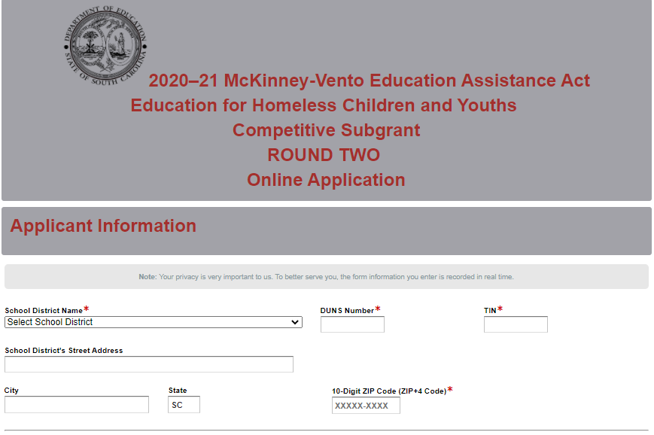
Indicate whether or not the district is registered and active with SAM.gov. If the district does not have an active SAM registration, the following message will be displayed. Refer to the information on page 6 on updating a registration in SAM to comply with 2 CFR Part 25.
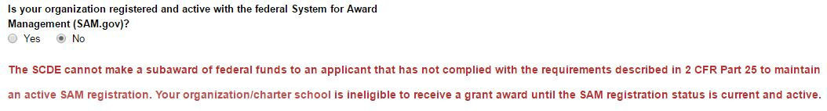
If the district selects “Yes” to indicate that their SAM registration is active, enter the date the current SAM registration expires.
Enter the contact information for the McKinney-Vento LEA liaison. If the liaison’s mailing address is the same as the school district, click on “Same as School District’s Address” and the fields will automatically populate. If the address is different, enter the appropriate information, including the 10-digit ZIP Code. Because the application submission confirmation will be sent only to this e-mail address, you must reenter the e-mail address to validate that it is correct.
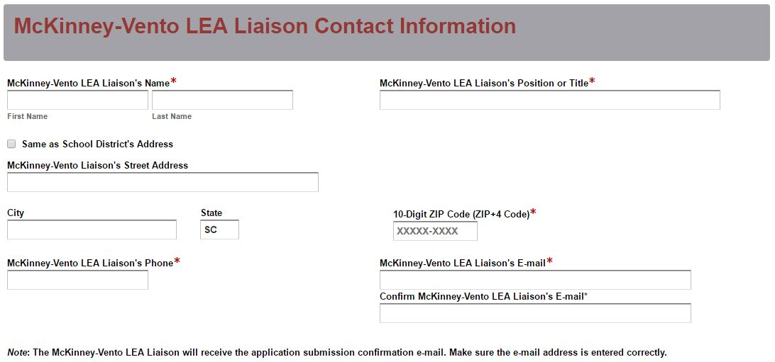
Indicate whether or not the McKinney-Vento LEA liaison will also serve as the project coordinator for this subgrant. Provide the additional information on the liaison to include the number of months they have been in this position, the percentage of a full-time equivalent (FTE) that will be devoted to the McKinney-Vento subgrant activities, and the other duties for which the liaison will be responsible.
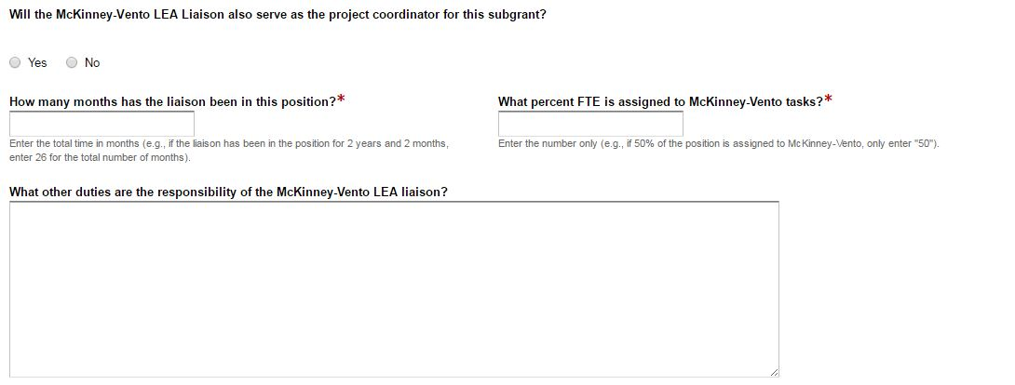
If the liaison will serve as the coordinator, click on “Same as McKinney-Vento Liaison” and the name, position or title, phone number, and e-mail address fields will automatically populate. If the liaison will not serve as the project coordinator, enter the coordinator’s contact information.
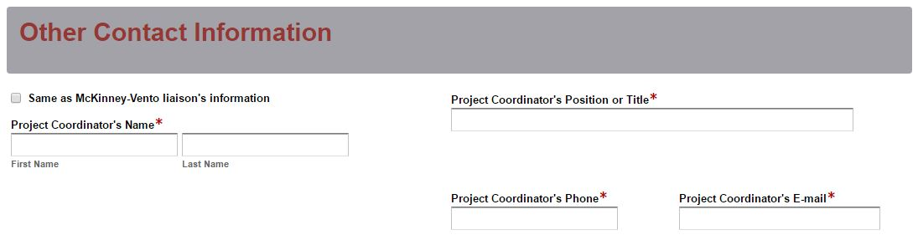
Enter the contact information for the district superintendent and the financial director. The superintendent is the authorized representative for the district and has the authority to enter into legally binding contractual agreements on behalf of the district. The names in the online application must match the names as provided on the Certification Signature Page.
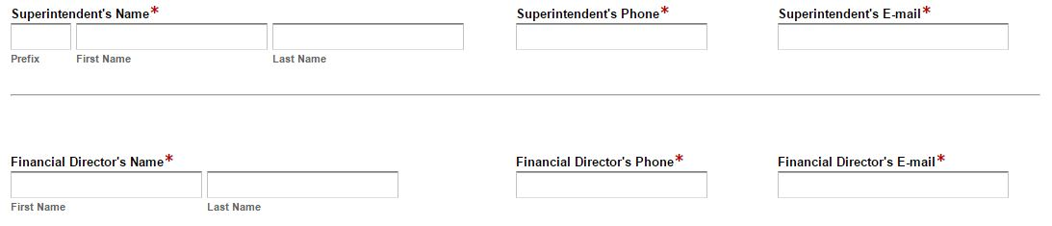
Provide the total number of homeless children and youths in the district by grade level for the 2019–20 school year to date as identified in PowerSchool. The field for the total identified homeless will automatically calculate. Enter the total student population for the district. The percent homeless field will auto-calculate the percentage of student homelessness for the district.
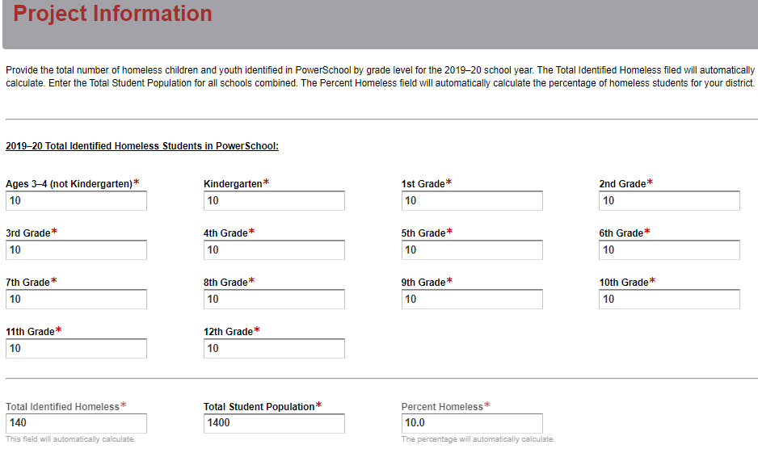
All amounts in the Funding Information and Budget Summary sections should be entered using whole dollars (no cents). Fill in all fields and enter 0 (zero) for line items that are not applicable.

In the Funding Information section, enter the total amount of subgrant funds requested for the first year of the project (November 2, 2020, through June 30, 2021).
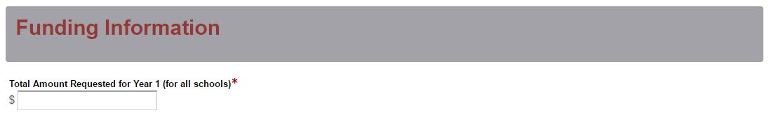
Enter the line-item totals for the funds requested for year one. The Total Funds Requested field will automatically calculate. The Total Funds Requested amount must match the Total Amount Requested under the Funding Information section.
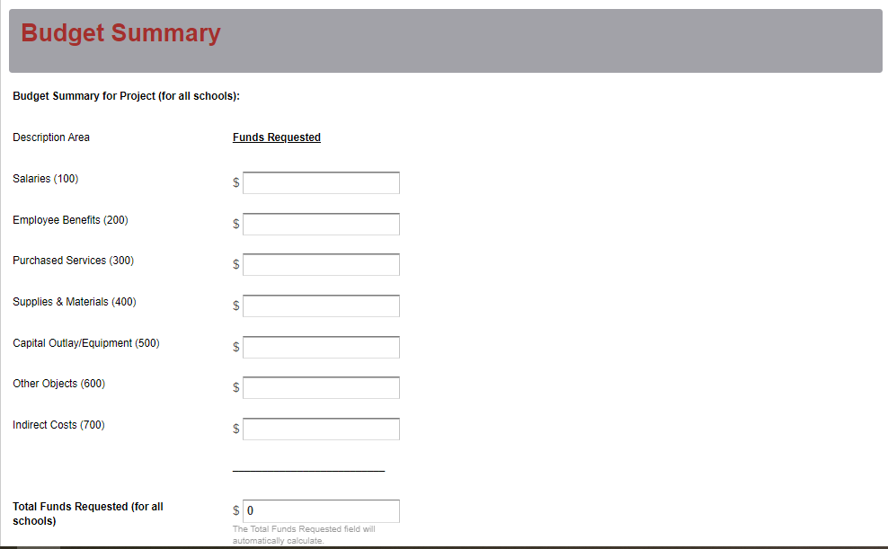
Enter the district’s current indirect cost rate percentage approved by the SCDE. Provide the beginning and ending dates of the effective period of the current indirect cost rate agreement.
Prepare each of the proposal attachments (i.e., Project Abstract, Application Narrative, Budget Narrative, Appendices, and Pre-Award Audit Questionnaire) following the preceding instructions on pages 16–28. Ensure that each attachment is saved in the proper format as either a PDF or Excel document. Pay close attention to attachments that must be scanned together into a single document. The online application will only allow one document to be uploaded for each attachment. Upload the attachments where indicated in the following screenshot. All attachments are required; you will not be able to submit the application without uploading all five documents.
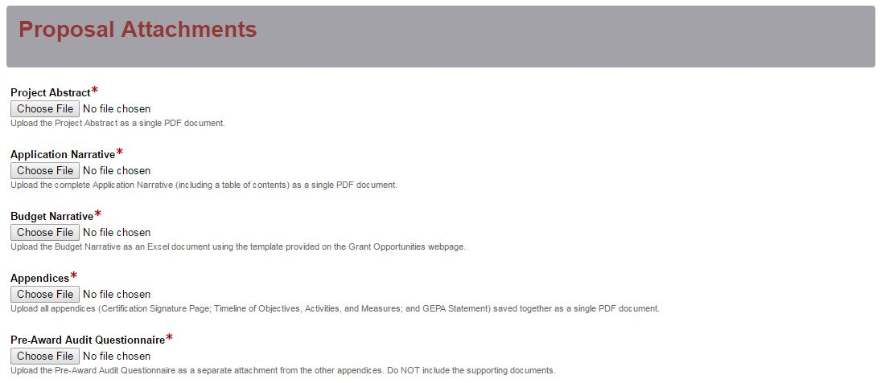
Thoroughly review the summary on the Data Review and Confirmation Page to verify that the information has been entered correctly in the online application prior to submitting. You will not be able to access the completed application form after it has been submitted. If any of the entries are incorrect, click on the "Previous" button at the bottom of each screen to return to the appropriate section(s) and reenter the correct information.
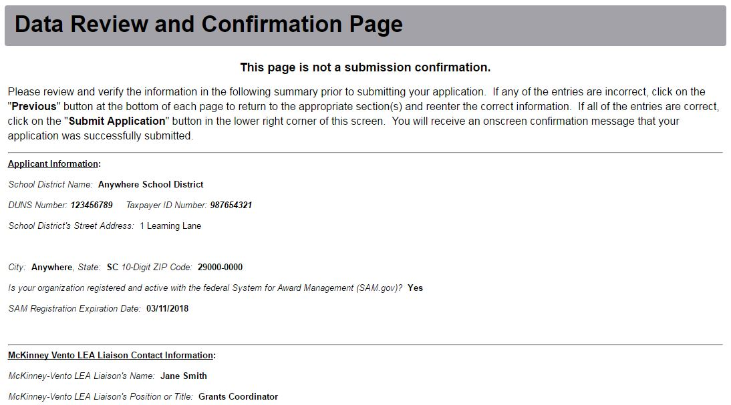
If all of the entries are correct, click on the “Submit Application” button in the lower right corner of this screen to complete the submission process.
Once the application is submitted, the following message will be displayed on the screen.
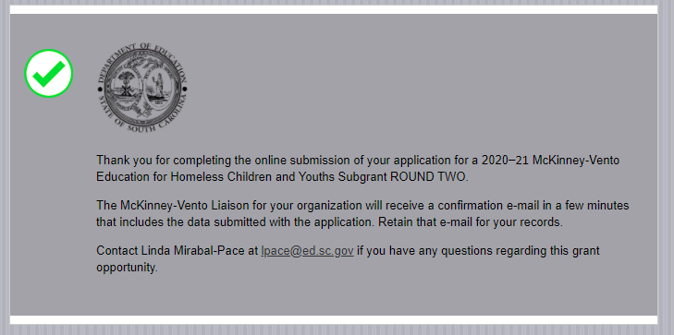
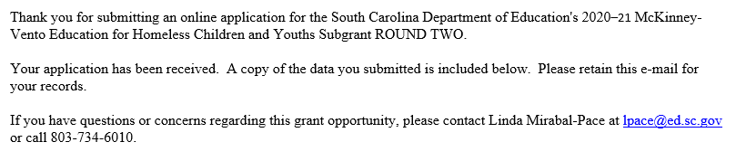
The following confirmation message will be sent to the e-mail address provided for the McKinney-Vento LEA liaison in the online application. If the liaison does not receive a confirmation e-mail, then the application did not successfully upload. You must go back and resubmit the entire online form, including all attachments, in order for your application to be considered for funding. Only the most recently submitted application will be reviewed.
An e-mail confirmation that the subgrant application was successfully submitted does not account for the quality of the uploaded documents or the completeness of the online form. The confirmation e-mail only notifies you that the online application has been submitted and received. Applicants are responsible for ensuring that the information entered in the online form, including all attachments, is accurate and complete in order for the application to be reviewed and considered for funding.
Appendix A: Definitions of Terms Used

De-obligation—The downward adjustment of the obligations recorded in a grant award document. It is caused by factors such as (1) termination of part of the project, (2) reduction in material prices, (3) cost savings, or (4) correction of recorded amounts.

Enrolled and enrollment includes attending classes and participating fully in school activities.

Homeless children and youths are defined by the McKinney-Vento Homeless Assistance Act as individuals who lacks a fixed, regular, and adequate nighttime residence, including
- children and youths who are
  - sharing the housing of other persons due to loss of housing, economic hardship, or a similar reason (sometimes referred to as doubled-up);
  - living in motels, hotels, trailer parks, or camping grounds due to the lack of alternative adequate accommodations;
  - living in emergency or transitional shelters; or
  - abandoned in hospitals;
- children and youths who have a primary nighttime residence that is a public or private place not designed for or ordinarily used as a regular sleeping accommodation for human beings;
- children and youths who are living in cars, parks, public spaces, abandoned buildings, substandard housing, bus or train stations, or similar settings; and
- migratory children who qualify as homeless for the purposes of this subtitle because the children are living in circumstances described above.

Local education agency (LEA) is a public board of education or school district.

Memorandum of Agreement (MOA)—A document signed by the authorized representative(s) of each collaborative partner that clearly specifies the role, services, contributions, expertise, and funding for each partner.

The term unaccompanied youth includes a homeless child or youth not in the physical custody of a parent or guardian.

School of origin is the school that the child or youth attended when permanently housed or the school in which the child or youth was last enrolled.

Title I Schools—Schools with a 40 percent student population eligible for free or reduced-price lunch that receive or are eligible to receive Title I funds.

Appendix B: Selection Criteria and Reviewers’ Scoring Rubric

Selection Criteria

A total of 100 points is available to applications that meet the maximum score for each selection criteria. While the budget is assigned zero (0) points, the budget remains a critical component of the entire application. An application with an incomplete budget will not be funded.

The point values for each section of the application are as follows:

Narrative Sections | Points Available
Needs Assessment | 20
Goals and Objectives | 10
Strategies and Activities | 35
Management and Sustainability | 20
Evaluation and Dissemination | 15
Budget (Summary and Narrative) | 0
TOTAL | 100

Scoring Rubric
Project Abstract: The applicant must, in one page, concisely describe the proposed project, the documented need for the project based on the needs assessment, each of the main components (e.g., tutoring, training, salaries), proposed goals and objectives for the project, the number of students to be served, and the amount of funding requested.
The applicant provides a one-page narrative that fully addresses all of the following items:  - the documented need for the project based on the needs assessment,  - each of the main components (e.g., tutoring, training, salary),  - proposed goals and objectives for the project,  - the number of students to be served, and  - the amount of funding requested. | Acceptable | Adequate/Meets—0 points  Applicant provides a narrative that fully addresses all required items.
 | Not Acceptable | Inadequate—0 points  Applicant provides a narrative that does not adequately address all required items.
Reviewer’s Comments

1.a. Needs Statement: The applicant must document trends in homeless identification over the past two years (including data submitted in the Project Information section of the online application form), include an analysis of the trends in identification (e.g., possible explanations for increases or decreases), and describe how identification rates in the LEA compare with the national rate and the expected rates of identification based on poverty data (see page 18 for further information).
The applicant provides a narrative that fully addresses all three of the following:  - documentation of the LEA’s trends in homeless identification over the past two years (referencing data submitted in online application form),  - an analysis of the trends in identification (e.g., possible explanations for increases or decreases), and  - a description of how identification rates in the LEA compare with  - the national rate, and  - the expected rates of identification based on poverty data. | Acceptable | Fully Meets—5–6 points  Applicant provides a narrative that fully addresses all required items.
 | Acceptable | Adequate/Meets—3–4 points  Applicant provides a narrative that moderately addresses all required items or fully addresses at least two of the items.
 | Not Acceptable | Limited/Approaches—1–2 points  Applicant provides a narrative that is limited or unclear in addressing at least two of the required items.
 | Not Acceptable | Inadequate—0 points  Applicant provides a narrative that does not adequately address the required items.
Reviewer’s Comments
1.b. Needs Statement: The applicant must identify the current academic and social/emotional functioning of McKinney-Vento students and the major needs of such students in the LEA as validated by needs assessment data and/or data from PowerSchool or other sources; include an analysis of the data on the number of homeless children and youths by primary nighttime residence, absenteeism, discipline referrals, dropout rate, level of academic proficiency, and any gaps between McKinney-Vento students, other subgroups such as students living in poverty, and/or the total student population; and describe the major barriers, both within the LEA and outside, that limit the identification, immediate enrollment, attendance (including prompt provision of transportation), and success in school of homeless children and youths.

The applicant provides a narrative that fully addresses all three of the following:  - identification of the current academic and social/emotional functioning of McKinney-Vento students, and the major needs of such students in the LEA as validated by needs assessment data and/or data from PowerSchool or other sources;  - an analysis of the data on the number of homeless children and youths by primary nighttime residence, absenteeism, discipline referrals, dropout rate, level of academic proficiency, and any gaps between McKinney-Vento students, other subgroups such as students living in poverty, and/or the total student population; and  - a description of the major barriers, both within the LEA and outside, that limit the identification, immediate enrollment, attendance (including prompt provision of transportation), and success in school of homeless children and youths. | Acceptable | Fully Meets—7–8 points  Applicant provides a narrative that fully addresses all required items.
 | Acceptable | Adequate/Meets—5–6 points  Applicant provides a narrative that moderately addresses all required items.
 | Not Acceptable | Limited/Approaches—3–4 points  Applicant provides a narrative that is limited or unclear in addressing all of the required items.
 | Not Acceptable | Inadequate—0–2 points  Applicant provides a narrative that does not adequately address the required items.
Reviewer’s Comments
1.c. Needs Statement: The applicant must document the effectiveness of existing programming and resources both within the LEA and externally, to assist McKinney-Vento students (e.g., existing LEA support including percent of time that the liaison and others devote to homeless education; support from McKinney-Vento grant-funded programming and programming targeted for homeless students through Title I Part A and other funding; and support from community, state, or national organizations (Coalition of Care, United Way, Department of Social Services, business partners, community and faith-based agencies)). Applicants should include available data and/or feedback on the effectiveness of the program(s); explain how the data on program effectiveness was collected and analyzed; and describe how the data demonstrates improvement (or not) on the part of students served (improved attendance, improved academic skills, increased participation in statewide assessments, improved performance on statewide assessments, etc.).

The applicant provides a narrative that fully documents all of the following:  - the effectiveness of existing programming and resources, both within the LEA and externally, to assist McKinney-Vento students;  - available data and/or feedback on the effectiveness of the program(s);  - how the data on program effectiveness was collected and analyzed; and  - how the data demonstrates improvement (or not) on the part of students served (improved attendance, improved academic skills, increased participation in statewide assessments, improved performance on statewide assessments, etc.). | Acceptable | Fully Meets—5–6 points  Applicant provides a narrative that fully documents all required items.
 | Acceptable | Adequate/Meets—3–4 points  Applicant provides a narrative that moderately documents all required items or fully addresses at least three of the items.
 | Not Acceptable | Limited/Approaches—1–2 points  Applicant provides a narrative that is limited or unclear in documenting at least three of the required items.
 | Not Acceptable | Inadequate—0 points  Applicant provides a narrative that does not adequately document the required items.
Reviewer’s Comments
2. Goals and Objectives: The applicant must state the goal(s) for the proposed McKinney-Vento project and the SMART (specific, measurable, achievable, relevant, and time-specific) objectives that are related to the goal(s) to be achieved.
The applicant provides a narrative that presents clear statements that address all of the following:  - goal(s) for the proposed McKinney-Vento project;  - objectives that are  - specific,  - measurable,  - achievable,  - relevant, and  - time-specific; and  - objectives that are related to the goal(s) to be achieved. | Acceptable | Fully Meets—9–10 points  Applicant provides a narrative that fully addresses all required items.
 | Acceptable | Adequate/Meets—6–8 points  Applicant provides a narrative that moderately addresses all required items.
 | Not Acceptable | Limited/Approaches—3–5 points  Applicant provides a narrative that is limited or unclear in addressing all required items.
 | Not Acceptable | Inadequate—0–2 points  Applicant provides a narrative that does not adequately address the required items.

Reviewer’s Comments:
3.a. Activities: The applicant must provide a clear, concise description of the activities that will be provided for students, a rationale for their selection, a discussion of how these proposed activities are expected to improve student academic achievement, and how the activities reflect the needs previously stated in the narrative.
The applicant provides a narrative that fully addresses all of the following:  - a clear, concise description of the activities that will be provided for students,  - a rationale for their selection,  - a discussion of how these activities are expected to improve student academic achievement, and  - a discussion of how these activities reflect the needs previously stated in the narrative. | Acceptable | Fully Meets—11–13 points  Applicant provides a narrative that fully addresses all required items.
 | Acceptable | Adequate/Meets—9–10 points  Applicant provides a narrative that moderately addresses all required items or fully addresses at least three of the items.
 | Not Applicable | Limited/Approaches—7–8 points  Applicant provides a narrative that is limited or unclear in addressing at least three of required items.
 | Not Applicable | Inadequate—0–6 points  Applicant provides a narrative that does not adequately address the required items.
Reviewer’s Comments:
3.b. Activities: The applicant must, for each activity, describe specific measurable indicators or outcomes that will indicate that the activity is successfully working toward the objective(s) and the data source(s) for measuring this success.
The applicant provides a narrative that clearly and in detail describes all of the following for each activity:  - specific measurable indicators or outcomes that will indicate that the activity is successfully working toward the objective(s), and  - the data source(s) for measuring this success. |  |  | Acceptable | Fully Meets—11–13 points  Applicant provides a narrative that fully describes all required items.
 |  |  | Acceptable | Adequate/Meets—9–10 points  Applicant provides a narrative that moderately describes all required items.

 |  |  | Not Applicable | Limited/Approaches—7–8 points  Applicant provides a narrative that is limited or unclear in describing all required items.
 |  |  | Not Applicable | Inadequate—0–6 points  Applicant provides a narrative that does not adequately describe the required items.
Reviewer’s Comments:
3.c. Activities: The applicant must provide, as an appendix item, a detailed Timeline of Objectives, Activities, and Measurable Outcomes that is complete (all columns populated for each activity) and accurately reflects the activities discussed in 3.a. and 3.b.
The applicant provides a detailed Timeline of Objectives, Activities, and Measurable Outcomes that  - is complete (all columns populated for each activity), and  - accurately reflects each activity discussed in 3.a. and 3.b. | Acceptable | Fully Meets—9 points  Applicant provides a timeline that fully addresses all required items.
 | Acceptable | Adequate/Meets—7–8 points  Applicant provides a timeline that moderately addresses all required items.
 | Not Applicable | Limited/Approaches—5–6 points  Applicant provides a timeline that is limited or unclear in addressing all required items.
 | Not Applicable | Inadequate—0–4 points  Applicant provides a timeline that does not adequately address the required items.
Reviewer’s Comments:

4.a. Management and Collaboration: The applicant must provide a management plan that
- describes the administrative structure for the proposed project, including a brief description of key personnel (including the McKinney-Vento liaison) who will be involved and their anticipated programmatic and/or fiscal responsibilities;
- identifies who will be responsible for managing and administering the subgrant;
- discusses what training and other supports the designated McKinney-Vento liaison will receive to ensure that he/she has the capacity to carry out the required duties described in the law (§ 11432(g)(6)(A));
- if intending to hire staff for the project, indicates the preferred qualifications and the planned responsibilities for those individuals; and
- if planning to contract with a vendor to provide direct services, describes what services will be provided by whom and includes a description of the fiscal arrangements.
The applicant provides a narrative that includes a management plan that fully addresses all of the following, as applicable:  - describes the administrative structure for the proposed project, including a brief description of key personnel (including the McKinney-Vento liaison) who will be involved and their anticipated programmatic and/or fiscal responsibilities;  - identifies who will be responsible for managing and administering the subgrant;  - discusses what training and other supports the designated McKinney-Vento liaison will receive to ensure that he/she has the capacity to carry out the required duties described in the law;  - if intending to hire staff, indicates the preferred qualifications and the planned responsibilities for those individuals; and  - if planning to contract with a vendor to provide direct services, describes what services will be provided by whom and includes a description of the fiscal arrangements. | Acceptable | Fully Meets—5 points  Applicant provides a narrative that fully addresses all required items.
 | Acceptable | Adequate/Meets—4 points  Applicant provides a narrative that moderately addresses all required items or fully addresses at least four of the items.
 | Not Applicable | Limited/Approaches—3 points  Applicant provides a narrative that is limited or unclear in addressing at least four of the required items.
 | Not Applicable | Inadequate—0–2 points  Applicant provides a narrative that does not adequately address the required items.
Reviewer’s Comments:

4.b. Management and Collaboration: The applicant must demonstrate how the LEA will collaborate with community-based organizations, public agencies, or other nonprofit organizations to provide services to homeless students by
- providing a detailed description of the proposed Title I Part A collaboration for 2020‒21, including the planned activities and the anticipated set-aside amount;
- indicating whether or not the LEA will use Title I Homeless Reservation funds for the McKinney-Vento liaison’s salary or excess cost of transportation to the school of origin;
- describing the process used to determine the amount of Title I Part A funds set-aside for 2019–20 and if that process has changed for the upcoming school year;
- discussing the activities funded out of the actual Title I Part A set-aside for the 2019–20 school year, including the percentage of those funds that were spent on activities for homeless children and youths, and, if the amount is less than 100 percent, explaining why;
- describing the mechanisms in place to improve or ensure ongoing coordination between the Title I Part A set-aside and the McKinney-Vento programs; and
- if the applicant does not currently have Title I Part A collaboration, describing a plan to incorporate collaboration within the first year of the project.
The applicant provides a comprehensive, detailed narrative that demonstrates how the LEA will collaborate with community-based organizations, public agencies, or other nonprofit organizations to provide services to homeless students by  - providing a detailed description of the proposed Title I Part A collaboration for 2020‒21, including the planned activities and the anticipated set-aside amount;  - indicating whether or not the LEA will use Title I Homeless Reservation funds for the McKinney-Vento liaison’s salary or excess cost of transportation to the school of origin;  - describing the process used to determine the amount of Title I Part A funds set-aside for 2019–20 and if that process has changed for the upcoming school year;  - discussing the activities funded out of the actual Title I Part A set-aside for the 2019–20 school year, including the percentage of those funds that were spent on activities for homeless children and youths, and, if less than 100 percent, explaining why; | Acceptable | Fully Meets—5 points  Applicant provides a narrative that fully demonstrates all required items.
 | Acceptable | Adequate/Meets—4 points  Applicant provides a narrative that moderately demonstrates all required items or fully demonstrates at least four required items.

- describing the mechanisms in place to improve or ensure ongoing coordination between the Title I Part A set-aside and the McKinney-Vento programs; and  - if the applicant does not currently have Title I Part A collaboration, describing a plan to incorporate collaboration within the first year of the project. |  | Not Acceptable | Limited/Approaches—3 points  Applicant provides a narrative that is limited or unclear in demonstrating at least four required items.
 |  | Not Acceptable | Inadequate—0–2 points  Applicant provides a narrative that does not adequately demonstrate the required items.
Reviewer’s Comments:
4.c. Management and Collaboration: The applicant must provide a detailed description of
- other collaborations within the LEA (National School Lunch and Breakfast Program, migrant, English Learners, preschool, special education, guidance counselors, etc.);
- the activities in place, the planned activities, and the services or resources provided;
- specific steps the LEA has already undertaken to build, maintain, and improve collaborations; and
- what future steps the LEA will take to solidify these collaborations.
The applicant provides a narrative that is a comprehensive and detailed description addressing all of the following, as applicable:  - the other collaborations within the LEA (National School Lunch and Breakfast Program, migrant, English Learners, preschool, special education, guidance counselors, etc.);  - the activities in place, the planned activities, and the services or resources provided;  - specific steps the LEA has already undertaken to build, maintain, and improve collaborations; and  - what future steps the LEA will take to solidify these collaborations. | Acceptable |  |  | Fully Meets—5 points  Applicant provides a narrative that fully addresses all required items.
Adequate/Meets—4 points
Applicant provides a narrative that moderately addresses all required items or fully addresses at least three required items.
 | Not Acceptable |  |  | Limited/Approaches—3 points  Applicant provides a narrative that is limited or unclear in addressing at least three required items.
Inadequate—0–2 points
Applicant provides a narrative that does not adequately address the required items.

Reviewer’s Comments:
4.d. Management and Collaboration: The applicant must provide a detailed description of
- collaborations with other state and community agencies (e.g., Department of Social Services, Department of Mental Health, Head Start, Early Head Start, IDEA Part C, Housing and Urban Development, Continuum of Care, shelters, county Youth Bureau, Runaway and Homeless Youth programs, community action agencies, food banks, Department of Agriculture, business partners, faith-based agencies);
- the activities in place, the planned activities, and the services or resources provided;
- specific steps the LEA has already undertaken to build, maintain, and improve collaborations;
- what future steps it will take to solidify these collaborations; and
- if the applicant does not currently have collaborations with outside agencies, the plan to incorporate collaboration within the first year of the project.
The applicant provides a narrative that includes a comprehensive, detailed description of the following, as applicable:  - collaborations with other state and community agencies (e.g., Department of Social Services, Department of Mental Health, Head Start, Early Head Start, IDEA Part C, Housing and Urban Development, Continuum of Care, shelters, county Youth Bureau, Runaway and Homeless Youth programs, community action agencies, food banks, Department of Agriculture, business partners, faith-based agencies);  - the activities in place, the planned activities, and the services or resources provided;  - specific steps the LEA has already undertaken to build, maintain, and improve collaborations;  - what future steps it will take to solidify these collaborations; and  - if the applicant does not currently have collaborations with outside agencies, the plan to incorporate collaboration within the first year of the project. | Acceptable | Fully Meets—5 points  Applicant provides a narrative that fully describes all required items.
 | Acceptable | Adequate/Meets—4 points  Applicant provides a narrative that moderately describes all required items or fully describes at least four required items.
 | Not Acceptable | Limited/Approaches—3 points  Applicant provides a narrative that is limited or unclear in describing at least four required items.
 | Not Acceptable | Inadequate—0–2 points  Applicant provides a narrative that does not adequately describe the required items.

Reviewer’s Comments:
5. Evaluation: Applicants must provide a plan to evaluate the project’s outcomes and demonstrate, using scientific methods as applicable, if and how well the project worked by
- describing the process they will undertake (including methodology) to determine whether adjustments or enhancements to the project are needed based on periodic data collection and analysis,
- describing whether all steps of the project have been fully and faithfully implemented,
- describing whether project goals and outcomes have been met,
- describing the outcome measures that will indicate that the project has been successful, and
- identifying the person who will be responsible for documentation and evaluation of the project.
The applicant provides a narrative that includes a clear and detailed plan to evaluate the project’s outcomes and demonstrate, using scientific methods as applicable, if and how well the project worked that fully addresses all of the following:  - describes the process they will undertake (including methodology) to determine whether adjustments or enhancements to the project are needed based on periodic data collection and analysis,  - describes whether all steps of the project have been fully and faithfully implemented,  - describes whether project goals and outcomes have been met,  - describes the outcome measures that will indicate that the project has been successful, and  - identifies the person who will be responsible for documentation and evaluation of the project. | Acceptable | Fully Meets—13–15 points  Applicant provides a narrative that fully addresses all required items.
 | Acceptable | Adequate/Meets—11–12 points  Applicant provides a narrative that moderately addresses all required items or fully addresses at least four required items.
 | Not Acceptable | Limited/Approaches—9–10 points  Applicant provides a narrative that is limited or unclear in addressing at least four required items.
 | Not Acceptable | Inadequate—0–8 points  Applicant provides a narrative that does not adequately address the required items.
Reviewer’s Comments:

Budget Summary and Budget Narrative: The applicant must provide a Budget Summary in the online form that computes correctly and a complete Budget Narrative in which the totals correctly reflect the line item totals in the Budget Summary. In the Budget Narrative, the applicant must provide
- items that are allowable, appropriate, justified, reasonable, and adequate for the scope of the project;
- line items that include the formulas used to calculate the cost(s); and
- evidence of a clear relationship between the requested funds and the proposed activities.
The applicant provides a project budget that includes all of the following:  - a Budget Summary in the online form that computes correctly;  - a complete Budget Narrative;  - totals in the Budget Narrative that correctly reflect the line item totals in the Budget Summary;  - items that are allowable, appropriate, justified, reasonable, and adequate for the scope of the project;  - line items that include the formulas used to calculate the cost(s); and  - evidence of a clear relationship between the requested funds and the proposed activities. | Acceptable | Adequate/Meets—0 points  Applicant provides a budget narrative that includes all required items.
 | Not Acceptable | Inadequate—0 points  Applicant provides a budget narrative that does not include all required items.
Reviewer’s Comments:

Appendix C: Required SCDE Forms

Certification Signature Page
(This form must be signed by the individual from each proposed district, school, or organization who holds the title listed below.)

Certification
I hereby certify that, to the best of my knowledge, the information and data contained in this application are true and correct. The applicant’s governing body has duly authorized this application and documentation, and the applicant will comply with the Program Specific Assurances (if applicable) and the SCDE Assurances and Terms and Conditions if the grant is awarded. The applicant is registered and current (active) on the federal System for Award Management (SAM).

Authorized Official (should be superintendent of school district)
Name:
Position: | Email:
Telephone: | Fax:

Signature of Authorized Official: | Typed name of Authorized Official:
Date Signed:
Signature of Financial Official: | Typed Name of Financial Official:
Date Signed:
Signature of McKinney-Vento Liaison: | Typed Name of McKinney-Vento Liaison:
Date Signed:
Signature of Project Coordinator (if liaison is not project coordinator): | Typed Name of Project Coordinato:
Date Signed:

Please complete, print, and obtain signatures prior to submission. Include the signed, scanned form in the required appendices as indicated on page 27.

Assurances and Terms and Conditions for Federal Subawards

Assurances

I certify that this applicant
- Has the legal authority to apply for federal assistance and the institutional, managerial, and financial capability (including funds sufficient to pay the nonstate share of project costs) to ensure proper planning, management, and completion of the project described in this application.
- Will give the South Carolina Department of Education (SCDE) access to and the right to examine all records, books, papers, or documents related to this award and will establish a proper accounting system in accordance with generally accepted accounting principles (GAAP) or agency directives.
- Has an accounting system with sufficient internal controls, a clear audit trail, and written cost-allocation procedures as necessary. The financial management systems are capable of distinguishing expenditures that are attributable to this grant from those that are not attributable to this grant. This system is able to identify costs by programmatic year and by budget line item and to differentiate among direct, indirect, and administrative costs. In addition, the applicant will maintain adequate supporting documents for the expenditures (federal and nonfederal) and in-kind contributions, if any, that it makes under this grant. Costs are shown in books or records (e.g., disbursements ledger, journal, payroll register) and are supported by a source document such as a receipt, travel voucher, invoice, bill, or in-kind voucher.
- Will also comply with the Office of Management and Budget 2 CFR Part 200 Subpart E-Cost Principles related to the allowability, reasonableness, and allocability of costs consistent with the approved budget and also by maintaining required support for salaries and wages. Required support includes certifications and/or personnel activity records depending upon the amount of time spent on cost objectives.
- Will approve all expenditures, document receipt of goods and services, and record payments on the applicant’s accounting records prior to submission of reimbursement claims to the SCDE for costs related to this grant.
- Will initiate and complete work within the applicable time frame after receipt of approval by the SCDE.
- Will not discriminate against any employee or applicant for employment because of race, color, religion, age, sex, national origin, or disability and comply with Title VI of the Civil Rights Act of 1964, Section 504 of the Rehabilitation Act of 1973, Title IX of the Education Amendments of 1972, the Age Discrimination Act of 1975, and Titles I, II, and III of the Americans with Disabilities Act of 1990 (ADA). The grantee will take affirmative action to ensure that applicants for employment and the employees during the period of their employment are treated without regard to their race, color, religion, age, sex, national origin, or disability.
- Has no policy that prevents, or otherwise denies, participation in constitutionally protected prayer in public schools as set forth in the Guidance on Constitutionally Protected Prayer in Public Education (20 U.S.C. § 7904).
- Will comply with the Family Educational Rights and Privacy Act. (20 U.S.C. §1232g; 34 CFR Part 99).
- Will comply with the Ethics, Government Accountability, and Campaign Reform Act (S.C. Code Ann. § 2-17-10 et seq. and § 8-13-100 et seq. (Supp. 2019)).
- Will comply with the South Carolina Drug Free Workplace Act (S.C. Code Ann. § 44-107-10 et seq. (Supp. 2019) if the amount of this award is $50,000 or more and the federal Drug Free Workplace Act of 1988 (41 USC 702).
- Will provide information to the SCDE, as requested, regarding the reporting requirements of the Federal Funding Accountability and Transparency Act (FFATA), which requires the SCDE to file a FFATA subaward report by the end of the month following the month in which it awards any subgrant equal to or greater than $25,000.
- Will comply with 2 CFR Part 25 and register and receive a unique entity identifier, fulfill the requirement for the System for Award Management, maintain the currency of the registration throughout the full grant term, and allow access by the granting agency to ensure compliance.
- Will comply with 2 CFR Part 200.112 and disclose in writing any potential conflict of interest to the SCDE.
- Will comply with 2 CFR Part 200.113 and disclose in writing to the SCDE all violations of federal criminal law involving fraud, bribery, or gratuity violations potentially affecting the federal award.
- Will comply with conditions under Executive Order 13513 “Federal Leadership on Reducing Text Messaging While Driving” (October 1, 2009) by refraining from text messaging while driving during official grant business.

Terms and Conditions

- Completeness of Proposal. All proposals should be complete and carefully worded and must contain all of the information requested by the South Carolina Department of Education (SCDE). If you do not believe a section applies to your proposal, please indicate that fact.
- Non-awards/Termination. The SCDE reserves the right to reject any and all applications and to refuse to grant monies under this solicitation. If the SCDE rejects an application, the applicant has a right to request a hearing, as provided by 2 CFR Part 200.341 and 34 CFR Part 76.401, if it alleges the SCDE’s actions violate a state or federal statute or regulation by (1) disapproving of or failing to approve the application or project, in whole or in part, or (2) failing to provide funds in amounts in accordance with the requirements of statutes and regulations.
After it has been awarded, the SCDE may terminate a grant by giving the grantee written notice of termination. In the event of a termination after award, the SCDE shall reimburse the grantee for allowable expenses incurred up to the notification of termination. In addition, this grant may be terminated by the SCDE if the grantee fails to perform as promised in its proposal. Federal grants will be terminated in accordance with 2 CFR Part 200.339 and 200.340.
In the event that this grant is terminated, the grantee shall have a right to a hearing as set forth in 34 CFR Part 76.783. The grantee must notify the SCDE of its request for a hearing within 30 days of receiving written notice of the termination. If a hearing is requested, the SCDE will conduct the hearing in accordance with the procedures outlined in 34 CFR Part 76.401(d)(2)–(7).
- Reduction in Budgets and Negotiations. The SCDE reserves the right to negotiate budgets with applicants. The SCDE may, at its sole discretion, determine that a proposed budget is excessive and may negotiate a lower budget with the applicant. The applicant may at that time negotiate or withdraw its proposal. In addition, the SCDE may desire to fund a project but not at the level proposed. In that case, the SCDE shall notify the applicant of the amount that can be funded, and the applicant and the SCDE shall negotiate a modification to the proposal to accommodate the lower budget. All final decisions are that of the SCDE.
- Amendments to Grants. Amendments are permitted generally for budgets, grant end date, and management upon the mutual agreement of the parties involved and will become effective when specified in writing and signed by both parties. However, amendments to scope of work that significantly alter the original application proposal may trigger partial or full termination consistent with 2 CFR Part 200.339 and 200.340.
- Use of Grant Funds. Funds awarded are to be expended only for purposes and activities covered by the approved project plan and approved budget and budget narrative.
- Submission of Expenditure Reports. Claims for reimbursement must be made at least quarterly and consistent with calendar quarters (e.g., an expenditure report claim for costs for January 1 through March 30 must be filed by May 15).
- Obligation of Grant Funds. Grant funds may not be obligated prior to the effective date or subsequent to the end or termination date of the grant period. No obligations are allowed after the end of the grant period. The final request for expenditure report claims must be submitted no later than forty-five (45) days after the end of the grant period unless the scope of work for the grant states a shorter reporting period.
- Deobligation of Funds. After a final expenditure report claim has been submitted to the SCDE, the grantee will go through the official deobligation process with the SCDE.
- Documentation. The grantee must provide for accurate and timely recording of receipts and expenditures. The grantee’s accounting system should distinguish receipts and expenditures attributable to each grant. The grantee must review the memo regarding “Guidelines for Retaining Documentation to Support Expenditure Claims.”
- Travel Costs. Travel costs, if allowed under this solicitation, must not exceed limits noted in the United States General Services Administration (GSA) per diem rates for lodging, except in the case of conference lodging required for program-required training. In the case that conference-related lodging exceeds the GSA per diem rate, the grantee shall follow their entity’s written procedure for obtaining prior approval to exceed a GSA rate for a conference hotel. Meals and incidentals are limited by the state budget proviso, currently not to exceed $35 per day for in-state travel and $50 for out-of-state travel (see page 86 of the State of South Carolina Statewide Disbursement Regulations). Mileage reimbursement must follow the current Office of Comptroller General instructions, which is consistent with the published IRS rates.
- Honoraria. Amounts paid in honoraria, if allowed under this grant, must be consistent with SCDE policies. Applicants should check with the program office before budgeting for honoraria.
- Reports. The grantee shall submit, as required or instructed by the awarding program office, all reports (programmatic, financial, or evaluation) within the specified period or date and in the prescribed format. An expenditure claim report must be filed by August 15 for all expenditures incurred by June 30 in order to comply with the generally accepted accounting principles (GAAP) and the production of the State's Comprehensive Annual Financial Report.
- Copyright. The grantee is free to copyright any books, publications, or other copyrightable materials developed in the course of this grant. However, the SCDE reserves a royalty-free, nonexclusive, and irrevocable license to reproduce, publish, or otherwise use, and to authorize others to use, the copyrighted work developed under this grant.
- Certification Regarding Lobbying, Suspension, and Debarment. By submitting an application, the applicant certifies, to the best of its knowledge and belief, that the
- Applicant and/or any of its principals, subgrantees, or subcontractors
  - Have not paid or will not pay to any person any federally appropriated funds for the purpose of influencing or attempting to influence an officer or employee of any agency, a Member of Congress, an officer or employee of Congress, or any employee of a Member of Congress in connection with making any federal grant and the extension continuation, renewal, amendment, or modification of any federal grant, as defined at 34 CFR Part 82.105 and 82.110. If any funds other than federally appropriated funds have been paid or will be paid to any person for influencing or attempting to influence an officer or employee of any agency, a Member of Congress, an officer or employee of Congress, or any employee of a Member of Congress in connection with this federal grant, the undersigned shall complete and submit Standard Form LLL, “Disclosure of Lobbying Activities,” in accordance with its instructions.
  - Are not presently debarred, suspended, proposed for debarment, or declared ineligible for the award of contracts by any state or federal agency as stated at 2 CFR Part 180 or 2 CFR Part 3485.
  - Have not, within a three-year period preceding this application, been convicted of or had a civil judgment rendered against them for commission of fraud or a criminal offense in connection with obtaining, attempting to obtain, or performing a public (federal, state, or local) contract or subcontract; violated federal or state antitrust statutes relating to the submission of offers; or committed embezzlement, theft, forgery, bribery, falsification or destruction of records, making false statements, tax evasion, or receiving stolen property.
  - Are not presently indicted for, or otherwise criminally or civilly charged by a governmental entity with, commission of any of the offenses enumerated above.
- Applicant has not, within a three-year period preceding this application, had one or more contracts terminated for default by any public (federal, state, or local) entity.
- Audits.
- Entities expending $750,000 or more in federal awards:
Entities that expend $750,000 or more in federal awards during the fiscal year are required to have an audit performed in accordance with the provisions of 2 CFR Part 200.501, et seq. Except for the provisions for biennial audits provided in 2 CFR Part 200.504 (a) and (b), audits must be performed annually as stated at 2 CFR Part 200.504. A grantee that passes through funds to subrecipients has the responsibility of ensuring that federal awards are used for authorized purposes in compliance with federal program laws, federal and state regulations, and grant agreements. The director of the OMB, who will review this amount every two years, has the option of revising the threshold upward.
- Entities expending less than $750,000 in federal awards:
Entities that expend less than $750,000 in a fiscal year in federal awards are exempt from the audit requirements in 2 CFR Part 200.504. However, such entities are not exempt from other federal requirements (including those to maintain records) concerning federal awards provided to the entity. The entity’s records must be available for review or audit by the SCDE and appropriate officials of federal agencies, pass-through entities, and the General Accounting Office (GAO).
- Records. The grantee shall retain federal grant records, including financial records and supporting documentation, for a minimum of six (6) years after the end date of the grant when the final expenditure report claim for reimbursement and all final reports have been submitted, unless informed otherwise or in the case of litigation.
- Electronic Signature Agreement. I agree that my electronic signature is the legally binding equivalent to my handwritten signature

Program-Specific Assurances

I certify that this applicant will abide by the following stipulations in federal law regarding the education of homeless children and youths:

- Ensure that services provided with these funds shall not replace the regular academic program and shall be designed to expand upon or improve services provided as part of the school’s regular academic program.
- Ensure that the LEA’s combined fiscal effort per student, or the aggregate expenditures of that agency and the state with respect to the provision of free public education by such agency for the fiscal year preceding the fiscal year for which the determination is made, was not less than 90 percent of such combined fiscal effort or aggregate expenditures for the second fiscal year preceding the fiscal year for which the determination is made.
- Ensure that the McKinney-Vento Liaison or program coordinator will
  - attend required meetings and professional development,
  - have access to the PowerSchool Student Information System,
  - be assigned a role in the grants accounting processing system (GAPS), and
  - submit all required reports and data to the SCDE by the required date.
- Ensure that the liaison and any applicable staff must comply with under Executive Order 13513, "Federal Leadership On Reducing Text Messaging While Driving."
- Ensure that the activities of the homeless education program does not segregate, isolate, stigmatize, or segregate homeless child or youth in a separate school, or in a separate program within a school, based on such child’s or youth’s status as homeless.
- Ensure that the LEA is in compliance with Section 722(g)(3)–(7) of the McKinney-Vento Act to include the following:
- The LEA of each homeless child and youth to be assisted shall, according to the child’s or youth’s best interest,
  - continue the education of each homeless child and youth in the school of origin for the duration of homelessness in any case in which a family becomes homeless between academic years or during an academic year or for the remainder of the academic year if the child or youth becomes permanently housed during an academic year; or,
  - enroll the child or youth in any public school that nonhomeless students who live in the attendance area in which the child or youth is actually living are eligible to attend;
- In determining best interest school selection, the LEA should,
  - presume that continuing in the school of origin is in the best interest of the child or youth if consistent with the wishes of the parent or guardian;
  - consider student-centered factors related to the best interest of the child or youth, including factors related to the impact of mobility on achievement, education, health, and safety of homeless children and youths, giving priority to the request of the child’s or youth’s parent or guardian or the unaccompanied youth.
- If after conducting the best interest determination based on the mandates listed above, the LEA determines that it is not in the best interest of the child or youth to attend the school of origin or the school requested by the parent, guardian, or unaccompanied youth, the LEA must
  - provide a written explanation of the reasons for its determination in a manner and form understandable to such parent, guardian, or unaccompanied youth, including information regarding their right to appeal the decision; and
  - ensure that the liaison will assist any unaccompanied youth in placement or enrollment decisions, giving priority to the student’s wishes. If the placement decision conflicts with the unaccompanied youth’s wishes, a written notice including the right to appeal will be provided by the LEA.
- A homeless child or youth shall be immediately enrolled in the selected school, even if records normally required for enrollment are not available. The enrolling school shall assist in obtaining relevant academic and other records, including immunization and medical records.
- Any record ordinarily kept by the school, including immunization records, academic records, birth certificates, guardianship records, and evaluation for special services or programs of each homeless child or youth, shall be maintained so that the records are made available in a timely fashion when a child or youth enters a new district.
- If a dispute arises over eligibility, or school selection or enrollment in a school, the student shall be immediately enrolled in the school in which enrollment is sought pending final resolution of the dispute, including all appeals. The parent or guardian of the student shall be provided with a written explanation of any decisions regarding eligibility, school selection, or enrollment made by the school, the LEA, or the SEA, including the right to appeal the decision. If the student is an unaccompanied youth, the liaison will make sure the same procedures occur. The liaison shall carry out the dispute resolution process as expeditiously as possible.
- The choice regarding placement shall be made regardless of whether the child or youth lives with the homeless parents or has been temporarily placed elsewhere.
- Information about the living situation of a homeless child or youth shall be treated as a student education record and shall not be deemed to be directory information.
- Each homeless child or youth shall be provided comparable services offered to other students in the selected school, including transportation services, educational services for which the child or youth meets the eligibility criteria (such as compensatory educational programs for the disadvantaged and educational programs for children with disabilities, students with limited English proficiency, and for the gifted and talented students), career and technology education, gifted and talented programs, and school nutrition.
- The LEA will coordinate with local social services agencies and other agencies or programs providing services to such children or youths and their families, and with other LEAs on interdistrict issues, such as transportation or transfer of school records. Coordination should be provided to raise the awareness of school personnel and service providers of the effects of short-term stays in a shelter and other challenges associated with homelessness.
- The LEA will designate an appropriate staff person as the liaison for the education of homeless children and youths to ensure that the following responsibilities are carried out:
  - Homeless children and youths are identified by school personnel through outreach and activities coordinated with other entities and agencies.
  - Homeless children and youths are enrolled in and have a full and equal opportunity to succeed in a school of that LEA.
  - Homeless families, children, and youths have access to and receive educational services for which such families, children, and youths are eligible, including Head Start, Early Head Start, early intervention services under part C of IDEA, and other preschool programs administered by the LEA; referrals to health care, dental, mental health, and substance abuse services; housing services; and other appropriate services.
  - The parents or guardians of homeless children and youths are informed of educational and related opportunities available to their children and are provided with meaningful opportunities to participate in the education of their children.
  - Public notice of the educational rights of homeless children and youths is disseminated in locations frequented by parents, guardians, and unaccompanied youths, including schools, shelters, public libraries, laundromats, and soup kitchens, in a manner and form understandable to the parents, guardians, and unaccompanied youth.
  - Enrollment disputes are mediated in accordance with Section 722(3)(E) of the McKinney-Vento Act.
  - The parent or guardian of a homeless child or youth, and any unaccompanied youth, is fully informed of all transportation services, including transportation to the school of origin, and is assisted in accessing transportation to the selected school.
  - Unaccompanied homeless youth are informed of their status as independent students and are provided assistance to receive verification of such status for FASFA purposes.
- The LEA will review and revise any policies that may act as barriers to the enrollment of homeless children and youths in school. Consideration shall be given to issues concerning transportation requirements, immunization, residency, birth certificates, school records or other documentation, and guardianship. Special attention shall be given to ensuring the enrollment and attendance of homeless children and youths who are not currently attending school.

South Carolina Department of Education

Pre-Award Audit Questionnaire

Visit the SCDE’s Office of Auditing Services Web site to access the Pre-Audit Award Questionnaire for LEAs and State Agencies.

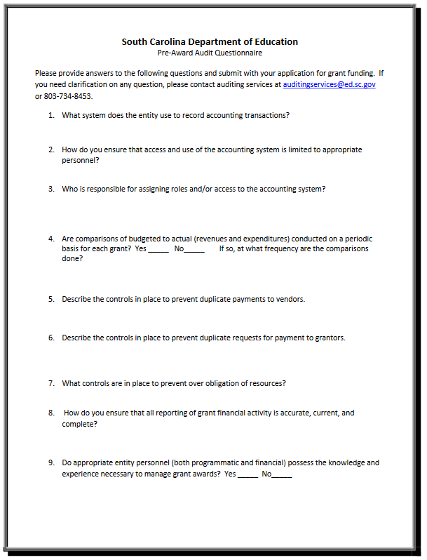

Instructions for GEPA Statement of Compliance

The purpose of this enclosure is to inform you about a new provision in the Department of Education's General Education Provisions Act (GEPA) that applies to applicants for new grant awards under Department programs. This provision is Section 427 of GEPA, enacted as part of the Improving America's Schools Act of 1994 (Public Law (P.L.) 103-382).
To Whom Does This Provision Apply?
Section 427 of GEPA affects applicants for new grant awards under this program. ALL APPLICANTS FOR NEW AWARDS MUST INCLUDE INFORMATION IN THEIR APPLICATIONS TO ADDRESS THIS NEW PROVISION IN ORDER TO RECEIVE FUNDING UNDER THIS PROGRAM.
(If this program is a state-formula grant program, a state needs to provide this description only for projects or activities that it carries out with funds reserved for state-level uses. In addition, local school districts or other eligible applicants that apply to the state for funding need to provide this description in their applications to the state for funding. The state would be responsible for ensuring that the school district or other local entity has submitted a sufficient Section 427 statement as described below.)

What Does This Provision Require?
Section 427 requires each applicant for funds (other than an individual person) to include in its application a description of the steps the applicant proposes to take to ensure equitable access to, and participation in, its federally assisted program for students, teachers, and other program beneficiaries with special needs. This provision allows applicants discretion in developing the required description. The statute highlights six types of barriers that can impede equitable access or participation: gender, race, national origin, color, disability, or age. Based on local circumstances, you should determine whether these or other barriers may prevent your students, teachers, etc. from such access or participation in the federally funded project or activity. The description in your application of steps to be taken to overcome these barriers need not be lengthy; you may provide a clear and succinct description of how you plan to address those barriers that are applicable to your circumstances. In addition, the information may be provided in a single narrative, or, if appropriate, may be discussed in connection with related topics in the application.

Section 427 is not intended to duplicate the requirements of civil rights statutes, but rather to ensure that, in designing their projects, applicants for federal funds address equity concerns that may affect the ability of certain potential beneficiaries to fully participate in the project and to achieve to high standards. Consistent with program requirements and its approved application, an applicant may use the federal funds awarded to it to eliminate barriers it identifies.

What are Examples of How an Applicant Might Satisfy the Requirement of This Provision?
The following examples may help illustrate how an applicant may comply with Section 427.
- An applicant that proposes to carry out an adult literacy project serving, among others, adults with limited English proficiency might describe in its application how it intends to distribute a brochure about the proposed project to such potential participants in their native language.
- An applicant that proposes to develop instructional materials for classroom use might describe how it will make the materials available on audio tape or in Braille for students who are blind.
- An applicant that proposes to carry out a model science program for secondary students and is concerned that girls may be less likely than boys to enroll in the course might indicate how it intends to conduct "outreach" efforts to girls to encourage their enrollment.
- An applicant that proposes a project to increase school safety might describe the special efforts it will take to address concern of lesbian, gay, bisexual, and transgender students, and efforts to reach out to and involve the families of LGBT students.
We recognize that many applicants may already be implementing effective steps to ensure equity of access and participation in their grant programs, and we appreciate your cooperation in responding to the requirements of this provision.

Estimated Burden Statement for GEPA Requirements
According to the Paperwork Reduction Act of 1995, no persons are required to respond to a collection of information unless such collection displays a valid OMB control number. Public reporting burden for this collection of information is estimated to average 1.5 hours per response, including time for reviewing instructions, searching existing data sources, gathering and maintaining the data needed, and completing and reviewing the collection of information. The obligation to respond to this collection is required to obtain or retain benefit (Public Law 103-382. Send comments regarding the burden estimate or any other aspect of this collection of information, including suggestions for reducing this burden, to the U.S. Department of Education, 400 Maryland Ave., SW, Washington, DC 20210-4537 or email ICDocketMgr@ed.gov and reference the OMB Control Number 1894-0005.

Examples of Measurable Outcomes for Activities Authorized
by the McKinney-Vento Act, § 11433(d)

Activities proposed do not need to match the activities in the first column exactly, but should be based on those approved activities.
ACTIVITIES | MEASURABLE OUTCOMES
- Tutoring, supplemental instruction, and enriched educational services. | • Pre-/post-test score improvement.  • Classroom teachers provide positive assessments of participants.  • School success, seen in grade and score improvement.  • Participation and performance on Standards of Learning Tests.  • High school or GED completion.
- Expedited student evaluations, including gifted and talented, special education, and limited English proficiency. | • Evaluations are made and records are transferred in a timely manner.  • Increased percentage of homeless children accessing education services for which they are eligible (e.g., Title I, special education, LEP services).
- Professional development for educators and other school personnel. | • Increase in numbers of public school personnel who are aware of and sensitive to the needs of homeless children and youths.  • Increase in awareness and sensitivity training opportunities for school personnel and community.
- Referrals for medical, dental, other health services, and social services. | • Increase in percentage of families referred for services.  • Increase in percentage of homeless children who are immunized.  • Increase in percentage of pregnant homeless teens receiving prenatal care.
- Defraying excess cost of transportation. | • Increase in percentage of homeless children and youths attending school regularly.  • Increase in the percentage of homeless children and youths attending the school of origin, with the approval of the parent/guardian.  • Decrease in number of days homeless students cannot attend school due to lack of transportation.
- Provision of developmentally appropriate early childhood education programs, not otherwise provided. | • Increase in the enrollment and attendance of homeless preschoolers in local preschool programs such as Even Start, Preschool Initiative, and Head Start.
- Provision of services and assistance to attract, engage, and retain homeless children and youths and unaccompanied youths in public school programs. | • Documentation of identification procedures and support services provided.  • Increase in the percentage of homeless youths completing school.
- Before- and after-school, mentoring, and summer programs with a teacher or other qualified individual. | • Increase in hours of education programs for homeless children and youths during non-school time.  • Improved school performance of participants as based on testing, grades, teachers’ assessments, etc.
- The payment of fees and other costs associated with tracking, obtaining, and transferring records necessary to enroll homeless children and youths. | • Decrease in amount of time used to obtain records of homeless children and youths.  • New schools of former LEA program participants receive information on students promptly; students are tracked into future schools and communities.
- Provision of education and training to parents of homeless students about educational rights and resources that are available. | • Brochures, newsletters, posters, etc. distributed to parents and providers on the rights of homeless children to an appropriate education.  • Increase in homeless parent and youth calls regarding rights and resources.  • Increase in percentage of homeless families involved in school enrollment decisions.
- Coordination between schools and service agencies. | • Increase in numbers of agencies participating in school programs.  • Increase in number of homeless families and youths receiving case-managed services from collaborating agencies.
- Provision of pupil services (including violence prevention counseling) and referrals for such services. | • Documentation of referrals and participation rates.
- Addressing needs of homeless children and youths arising from domestic violence. | • Increase in education services (such as tutoring and adaptation of space for studying) for children at domestic violence shelters.
- Adaptation of space, purchase of supplies for on-school facilities. | • Increase in number of shelters with homework rooms, libraries, and tutorial supplies.
- School supplies for distribution at shelters and temporary housing facilities. | • Increase in percentage of homeless children with supplies needed to attend and succeed in school.
- Extraordinary or emergency assistance to enable homeless children to attend school. | • Increase in percentage of homeless children and youths attending school ready to learn.  • Decrease in barriers that keep homeless children from attending school.

Developing a Plan of Operation for a Project

Grant Design Chart

Goal:
Objectives | Tasks/Activities | Begin/End  Dates | Personnel | Outcomes |  |  | Evaluation | Budget
 |  |  |  | Short | Mid | Long | Evaluation | Budget
A. | A-1:
A. | A-2:
A. | A-3:
B. | B-1:
B. | B-2:
B. | B-3:
C: | C-1:
C: | C-2:
C: | C-3:
D: | D-1:
D: | D-2:
D: | D-3:

Timeline of Objectives, Activities, and Measurable Outcomes Template
McKinney-Vento Homeless Assistance Act
2020–21 Education for Homeless Children and Youths Subgrant

Use a new page for each objective; add lines as needed. Save all pages as a single PDF document to upload in the online application.

Objective Number: |  | Objective:

 | Start/  End Date | Activity to Achieve Objective | Number of  M-V students to be impacted | Data Source(s) | Measurable Outcome | Person/Agency Responsible
1.
2.
3.
4.
5.

Goals, Objectives, and Outcomes Worksheet

Goal _____:

Objective _____:

Activities and Outcomes
1. Identify a result you expect to achieve through this program.
2. Describe what you will do to achieve this result.
3. What data will you collect to prove that you have achieved this result?
4. Are there target benchmarks for progress toward achieving this result over time?
5. Combine the information from Steps 1-4 into one sentence. (This combined statement is a performance measure)
6. How long will it take to achieve this result?
7. What baseline data will you need to have to measure achievement of this result?

Budget Narrative Template

Use the budget format file that accompanies this funding opportunity announcement at the SCDE’s Grant Opportunities webpage to develop the required Budget Narrative. The screenshot below is for informational purposes only.

