Request for Proposals (RFP)
Application Package

2018–19 African American History Instructional Materials Grant

The African American History Instructional Materials grant is funded by the South Carolina General Assembly, authorized by the 2018 General Appropriations Act, Proviso 1A.2, and administered by the South Carolina Department of Education.

Deadline for Receipt of Applications: 4:00 p.m., October 1, 2018

Technical Assistance for Applicants: 10:00 a.m., August 30, 2018

For questions, contact:
Stephen Corsini
Social Studies Education Associate
803-734-8335
spcorsini@ed.sc.gov

Issued by:
South Carolina Department of Education
Office of Standards and Learning
1429 Senate Street, Suite 611-C
Columbia, SC 29201

TABLE OF CONTENTS

PART I: General Information 1
A. Introduction and Purpose 1
B. Eligible Applicants 2
C. Timeline of Grant Process 2
D. Technical Assistance Session for Applicants 2
E. Statutory and State Requirements 2
F. Authorized Activities 3
G. Unauthorized Activities 5
H. Program Accountability and Monitoring 5
I. Fiscal Operations 9
J. Review and Selection Process 10
K. Appeals Process 11

PART II: Application Overview, Content, and Instructions 12
A. Application Overview 12
B. Application Narrative Format 13
C. Online Application Submission 13
D. Project Summary 13
E. Proposal Narrative Content 13
1. Goals and Objectives (maximum of 20 points available) 14
2. Strategies and Activities (maximum of 20 points available) 14
3. Management (maximum of 20 points available) 15
F. Application Budget 15
G. Appendices 17
H. Deadline and Submission Procedures 18
I. Screenshots of Online Application Submission Forms 19

Appendix A: Definitions of Terms Used 23

Appendix B: Selection Criteria and Reviewers’ Scoring Rubric 24

Appendix C: Required SCDE Forms 28
Certification Signature Page 28
Assurances and Terms and Conditions for State Awards 29
Terms and Conditions 29
Request for Taxpayer Identification Number and Certification 32
Action Plan Form 33

PART I: General Information

Introduction and Purpose

The South Carolina General Assembly has authorized funds allocated to the South Carolina Department of Education (SCDE) through legislative proviso 1A.2 (SDE-EIA: African-American History) to be used for the development of additional instructional materials for African American History curricula.

The SCDE will award grants to nonprofit organizations, school districts, and institutions of higher education (IHEs) for the development of new instructional materials in each of the following areas:
- a multiple day experience for teachers in June 2019, emphasizing the African American Freedom Movement, including but not limited to culture, prosperity, and prominent historic sites within South Carolina, and leading teachers to develop instructional plans on African American Freedom Movement aligned to Standard 5-5, Standards 8-6 and 8-7, and United States History and the Constitution (USHC)-7 and USHC-8 of the 2011 South Carolina Social Studies Academic Standards, to be posted to the SCDE website; or
- develop an inquiry-based instructional unit accompanied by an evidence set made of primary and secondary sources, aligned to the 2011 South Carolina Social Studies Academic Standards emphasizing African American history and the contributions of African Americans aligned to identified essential content.

Applicants may propose to develop one or more of these instructional materials but must submit a separate application for each category and a separate application if wishing to focus on more than one identified essential content. All instructional plans and units must be original creations and cannot be copied or plagiarized from existing materials.

Approximately $200,000 will be available for new grants in the 2018–19 funding cycle. The SCDE anticipates awarding one grant for the multiple day experience and several grants for the development of instructional units accompanied by an evidence set; however, only one grant will be awarded per/for each instructional unit aligned with essential content. Award amounts will be determined based on the quality of applications received and total funding requested; however, the maximum award for the multiple day experience is $60,000 and the maximum award for the instructional unit accompanied by an evidence set is $10,000 per essential content. Final budgets may be negotiated based on demonstrated needs and available funding.

The 2018–19 grant budget period is December 3, 2018, through June 26, 2019. Funding is subject to the availability of state funds and projects meeting all African American History Instructional Materials program requirements.

The grantee may obligate funds upon receipt of the grant award notice. However, no grant funds will be disbursed until after successful completion and verification of the first benchmark on February 15, 2019. Subsequent payments will be made upon verification following the achievement of the remaining benchmarks (see pages 7–8).

Eligible Applicants

Eligible applicants are nonprofit organizations, school districts, or IHEs that are capable of developing one of the following African American History instructional materials:
- a multiple day experience for teachers in June 2019, emphasizing the African American Freedom Movement including but not limited to culture, prosperity, and prominent historic sites within South Carolina leading teachers to develop inquiry-based instructional plans aligned to Standard 5-5, Standards 8-6 and 8-7, and USHC-7 and USHC-8 of the 2011 South Carolina Social Studies Academic Standards; and/or
- develop an inquiry-based instructional unit accompanied by an evidence set made of primary and secondary sources aligned to 2011 South Carolina Social Studies Academic Standards emphasizing African American history and the contributions of African Americans aligned to identified essential content.

Applicants seeking funding for more than one instructional materials category must submit a separate application for each category and a separate application if seeking to focus on more than one identified essential content. Each project should clearly articulate the process for determining alignment to the 2011 South Carolina Social Studies Academic Standards and use the Office of Standards and Learning template located at the SCDE’s Grant Opportunities webpage.

Timeline of Grant Process

Date | Activity/Action
August 30, 2018 | Technical assistance session
October 1, 2018 | Deadline for receipt of applications
November 2018 | Notification of awards
December 3, 2018 | Funding period begins; projects can begin
February 15, 2019 | Benchmark 1 report(s) due to the SCDE
April 18, 2019 | Benchmark 2 report(s) due to the SCDE
June 26, 2019 | Funding period ends; final projects must be submitted to SCDE

Technical Assistance Session for Applicants

The SCDE’s Office of Standards and Learning will offer a technical assistance webinar via Adobe Connect on August 30, 2018, from 10:00 a.m. until 11:30 a.m. to assist eligible applicants in understanding this RFP and how to apply. No password is required to join the session. Participants should enter their full names when logging in. Participants will be able to log in 30 minutes prior to the start time to test their audio settings and download/print handouts. While participation is not mandatory to submit an application, it is highly recommended.

Statutory and State Requirements

Performance reporting requirements include those for both programmatic and fiscal reporting and are required as stated in the tables on pages 7–8. The grantee is responsible for ensuring that all reports are accurate, complete, and submitted on time. Achievement of grant goals and objectives will be monitored through the final report process. Failure to meet deadlines may result in a loss of funding and may eliminate the applicant from consideration for future funding.

Applicants should review the Assurances and Terms and Conditions for State Awards on pages 29–31 to ensure that if awarded a grant, they are capable of full compliance with all the referenced regulations and state laws in order to enter into an agreement with the SCDE for this program. Pursuant to S.C. Code Ann. § 8-13-700 (Supp. 2017) the applicant must disclose any potential conflict of interest to the SCDE in accordance with the SC Ethics Reform Act conflict of interest policy. A signed Certification Signature Page (see page 28) is required with the grant application and legally binds the applicant to the agency’s Assurances and Terms and Conditions for State Awards.

Authorized Activities

All projects funded through this grant must be aligned with the 2011 South Carolina Social Studies Academic Standards and indicators found on the SCDE website.

Grant funds may be used for one or more of the following:
- Creation and execution of a multiple day experience for teachers in June 2019, emphasizing the African American Freedom Movement, including but not limited to culture, prosperity, and prominent historic sites within South Carolina. This experience will lead teachers to develop inquiry-based instructional plans on the African American Freedom Movement aligned to Standard 5-5, Standards 8-6 and 8-7, or USHC-7 and USHC-8 of the 2011 South Carolina Social Studies Academic Standards for posting to the SCDE’s website.
- Development of an inquiry-based instructional unit emphasizing African American history and the contributions of African Americans. The units must explore one essential content listed in the chart below, or related to content as expressed in 2011 South Carolina Social Studies Academic Standards such as, but not limited to, K-3, 1-3, 2-4, 3-2, 3-4, 3-5, 4-2, 4-3, 4-4, 4-5, 4-6, 5-1, 5-2, 5-3, 5-4, 5-5, 5-6, 6-6, 7-3, 8-1, 8-2, 8-4, 8-5, 8-6, 8-7, WG-1, WG-3, WG-4, MWH-2, MWH-7, USHC-2, USHC-3, USHC-4, USHC-6, USHC-7, USHC-8, USG-2, or USG-4. Units must be accompanied by an evidence set comprised of a variety of primary and secondary sources. These strands of essential content were determined through a needs assessment conducted by the SCDE. Each unit must align to the 2011 South Carolina Social Studies Standards, connect to a theme within the course, and include the historical thinking skills of comparison, causation, periodization, contextualization, and continuity and change. Content should be school- and grade-level appropriate.

For all proposed projects, applicants must clearly articulate the process for determining alignment with the standards and the rationale for the grade-level chosen. All proposed instructional units must follow the Office of Standards and Learning template located at the SCDE’s Grant Opportunities webpage. All accompanying evidence must be cited using American Psychological Association (i.e., APA) style. Copyright in all plans must be assigned to the SCDE.
Essential Content | Possible Topics | Aligned Standards
West Africa (pre-1500s) | - Triangular trade  - African resistance movements  - European navigational technology (caravel, compass)  - Continuities and changes in a specific African geographic area or country  - Prince Henry’s school of navigation  - Bartolomeu Dias  - West African trading posts | 7-1.5,  MWH-2.1, MWH-2.2
Scramble for Africa | - Social Darwinism/White Man’s Burden  - Imperialism  - Industrial revolution (focus on resources)  - Belgium and the creation of the Congo  - Berlin Conference of 1884–1885  - Liberia and Ethiopia  - Zulu Wars  - History of slavery in Africa before European slave trade  - Gold coast/slave trade  - Continuities and changes in African society as a result of the slave trade | 7-3.5, 7-3.6,  MWH-4.7
African Americans in the Early 20th Century | - Booker T. Washington, W.E.B. DuBois  - NAACP, Urban League, Women’s Groups  - The Black Elite (upper-class, fraternities and sororities)  - Black men in the military and WWI  - The Great Migration and Northern Communities | 5-3.2, 5-3.3,  8-5.7, 8-5.8, USHC-3.5
African Americans and the 1920s | - Racism and Scientific Study  - Birth of a Nation  - Black Organizations (UNIA, NAACP)  - Labor (A. Philip Randolph, Efforts of the NAACP and the Urban League)  - Harlem Renaissance and the Jazz Age  - James Weldon Johnson or Langston Hughes  - William H. Johnson | 5-4.1, 8-6.2, USHC-6.1, 6.2
Great Depression and the New Deal | - Booker T. Washington, W.E.B. DuBois  - Black Businesses  - Challenging racial discrimination (Charles Houston, Thurgood Marshall, community organizing)  - The Black Cabinet (Mary McLeod Bethune)  - The Communist Party and African Americans (Scottsboro Boys) | 5-4.2, 5-4.3,  7-4.3,  8-6.3, 8-6.4,  USHC-6.3, USHC-6.4
Black Nationalism | - Malcolm X  - Stokely Carmichael  - Black Panther Movement  - Great Society  - Black Americans and Vietnam  - King: New Strategy  - 2nd Phase of the Black Student Movement including the Orangeburg Massacre  - Election of 1968 (Moynihan Report, busing)  - Rise of black elected officials  - Carter Administration | 5-5.3,  8-7.2, 8-7.3,  USHC-8.1, USHC-8.2
African Americans in the Millennium | - Progress and Poverty  - Black Conservatives  - Black Activism  - Human Rights  - Clinton Administration (welfare reform)  - Bush Administration (Dr. Condoleeza Rice, Colin Powell)  - 2004 Presidential Election  - Hurricane Katrina  - Election of Barack Obama | 8-7.4,  MWH-8.1, MWH-8.4, MWH-8.5  USHC-8.5

Unauthorized Activities

Grant funds may not be used for graduate-level courses, professional memberships, or indirect costs. Out-of-state travel must be justified and requires prior approval by the SCDE’s Office of Standards and Learning.

Program Accountability and Monitoring

The SCDE is responsible for monitoring grantee development of instructional materials for African American History curricula in accordance with the following program accountability requirements:
- Each applicant receiving funding through this RFP meets the eligibility requirements for the grant described herein, and the applicant has provided all required assurances that it will comply with all program implementation and reporting requirements established through this RFP.
- Each applicant receiving funding through this RFP appropriately uses these funds as described in this application package.
- Each applicant implements activities funded through this application within the timeline in which the funds provided are to be used.

To fulfill its monitoring responsibilities, the SCDE requires grantees to submit appropriate fiscal and program documentation following guidance provided by the SCDE program office. In addition, representatives of the state may conduct site visits to a selected representative sample of funded applicants.

Applicants may be subjected to an evaluation of their financial system, internal controls processes, and policies and procedures by the SCDE’s Office of Auditing Services before a grant award is issued or during the grant term. The review process and procedures are accessible at the Office of Auditing Services webpage.

Applicants awarded grant funds must satisfy periodic reporting and accountability requirements throughout the term of the grant. These requirements address: (1) program accountability; (2) performance reporting; (3) annual budget; (4) monitoring; (5) program evaluation; and (6) technical assistance.

    - Program Accountability
Each grantee is responsible for carrying out its responsibilities in accordance with proviso 1A.2 (SDE-EIA: African-American History), all applicable statutes, regulations, and programmatic guidance, and its approved grant application and work plan. Grantees may also be required to submit periodic reports to the SCDE to report on the use of grant funds and the progress of proposed grant activities.

    - Performance Reporting
Performance reporting requirements include those for both programmatic reporting and fiscal reporting.

Programmatic Reporting Requirements
The benchmark 1 progress report is due no later than February 15, 2019, and the benchmark 2 report is due by April 18, 2019. A final performance report must be submitted to the SCDE to report project progress and delivery of final products no later than June 26, 2019. The grantee is responsible for ensuring that reports are accurate, complete, and submitted on time. Progress toward achieving grant goals and objectives and benchmarks will be monitored through the interim and final performance report process.

All grantees must address the reporting requirements of the applicable table(s) below in completing the interim and final progress reports for each period in which the activities occurred. Reimbursements will be based on the attainment of these benchmarks.

Table 1: Minimum Benchmarks for Funds and Deadlines for Deliverables: Instructional Units and Evidence Set
Benchmark #1 | Deadline
Evidence of progress towards completion:  - Possible topics to be included in the instructional unit and its alignment to the 2011 SC Social Studies Academic Standards  - Application and rubric(s) used to determine participants  - List of participants chosen through the application process  - Timeline for completion of the instructional units  - Record of expenditures  - Other evidence as required by the SCDE | February 15, 2019
Benchmark #2 | Deadline
Evidence of progress towards completion:  - Metric used to determine the quality of the inquiry-based instructional unit and evidence set  - Submitted Microsoft Word file of the instructional unit at approximately 25 percent completion including alignment to the 2011 SC Social Studies Academic Standards  - Status of the instructional unit towards completion  - Record of expenditures  - Other evidence as required by the SCDE | April 18, 2019
Deadline for Final Products and Report | Deadline
Evidence of completion:  - Submitted Microsoft Word file of the completed inquiry-based instructional unit aligned to the 2011 SC Social Studies Academic Standards  - Copyright assignment  - Final record of expenditures | June 26, 2019

Table 2: Minimum Benchmarks for Funds and Deadlines for Deliverables: Multiple Day Experience Creating Instructional Plans
Benchmark #1 | Deadline
Evidence of progress towards completion:  - Proposed travel itinerary including locations and dates  - Proposed application to be completed by interested applicants  - Rubric(s) used to score applications  - Record of expenditures  - Other evidence as required by the SCDE | February 15, 2019
Benchmark #2 | Deadline
Evidence of progress towards completion:  - List of participants chosen through the application process  - Finalized travel itinerary including locations and dates  - Metric used to determine the quality of the inquiry-based instructional plans  - Record of expenditures  - Other evidence as required by the SCDE | April 18, 2019
Deadline for Final Products and Report | Deadline
Evidence of completion:  - Submitted Microsoft Word documents (using the SCDE template) of at least 2 inquiry-based instructional plans per participant aligned to grade level standards (grades 5, 8, USHC) in formats accessible to individuals with disabilities. The grant awardee is responsible for collecting these from individual teachers and submitting them to the SCDE.  - Participant Evaluation Survey results  - Final record of expenditures | June 26, 2019

Fiscal Reporting Requirements
Grantees must upload their approved budgets into the SCDE’s grants accounting processing system (GAPS) following receipt of their grant award notifications and prior to submitting any reimbursement requests. GAPS training will be provided to grantees. All expenditure reports must be submitted through GAPS. The grantee is responsible for ensuring that reports are accurate, complete, and submitted on time. The grantee must submit the final expenditure report by July 5, 2019, and a final fiscal report to the SCDE that covers the duration of the grant award.

    - Project Budget
A project budget of projected expenditures to be funded by the grant must be submitted with the application.

    - Monitoring
The SCDE will monitor grantees by reviewing and approving the progress reports and final performance reports. All information in monitoring reports is subject to verification.

The SCDE may conduct programmatic and financial monitoring site visits. Grantees must agree to site visits conducted by the SCDE. The purpose of site visits is to validate information provided in fiscal and progress reports, and to gather more detailed information on implementation efforts and challenges from interviews and observations for monitoring and evaluation purposes.

The SCDE may require additional information from the grantee, or require the submission of additional documentation including, but not limited to, invoices, receipts, and personnel time and effort reports. Prior to or after a site visit, the grantee may be required to submit additional relevant information that will allow the SCDE to conduct a useful, efficient, and effective visit or evaluation. The SCDE may require electronic submission of documents instead of a paper-copy submission.

SCDE staff will verify the contents of documentation submitted. Grantees may be asked to revise reports when
- non-allowable expenses are found;
- reports are confusing or difficult to understand; or
- there are unexplained discrepancies between the proposed use of grant funds, as provided in the annual budget, and actual expenditures found in the submitted documentation.

    - Program Evaluation

Grant Recipient Project Monitoring and Evaluation
Grantees are required to conduct ongoing self-monitoring and evaluation to ensure project goals are achieved. Progress toward meeting project goals is to be reported through the benchmark review process.

A final project evaluation report is to be completed by the end of the grant period. The final evaluation report must address project success toward each goal stated in the application. If a grantee fails to conduct the final project evaluation report by the end of the grant period, or if any of the performance requirements in section I.2 are not completed, the SCDE may consider the grantee a high risk and elect to discontinue funding or disqualify the grantee from future funding opportunities.

SCDE External Review
The SCDE may contract with an external evaluator of the African American History Instructional Materials Project. Grant recipients are required to comply with any request by the SCDE and its evaluation subcontractor, including, but not limited to, requests for information, site visits, interviews, completing surveys, or participating in data collections.

    - Technical Assistance to Grantees
Grantees are required to participate in any technical assistance that the SCDE may conduct related to completing and filing reports or other requirements of the African American History Instructional Materials Project grant. Delivery of such technical assistance may include in-person meetings, webinars, and conference calls.

Fiscal Operations

Grantees must use grant funds for allowable grant expenditures during the grant period only. African American History Instructional Materials grant funds are disbursed upon verification of attainment of required benchmarks and approval of reimbursement requests submitted via GAPS. The SCDE will deobligate any unspent funds remaining at the end of the grant period for reallocation to other grantees or for purposes allowed under the authorizing legislation.

Matching or in-kind funds are not required.

Allowable Costs
Grants must be used in accordance with statutory and regulatory requirements. Grant funds may be used for research, travel, transcription software, and salaries.

Unallowable Costs
Expenditures charged to the grant should be reasonable, necessary, and adequately documented to achieve the grant project’s goals and objectives. Indirect costs are not allowed. Costs for office furniture, construction, entertainment, and alcohol are not allowed. Note: The unallowable expenditures listed are not all-inclusive; applicants should use prudent judgment to determine expenditure allowability and alignment with the proposed project’s scope of work.

Review and Selection Process

Only those grant applications that are received by the deadline and deemed complete will be forwarded for review and funding consideration. All required materials including forms and appendices must be submitted for the application to be considered complete and eligible for review. Program staff will conduct an initial review of applications for completeness and compliance with the RFP instructions.

Three reviewers from diverse backgrounds without a vested interest in any applicant being funded will be trained to evaluate each application based on the quality of the proposed activities and the capability of the applicant to implement the proposed project. The review team will be comprised of experienced grant readers from various entities representing the stakeholders of South Carolina.

Reviewers will use the scoring rubric on pages 24–27 to read and score each application independently. After the three reviewers have individually rated each application, the scores will be averaged. An application can earn up to 60 points for an average score. Applications that fail to earn an average score of 41 or higher will not be eligible for funding.

Applications will be rank-ordered by final scores. Subject to the SCDE’s final approval, grant awards will be made starting with applications that earned an average score of 41 points or higher. If funds remain following these awards, the SCDE will consider funding remaining applications earning an average score within the adequate/meets range until all funds are allocated. Only one grant award will be awarded per instructional unit aligned to identified essential content.

The SCDE reserves the right to interview applicants recommended for funding, request additional documentation, and make site visits as appropriate to ensure compliance with state requirements.

The SCDE reserves the right to negotiate final budgets and to disqualify costs associated with any line items that are unallowable, unallocable, unreasonable, or inconsistent with the program’s goals or the proposed project’s activities and strategies.

Grant awards are not final until an SCDE grant award notice is fully executed. Notification of funding will be sent in November 2018 to the authorized official listed on the Certification Signature Page. After the notification of awards, copies of the reviewers’ comments and score sheets will be sent to the contact person identified in the online application.

Appeals Process

An applicant who has submitted a proposal that the SCDE does not fund has 30 calendar days after receiving notification that the proposal is not funded to request a review of the process. Scores may not be appealed. An unfunded applicant may inquire as to whether or not the application process was followed. The request for review must be directed to the State Superintendent of Education and must state the reasons for the request. The Superintendent may delegate to a deputy superintendent the authority to conduct a review. The deputy superintendent will issue a decision after the review of the information submitted by the applicant and the program office. This decision will be the final decision of the agency. The applicant may appeal the agency’s decision to the Administrative Law Court under the terms of the Administrative Procedures Act.

PART II: Application Overview, Content, and Instructions

Read all guidelines and criteria carefully before preparing your application. Adhere to font, format, page limit, and organizational requirements. Only applications that include all sections and appendices and fully adhere to these guidelines will be reviewed and considered for funding. Incomplete applications will not be reviewed.

Application Overview

Applications must be submitted online. Applicants are encouraged to prepare all of the following elements of the application before beginning the online submission process. Do not wait until the last minute to submit an application. Applicants should use the following overview as a checklist to ensure that they submit a complete application with items labeled accordingly and presented in the order outlined below. Verify that all components of the narrative and appendices are included prior to uploading attachments.

The African American History Instructional Materials online application is organized into the following sections (also see the screenshots on pages 19–22):
- Online Form
- Applicant Information
- Authorized Official Contact Information
- Project Director Contact Information
- Budget Summary
- Proposal Attachments
- Project Summary
- Proposal Narrative
  - Goals and Objectives
  - Activities and Strategies
  - Management
- Budget Narrative
- Appendices
  - Certification Signature Page (see page 28)
  - Proof of Nonprofit Status
  - Nonprofit Mission Statement
  - Request for Tax Identification Number and Certification (W-9)
  - Action Plan Form
  - Resumés for Project Manager and Key Staff Members
  - Letters of Recommendation
- Work Sample

Application Narrative Format

Length of Narrative: | Maximum of 10 pages. The project summary, budget, and attachments are excluded from the page count.
Required Font/Size: | Times New Roman/12 or Arial/12.
Margins: | 1” on all sides.
Page Numbers: | Insert either top right or bottom right.
Spacing: | Double-space with chart and tables in single spacing.
Final File Format: | PDF document.

Each section must be clearly identified using the headings provided in the instructions below. Sections may not be combined. Reviewers will not consider information requested in one section that is provided in another section.

Online Application Submission

Applications must be submitted online. The online submission is organized into two sections—Online Forms and Proposal Attachments.

Provide the primary applicant’s nine-digit Data Universal Numbering System (DUNS) number and Taxpayer Identification Number (TIN) in the application form. Applicants should contact their organization’s finance office if they need assistance with these items.

Use the following instructions to compile and complete all proposal attachments prior to submitting your application. Follow the directions in each section for saving the documents and refer to the screenshot on page 21 for upload locations.

Project Summary

In one page, double-spaced, concisely describe the applicant organization and its mission, the target population to be served with the proposed project, the goals and objectives of the proposed project, and the amount of funding requested.

When completed, save this page as a single PDF document to be uploaded in the proposal attachments section of the online application.

Proposal Narrative Content

Use the following directions to write the proposal narrative and organize it into sections following the sequence presented below. Label each section using the headers Goals and Objectives, Activities and Strategies, and Management. Do not combine sections. Required components must be located in their designated sections in order to be scored.

When complete, save the entire narrative as one PDF document to be uploaded into the online application where indicated in the proposal attachments section.

Goals and Objectives (maximum of 20 points available)

Goals and objectives are clear statements of what the applicant proposes to accomplish with the proposed project. All goals and objectives must mirror the purpose of the grant and address the needs identified in the RFP.

A goal is a statement that explains the purpose of your project (also known as what the project wishes to accomplish with the end in mind). It sets the fundamental, long-range direction. In short, what is the desired end result? Typically, a goal is a broad general statement that expresses the desired change(s).

Objectives are statements that define the results the applicant expects to achieve through the proposed project. They explain the methods the applicant will use to achieve the goal(s). Objectives break the goal down into smaller parts that provide specific, measurable actions by which the goal can be accomplished. They refer to specific activities in a proposal and must be specific, measurable, achievable, relevant, and time-specific (SMART) for meeting the benchmarks and completion deadline.

An applicant must provide a narrative that includes:
- A clearly stated goal;
- SMART objectives that, as applicable, explain how a relevant and school appropriate instructional unit will be developed using the identified essential content or how the instructional plans will be developed based on the multi-day experience focusing on the African American Freedom Movement using proven content specific methods; and
- A description of how the instructional materials will align with specific 2011 South Carolina Social Studies Academic Standards.

Strategies and Activities (maximum of 20 points available)

Strategies are considered those tasks that are the catalyst to help the applicant achieve objectives. For example, in a classroom, strategies are what the teacher does/plans for the students to do so that they learn. Activities are considered those tasks that the client does to achieve objectives. For example, in a classroom, activities are what the students do to learn.

Applicants must describe the strategies and activities to be used in developing the applicable African American History instructional materials as follows:
- a multiple day experience for teachers in June 2019, emphasizing the African American Freedom Movement including but not limited to culture, prosperity, and prominent historic sites within South Carolina and leading teachers to develop instructional plans on the African American Freedom Movement aligned to Standard 5-5, Standards 8-6 and 8-7, and USHC-7 and -8 of the 2011 South Carolina Social Studies Academic Standards for posting to the SCDE’s website; or
- develop an inquiry-based instructional unit accompanied by an evidence set (primary and secondary sources) aligned to specific 2011 South Carolina Social Studies Academic Standards emphasizing identified essential content (see page 3).

Like objectives, strategies and activities use action verbs such as work, create, and hire. Both strategies and activities must relate to the line item costs in the Budget Narrative for the proposed project. Any activities that require funding must be described in the strategies and activities section and must be explained in the Budget Narrative or the item(s) will not be funded. If a strategy or activity does not “equate to a dollar sign,” it is not a true strategy or activity.

Use the Action Plan Form located on page 33 to develop the strategies, timeline of activities, and funds allocated for the activities for each objective. Include the Action Plan Form(s) in the appendices (see page 18).

Management (maximum of 20 points available)

The management section outlines the plan to manage the project. Applicants must provide a narrative that
- clearly describes the plan to manage the project to ensure that high-quality instructional materials are completed and delivered on time; and
- identifies the chain of command, who will manage the project, a job description of the project director, and the responsibilities for each key staff member.

The applicant should include résumés, vitae, or a paragraph summary for each staff member in the appendices.

Use the Action Plan Form on page 33 to identify who is responsible for overseeing each activity. Include the Action Plan Form(s) in the appendices (see page 18).

Application Budget

While the budget is assigned zero (0) points, the budget is a critical component of the entire application. No application with an incomplete budget will be funded.

The application budget consists of two parts: the Budget Summary and the Budget Narrative. All proposed expenditures for the grant funding period must be itemized in the Budget Summary and detailed in the Budget Narrative. Budget items not explained in the proposal narrative will not be funded.

- The Budget Summary is the financial overview of the grant and must include all proposed expenditures for the project. Each line item of the Budget Summary must correspond to the line items of the Budget Narrative (discussed below). In the online application Budget Summary section, provide a budget summary for the December 3, 2018–June 26, 2019, budget period (see screenshot on page 20).
- The Budget Narrative must provide clear evidence that the budget is appropriate and justified based on the needs assessment. Use an Excel spreadsheet to provide a detailed Budget Narrative that includes estimates for any matching funds and in-kind contributions, if applicable. Structure the Budget Narrative line-item categories to parallel the line-item categories of the Budget Summary. Include all formulas used to calculate each line-item expense. This narrative must demonstrate that all expenditures are allowable, reasonable, and allocable; are adequate to support the activities of the project; and directly connect to the goals and objectives in the proposal narrative.

Ensure that the totals in the Budget Summary equal the totals in the Budget Narrative.

The following describes the line items that should be budgeted in each category.

Salaries/Stipends (100)
This category includes pay for salaries for staff members and substitutes and stipends for teachers. The total percentage of time charged to the grant and to non-grant funds cannot exceed 100 percent of the total time worked by any staff member.

Employee Benefits (200)
FICA, workers’ compensation, health insurance, and other employee benefits costs should be included here. These costs will represent a percentage of the total in Salaries/Stipends (100).

Purchased Services (300)
Expenses such as consultant fees, travel/transportation costs, telephone costs, and other purchased services will be included here. This includes amounts paid for personal services rendered by personnel who are not on the payroll and for other specialized services purchased by the organization. While a product may or may not result from the transaction, the primary reason for the purchase is the service provided. Note: Salaries for direct teachers and project staff should be recorded in Salaries/Stipends (100) and not in this section.

For a grantee to pay a vendor, a contract must be in place. At a minimum, the contract should include the scope of services, the duration of the contract, and the method and amount of payment; the contract must be executed by both parties. Consulting/service contracts must be procured in accordance with South Carolina Procurement Law.

Applicants/grantees must ensure that they do not enter a contract with any vendor that is debarred, suspended, or ineligible for participation in federal programs by
- checking the Exclusion Search at the federal System for Award Management (SAM) website (Applicants are encouraged to review the user guides for exclusions provided via the “Help” page prior to conducting searches.);
- collecting a certification from the vendor and attaching it to the contract; or
- adding a clause or condition to the contract that indicates the vendor is eligible.

Supplies and Materials (400)
Include the amounts paid for material items of an expendable nature. It is recommended that applicants group items into categories to avoid listing every item; however, make sure that such expenditures are aligned with relevant project characteristics (objectives, number of participants, frequency of activity, etc.). Allow for maintenance, repair, and replacement costs over the grant life cycle of the proposed project for any equipment that totals $5,000 and below.

Capital Outlay/Equipment (500)
Equipment and supplies totaling more than $5,000 per unit are not allowable. Itemize equipment that total $5,000 and below per unit under Supplies and Materials.

Other Objects (600)
This category includes expenditures such as postage, liability insurance fees, and copyright fees that do not neatly fit into the other categories.

The SCDE reserves the right to disqualify, disallow, and negotiate costs associated with any line item proposed in the budget. If any line item cost is determined to be excessive, given the nature and scope of the entire project or of a particular activity, the SCDE can request the applicant reduce the cost of the line item or ask the applicant to assume a portion of the cost before the budget is approved and funds are awarded.

Funds will be disbursed on a reimbursement basis upon the receipt of expenditure reports with all supporting documentation from the grantees. Grantees may not obligate funds prior to the receipt of a grant award notice. No expenditures incurred prior to December 3, 2018, will be reimbursed. Applicants should have at their disposal at least three months of sustainable funds to implement the program prior to SCDE reimbursement. Grantees are not permitted to pick up their reimbursements from the SCDE office.

Appendices

Items 1–7 of the appendices must be scanned into a single PDF document to be uploaded into the online application where indicated. Item 8 (work sample) must be saved as a separate PDF document and uploaded where indicated in the screenshot on page 21.

    - Certification Signature Page
Print the Certification Signature Page (located on page 28) and obtain the appropriate signatures. Note: This form includes the certification of the SCDE’s Assurances and Terms and Conditions for State Awards and any applicable program-related conditions conveyed in this RFP. Those forms are not required to be included in the applicant’s proposal submission. However, please retain the copy included in this RFP for your records and ensure that the signatories and partner organizations have copies of each document.

By signing the Certification Signature Page, the signatories assure that they will comply with all the assurance and terms and conditions for the project/program. All signatories must understand that they are signing a document that is legally binding in the event a grant is awarded. Applications that do not include the signed Certification Signature Page will not be reviewed or considered for funding.

    - Proof of Nonprofit Status
Include the nonprofit’s IRS Determination Letter and your recognition by the South Carolina Secretary of State. Applications that do not include these documents will not be reviewed or considered for funding.

    - Nonprofit Mission Statement
Include the mission statement for the nonprofit. This statement does not have to be specific to this project but represents the entire mission of the organization.

    - Request for Taxpayer Identification Number and Certification (W-9)
Print and complete the W-9 Request for Taxpayer Identification Number and Certification form (see page 32) for the primary applicant organization. When finalized, save the W-9 to be scanned with the other appendices.

    - Action Plan Form
Include an Action Plan Form (see page 33) that includes each benchmark activity, when each project activity begins and ends, how each activity relates to a particular objective, and who is responsible for overseeing the activity. The Action Plan Form may be single-spaced.

    - Résumés of Project Director and Key Personnel
Include a résumé or vitae for the project director. For any other key personnel to be involved in this program, include a résumé, vitae, or a paragraph summary.

    - Letters of Recommendation
Include at least two letters of recommendation in reference to your work on similar projects including your timeliness, attention to detail, and ability to be a good steward of budgets/funding.

    - Work Sample
Provide a sample of similar work to demonstrate your experience and quality of work.

Deadline and Submission Procedures

- Applications must be submitted using the online application form.
- No hard-copy applications will be accepted. Applications delivered by hand, postal mail, e-mail, or fax will not be accepted.
- Only applications that adhere to all of the guidelines and directions set forth in this RFP will be reviewed and considered for funding.
- Applications must originate from the applicant. Applications that are plagiarized from the Internet, other grants, or second-party resources will not be considered for funding. Grants are not transferrable.
- Do not attach or submit any additional materials other than what is specifically required. Any additional materials will be disposed of without review.
- Applications will not be returned. Keep a copy of the entire application for your records.
- A complete application must include all required documentation and appendices.
- Applications must be received no later than 4:00 p.m. on October 1, 2018. Applications received after this deadline will not be considered. Because potential technology issues may arise, it is best to submit well in advance of the deadline. No exceptions to the deadline will be entertained regardless of circumstances.

Screenshots of Online Application Submission Forms

The following screenshots are for informational purposes only and are provided to assist applicants in compiling all elements needed to complete the online submission. Complete the attachments for the online application as directed in the preceding instructions. The SCDE encourages applicants to prepare all elements of the application prior to beginning the online submission process. Make sure all information submitted is accurate, including formal or official names such as the school district, and that spelling is correct. Do not use abbreviations or acronyms.

If necessary, you may save your progress in the online application and return to the form later. Click on the “Save and Resume Later” link to save your progress. You will be given the option of copying and saving the link to the partially completed form or entering an e-mail address to have the link e-mailed to you. Be sure to enter the e-mail address correctly as SCDE personnel cannot access the link or the incomplete application. Using this link you can access the application from any computer within thirty days to complete the online submission. Without the link or after thirty days, the data previously entered cannot be retrieved, and you will have to begin a new application. A saved application is not a submitted application. You must follow all of the steps described on pages 21–22 to complete the submission process.

Enter the official name of the applicant organization. Enter the organization’s physical address, 10-digit ZIP Code (ZIP+4), DUNS number, and TIN (tax identification number). Select the project(s) being proposed. Fields denoted by a red asterisk are required fields; applicants will not be able to proceed to the next screens of the application without entering this information.
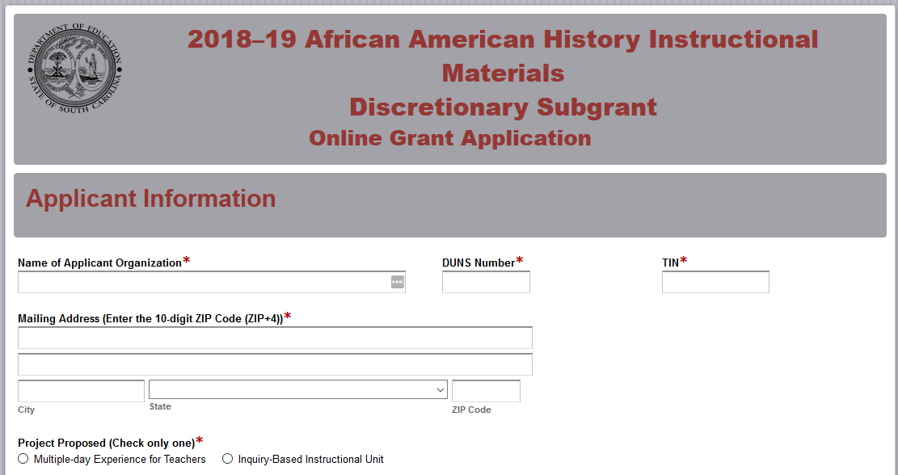
Enter the contact information for the authorized official for the organization including their title/position, phone number, and e-mail address. The authorized official is an individual who can enter into legally binding agreements on behalf of the organization. The name as entered in the online application must match the name as shown on the Certification Signature Page.
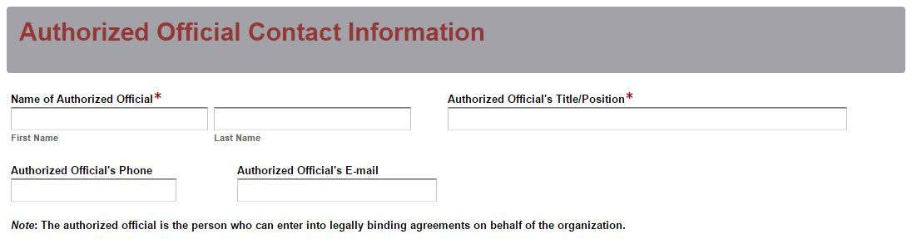
Enter the contact information for the project director including their title/position, phone number, and e-mail address. The confirmation e-mail of a successful online application submission will be sent only to this e-mail address. Reenter the e-mail address to confirm that it is correct.
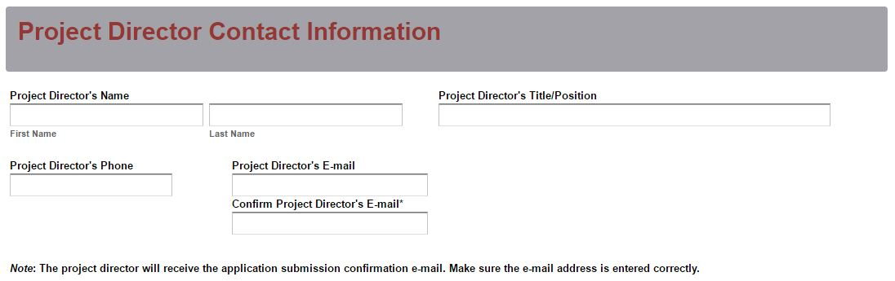
Enter the line-item breakdowns for the grant funds requested using only whole dollars (no cents). Fill in all fields and enter 0 (zero) for line items that are not applicable to the project. The amounts for each line-item and the total funds requested must match the amounts in the Budget Narrative. The Total Grant Funds Requested field will automatically calculate.
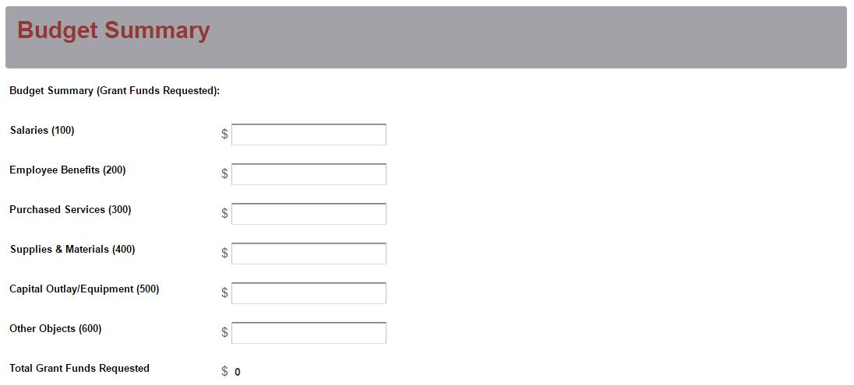
Prepare each of the proposal attachments (i.e., Project Summary, Proposal Narrative, Budget Narrative, appendices, and work sample) following the preceding instructions in this RFP. Ensure that each attachment is saved in the proper format as either a PDF or Excel document. Pay close attention to attachments that must be scanned together into a single document. The online application will only allow one document to be uploaded for each attachment. Upload the attachments where indicated in the following screenshot. All attachments are required; you will not be able to submit the application without uploading all four documents.
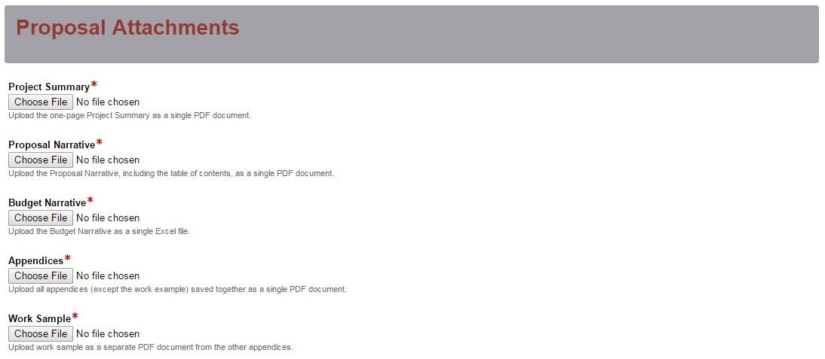
Thoroughly review the summary on the Data Review and Confirmation Page to verify that the information has been entered correctly in the online application prior to submitting. You will not be able to access the completed application form after it has been submitted. If any of the entries are incorrect, click on the "Previous" button at the bottom of each page to return to the appropriate section(s) and reenter the correct information.
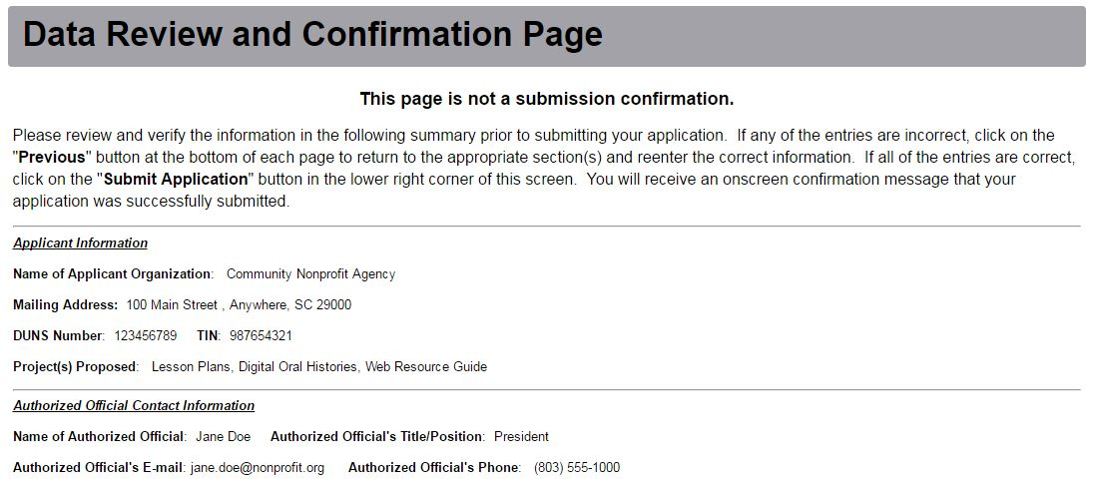
If all of the entries are correct, click on the “Submit Application” button in the lower right corner of this screen to complete the submission process.
Once the application is submitted, the following message will be displayed on the screen, and a submission confirmation will be sent to the e-mail address provided for the project director in the online application.

If the project director does not receive a confirmation e-mail, then the application did not successfully upload. You must go back and resubmit the entire online form, including all attachments, in order for your application to be considered for funding.
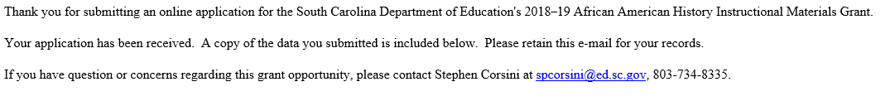
An e-mail confirmation that the grant application was successfully submitted does not account for the quality of the uploaded documents or the completeness of the online form. The confirmation e-mail only notifies you that the online application has been submitted. Applicants are responsible for ensuring that the information entered in the online form, including all attachments, is accurate and complete in order for the application to be reviewed and considered for funding.

Appendix A: Definitions of Terms Used

Deobligation–The downward adjustment of the obligations recorded in a grant award document. It is caused by factors such as (1) termination of part of the project, (2) reduction in material prices, (3) cost savings, or (4) correction of recorded amounts.

Primary Applicant–The organization that serves as the fiscal agent and is responsible for the programmatic and fiduciary management of the grant.

Inquiry-Based Instructional Unit–A unit of instruction that “enables students to experience the processes of knowledge creation and the key attributes are learning stimulated by inquiry, a student-centered approach, a move to self-directed learning, and an active approach to learning.” (Spronken-Smith, 2012)

Appendix B: Selection Criteria and Reviewers’ Scoring Rubric

Selection Criteria

Narrative Sections | Points Available
Goals and Objectives | 20
Strategies and Activities | 20
Management | 20
TOTAL | 60

Scoring Rubric

- Goals and Objectives: The applicant must provide a narrative that includes:
  - A clearly stated goal;
  - SMART (specific, measurable, achievable, relevant, and time-specific) objectives that, as applicable, address how the instructional plans will be developed using the identified essential content or how the instructional plans will be developed based on the multi-day experience focusing on the African American Freedom Movement using proven content specific methods; and
  - A description of how the instructional materials will align with the 2011 SC Social Studies Academic Standards.
The applicant must provide a narrative that includes:  - A clearly stated goal;  - SMART (specific, measurable, achievable, relevant, and time-specific) objectives that, as applicable, address how the instructional plans will be developed using the identified essential content or how the instructional plans will be developed based on the multi-day experience focusing on the African American Freedom Movement using proven content specific methods; and  - A description of how the instructional materials will align with the 2011 SC Social Studies Academic Standards. | Acceptable | Fully Meets—16–20 points  Applicant provides a narrative that fully addresses all required items.
 | Acceptable | Adequate/Meets—11–15 points  Applicant provides a narrative that moderately addresses all required items.
 | Not Acceptable | Limited/Approaches—6–10 points  Applicant provides a narrative that is limited or unclear in addressing all required items.
 | Not Acceptable | Inadequate—0–5 points  Applicant provides a narrative that does not adequately address all required items.
Reviewer’s Comments
- Strategies and Activities: The applicant must describe the strategies and activities to be used in developing the applicable African American History instructional materials as follows:
  - a multiple day experience for teachers in June 2019, emphasizing the African American Freedom Movement including but not limited to culture, prosperity, and prominent historic sites within South Carolina leading teachers to develop instructional plans for the SCDE website on African American Freedom Movement aligned to Standard 5-5, Standards 8-6 and 8-7, and United States History and the Constitution (USHC) -7 and -8 of the South Carolina Social Studies Academic Standards; or
  - develop an inquiry-based instructional unit accompanied by an evidence set (primary and secondary sources) aligned to Social Studies standards emphasizing identified essential content.

The applicant provides a narrative that clearly describes strategies and activities to be used in developing the applicable African American History instructional materials as follows:  - A multiple day experience for teachers in June 2019, emphasizing the African American Freedom Movement including but not limited to culture, prosperity, and prominent historic sites within South Carolina leading teachers to develop instructional plans for the SCDE website on African American Freedom Movement aligned to Standard 5-5, Standards 8-6 and 8-7, and USHC-7 and USHC-8 of the South Carolina Social Studies Academic Standards; or  - develop an inquiry-based instructional unit accompanied by an evidence set (primary and secondary sources) aligned to 2011 SC Social Studies Academic Standards emphasizing identified essential content. | Acceptable | Fully Meets—16–20 points  Applicant provides a statement that fully describes all required items.
 | Acceptable | Adequate/Meets—11–15 points  Applicant provides a statement that moderately describes all required items.
 | Not Acceptable | Limited/Approaches—6–10 points  Applicant provides a statement that is limited or unclear in describing all required items.
 | Not Acceptable | Inadequate—0–5 points  Applicant provides a statement that does not adequately describe all required items.
Reviewer’s Comment
- Management: The management section outlines the plan to manage the project. Applicants must provide a narrative that
  - clearly describes the plan to manage the project to ensure that high-quality instructional materials are completed and delivered on time;
  - identifies the chain of command, who will manage the project, a job description of the project director, and the responsibilities for each key staff member; and
  - includes résumés, vitae, or a paragraph summary for each staff member in the appendices.
The applicant provides a narrative with a detailed and thorough plan to manage the project that  - clearly describes the plan to manage the project to ensure that high-quality instructional materials are completed and delivered on time;  - identifies the chain of command, who will manage the project, a job description of the project director, and the responsibilities for each key staff member; and  - includes résumés, vitae, or a paragraph summary for each staff member in the appendices. | Acceptable | Fully Meets—16–20 points  Applicant provides a narrative that fully describes all required items.
 | Acceptable | Adequate/Meets—11–15 points  Applicant provides a narrative that moderately describes all required items.

 | Not Acceptable | Limited/Approaches—6–10 points  Applicant provides a narrative that is limited or unclear in describing all required items.
 | Not Acceptable | Inadequate—0–5 points  Applicant provides a narrative that does not adequately describe all required items.
Reviewer’s Comments

Appendix C: Required SCDE Forms

Certification Signature Page

Certification
I hereby certify that, to the best of my knowledge, the information and data contained in this application are true and correct. The applicant’s governing body has duly authorized this application and documentation, and the applicant will comply with the SCDE Assurances and Terms and Conditions for State Awards if the grant is awarded.

Authorized Official (CEO of organization)
Name:
Position: | E-mail:
Telephone: | Fax:
Signature of Authorized Official:

Date Signed:

Financial Official
Name:
Position: | E-mail:
Telephone: | Fax:
Signature of Financial Official:

Date Signed:

Please complete, print, and obtain signatures prior to submission. Include the signed, scanned form in the required appendices as indicated on page 17.

Assurances and Terms and Conditions for State Awards

Assurances

As the duly authorized representative of ,
I certify that this applicant (Please print or type name of applicant.)
- Has the legal authority to apply for state assistance and the institutional, managerial, and financial capability (including funds sufficient to pay the nonstate share of project costs) to ensure proper planning, management, and completion of the project described in this application.
- Will give the South Carolina Department of Education (SCDE) access to and the right to examine all records, books, papers, or documents related to this award and will establish a proper accounting system in accordance with generally accepted accounting principles (GAAP) or agency directives.
- Has an accounting system that includes sufficient internal controls, a clear audit trail, and written cost-allocation procedures as necessary. The financial management systems are capable of distinguishing expenditures that are attributable to this grant from those that are not attributable to this grant. This system is able to identify costs by programmatic year and by budget line item and to differentiate among direct, indirect, and administrative costs. In addition, the applicant will maintain adequate supporting documents for the expenditures and in-kind contributions, regardless of the type of funds, if any, that it makes under this grant. Costs are shown in books or records (e.g., disbursements ledger, journal, payroll register) and are supported by a source document such as a receipt, travel voucher, invoice, bill, or in-kind voucher.
- Will also comply with GAAP as it relates to budgets, budget amendments, and expenditure claim submissions.
- Will approve all expenditures, document receipt of goods and services, and record payments on the applicant’s accounting records prior to submission of reimbursement claims to the SCDE for costs related to this grant.
- Will initiate and complete work within the applicable time frame after receipt of approval by the SCDE.
- Will not discriminate against any employee or applicant for employment because of race, color, religion, age, sex, national origin, or disability. The applicant will take affirmative action to ensure that applicants for employment and the employees during the period of their employment are treated without regard to their race, color, religion, age, sex, national origin, or disability.
- Will comply with the Ethics, Government Accountability, and Campaign Reform Act (S.C. Code Ann. § 2-17-10 et seq. and § 8-13-100 et seq. (Supp. 2017)).
- Will comply with the Drug Free Workplace Act (S.C. Code Ann. § 44-107-10 et seq. (Supp. 2017)) if the amount of this award is $50,000 or more.

Terms and Conditions

- Completeness of Proposal. All proposals should be complete and carefully worded and must contain all of the information requested by the South Carolina Department of Education (SCDE). If you do not believe a section applies to your proposal, please indicate that fact.
- Non-awards/Termination. The SCDE reserves the right to reject any and all applications and to refuse to grant monies under this solicitation. If the SCDE rejects an application, the applicant has a right to request a review of the process consistent with the appeals process presented in the Request for Proposals (RFP).
After it has been awarded, the SCDE may terminate a grant by giving the grantee written notice of termination. In the event of a termination after award, the SCDE shall reimburse the grantee for expenses incurred up to the notification of termination. In addition, this grant may be terminated by the SCDE if the grantee fails to perform as promised in its proposal.
Upon the termination of a grant, the grantee shall have the right to a review process. The grantee must notify the SCDE of its request within 30 days of receiving written notice of the termination.
- Reduction in Budgets and Negotiations. The SCDE reserves the right to negotiate budgets with potential grantees. The SCDE may, at its sole discretion, determine that a proposed budget is excessive and may negotiate a lower budget with the applicant. The applicant may at that time negotiate or withdraw its proposal. In addition, the SCDE may desire to fund a project but not at the level proposed. In that case, the SCDE shall notify the applicant of the amount that can be funded, and the applicant and the SCDE shall negotiate a modification to the proposal to accommodate the lower budget. All final decisions are that of the SCDE.
- Amendments to Grants. Amendments are permitted upon the mutual agreement of the parties and will become effective when specified in writing and signed by both parties.
- Use of Grant Funds. Funds awarded are to be expended only for purposes and activities covered by the approved project plan, budget, and budget narrative.
- Submission of Expenditure Reports. Claims for reimbursement must be made at least quarterly and consistent with calendar quarters (e.g., an expenditure report claim for costs for January 1 through March 30 must be filed by May 15).
- Obligation of Grant Funds. Grant funds may not be obligated prior to the effective date or subsequent to the end or termination date of the grant period. No obligations are allowed after the end of the grant period. The final request for expenditure report claims must be submitted no later than thirty (30) days after the end of the grant period.
- Deobligation of Funds. After a final expenditure claim has been submitted to the SCDE, the grantee will go through the official deobligation process with the SCDE.
- Documentation. The grantee must provide for accurate and timely recording of receipts and expenditures. The grantee’s accounting system should distinguish receipts and expenditures attributable to each grant. The grantee must review the memo regarding “Guidelines for Retaining Documentation to Support Expenditure Claims.”
- Travel Costs. Travel costs, if allowed under this solicitation, must not exceed limits noted in the United States General Services Administration regulations for lodging. Meals and incidentals are limited by the state budget proviso, currently not to exceed $25 per day for in-state travel and $32 for out-of-state travel (see page 91 of the State of South Carolina Statewide Disbursement Regulations). Mileage reimbursement must follow the current Office of Comptroller General instructions, which is consistent with the published IRS rates.
- Honoraria. Amounts paid in honoraria, if allowed under this grant, must be consistent with SCDE policies. Applicants should check with the program office before budgeting for honoraria.
- Reports. The grantee shall submit, as required or instructed by the awarding program office, all reports (programmatic, financial, or evaluation) within the specified period or date and in the prescribed format. An expenditure claim report must be filed by July 5 for all expenditures incurred by June 30 in order to comply with the generally accepted accounting principles (GAAP) and the production of the State's Comprehensive Annual Financial Report.
- Copyright. The grantee is free to copyright any books, publications, or other copyrightable materials developed in the course of this grant. However, the SCDE reserves a royalty-free, nonexclusive, and irrevocable license to reproduce, publish, or otherwise use, and to authorize others to use, the copyrighted work developed under this grant.
- Certification Regarding Suspension and Debarment. By submitting an application, the applicant certifies, to the best of its knowledge and belief, that the
- Applicant and/or any of its principals, subgrantees, or subcontractors
  - are not presently debarred, suspended, proposed for debarment, or declared ineligible for the award of contracts by any state or federal agency; have not, within a three-year period preceding this application, been convicted of or had a civil judgment rendered against them for commission of fraud or a criminal offense in connection with obtaining, attempting to obtain, or performing a public (federal, state, or local) contract or subcontract; violation of federal or state antitrust statutes relating to the submission of offers; or commission of embezzlement, theft, forgery, bribery, falsification or destruction of records, making false statements, tax evasion, or receiving stolen property; and
  - are not presently indicted for, or otherwise criminally or civilly charged by a governmental entity with, commission of any of the offenses enumerated above.
- Applicant has not, within a three-year period preceding this application, had one or more contracts terminated for default by any public (federal, state, or local) entity.
- Audits. Although this Assurances, Terms, and Conditions document is for a state award, federal audit requirements apply as follows:
- Entities expending $750,000 or more in federal awards:
Entities that expend $750,000 or more in federal awards during the fiscal year are required to have an audit performed in accordance with the provisions of 2 CFR Part 200.501, et seq. Except for the provisions for biennial audits provided in 2 CFR Part 200.504 (a) and (b), audits must be performed annually as stated at 2 CFR Part 200.504. A grantee that passes through funds to subrecipients has the responsibility of ensuring that federal awards are used for authorized purposes in compliance with federal program laws, federal and state regulations, and grant agreements. The director of the OMB, who will review this amount every two years, has the option of revising the threshold upward.
- Entities expending less than $750,000 in federal awards:
Entities that expend less than $750,000 in a fiscal year in federal awards are exempt from the audit requirements in 2 CFR Part 200.504. However, such entities are not exempt from other federal requirements (including those to maintain records) concerning federal awards provided to the entity. The entity’s records must be available for review or audit by the SCDE and appropriate officials of federal agencies, pass-through entities, and the General Accounting Office (GAO).
- Records. The grantee shall retain grant records, including financial records and supporting documentation, for a minimum of six (6) years after the end date of the grant when the final expenditure report claim for reimbursement and all final reports have been submitted, unless informed otherwise or in case of litigation.
- Electronic Signature Agreement. I agree that my electronic signature is the legally binding equivalent to my handwritten signature.

Request for Taxpayer Identification Number and Certification
Visit the IRS website for an easy-to-complete version of this form.
(To be completed by fiscal agent)
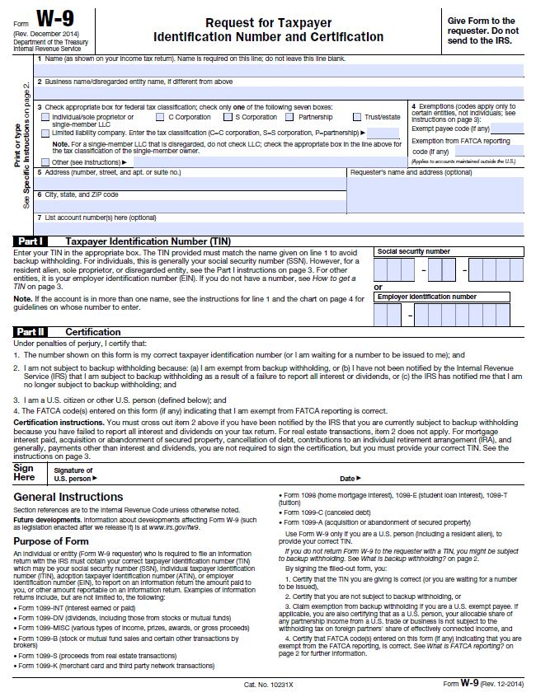

Action Plan Form

Objective:
(Note: Each Objective requires an Action Plan Form)

Strategy | Activity | Result/Measurable Outcome | Timeline | Responsible Agency/Personnel | Budget Needed for Activity

