Request for Proposals (RFP)
Application Package

Workforce Innovation and Opportunity Act (WIOA):
Integrated English Literacy/Civics Education Program – Round Two
2018–21 Competitive Subgrant

The Integrated English Literacy/Civics Education (IEL/CE) subgrant program is funded by Title II: Adult Education and Family Literacy Act (AEFLA), authorized by Public Law 113–128, Section 243 and administered by the South Carolina Department of Education.

Deadline for Receipt of Applications: August 27, 2018, at 4:00 p.m.

Pre-Application Technical Assistance Webinar for Applicants: August 9, 2018

Email of Intent Deadline: August 15, 2018

For questions about this RFP contact:
Wendy Griffin via adultedgrants@ed.sc.gov

Issued by:
South Carolina Department of Education (SCDE)
Office of Adult Education
1429 Senate Street, Suite 906
Columbia, SC 29201
803-734-0890

TABLE OF CONTENTS

PART I: General Information 1
A. Introduction and Purpose 1
B. Eligible Applicants 1
C. Competitive Priorities 1
D. Timeline of Subgranting Process 1
E. Technical Assistance Sessions for Applicants 1
F. Statutory, Federal, and State-Level Requirements 1
G. Authorized Activities 1
H. Unauthorized Activities 1
I. Program Accountability and Monitoring 1
J. Fiscal Operations 1
K. Supplement, Not Supplant 1
L. Review and Selection Process 1
M. Appeals Process 1

PART II: Application Overview, Content, and Instructions 1
A. Application Overview 1
B. Application Narrative Format 1
C. Online Application Submission 1
D. Program Abstract 1
E. Application Narrative Content 1
F. Application Budget 1
G. Appendices 1
H. Deadline and Submission Procedures 1
I. Screenshots of IEL/CE Online Application Submission Form 1

Appendix A: Definitions of Terms Used 1

Appendix B: Selection Criteria and Reviewers’ Scoring Rubric 1
Reviewers Scoring Rubric 1
IEL/CE Local Workforce Development Board (LWDB) Reviewing Rubric 1

Appendix C: Additional Information 1
South Carolina Performance Measures for AEFLA 1
Measurable Skill Gains 1
IEL/CE College and Career Navigator Job Description 1

Appendix D: Required SCDE Forms 1
Request for Taxpayer Identification Number and Certification 1
Pre-Award Audit Questionnaire for LEAs and State Agencies 1
Recruitment and Retention Action Plan—Year 1 1
Past Effectiveness Chart 1
IEL/CE Program Budget Planning Form and Budget Narrative Template Guidance 1
IEL/CE Partners and Partnership Coordination 1
Weekly Schedule 1
Certification Signature Page 1
Assurances and Terms and Conditions for Federal Subawards 1
GEPA: Notice to All Applicants 1
Partner Identification and Funding Request Form 1
Program Personnel Schedule 1
South Carolina: Languages Spoken by Limited English Proficient (LEP) Individuals Statewide and by County 1

PART I: General Information

Introduction and Purpose

The Integrated English Literacy and Civics Education (IEL/CE) program is authorized by the Workforce Innovation and Opportunity Act (WIOA), which was signed into law on July 22, 2014. The WIOA is designed to help job seekers access employment, education, training, and support services to succeed in the labor market and to match employers with the skilled workers they need to compete in the global economy. The WIOA brings together, in strategic coordination, the core programs of federal investment in skill development:
- employment and training services for adults, dislocated workers, and youth and Wagner-Peyser employment services administered by the Department of Labor (DOL) through formula grants to states; and
- adult education and literacy programs and Vocational Rehabilitation state grant programs that assist individuals with disabilities in obtaining employment administered by the U.S. Department of Education (USED).

The purpose of IEL/CE is to assist immigrants and other individuals who are English language learners (ELLs) to improve their reading, writing, and comprehension skills in English and mathematics, as well as their understanding of the United States system of government, individual freedom, and the responsibilities of citizenship. Eligible providers are required to integrate English literacy and civics education, in combination with integrated education and training activities.

The USED allocates IEL/CE funds to the South Carolina Department of Education (SCDE) by statutory formula. The SCDE must award funds through a competitive subgranting process to eligible local providers/applicants for the development, implementation, and improvement of adult education and literacy activities within South Carolina. Each eligible provider receiving a subgrant must use the funding to establish or operate programs that provide adult education and literacy activities, including programs that provide such activities concurrently.

The maximum subgrant period is three (3) years (July 1, 2018–June 30, 2021) and is subject to the availability of federal funds and the subgrantee meeting all IEL/CE program requirements. The 2018 subgrant budget period is July 1, 2018–June 30, 2019. Funds may not be carried over to the following year.

Approximately $45,000 will be available for new subgrants in the 2018–19 funding round. The SCDE anticipates awarding approximately 3 subgrants in round two. Award amounts will be determined based on the quality of applications received and total funding requested and may vary depending upon program size, population (number of anticipated enrollees), and the number of subgrants within the service area(s). An applicant may submit a single application to serve multiple counties. Partnerships are encouraged to provide program services over large geographic areas. Final budgets may be negotiated based on demonstrated needs. All subgrants are contingent upon total allocations to the SCDE by the USED.

Official grant award documents will be processed annually as continuation of funding is not automatic. In determining continuation funding, the SCDE will consider the subgrantee’s evidence of a program’s effectiveness in achieving objectives, program performance, timely submission and quality of all required reports (including interim and Annual Progress Reports), and the rationale for budget expenditures. A continuation application may be required.

The subgrantee may obligate funds upon receipt of the subgrant award notice. However, no funds will be disbursed until after July 1, 2018. Subgrant payments are made on a cost-reimbursement basis so applicants should have at least three months of operating funds at their disposal to implement the program to compensate for any delays in receiving reimbursement payments.

Eligible Applicants

Eligible applicants (i.e., eligible providers) are organizations that can prove evidence of demonstrated effectiveness in providing adult education and literacy activities; these may include—
- a local educational agency (LEA, i.e. school district);
- a community-based organization or faith-based organization;
- a volunteer literacy organization;
- an institution of higher education;
- a public or private nonprofit agency;
- a library;
- a public housing authority;
- a nonprofit institution that is not described in any of subparagraphs 1 through 7 and has the ability to provide adult education and literacy activities to eligible individuals;
- a consortium or coalition of the agencies, organizations, institutions, libraries, or authorities described in any of items 1 through 8; and
- a partnership between an employer and an entity described in any of items 1 through 9.

An eligible provider must demonstrate effectiveness by providing adult education and literacy activities by submitting:
- Performance Record—a minimum of two consecutive years of performance data (within the previous five years) on improving the skills of eligible individuals, particularly eligible individuals who have low levels of literacy, in the content domains of
- reading;
- writing;
- mathematics; and
- English language acquisition.
- Participant Outcomes—a minimum of two consecutive years of data and/or information (within the previous five years) on outcomes for participants related to
- employment;
- attainment of secondary school diploma or its recognized equivalent; and
- transition to postsecondary education and training.

To fulfill the demonstrated effectiveness requirement, an applicant must submit, in no more than two pages, its performance record and participant outcomes. An applicant must submit a minimum of two consecutive years of performance data and/or information and a minimum of two consecutive years of participant outcomes data and/or information. Instructions on how to submit documentation of demonstrated effectiveness are on page 29. An applicant that is unable to provide evidence of their demonstrated effectiveness in providing adult education and literacy activities will not be considered for funding, and their application will not be reviewed.

An applicant may choose to partner with other providers in order to serve multiple service areas.

Competitive Priorities

Competitive priority points are not offered for this funding round.

Timeline of Subgranting Process

Date | Activity/Action
August 9, 2018 | Technical assistance webinar
August 15, 2018 | Deadline for letter/email of intent
August 27, 2018 | Deadline for receipt of applications
October 2018 | Notification of awards
October 2018 | Project technical assistance session
July 1, 2018 | First year funding period begins
January 30, 2019 | Interim report(s) due to the SCDE
June 30, 2019 | Funding period ends
August 15, 2019 | First year report due to the SCDE

Technical Assistance Sessions for Applicants

The Office of Adult Education will offer a pre-award technical assistance webinar via Adobe Connect on August 9, 2018, from 10:00 a.m. until 12:00 p.m. (noon). Registration is not required; please provide your full name when logging into the session. Participants will be able to log in 30 minutes prior to the start of the session to test their audio settings and download handouts. While participation is not mandatory in order to submit an application, it is highly recommended.

Statutory, Federal, and State-Level Requirements

Required Thirteen Considerations
In accordance with the WIOA, the SCDE must consider the following for all applicants when awarding all subgrants:
- the degree to which the eligible provider (applicant) would be responsive to—
  - Regional needs as identified in the local workforce development plan; and
  - Serving individuals in the community who were identified in such plan as most in need of adult education and literacy activities, including individuals—
- who have low levels of literacy skills; or
- who are ELLs;
- the ability of the eligible provider (applicant) to serve eligible individuals with disabilities, including eligible individuals with learning disabilities;
- past effectiveness of the eligible provider (applicant) in improving the literacy of eligible individuals, to meet state-adjusted levels of performance for the primary indicators of performance described in the WOIA section 116, especially with respect to eligible individuals who have low levels of literacy (see 34 CFR §463.155);
- the extent to which the eligible provider (applicant) demonstrates alignment between proposed activities and services and the strategy and goals of the local plan under of the WIOA section 108, as well as the activities and services of the one-stop partners;
- whether the eligible provider's program—
- is of sufficient intensity and quality, and based on the most rigorous research available so that participants achieve substantial learning gains; and
- uses instructional practices that include the essential components of reading instruction;
- whether the eligible provider's activities, including whether reading, writing, speaking, mathematics, and English language acquisition instruction delivered by the eligible provider, are based on the best practices derived from the most rigorous research available, including scientifically valid research and effective educational practice;
- whether the eligible provider's activities effectively use technology, services and delivery systems, including distance education, in a manner sufficient to increase the amount and quality of learning, and how such technology, services, and systems lead to improved performance;
- whether the eligible provider’s activities provide learning in context, including through integrated education and training, so that an individual acquires the skills needed to transition to and complete postsecondary education and training programs, obtain and advance in employment leading to economic self-sufficiency, and to exercise the rights and responsibilities of citizenship;
- whether the eligible provider's activities are delivered by well-trained instructors, counselors, and administrators who meet any minimum qualifications established by the state, where applicable, and who have access to high quality professional development, including through electronic means;
- whether the eligible provider’s activities coordinate with other available education, training, and social service resources in the community, such as by establishing strong links with elementary schools and secondary schools, postsecondary educational institutions, institutions of higher education, local workforce development boards (LWDBs), one-stop centers, job training programs, and social service agencies, business, industry, labor organizations, community-based organizations, nonprofit organizations, and intermediaries, in the development of career pathways;
- whether the eligible provider's activities offer the flexible schedules and coordination with federal, state, and local support services (such as child care, transportation, mental health services, and career planning) that are necessary to enable individuals, including individuals with disabilities or other special needs, to attend and complete programs;
- whether the eligible provider maintains a high quality information management system that has the capacity to report measurable participant outcomes (consistent with the WIOA section 116) (see 34 CFR §463.155) and to monitor program performance; and
- whether the local area(s) in which the eligible provider is located has a demonstrated need for additional English language acquisition programs and civics education programs.

The application narrative instructions in Part II of this RFP are designed to assist the applicant with demonstrating responsiveness to these required thirteen considerations.

To comply with Section 427 of the General Education Provisions Act (GEPA), each subgrant application must contain an appropriate GEPA statement as described on page 124.

Applicable Federal Regulations
Applicants should review the following federal regulations, accessible at the electronic Code of Federal Regulations (e-CFR) Web site, that are applicable to the IEL/CE program. Applicants are reminded that, if funded, their programs must comply with these regulations.
- 2 CFR Part 25—Universal Identifier and System for Award Management
- 2 CFR Part 170—Reporting Subaward and Executive Compensation Information
- 2 CFR Part 175—Award Term for Trafficking in Persons
- 2 CFR Part 180—OMB Guidelines to Agencies on Governmentwide Debarment and Suspension (Nonprocurement) as adopted at 2 CFR Part 3485
- 2 CFR Part 200—Uniform Administrative Requirements, Cost Principles, and Audit Requirements for Federal Awards as adopted at 2 CFR Part 3474 (Note: 2 CFR Part 200.210(a)(1) requires that a grant recipient’s name match their registered name in DUNS, the Data Universal Numbering System, for their DUNS number. Also § 200.307 applies as the AEFLA allows subgrantees to earn program income.)
- 34 CFR Part 76—State-Administered Programs
- 34 CFR Part 77—Definitions that Apply to Department Regulations
- 34 CFR Part 81—General Education Provisions Act—Enforcement
- 34 CFR Part 82—New Restrictions on Lobbying
- 34 CFR Part 86—Drug and Alcohol Abuse Prevention
- 34 CFR Part 462—Measuring Educational Gain in the National Reporting System for Adult Education
- 34 CFR Part 463— Adult Education and Family Literacy Act

Additional information on select governmentwide regulations is presented below:

Universal Identifier and System for Award Management—2 CFR Part 25
All applicants must obtain a Dun and Bradstreet (D&B) Data Universal Numbering System (DUNS) number as a universal identifier for federal financial assistance. Active grant recipients and their direct subrecipients of a subgrant award also must obtain a DUNS number. Visit the D&B DUNS Web site to request a DUNS number.

The applicant must also be registered in the federal System for Award Management (SAM) prior to submitting an application, maintain their SAM registration throughout the application and award process, and include a valid DUNS number in the online application. To register in SAM, you will need your entity’s DUNS number and your entity’s Tax ID Number (TIN) and taxpayer name (as it appears on your last tax return), and ten-digit ZIP Code (ZIP+4). You must also submit an original, signed notarized letter identifying the authorized Entity Administrator for the applicant entity associated with the DUNS number before a new SAM.gov registration will be activated. Visit the SAM update Web site for more information on new registrations. See the USED’s SAM.gov tip sheet for guidance on registering. Registration should take 3–5 days. If you do not receive confirmation that your SAM registration is complete, please contact SAM.gov.

The SCDE cannot make a subaward of federal funds to an applicant until the applicant has complied with the requirements described in 2 CFR 25 to provide a valid DUNS number and maintain an active SAM registration with current information.

Reporting Subaward and Executive Compensation Information—2 CFR Part 170
The Federal Funding Accountability and Transparency Act (FFATA) of 2006 (Public Law 109–282), as amended by Section 6202 of Public Law 110–252, requires primary grantees of federal grants and cooperative agreements to report information on subgrantee obligations and executive compensation. The FFATA promotes open government by enhancing the federal government’s accountability for its stewardship of public resources. This is accomplished by making government information, particularly information on federal spending, accessible to the general public.

Primary grantees, like the SCDE, are required to report actions taken that obligate $25,000 or more in federal grant funds to first-tier subgrantees. This information must be reported in the governmentwide FFATA Subaward Reporting System (FSRS). A primary grantee and first-tier subgrantees must also report total compensation for each of its five most-highly compensated executives. Additional information will be provided to subgrant recipients upon award.

Program Income–2 CFR Part 200.307
Ordinarily, program income is deducted from total allowable program costs, and all program income, except for tuition and fees charged to students and employers earned by a subgrantee under this award, must be so deducted. A local subgrantee charging reasonable and necessary tuition or fees to students and employers may use that income to provide additional adult education and literacy services that it would otherwise be unable to provide. Program income from tuition and fees must be (1) governed by the terms of the agreement between the SCDE and the local subgrantee to which the state provides federal funds, (2) accounted for in program records, and (3) used only for costs allowable under AEFLA.

Applicants should review the Assurances and Terms and Conditions for Federal Subawards (on pages 120–123) to ensure that, if awarded a subgrant, they are capable of full compliance, especially with all the referenced federal regulations and state laws, in order to enter into an agreement with the SCDE for this program. For example, in compliance with 2 CFR Part 200.112, applicants must disclose in writing any potential conflict of interest to the SCDE in accordance with the USED’s conflict of interest policy. A signed Certification Signature Page (see page 119) is required with the application and legally binds the applicant to the agency’s Assurances and Terms and Conditions.

Primary Indicators of Performance
Section 116 of WIOA establishes performance accountability indicators and performance reporting requirements to assess the effectiveness of states and local areas in achieving positive outcomes for individuals served by the workforce development system’s six core programs. Adult education is one of the six core workforce development programs. The WIOA core programs in South Carolina include:
- Programs authorized under the WIOA Title I and administered by the SC Department of Employment and Workforce (SCDEW): Adult, Dislocated Worker, and Youth;
- the AEFLA program, authorized under the WIOA Title II and administered by the SCDE Office of Adult Education;
- the Employment Service program authorized under the Wagner-Peyser Act, as amended by the WIOA Title III and administered by the SCDEW; and
- the Vocational Rehabilitation (VR) program authorized under Title I of the Rehabilitation Act of 1973, as amended by the WIOA Title IV and administered by the SC Vocational Rehabilitation Department and the SC Commission for the Blind.

Under the WIOA, there are six primary indicators of performance that apply to all six core programs. The primary indicators of performance focus on employment, median earnings, credential attainment, and measurable skill gains. In accordance with the WIOA Title I (Sec. 116) and Title II (Sec. 212), the primary indicators of performance include:
- the percentage of program participants who are in unsubsidized employment during the second quarter after exit from the program;
- the percentage of program participants who are in unsubsidized employment during the fourth quarter after exit from the program;
- the median earnings of program participants who are in unsubsidized employment during the second quarter after exit from the program;
- the percentage of program participants who obtain a recognized postsecondary credential, or a secondary school diploma or its recognized equivalent, during participation in or within one year after exit from the program;
- the percentage of program participants who, during a program year, are in an education or training program that leads to a recognized postsecondary credential or employment and who are achieving measurable skill gains toward such a credential or employment (see pages 96–97 for guidance on measurable skill gains as related to adult education); and
- the indicators of effectiveness in serving employers.

The AEFLA performance measures will contribute to the state’s WIOA primary indicators of performance. The processes and procedures around this will be determined at a later date.

Performance Measures
Performance measures are used to quantitatively assess the implementation and outcomes of AEFLA programs and the effectiveness of the programs in serving students. Performance measures can provide useful information on how well programs are performing and whether educators are meeting instructional goals. Performance measures hold the SCDE and its subgrantees accountable for program results. IEL/CE programs are held accountable for the WIOA primary indicators of performance as well as the adult education performance measures which are a part of the primary indicators of performance.
A primary measure of adult education participant and program performance is measureable skill gain (MSG). MSG can be demonstrated through educational functioning level gain and receipt of a secondary credential or its equivalent. For additional information about MSG, see page 96.

Subgrantees providing activities and services under IEL/CE must meet or exceed adult education performance levels as determined by the SCDE Office of Adult Education. Each subgrantee’s program performance contributes to the overall success of the state in meeting or exceeding the federally-agreed upon performance levels. The chart on page 95 shows the performance levels that adult education programs have been expected to meet or exceed in the past. In most cases, performance levels have increased annually; thus, subgrantees awarded funds under this RFP must also program and expect continuous improvement in their performance levels. AEFLA related performance-levels will be shared with subgrantees at a later time.

IEL/CE Program Requirements
Services provided through the IEL/CE program must include education services that enable adult ELLs to achieve competency in the English language and acquire the basic and more advanced skills needed to function effectively as parents, workers, and citizens. As part of the IEL/CE program requirements, each program must provide services that
    - include instruction in literacy and English language acquisition and instruction on the rights and responsibilities of citizenship and civic participation;
    - are designed to
- prepare adults who are ELLs for, and place such adults in, unsubsidized employment in in-demand industries and occupations that lead to economic self-sufficiency; and
- integrate with the local workforce development system and its functions to carry out the activities of the program; and
    - may include workforce training.

All subgrantees must provide the following local activities:
- integrated English literacy and civics education,
- English language acquisition, and
- workforce preparation.

In addition, implementation of integrated education and training (IET) with eligible English as a second language (ESL) students will be required beginning in year one.

Classes should meet a minimum of 6 hours per week with a minimum total duration of 72 hours.

Adult education programs in South Carolina must serve individuals who are eligible to receive services. In compliance with South Carolina State Board of Education Regulation 43-259, an individual eligible to participate in an adult education program must be at least eighteen (18) years of age unless there is local school board or school district superintendent approval or verification of school withdrawal. (No student under the age of sixteen (16) may be assigned to the adult education program for any reason.) In addition, the individual must not be enrolled in or required to be enrolled in secondary school under state law. An individual must also meet any of the following criteria to be eligible to receive services:
- is basic skills deficient;
- does not have a secondary school diploma or its recognized equivalent, and has not achieved an equivalent level of education; or
- is an ELL.

South Carolina requires that every IEL/CE program provider have a College and Career Navigator (CCN) or a position on staff that is responsible for career planning and career development of students. Expected job duties and qualifications of the CCN are provided on page 98.

Authorized Activities

Subgrant funds may be used to establish or operate programs that provide adult education and literacy activities, including programs that provide such activities concurrently.

Of the amount of funds awarded to an eligible provider, no more than five percent must be used for administration (see the definition for administrative costs in Appendix A). In cases where these cost limits are too restrictive to allow for adequate planning, administration, personnel development, and interagency coordination, the eligible provider can negotiate with the SCDE to determine an adequate level of funds to be used for non-instructional purposes.

Unauthorized Activities

Subgrant funds must not be used for the purpose of supporting or providing programs, services or activities for individuals who are not eligible individuals as defined in AEFLA for the IEL/CE program.

Program Accountability and Monitoring

The SCDE is responsible for monitoring the implementation of the IEL/CE program that provides allowable integrated English literacy and civics education, in combination with integrated education and training activities in accordance with the following program accountability requirements:
- Each applicant receiving funding through this RFP meets the eligibility requirements for the subgrant described herein, and the applicant has provided all required assurances that it will comply with all program implementation and reporting requirements established through this RFP.
- Each applicant receiving funding through this RFP appropriately uses these funds as described in this application package.
- Each applicant implements activities funded through this application within the timeline in which the funds provided are to be used.

To fulfill its monitoring responsibilities, the SCDE requires subgrantees to submit appropriate fiscal and program documentation per guidance provided by the SCDE Office of Adult Education. In addition, representatives of the state may conduct site visits to funded applicants. The purpose of these visits is to validate information submitted by applicants and to gather additional information from interviews and observations for monitoring and evaluation purposes.
In compliance with 2 CFR Part 200.331, the SCDE will conduct a risk assessment of potential subgrantees before an award is issued. As a part of this process, each applicant must complete the appropriate pre-award audit questionnaire to submit with their application as described on pages 102–110 The SCDE’s Office of Auditing Services will evaluate this questionnaire and may conduct a further evaluation of the applicant’s financial system, internal controls, and policies and procedures. Visit the Office of Auditing Services to access the review process and procedures.

Applicants awarded subgrant funds must satisfy periodic reporting and accountability requirements throughout the term of the subgrant. These requirements address: (1) program accountability; (2) performance reporting; (3) annual budget; (4) monitoring; (5) program evaluation; and (6) technical assistance.

1. Program Accountability
Each subgrantee is responsible for carrying out its responsibilities in accordance with AEFLA (Title II of WIOA); all applicable statutes, regulations, and programmatic guidance; and its approved subgrant application and work plan. Subgrantees will also be required to submit periodic reports to the SCDE to report on the use of subgrant funds and the progress of proposed subgrant activities.

2. Performance Reporting
Performance reporting requirements include those for both programmatic reporting and fiscal reporting. The subgrantee is responsible for ensuring that all required performance reports are accurate, complete, and submitted on time.

Performance Reporting Data Management
South Carolina Adult Education uses the Literacy Adult Community Education System (LACES) web-based application designed by LiteracyPro for the collection of state adult education data and National Reporting System (NRS) data. Subgrantees are responsible for allocating sufficient staffing resources to collect NRS measures data according to requirements, verify the data, and report the data in LACES. LACES is free of charge to subgrantees.

Programmatic Reporting Requirements
The SCDE uses various reports to gather data on programs and initiatives and account for the funds expended in local adult education programs. Reports allow the SCDE and local programs to understand how local programs are performing throughout the school year. Some reports are submitted quarterly and some annually.

Subgrantees will be evaluated through an examination of enrollment, retention, educational functioning level (EFL) gain, Career Readiness Certificate (CRC) attainment, IET participation, and employment and post-secondary transition data obtained through LACES. The following data is due on July 28, 2019, (or the LACES freeze date, if different):
- NRS Tables 4 and 4b for IEL/CE students only for July 1, 2018–June 30, 2019;
- NRS Tables 4 and 4b for all ESL students for July 1, 2018–June 30, 2019;
- Desktop Monitoring Tool (DMT) for July 1, 2018–June 30, 2019;
- Special Initiatives Desk Audit (SIDA) for July 1, 2018–June 30, 2019; and
- College and Career Navigator Annual Report (CNAR) for July 1, 2018–June 30, 2019.

The IEL/CE program reporting includes, but is not limited to, the
- IEL/CE Final Annual Report (IEL/CE-FAR) that includes a narrative describing the program’s strengths, challenges, and quality of processes (due August 15 each year); and
- IEL/CE Interim Performance Report that contains fiscal, programmatic and performance data (due in January each year).

Progress toward achieving subgrant goals and objectives will be monitored through the annual performance report process. Programs that do not submit the required reports by the deadlines outlined above may be deemed ineligible for 2019–20 IEL/CE funds.

Fiscal Reporting Requirements
Subgrantees must upload their approved budget into the SCDE’s grants accounting processing system (GAPS) following receipt of their subaward notification and prior to submitting any reimbursement requests. GAPS training will be provided to subgrantees. All expenditure reports must be submitted through GAPS. Submission of expenditure reports will be accepted monthly but is required at least quarterly throughout the subgrant period (see table below). The subgrantee is responsible for ensuring that reports are accurate, complete, and submitted on time. The subgrantee must submit a final fiscal report to the SCDE that covers the duration of the subgrant award.

The Expenditure Reporting Due Dates for the IEL/CE program are:
Quarter | Reporting Period | Report Due Date
1st Quarter | July 1–September 30 | October 15
2nd Quarter | October 1–December 31 | January 15
3rd Quarter | January 1–March 31 | April 15
4th Quarter | April 1–June 30 | August 15

3. Program Budget
Applicants must submit a budget of projected subgrant expenditures for year one of the three-year subgrant with their application. A budget must be submitted to the SCDE no later than July 1 for each subsequent year of the subgrant.

4. Monitoring
The SCDE will monitor subgrantees by reviewing and approving the progress reports and annual performance reports. All information in monitoring reports is subject to verification.

The SCDE may conduct programmatic and financial monitoring site visits. Subgrantees must agree to site visits conducted by the SCDE or federal program representatives. The purpose of site visits is to validate information provided in fiscal and program reports, and to gather more detailed information, through interviews and observations, on implementation efforts and challenges.

The SCDE may require additional information from the subgrantee, verify information with the authorizing agency, or require the submission of additional documentation including, but not limited to, invoices, receipts, and personnel time and effort reports. Prior to a site visit, the subgrantee may be required to submit additional relevant information that will allow the SCDE to conduct a useful, efficient, and effective visit. The SCDE may require electronic submission of documents instead of a paper-copy submission.

SCDE staff will verify the contents of documentation submitted. A subgrantee may be asked to revise reports when
- non-allowable expenses are found;
- reports are confusing or difficult to understand; or
- there are unexplained discrepancies between the proposed use of subgrant funds, as provided in the annual budget, and actual expenditures found in the submitted documentation.

5. Program Evaluation
Subgrant Recipient Program Monitoring and Evaluation
Subgrant recipients are required to conduct ongoing monitoring and evaluation to ensure program goals are achieved. While hiring an external monitoring and evaluation contractor is not required, it is also not prohibited. Progress toward meeting program goals is to be reported through the interim progress review process.

A final program evaluation report is to be completed before the end of the subgrant period. The final evaluation report must address success toward each goal stated in the application. If a subgrantee fails to conduct the final program evaluation report before the end of the subgrant period, or if any of the performance requirements in section I. on pages 9–12 are not completed, the SCDE may consider the subgrantee a high risk and elect to discontinue funding or disqualify the subgrantee from future funding opportunities.

SCDE External Review
The SCDE or its representatives may conduct evaluations of the IEL/CE programs. Subgrant recipients are required to comply with any request by the SCDE or its evaluation subcontractor, or the SCDE and its evaluation subcontractor, including but not limited to, requests for information, site visits, interviews, completing surveys, or participating in data collections.

6. Technical Assistance to Subgrantees
Subgrantees are required to participate in any technical assistance that the SCDE may conduct related to completing and filing reports or other requirements of the IEL/CE program subgrant. Delivery of such technical assistance may include in-person meetings, webinars, and conference calls.

Fiscal Operations

Subgrantees must use subgrant funds only for allowable expenditures during the subgrant period. IEL/CE program subgrant funds are disbursed on a reimbursement basis. The SCDE will de-obligate any unspent funds remaining at the end of the subgrant period for reallocation to other subgrantees. Carryover is not allowed.

Indirect costs are allowable; applicants must use their restricted indirect cost rate. Applicants who do not have a federally negotiated indirect cost rate should contact the SCDE’s Office of Auditing Services to negotiate an interim rate if they want to include indirect costs in their budget request. Matching or in-kind funds are not required; however, matching and in-kind funds are an indicator of potential long-term sustainability of an IEL/CE program.

Allowable Costs
- Salaries and Employee Benefits
- Teacher and Teacher Aides
- Support Staff (coordinators, counselors, administrative support)
- Instructional and Administrative Staff time while participating in professional development and/or improvement of instruction
- Capital Outlay (Equipment)*
- Services
- Travel*
- Advertising/Marketing/Public Relations*
- Publication and Printing
- Office Supplies
- Postage
- Instructional Materials, Books, Software, etc.
- Student education
- Improvement of instruction/staff development (professional development/training and education)
- Integrated Education & Training:
- Teachers (excluding post-secondary instructors), Administrators, and Support Staff Salaries and Benefits
- Purchase Services
- Supplies & Materials
*requires approval of the SCDE Office of Adult Education and the applicant/eligible provider’s governing board.

Applicants should review the cost principles in 2 CFR Part 200 and the USED’s guidance regarding the use of federal grant funds for conferences and meetings (memo dated June 2012 and frequently asked questions dated December 2014) prior to developing budget items.

Unallowable Costs
Unallowable costs include, but are not limited to, the following:
- Alcoholic Beverages,
- Commencement and Convocation,
- Construction,
- Entertainment,
- Fundraising,
- Goods or Services—personal use,
- Lobbying, and
- Transportation for Student Activities.

Supplement, Not Supplant

IEL/CE subgrant funds must supplement, not supplant, existing services and may not be used to supplant federal, state, local, or non-federal funds. Programs may not use subgrant funds to pay for existing levels of services funded from any other sources. If current expenditures are being paid from state or local public funds, a funded applicant may not start paying for those expenditures from these subgrant funds. An applicant also cannot remove or transfer funding from this federally supported program to another program because this subgrant has been received.

Review and Selection Process

Only subgrant applications that are received by the deadline and deemed complete will be forwarded for review and funding consideration. All required materials including forms and appendices must be submitted for the application to be considered complete and eligible for review. Incomplete applications will not be forwarded to the selected reviewers or considered for funding.

In accordance with the WIOA, each application will be reviewed by its local workforce development board (LWDB) to determine alignment with the LWDB’s plan. If an applicant’s intended service delivery area includes more than one LWDB area, each LWDB must review the application. Applicants are prohibited from communicating with the LWDB regarding an application submission after the application due date.

The review of all IEL/CE applications will follow this process:
- The SCDE Office of Adult Education will check applications for completeness and compliance with the RFP instructions and will determine if the demonstrated effectiveness eligibility requirement has been met.
- Complete applications meeting the demonstrated effectiveness prerequisite will be forwarded to the respective LWDBs.
- The LWDBs will use the rubric (see page 84) to review applications for alignment with the LWDB plans and submit recommendations to the SCDE. LWDB recommendations will serve as supplemental information for the application review.
- Three reviewers from diverse backgrounds, without a vested interest in any applicant being funded, will evaluate each application based on the quality of the proposed activities and the capability of the applicant to implement the proposed program. The review team is comprised of experienced grant readers from various professions and entities, including the SCDE. These reviewers will use a separate scoring rubric (see page 50) to read and score each application independently.
- After the three reviewers have individually scored each application, the scores will be averaged. An application can earn up to 385 points for an average score.
- Applications will be rank-ordered by averaged scores.

Prior to making awards, the SCDE’s Office of Auditing Services will conduct a pre-award risk assessment. Based upon the results of this assessment, special conditions may be applied to the award that may include, but are not limited to, requirements for more frequent programmatic or financial reporting, increased monitoring of subgrant activities, and the provision of additional technical assistance. The SCDE reserves the right to interview applicants recommended for funding, request additional documentation, and make a site visit as appropriate to ensure compliance with federal and state requirements.

The SCDE may negotiate elements of an applicant’s proposed plan(s) and/or proposed budget(s) prior to making subawards. The SCDE reserves the right to negotiate final budgets and to disqualify costs associated with any line items that are unallowable, unallocable, unreasonable, or inconsistent with the program’s goals or the proposed program’s activities and strategies.

Subject to the SCDE’s final approval, the availability of federal funds, geographic equity, and the inclusion of priority programming, subgrant awards will be made starting with applications that earned the highest averaged scores. To the extent practical, the SCDE will award subgrants equitably among geographic regions within the state to include rural and urban communities.

Continuation awards are contingent upon the subgrantee meeting all reporting requirements and demonstrating substantial progress toward meeting program objectives and use of all funds requested. The SCDE will review the subgrantee’s prior year’s audit, year-end reports, thoroughness and timeliness in submitting reports and annual budgets, and the availability of funds before awarding any continuation grants. A continuation application may be required.

Subgrant awards are not final until an SCDE subgrant award notice is fully executed. Notification of award will be sent in July 2018, to the authorized official listed on the Certification Signature Page. After the notification of awards, copies of the reviewers’ comments and score sheets will be sent to the contact person identified in the online application.

Appeals Process

An applicant who has submitted an application that is not funded by the SCDE has 30 calendar days after receiving notification that the application is not funded to request a review of the process. Scores may not be appealed; the SCDE will not rescore applications. An unfunded applicant may inquire as to whether or not the application process was followed. The request for review must be directed to the State Superintendent of Education and must state the reasons for the request. The SCDE will conduct a hearing in accordance with the provisions of 34 CFR Part 76.401.

PART II: Application Overview, Content, and Instructions

Read all guidelines and criteria carefully before preparing your application. Adhere to font, format, page limit, and organizational requirements. Only applications that include all sections and appendices and fully adhere to these guidelines will be reviewed and considered for funding. Incomplete applications will not be reviewed.

Application Overview

Applications must be submitted online. Prepare all of the following elements of the application before beginning the online submission process. Do not wait until the last minute to submit an application. Use the following overview as a checklist to ensure submission of a complete application with items labeled accordingly and presented in the order outlined below. Verify that all components of the narrative and appendices are included prior to uploading attachments.

The IEL/CE subgrant online application is organized into the following sections (also see the screenshots on pages 32–39):

- Online Form Sections
- Applicant Information
- Demonstrated Effectiveness
- Authorized Official’s Contact Information
- IEL/CE Subgrant Lead Contact Information
- Financial Official’s Contact Information
- Program Information
- 2018–19 Budget Summary
- Proposal Attachments
- Program Abstract
- Application Narrative
  - Table of Contents
  - Required Considerations 1–13
- Budget Planning Form and Budget Narrative
- Appendices
- Demonstrated Effectiveness Documentation
- Pre-Award Audit Questionnaire
- Application Attachments
  - Request for Tax Identification Number and Certification (W-9)
  - Policies to Accommodate Students and Staff with Disabilities
  - Indirect Cost Rate Agreement
  - Program Personnel Schedule
  - Recruitment & Retention Action Plan
  - Past Effectiveness Chart
  - Partners and Partnership Collaboration Chart
  - Weekly Schedule
  - Certification Signature Page
  - GEPA Statement
  - Memorandums of Agreement or Letters of Commitment from Collaborative Partners
  - Partner Identification and Funding Request Form
  - Letters of Support (optional)
  - Résumé for Key Staff.

Application Narrative Format

Length of Narrative: | Maximum of 50 pages. The program abstract and appendices are excluded from the page limit.
Required Font/Size: | Times New Roman/12 or Arial/12. Charts and tables may be in Times New Roman/11 or Arial/11.
Margins: | 1” on all sides.
Page Numbers: | Insert page numbers on the bottom right at the 0.5 inch margin. All pages of the application narrative must be numbered.
Spacing: | Double-spaced. Text in charts and tables may be single-spaced.
Final File Format: | Separate PDF documents for program abstract, application narrative, Demonstrated Effectiveness Documentation, Pre-Award Audit Questionnaire, and appendices. Excel document for Budget Planning Form and Budget Narrative.

Each section must be clearly identified using the headings provided in the instructions below. Sections may not be combined.

Online Application Submission

Applications must be submitted online. The IEL/CE online submission is organized into two sections—Online Forms and Application Attachments.

Provide the applicant’s nine-digit DUNS number and TIN in the application form. Applicants should contact their organization’s finance office if they need assistance with these items.

Use the following instructions to compile and complete all required information and attachments prior to submitting your application. Follow the directions in each section for saving the documents and refer to the screenshot on page 37 for upload locations.

Program Abstract

In one page, concisely
- describe the applicant’s organization and its mission,
- indicate the target population to be served with the proposed program,
- provide the anticipated number of individuals to be served in year one,
- briefly state the documented need for the program,
- state the amount of funding being requested,
- list the Adult Education and IEL/CE activities to be provided,
- identify the career pathway of the proposed program,
- indicate the proposed service area (i.e., county or counties), and
- indicate the LWBD plan(s) with which the proposed program aligns.

When completed, save this page as a single PDF document to be uploaded as an attachment in the online application as indicated on page 37.

Application Narrative Content

Use the following directions to write the application narrative and organize it into sections following the sequence presented below. Do not combine sections. Required components must be located in their designated sections in order to be scored. Include a table of contents as the first page of the narrative (not included in the page limit).

When complete, save the entire narrative as one PDF document to be uploaded into the online application where indicated in the attachments section.

Consideration 1. Commitment to Serve Individuals in Need

The SCDE will consider the degree to which the applicant (eligible provider) would be responsive to—
- regional needs as identified in the local plan under the WIOA section 108 (local workforce development board’s plan); and
- serving individuals in the community who were identified in the specific local plan as most in need of adult education and literacy activities, including individuals—
  - who have low levels of literacy skills or
  - who are ELLs.

1.a. Describe the population to be served under the IEL/CE program using local and regional demographics that demonstrates the need for an IEL/CE program in the service delivery area. The description should include, but not be limited to, levels of educational attainment, including data on individuals with low literacy levels and ELLs in the community, and labor market information including current unemployment data, short- and long-term employer needs, high school graduation rates, and postsecondary enrollment and completion. Cite sources.

1.b. Identify the local workforce development plan with which the proposed IEL/CE program will align. What are the proposed education and workforce priorities for the program based on the local plan and community demographics?

1.c. List the adult education and literacy activities that will be provided to address the needs of the ELL population to be served. Explain how the program will meet the needs of the community through the identified adult education and literacy activities.

1.d. Outline the program’s recruitment and retention action plan for year one by completing the Recruitment and Retention Action Plan form (page 111). Include specific activities that will be implemented to recruit and retain individuals with limited English proficiency.

1.e. Describe how the program will provide services to meet the specific needs of the target populations, including the particular needs of
a. individuals with limited English proficiency,
b. individuals pursuing citizenship, and
c. individuals with multiple barriers to employment.

Consideration 2. Serving Individuals with Disabilities

The SCDE will consider the ability of the applicant/eligible provider to serve eligible individuals with disabilities, including eligible individuals with learning disabilities.

2.a. Describe how the applicant organization will identify students with disabilities and the organization’s ability to serve individuals with disabilities (i.e., physical, mental, emotional, and learning). Include a copy of the organization’s policies to accommodate students and staff with disabilities as an appendix item (see page 30).

2.b. What steps will the organization take to promote the inclusion of students with disabilities and ensure equitable access to program activities and services?

2.c. How will your organization collaborate and partner with other organizations and agencies to assist and support serving eligible individuals with disabilities?

Consideration 3. Past Effectiveness

The SCDE will consider past effectiveness of the applicant/eligible provider in improving the literacy of eligible individuals to meet state-adjusted levels of performance for the primary indicators of performance described in the WIOA section 116, especially with respect to eligible individuals who have low levels of literacy.

3.a. Describe the applicant organization’s previous experiences, past successes, and unique qualifications to serve ELLs in need of adult education and literacy services.

3.b. Discuss how the applicant organization has effectively served eligible ELLs in the past. As a part of your explanation, include the following:
- A minimum of two consecutive years of performance data (within the previous five years) to demonstrate your organization’s record of improving the skills of eligible individuals, particularly eligible individuals who have low levels of literacy, in the content domains of
- reading,
- writing,
- mathematics, and
- English language acquisition.
- A table to reflect the two consecutive years of performance data as a part of the narrative or complete the Past Effectiveness Chart (pages 113–114). If completing the Past Effectiveness Chart, reference it in your response and include the chart as an appendix item.
- The number of individuals served during each of the selected two years.
- The timeframe of the data (e.g., January 2015–December 2015, August 2015–July 2016).

3.c. Discuss how the applicant organization has assisted eligible ELLs in successfully attaining a high school diploma or equivalent and transitioning to postsecondary and/or employment. As a part of your explanation, provide the following:
- Two consecutive years of performance data (within the previous five years) on the outcomes of participants, particularly eligible individuals who have low levels of literacy, related to
- employment,
- attainment of secondary school diploma or its recognized equivalent, and
- transition to postsecondary education and training.
- A table to reflect two consecutive years of performance data as a part of the narrative or complete the Past Effectiveness Chart (pages 113–114). If completing the Past Effectiveness Chart, reference it in your response and include the chart as an appendix item.
- The number of individuals served during each of the selected two years.
- The timeframe of the data (e.g., January 2015–December 2015, August 2015–July 2016).

3.d. Describe how the applicant organization measures the target population’s educational performance and student transition into postsecondary education, training, and/or the workforce.

Consideration 4. One-Stop System Alignment

The SCDE will consider the extent to which the applicant/eligible provider demonstrates alignment between proposed activities and services and the strategy and goals of the local plan under the WIOA section 108, as well as the activities and services of the one-stop partners

4.a. Describe how the applicant’s activities and services to eligible ESL students will align with the strategies and goals of the local workforce development board’s plan and the activities and services of local SC Work Center(s), core partners, and any additional one-stop partners. At a minimum, applicants should align the proposed program with the activities and services of the core partners. Complete the Partners and Partnership Coordination Chart (on pages 116–117) to indicate partners and collaborative efforts that have been established or will be established with partners to meet mutual goals and strategies. Include letters of commitment or MOUs/MOAs (first page and signature page only) in the appendix.

4.b. Explain your program’s processes and procedures for promoting and implementing student concurrent enrollment in the WIOA Title I programs and activities as it relates to the ESL student population. Include how your organization will coordinate the referral, intake, and orientation of eligible participants into core partner programs.

Considerations 5. & 6. Evidence-Based Instructional Practices

The SCDE will consider whether the applicant’s/eligible provider’s program—
- is of sufficient intensity and quality, and based on the most rigorous research available so that participants achieve substantial learning gains; and
- uses instructional practices that include the essential components of reading instruction.

The SCDE will consider whether the applicant’s/eligible provider’s activities, including whether reading, writing, speaking, mathematics, and English language acquisition instruction delivered by the eligible provider, are based on the best practices derived from the most rigorous research available and appropriate, including scientifically valid research and effective educational practice.

5. & 6.a. Describe how the proposed program design and schedule is of sufficient intensity (hours per week) and duration (number of weeks) to promote substantial learning gains of participants.

5. & 6.b. Demonstrate that a variety of class opportunities will be available by completing the Weekly Schedule (see page 118). When completing the template, include all planned class sites. A variety of opportunities may include multiple classes/sites, specific EFL levels and/or specific skills addressed in individual classes (e.g., conversational classes, grammar-based classes, reading/writing classes).

5. & 6.c. Describe how instructional practices, curricula, and proposed program activities will be of sufficient quality and based on best practices derived from the most rigorous, scientifically-valid research and effective educational strategies. Include how ELLs will make substantial learning gains in reading, writing, speaking, mathematics, English language acquisition, as well as receive instruction on the rights and responsibilities of citizenship.

5. & 6.d. Describe the criteria and process for evaluating program quality and instructional practices. How often will evaluations occur? Describe the plan for making adjustments and changes.

Consideration 7. Activities Implementation, Technology Use, and Delivery Method

The SCDE will consider whether the applicant’s/eligible provider’s activities effectively use technology, services, and delivery systems, including distance education, in a manner sufficient to increase the amount and quality of learning and how such technology, services, and systems lead to improved performance.

7.a. Describe how your organization will effectively use technology products, tools, and resources with ELLs to conduct adult education and literacy activities. Address:
- your organization’s plan to give access to and integrate technology into classroom instruction and the adult education program;
- the specific technology products, tools, and resources that will be used;
- how technology will be used to improve quality of learning; and
- how staff will be trained to use the technology products, tools, and resources.

7.b. Describe current or proposed strategies for incorporating digital literacy into instruction to teach and enable ESL students to find, evaluate, organize, create, and communicate information.

7.c. Describe the distance education opportunities and any other instructional delivery methods that your program will implement to increase the accessibility and quality of learning for ESL students. How will the program ensure substantial learning gains for distance learning students?

Consideration 8. Contextualized Instruction

The SCDE will consider whether the applicant’s/eligible provider’s activities provide learning in context, including through integrated education and training, so that an individual acquires the skills needed to transition to and complete postsecondary education and training programs, obtain and advance in employment leading to economic self-sufficiency, and to exercise the rights and responsibilities of citizenship.

8.a. Describe how the organization will provide learning in context to meet the employment needs of area employers, workers, and jobseekers as described in the local workforce development board plan. Include all of the following:
- A description of the curriculum that will be used to provide contextualized instruction including the resources, tools, and materials that will be used;
- Strategies and processes that will be employed to implement contextualized instruction;
- Partnerships and collaborative efforts that will support contextualized instruction;
- A description of how your organization’s contextualized instruction will support individuals acquiring skills needed to
a) transition to and complete postsecondary education and training programs,
b) obtain and advance in employment leading to economic self-sufficiency, and
c) exercise the rights and responsibilities of citizenship; and
- A description of how the program will provide workforce preparation skills to ESL students.

8.b. Describe how the program will foster integrated education and training (IET) opportunities for eligible ESL students. Provide specific details of these opportunities. How will students access and participate in the IET program?

8.c. Describe how the program will use IET and other applicable models of contextualized instruction to help eligible adult ESL students develop the skills required to advance in an educational setting, transition to post-secondary education, or become employed.

8.d. Outline a one-year plan for development of an IET program with eligible ESL students. Include how the organization plans to implement the three required components of IET (adult education and literacy, workforce preparation, and workforce training). Provide details regarding IET components such as post-secondary education, workforce training, apprenticeships, or other career pathway components.

8.e. Describe the transition resources and strategies the program will use to enable eligible adult ESL students to enter post-secondary education, training opportunities, or the workforce.

Consideration 9. Instructor and Staff Qualifications

The SCDE will consider whether the applicant’s/eligible provider’s activities are delivered by well-trained instructors, counselors, and administrators who meet South Carolina’s minimum qualifications, where applicable, and who have access to high quality professional development, including through electronic means.

9.a. Describe how your organization will ensure there are well-trained instructors, counselors, and administrators who meet minimum state qualifications and program-related requirements in accordance with South Carolina State Board of Education Regulation 43-259, II.C. Complete the Program Personnel Schedule spreadsheet (screenshot located on page 126) to document relevant faculty and staff associated with the IEL/CE program.

9.b. Provide an overview of how your organization delivers professional development activities to ensure that instructors and staff are trained in current research, best practices, and evidence-based instructional strategies in working with adult ESL students that lead to effective program outcomes. Answer the following:
- How will instructors and staff have access to high quality professional development including through electronic means?
- What professional development opportunities will be offered and delivered beyond what the state will provide?
- How will you ensure part-time staff, as well as full-time staff, receive and participate in professional development?

9.c. Describe how state and program priorities/goals are communicated to new and current instructors and staff. How often is communication provided and information shared? How do you ensure instructors and staff are acclimated to and knowledgeable of adult education instruction, policies, and procedures?

9.d. What is the process for observing and evaluating instructors and staff? How will instructor performance be evaluated against student retention and performance outcomes? How will instructors be commended and performance issues addressed and reconciled?

Considerations 10. & 11. Partner Coordination, Support Services, and Service Flexibility

The SCDE will consider:
- whether the applicant’s/eligible provider’s activities coordinate with other available education, training, and social service resources in the community, such as by establishing strong links with elementary schools and secondary schools, postsecondary educational institutions, institutions of higher education, local workforce investment boards, one-stop centers, job training programs, and social service agencies, business, industry, labor organizations, community-based organizations, nonprofit organizations, and intermediaries, for the development of career pathways; and
- whether the applicant’s/eligible provider’s activities offer flexible schedules and coordination with federal, state, and local support services (such as child care, transportation, mental health services, and career planning) that are necessary to enable individuals, including individuals with disabilities or other special needs, to attend and complete programs.
10. & 11.a. Describe how the program offers flexible class schedules to best accommodate student needs. Include specific justifications for scheduling decisions. Complete the Weekly Schedule using the template on page 118 for the main and satellite sites and include it in the appendices where indicated.

10. & 11.b. How will the program coordinate with local WIOA partners and service providers to develop career pathway programs for ELLs consistent with strategies identified in the local plan? Describe the program’s existing career pathway(s) (if applicable). Include partnerships with service providers such as schools, libraries, post-secondary institutions, businesses, and social service agencies.

10. & 11.c. Describe the ESL student intake and orientation process at both main and satellite sites. How will students be introduced to the career pathway opportunity?

10. & 11.d. How will the program assess ESL students’ educational needs, and need for support services and accommodations? Include details regarding barriers to participation such as child care, transportation, mental health services, and career planning.

10. & 11.e. Describe how the program will partner with other providers to offer support services to adult ESL students to increase access to program services and ensure program completion. Include information on services such as child care, transportation, mental health services, and career planning.

10. & 11.f. The SCDE requires every adult education provider to have a CCN or a position on staff that is responsible for career planning and career development of students. Expected job duties and qualifications of the CCN are provided on page 98. Address each of the following as it relates to the CCN or equivalent for your program.
  - Clearly define the job description and qualifications of your program’s CCN. How many hours will he/she work each week to fulfill job responsibilities?
  - Explain how the CCN will aid in the development and implementation of career pathways for eligible ESL students.
  - Explain how the CCN or equivalent will identify and connect students to support services and other activities and services to ensure successful transition into and completion of postsecondary education/training and/or employment.
  - Describe the process the program will use to assist eligible ESL students in obtaining employment and/or entering post-secondary education or training

Consideration 12. Performance Management and Outcomes

The SCDE will consider whether the eligible provider maintains a high-quality information management system that has the capacity to report measurable participant outcomes (consistent with the WIOA section 116) and to monitor program performance.

12.a. Describe your organization’s experience and capacity to use an information management system. Describe the information management system your organization currently uses to report participant outcomes. How are instructors and staff trained on the information management system?

12.b. Explain how the organization collects data, enters data, ensures data reliability, and corrects errors and resolves issues. How are attendance records and student assessments tracked and reported?

12.c. Measurable skill gains are a critical component of student and program performance. See page 96 for a description of measurable skill gains. Describe your organization’s process for managing and monitoring measurable skill gains: Post-testing for EFL gain; Carnegie unit accrual; High School Diploma (HSD) attainment; High School Equivalency Diploma (HSED) attainment; and Entered post-secondary. In your response, address:
  - how often program performance will be monitored;
  - how data will be used for program management and program improvement;
  - the processes and procedures that will be implemented to ensure student and program goals are met; and
  - how enrollment data and student outcomes are communicated to instructors and the students, as appropriate.

12.d. Review the SCDE Office of Adult Education’s Performance Measures for AEFLA on page 95. Provide 3–5 strategies that your program will employ to meet the state-adjusted levels of performance as described in WIOA Section 116(b)(3).

12.e. Describe the resources the program will employ to ensure that eligible students achieve learning gains. What steps will be taken should there be deficiencies in meeting one or more categories?

12.f. Describe how the organization will ensure timely submission of required reports to the SCDE.

Consideration 13. English Language Acquisition and Civics Education

The SCDE will consider whether the local area in which the applicant/eligible provider is located has a demonstrated need for additional ELA programs and civics education programs. See page 127 for a listing of Limited English Proficient (LEP) populations by county in South Carolina.
13.a. Describe the demonstrated need for ESL programs and civic education programs in your area. Include data and information on the ELL population in your area and the anticipated growth of the ELL population. Reference any applicable data sources used.

13.b. Detail the program’s experience and ability to provide ELA and civics education to ELLs. Include information regarding
a. instructor qualifications/experience working with this population;
b. curriculum/materials to be used to provide instruction to this population; and
c. instructional strategies to be implemented to promote substantial learning gains in the areas of ELA and civics education for this population.

Application Budget

While the budget is assigned zero points, the budget is a critical component of the entire application. No application with an incomplete budget will be funded.

The application budget consists of two parts: the Budget Summary and the Budget Planning Form and Budget Narrative. All proposed expenditures for year one must be itemized in the Budget Summary and detailed in the Budget Planning Form and Budget Narrative. Budget items not explained in the application narrative will not be funded.

- The Budget Summary is the financial overview of the subgrant and must include all proposed expenditures for the program. Each line item of the Budget Summary must correspond to the line items of the Budget Planning Form and Budget Narrative (discussed below). Provide a Budget Summary for the first year of the program in the online application Budget Summary section (see screenshot on page 36).

- The Budget Planning Form and Budget Narrative must provide clear evidence that the budget is appropriate and justified based on proposed program activities, services, and requirements and any other requirements as indicated in WIOA Title II. Use the budget template (Excel spreadsheet) accessible on page 115 to provide a detailed Budget Planning Form and Budget Narrative.

Structure the Budget Planning Form and Budget Narrative line-item categories to parallel the line-item categories of the Budget Summary. Include all formulas used to calculate each line-item expense. This narrative must demonstrate that all expenditures are allowable, reasonable, and allocable; are adequate to support the activities of the program; and directly connect to the goals and objectives in the application/proposal narrative and any requirements as indicated in the WIOA Title II.

Review 2 CFR Part 200 Subpart E Cost Principles, specifically §§ 200.403–200.405, for additional information on the allowability, reasonableness, and allocability of costs for federal subgrant awards. According to 2 CFR 200.403, except where otherwise authorized by statute, costs must meet the following general criteria in order to be allowable under federal awards:
- Be necessary and reasonable for the performance of the federal award and be allocable thereto under these principles.
- Conform to any limitations or exclusions set forth in these principles or in the federal award as to types or amount of cost items.
- Be consistent with policies and procedures that apply uniformly to both federally-financed and other activities of the non-federal entity.
- Be accorded consistent treatment. A cost may not be assigned to a federal award as a direct cost if any other cost incurred for the same purpose in like circumstances has been allocated to the federal award as an indirect cost.
- Be determined in accordance with generally accepted accounting principles (GAAP), except, for state and local governments and Indian tribes only, as otherwise provided for in this part.
- Not be included as a cost or used to meet cost sharing or matching requirements of any other federally-financed program in either the current or a prior period. See also §200.306 cost sharing or matching paragraph (b).
- Be adequately documented. See also §§200.300 statutory and national policy requirements through 200.309 period of performance of this part.

The General Provisions for Selected Items of Cost can be found in 2 CFR §§ 200.420–200.475.

Ensure that the totals in the Budget Summary equal the totals in the Budget Planning Form and Budget Narrative.

Because sustainability of the proposed program is of paramount importance, an applicant should indicate any matching and/or in-kind funding as a clear sign of sustainability plans and potential. In addition, demonstrate the use of supplemental funds through the schools and districts (such as Title I).

When finalized, save the Budget Planning Form and Budget Narrative as an Excel spreadsheet to be uploaded into the online application as indicated on page 36.

The following describes the line items that should be budgeted in each category.

Salaries/Stipends (100)
This category includes pay for salaries for staff members and substitutes and stipends for teachers. The total percentage of time charged to the subgrant and to non-grant funds cannot exceed 100 percent of the total time worked by any staff member. Provide a justification for each position funded through the subgrant. In addition, indicate any other positions tied to the subgrant that will be supported through other funds and sources.

Employee Benefits (200)
Federal Insurance Contributions Act (FICA), workers’ compensation, health insurance, and other employee benefits costs should be included here. These costs will represent a percentage of the total in Salaries/Stipends (100).

Purchased Services (300)
Expenses such as consultant fees, travel/transportation costs, telephone costs, and other purchased services will be included here. This includes amounts paid for personal services rendered by personnel who are not on the payroll and for other specialized services purchased by the organization. While a product may or may not result from the transaction, the primary reason for the purchase is the service provided. Note: Salaries for direct teachers and program staff should be recorded in Salaries/Stipends (100) and not in this section.

For a subgrantee to pay a vendor with federal funds, a contract must be in place. At a minimum, the contract should include the scope of services, the duration of the contract, and the method and amount of payment; the contract must be executed by both parties. Consulting/service contracts must be procured in accordance with procurement regulations in 2 CFR Part 200 (see § 200.317 to § 200.326 and Appendix II). LEA applicants should also review South Carolina Procurement Law.

Applicants/grantees must ensure that they do not enter a contract with any vendor that is debarred, suspended, or ineligible for participation in federal programs by
- checking the excluded parties list at the federal SAM Web site. (Applicants are encouraged to review the user guides for exclusions provided via the “Help” page prior to conducting searches.);
- collecting a certification from the vendor and attaching it to the contract; or
- adding a clause or condition to the contract that indicates the vendor is eligible.

Supplies and Materials (400)
Include the amounts paid for material items of an expendable nature. It is recommended that applicants group items into categories to avoid listing every item; however, make sure that such expenditures are aligned with relevant program characteristics (objectives, number of participants, frequency of activity, etc.). Allow for maintenance, repair, and replacement costs over the subgrant life cycle of the proposed program for any equipment that totals below $5,000 per unit.

Capital Outlay/Equipment (500)
Include equipment totaling $5,000 or more per unit. (Itemize furniture, fixtures, and equipment that total below $5,000 per unit under Supplies and Materials.) Applicants are reminded that equipment purchased with federal funds must be managed in compliance with 2 CFR Part 200 Subpart D § 200.313 (and § 200.439 as applicable). See part I, section F for more information on applicable federal regulations. Note: Equipment and supplies totaling $5,000 or more per unit require SCDE Office of Adult Education approval.

Other Objects (600)
This category includes expenditures such as liability insurance fees, and copyright fees that do not neatly fit into the other categories. Include expenses not covered in any of the previous budget categories in this category.

Indirect Costs (700)
Indirect costs are allowed; applicants must use their restricted indirect cost rate. Indirect costs represent the operating expenses that are not readily identified with a particular grant, contract, program function, or activity, but are necessary for the general operation of an organization and the conduct of activities it performs. In theory, expenses like heat, electricity, accounting, and personnel might be charged directly if little meters could record minutes in a cross-cutting manner; however, practical difficulties preclude such an approach. Therefore, cost allocation plans or indirect cost rates are used to distribute those costs to benefiting revenue sources.

An applicant must have an approved indirect cost rate and provide a copy of the agreement as an appendix item. Costs must be consistently charged as either indirect or direct costs, but may not be double-charged as both. Any applicant without a negotiated indirect cost rate that elects to apply for a rate should contact the SCDE’s Office of Auditing Services for guidance on applying for a rate.

The SCDE reserves the right to disqualify, disallow, and negotiate costs associated with any line item proposed in the budget. If any line item cost is determined to be excessive, given the nature and scope of the entire program or of a particular activity, the SCDE can request the applicant reduce the cost of the line item or ask the applicant to assume a portion of the cost before the budget is approved and funds are awarded.

Funds will be disbursed on a reimbursement basis upon the receipt of expenditure reports with all supporting documentation from the subgrantees. Subgrantees may not obligate funds prior to the receipt of a grant award notice. No expenditures incurred prior to July 1, 2018, will be reimbursed. Applicants should have at their disposal at least three months of sustainable funds to implement the program prior to SCDE reimbursement. Subgrantees are not permitted to pick up their reimbursements from the SCDE office.

Appendices

Applicants will complete the following appendix items and save or scan them as individual PDF documents for uploading separately into the application form (see screenshots beginning on page 37 for upload locations).

Demonstrated Effectiveness Documentation

As described on pages 2–3, an applicant organization must prove evidence of demonstrated effectiveness in providing adult education and literacy activities to be considered an eligible applicant under this subgrant. An eligible provider must show demonstrated effectiveness in providing adult education and literacy activities by submitting:
- Performance Record—a minimum of two consecutive years of performance data (within the previous five years) on improving the skills of eligible individuals, particularly eligible individuals who have low levels of literacy, in the content domains of
- reading;
- writing;
- mathematics; and
- English language acquisition.
- Participant Outcomes— a minimum of two consecutive years of data and/or information (within the previous five years) on outcomes for participants related to
- employment;
- attainment of secondary school diploma or its recognized equivalent and
- transition to postsecondary education and training.

Data and/or information on the applicant’s performance record and participant outcomes for two consecutive years, within the previous five years, should be provided in no more than two pages and uploaded into the online application.

Pre-Award Audit Questionnaire

Complete the appropriate Pre-Award Audit Questionnaire for the applicant organization (see pages 102–110). Go to the Pre-Award Audit Questionnaires SCDE Web page to acquire the questionnaire for LEAs and state agencies and the questionnaire for non-LEAs.

Application Attachments

All sections of the application attachments must be scanned into one PDF document to be uploaded into the online application where indicated. Scan the documents and save them in the order indicated by this application.

Request for Taxpayer Identification Number and Certification (W-9)
Print and complete the Request for Taxpayer Identification Number and Certification (W-9) form for the primary applicant organization (see page 101 for sample).

Policies to Accommodate Students and Staff with Disabilities
Include a copy of the organization’s policies to accommodate students and staff with disabilities as described in the American Disabilities Act of 1990 (42 U.S.C. 12102), WIOA Section 3(25), and the IDEA. In addition, include the organization’s procedures to ensure that individuals with disabilities, including those with individualized education plans (IEP) and 504 plans (plans for special services and accommodations) have equitable access to accommodations, programs, activities, and transition services.

Indirect Cost Rate Agreement
If charging indirect costs to the subgrant, include a copy of the applicant organization’s indirect cost rate agreement.

Program Personnel Schedule
Complete the administrative, instructional support, and instructional pages in the Program Personnel Schedule spreadsheet (see page 126) and include all planned positions.

Recruitment and Retention Action Plan
Outline the proposed program’s recruitment and retention action plan by completing the form located on page 112.

Past Effectiveness Chart
Complete the chart on page 114 if you opt to provide the Past Effectiveness Chart in response to Consideration 3 (instead of providing a table within the narrative). Be sure to reference the Past Effectiveness Chart in your response to Consideration 3.

Partners and Partnership Collaboration
In response to Consideration 4 and Consideration 10 & 11, complete the Partners and Partnership Coordination chart (pages 116–117). Indicate partners and collaborative efforts that have been established or will be established with SC Works system partners to meet mutual goals and strategies. In the chart, outline the activities and/or support services to be provided by the partner; the type of partner (core, one-stop, or other); how activities/services will be coordinated, and the referral process.

Weekly Schedule
Include a Weekly Schedule that details all activities. A template for this Weekly Schedule is included on page 118. The Weekly Schedule may be single-spaced.

Certification Signature Page
Print the Certification Signature Page (located on page 119) and obtain the appropriate signatures. By signing the Certification Signature Page, the signatories assure that they will comply with all the assurances and terms and conditions for the program. All signatories must understand that they are signing a document that is legally binding in the event a subgrant is awarded. Note: This form includes the certification of the SCDE’s Assurances and Terms and Conditions for Federal Subawards and any applicable program-related conditions conveyed in this RFP. Those documents are not required to be included in the applicant’s proposal submission. However, please retain the copy included in this RFP for your records and ensure that the signatories and partner organizations have copies of each document. Applications that do not include the signed Certification Signature Page will not be reviewed or considered for funding

GEPA Statement
Follow the instructions on page 124 to create a GEPA Statement for the proposed program.

Memorandums of Understanding (MOUs) or Memorandums of Agreement (MOAs)
As applicable for Consideration 4, include any letters of commitment or MOUs/MOAs. Include the full letters of commitment. For MOUs and MOAs, only include the first page and the signature page.

Partner Identification and Funding Request Form
As applicable, include a Partnership Identification and Funding Request Form (page 125) for each partner institution/organization that your organization will contract with to provide adult education and literacy services and/or activities. Provide the partners’ organizational title and address and enter the cost sharing and/or contributing one to match. Describe the services to be offered and enter the estimated value of the service (this applies to cost sharing and may apply to the required one-to-one matches); and check the type of service(s) that apply. If applicable, check other and enter other services not listed.
Letters of Support
If applicable, provide a letter of support from each partner organization. The letter of support must indicate the specific support to be provided by the partner organization, including the financial commitment with the amount and services to be provided for all in-kind donations.

Résumé for Key Staff
Include a résumé or curriculum vita for the IEL/CE subgrant program director. Limit the résumé or curriculum vitae to 2 pages.

Deadline and Submission Procedures

- Applicants should email a notice of intent to apply by August 15, 2018, to the SCDE’s Office of Adult Education at adultedgrants@ed.sc.gov with a copy to Wendy Griffin. Include the following in the email:
  - the applicant’s name;
  - the contact person’s name, address, phone number, and email address;
  - the county or counties to be served;
  - the name of the local workforce development board in which the program(s) will be aligned; and
  - the organizations that comprise the partnership (if applicable).
A notice of intent is not required but will help the SCDE prepare for the application submission and review process.
- The SCDE prefers that applications be submitted online. However, if an applicant has a mitigating circumstance that prevents the online submittal of this application, the applicant must notify the SCDE’s Office of Adult Education at adultedgrants@ed.sc.gov of their intention not to submit using the online forms by 4:00 p.m. on May 22, 2018 (two weeks before the application deadline). The Office of Adult Education will provide directions for submission.
- Only applications that adhere to all of the guidelines and directions set forth in this RFP will be reviewed and considered for funding.
- Applications must originate from the applicant. Applications that are plagiarized from the Internet, other grants, or second-party resources will not be considered for funding. Grants are not transferrable.
- Do not attach or submit any additional materials other than what is specifically required. Any additional materials will be disposed of without review.
- Applications will not be returned. Keep a copy of the entire application for your records.
- A complete application must include all required documentation and appendices.
- Applications must be received no later than at 4:00 p.m. on August 27, 2018. Applications received after this deadline will not be considered. Because potential technology issues may arise, it is best to submit well in advance of the deadline. No exceptions to the deadline will be entertained regardless of circumstances.

Screenshots of IEL/CE Online Application Submission Form

The following screenshots are for informational purposes only and are provided to assist applicants in compiling all elements needed to complete the online submission forms. Complete the applications as directed in the preceding instructions. The SCDE encourages applicants to prepare all items of the application prior to beginning the online submission process.

Make sure all information submitted is accurate, including formal or official names of the applicant’s organization and authorized official, and that spelling is correct. Do not use abbreviations or acronyms. All fields marked with a red asterisk are required; you will not be able to proceed to the next screen of the application without entering all required information.

If necessary, you may save your progress in the online application form and return to the form later. When saving the online application form, the attachments and signature fields will not be included in the saved form (see screenshot below). Those fields must be populated again before submitting the application form.
Click on the “Save and Resume Later” link to save your progress. You will be prompted to create a password to securely save your form. You will be given the option of copying and saving the link to the partially completed form or entering an email address to have the link emailed to you. Be sure to enter the email address correctly as SCDE personnel cannot access the hyperlink or the incomplete application form. Use the link to access the application form from any computer within thirty days to complete the online submission. Without the link and password or after thirty days, the data previously entered cannot be retrieved and you will have to begin a new application form. A saved application form is not a submitted application. You must follow all of the steps described on pages 37–38 to complete the submission process.

Enter the official name of the applicant organization. The name as entered must match the registered DUNS name. Enter the applicant organization’s physical address with the 10-digit ZIP Code (ZIP+4).
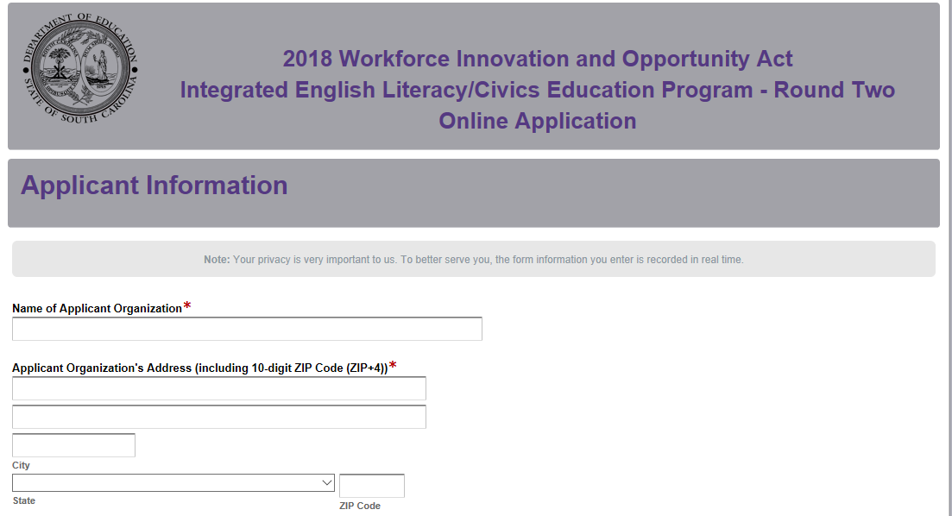
Select the type of applicant and then provide the phone number, Web site address, DUNS number, and TIN. Also select the program(s) for which the organization is applying.
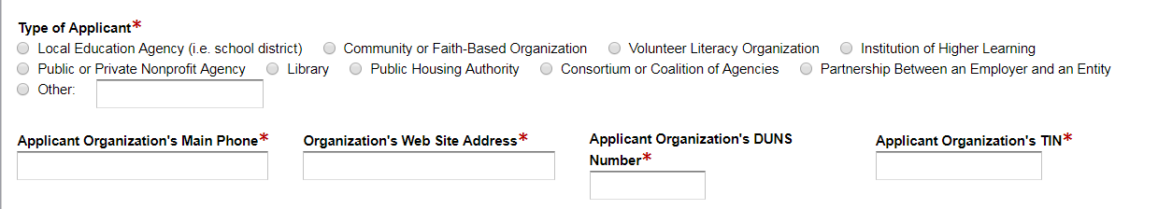
Indicate whether or not the applicant is registered and active with SAM. If the applicant does not have an active SAM registration, the following message will be displayed. See pages 5–6 for information on registering in SAM or updating a registration to comply with 2 CFR Part 25.
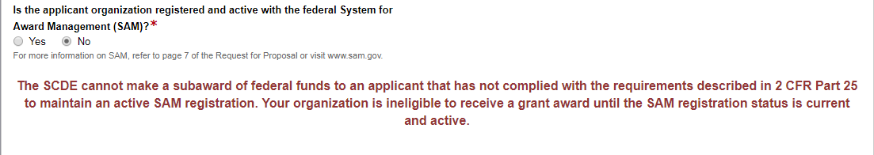

If the applicant selects “Yes” to indicate that their SAM registration is active, enter the date the current SAM registration expires.

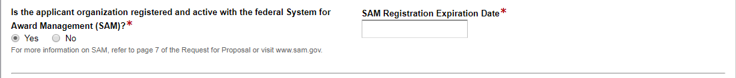
An applicant must demonstrate past effectiveness by providing performance data on its record of improving the skills of eligible individuals, particularly eligible individuals, particularly limited English proficient individuals who have low levels of literacy, in the content domains of reading, writing, mathematics, and ELA. Answer the questions below and include the appropriate documentation in the Application Attachments section of the form.
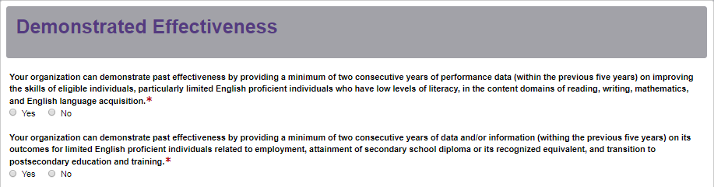
Enter the contact information for the authorized official who has the authority to enter into legally binding contractual agreements on behalf of the applicant entity. The name, as entered, must match the authorized official’s name on the Certification Signature Page. Indicate whether the authorized official will serve as the primary contact for the IEL/CE subgrant program. The authorized official will receive the confirmation email of submission.
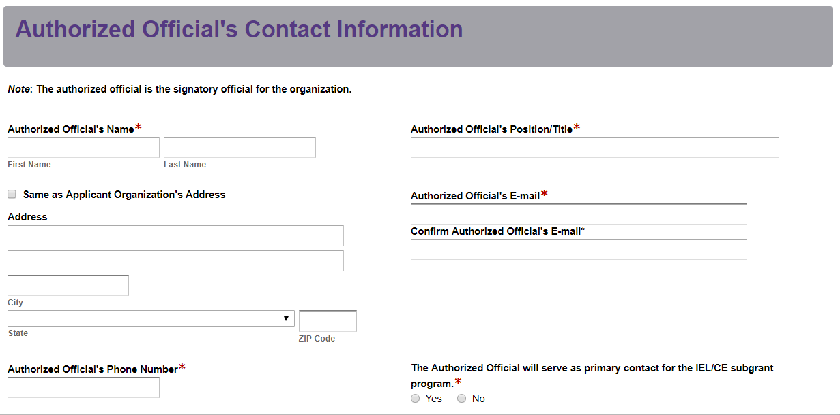
If the authorized official will not serve as the primary contact for the IEL/CE subgrant program, enter the contact information for the IEL/CE subgrant lead.
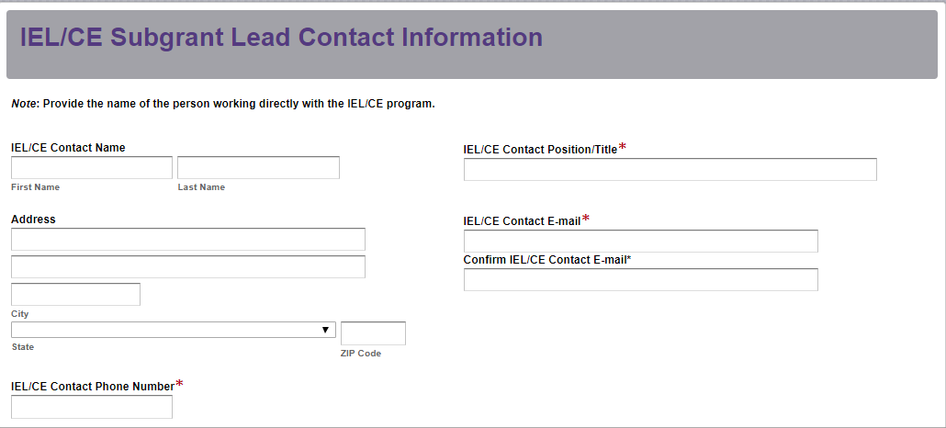
Provide the financial official’s contact information. The name, as entered, must match the financial official’s name on the Certification Signature Page.
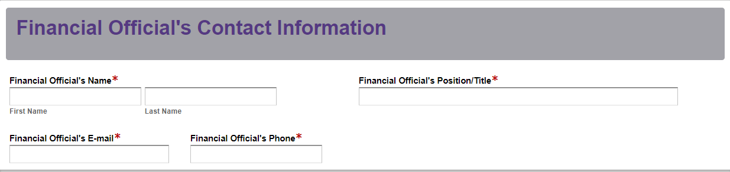
Enter the total number of staff (both full and part-time) who will be charged to this subgrant. Select all activities and services your program will provide. Check the counties to be served and indicate which LWDB(s) is associated with your IEL/CE program.

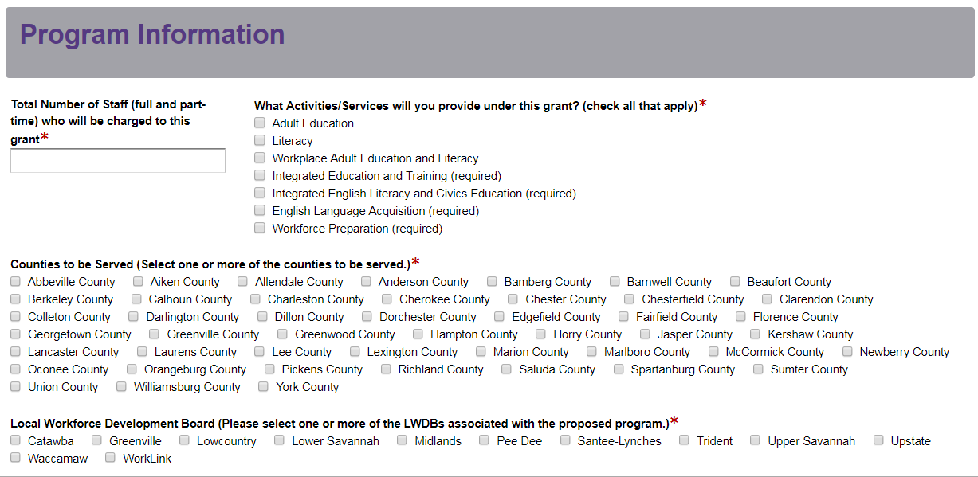
Enter the line item totals for subgrant funds requested for year one. The Total Program Costs field will automatically calculate.
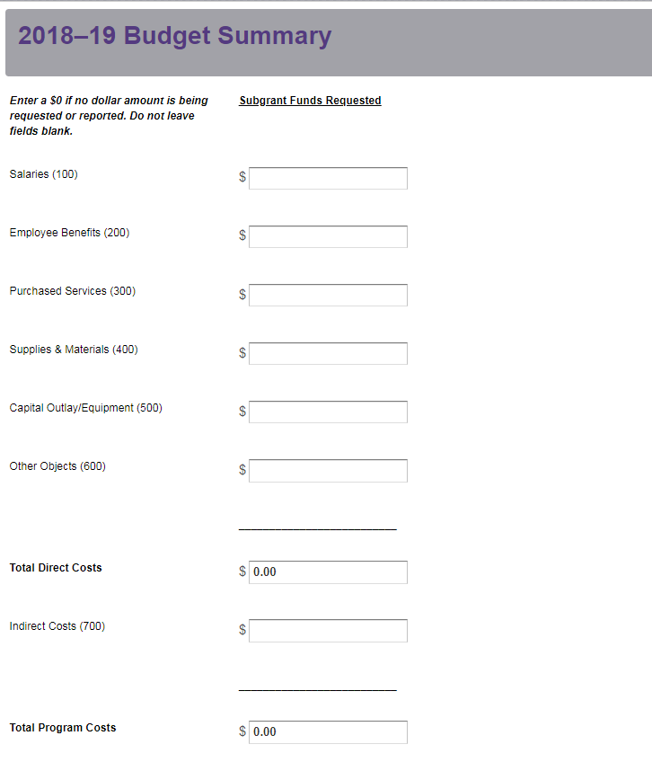
Enter the primary applicant organization’s indirect cost rate percentage approved by the cognizant agency.
Prepare each of the application attachments (i.e., the Program Abstract, the Application Narrative, the Budget Planning Form and Budget Narrative, and the Appendices) following the preceding instructions in this RFP. Ensure that each attachment is saved in the proper format as either a PDF or Excel document. Pay close attention to attachments that must be scanned together into a single document. The online application will only allow one document to be uploaded for each attachment.

Upload the attachments where indicated in the following screenshot. All attachments are required; you will not be able to submit the application without uploading all six documents.
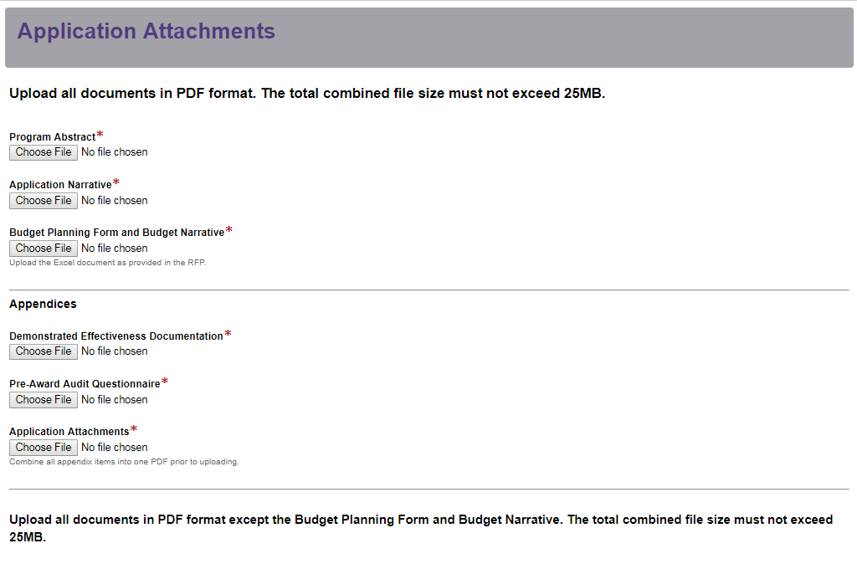
Thoroughly review the Data Review and Confirmation Page to verify that the information has been entered correctly in the online application prior to submitting. You will not be able to access the completed application form after it has been submitted. If any of the entries are incorrect, click on the "Previous" button at the bottom of each screen to return to the appropriate section(s) and reenter the correct information.
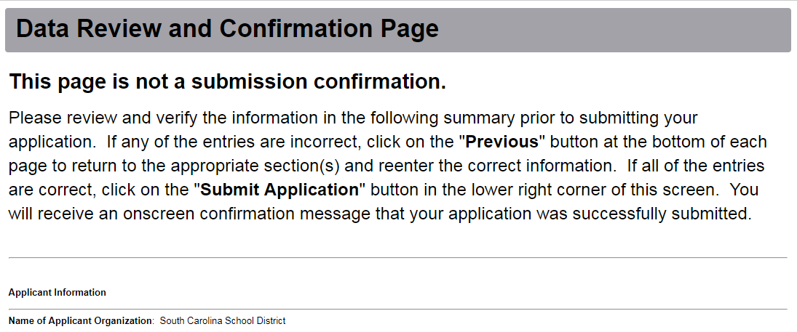
If all of the entries are correct, click on the “Submit Application” button in the lower right corner of this screen to complete the submission process.
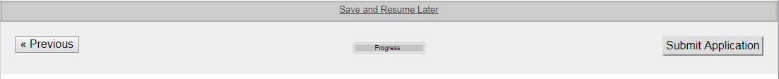
Once the application is submitted, the following message will be displayed on the screen.
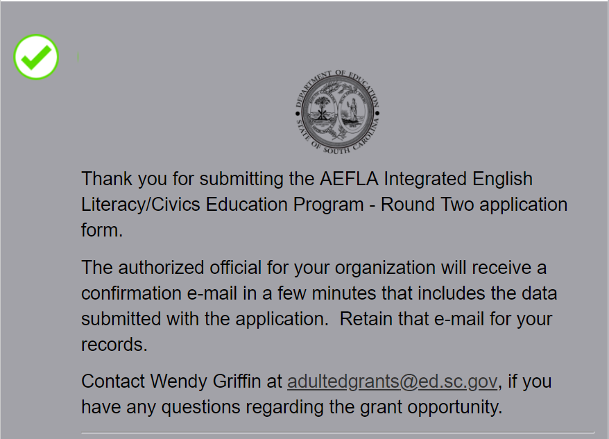
The following confirmation message will be sent to the email address provided for the authorized official.
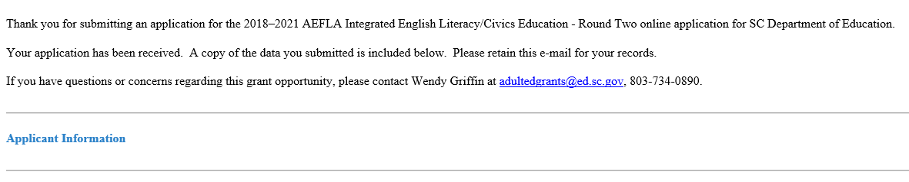
If the authorized official does not receive a confirmation email, then the application did not successfully upload. You must go back and resubmit the entire online form, including all attachments, in order for your application to be considered for funding. Only the most recently submitted application will be reviewed.

An email confirmation that an application was successfully submitted does not account for the quality of the uploaded documents or the completeness of the online form. The confirmation email only notifies you that the online application has been submitted. Applicants are responsible for ensuring that the information entered in the online form, including all attachments, is accurate and complete in order for the application to be reviewed and considered for funding.

Appendix A: Definitions of Terms Used

Administrative Costs—Costs incurred in connection with the following activities:
      - Planning;
      - Administration, including carrying out performance accountability requirements;
      - Professional development;
      - Providing adult education and literacy services in alignment with local workforce plans, including promoting co-enrollment in programs and activities under Title I, as appropriate; and
      - Carrying out the one-stop partner responsibilities described in §463.420, including contributing to the infrastructure costs of the one-stop delivery system.
(Authority: 29 U.S.C. 3323, 3322, 3151)

Adult Basic Education (ABE)—A program of instruction designed for adults who lack competence in reading, writing, speaking, problem solving, or computation at a level necessary to function in society, on a job, or in the family. ABE includes curriculum and instruction to help students progress within educational functioning levels 1 to 4 or grade zero through the eighth-grade competency level, as determined by Tests of Adult Basic Education (TABE).

Adult Education—Academic instruction and education services below the postsecondary level that increase an individual’s ability to:
      - read, write, and speak in English and perform mathematics or other activities necessary for the attainment of a secondary school diploma or its recognized equivalent;
      - transition to postsecondary education and training; and
      - obtain employment.

Adult Education and Literacy Activities—Programs, activities, and services that include adult education, literacy, workplace adult education and literacy activities, family literacy activities, English language acquisition activities, integrated English literacy and civics education, workforce preparation activities, or integrated education and training.

Adult Secondary Education Program (ASE)—A program of instruction designed for adults who have some literacy skills and can function in everyday life, but who are not proficient or do not have a certificate of graduation or its equivalent from a secondary school. ASE includes curriculum and instruction to help students progress within educational functioning levels 5 to 6 or ninth-grade through the twelfth-grade competency level, as determined by TABE.

Americans with Disabilities Act of 1990 (ADA)—An Act that prohibits discrimination and ensures equal opportunity for persons with disabilities in employment, state and local government services, public accommodations, commercial facilities, and transportation. It also mandates the establishment of TDD/telephone relay services. The ADA is codified at 42 U.S.C. 12101 et seq. On July 15, 2016, the Final Rule was signed revising the ADA title II and III regulations to implement the requirements of the ADA Amendments Act of 2008. The Final Rule was published in the Federal Register on August 11, 2016, and took effect on October 11, 2016. Congress enacted the ADA Amendments Act to make a number of significant changes to the meaning and interpretation of the ADA definition of “disability” to ensure that the definition of disability would be broadly construed and applied without extensive analysis. Additional information about the ADA can be accessed at the U.S. Department of Justice’s Americans with Disabilities website.

Applicant—The entity or organization that meets the definition of eligible provider (see below) and is therefore eligible to apply for funds offered under this RFP. If the application is approved, the “applicant” becomes a subgrantee.

Basic Skills Deficient—A youth who has English reading, writing, or computing skills at or below the 8th grade level on a generally accepted standardized test; or a youth or adult who is unable to compute or solve problems, or read, write, or speak English, at a level necessary to function on the job, in the individual’s family, or in society.

Career Pathway—A career pathway is a combination of rigorous and high-quality education, training, and other services that—
      - aligns with the skill needs of industries in the economy of the state or regional economy involved;
      - prepares an individual to be successful in any of a full range of secondary or postsecondary education options, including apprenticeships registered under the Act of August 16, 1937 (commonly known as the National Apprenticeship Act; 50 Stat. 664, chapter 663; 29 U.S.C. 50 et seq.) (referred to individually in this Act as an ‘‘apprenticeship,’’ except in section 171);
      - includes counseling to support an individual in achieving the individual’s education and career goals;
      - includes, as appropriate, education offered concurrently with and in the same context as workforce preparation activities and training for a specific occupation or occupational cluster;
      - organizes education, training, and other services to meet the particular needs of an individual in a manner that accelerates the educational and career advancement of the individual to the extent practicable;
      - enables an individual to attain a secondary school diploma or its recognized equivalent, and at least 1 recognized postsecondary credential; and
      - helps an individual enter or advance within a specific occupation or occupational cluster.

Cognizant Agency—The entity responsible for negotiating indirect cost rate proposals with applicant organizations. The SCDE serves as the cognizant agency for all public school districts in South Carolina.

Collaborative Partner—An organization that provides routine, regular, and ongoing services to the program as outlined in a signed memorandum of agreement (e.g., the regular use of facilities and equipment, mentors/tutors). A collaborative partner plays a critical role in sustaining the program as subgrant funds decrease.

Concurrent enrollment or co-enrollment—Enrollment by an eligible individual in two or more of the six core programs administered under the WIOA.
Contextualized Instruction—A set of teaching, learning and assessment practices that are aimed directly at developing the skills and knowledge that adults need to deal with specific situations or perform specific tasks, and that they have identified as important and meaningful to themselves “right now” in their everyday lives. Rather than focus only on the possession of basic skills and knowledge, contextualized instruction focuses on the active application of those skills and that knowledge “in a context.” This context should be as “real-world” as is feasible.

Contextualized instruction is also an instructional strategy that integrates the teaching of literacy skills and job content to move learners more successfully and quickly toward their educational and employment goals.

Core Program/Partner—A program/partner authorized under a core program provision. Core program provisions include:
- Chapters 2 and 3 of subtitle B of Title I of the WIOA (relating to youth workforce investment activities and adult and dislocated worker employment and training activities);
- Title II of the WIOA (relating to adult education and literacy activities);
- Sections 1 through 13 of the Wagner-Peyser Act (29 U.S.C. 49 et seq.) (relating to employment services); and
- Title I of the Rehabilitation Act of 1973 (29 U.S.C. 720 et seq.), other than section 112 or part C of that title (29 U.S.C. 732, 741) (relating to vocational rehabilitation services).

Demonstrated Effectiveness—For an organization to be eligible to apply for a subgrant under AEFLA, the organization must be able to demonstrate effectiveness in providing adult education and literacy activities. Demonstrated effectiveness is a requirement for an organization to be an eligible provider (i.e., eligible applicant) to receive AEFLA funds.
According to 34 CFR Part 463.24, an eligible provider must demonstrate past effectiveness by providing performance data on its record of improving the skills of eligible individuals, particularly eligible individuals who have low levels of literacy, in the content domains of reading, writing, mathematics, English language acquisition, and other subject areas relevant to the services contained in the State's application for funds. An eligible provider must also provide information regarding its outcomes for participants related to employment, attainment of secondary school diploma or its recognized equivalent, and transition to postsecondary education and training. There are two ways in which an eligible provider may meet these requirements:
        - An eligible provider that has been funded under title II of WIOA must provide performance data required under section 116 to demonstrate past effectiveness.
        - An eligible provider that has not been previously funded under title II of the Act must provide performance data to demonstrate its past effectiveness in serving basic skills deficient eligible individuals, including evidence of its success in achieving outcomes listed above.
(Authority: 29 U.S.C. 3272(5))

Deobligation—The downward adjustment of the obligations recorded in a subgrant award document. It is caused by factors such as (1) termination of part of the program, (2) reduction in material prices, (3) cost savings, or (4) correction of recorded amounts.

Digital Literacy—Skills associated with using technology to enable users to find, evaluate, organize, create, and communicate information.

Educational Functioning Level (EFL)—The levels at which students are placed based on their ability to perform literacy-related tasks in specific content areas. Each level describes a set of skills and competencies that students entering at that level can do in the areas of reading, writing, numeracy, speaking, listening, and functional and workplace areas. There are four levels for adult basic education (ABE), two for adult secondary education (ASE), and six levels for English Second Language (ESL).

Educational Functioning Levels for Adult Education
Adult Basic Education (ABE) Levels
Level 1: Beginning Literacy
Level 2: Beginning Basic
Level 3: Intermediate Low
Level 4: Intermediate High

Adult Basic Education (ABE) Levels
Level 5: Low Adult Secondary
Level 6: High Adult Secondary

English Second Language (ESL)
Level 1: ESL Beginning Literacy
Level 2: Low ESL Beginning
Level 3: High ESL Beginning
Level 4: ESL Intermediate Low
Level 5: ESL High Intermediate
Level 6: ESL Advanced

Educational Functioning Level (EFL) Gain—Educational functioning level gain is one of two ways that adult education participants can demonstrate measurable skill gains; the other way being receipt of a secondary credential. An EFL gain can be demonstrated in one of three ways: pre-testing/post-testing; completion of a Carnegie credit; or enrollment in postsecondary after adult education program exit.

Eligible Agency—The sole entity or agency in a state or an outlying area responsible for administering or supervising policy for adult education and literacy activities in the state or outlying area, respectively, consistent with the law of the state or outlying area, respectively. In South Carolina, the SCDE Office of Adult Education is the eligible agency.

Eligible Individual—An individual who meets the following criteria:
  - is at least eighteen (18) years of age unless there is local school board or school district superintendent approval;
  - is not enrolled or required to be enrolled in secondary school under state law; and
  - either—
    - is basic skills deficient;
    - does not have a secondary school diploma or its recognized equivalent, and has not achieved an equivalent level of education; or
    - is an ELL.

Eligible Provider—An organization that has demonstrated effectiveness in providing adult education and literacy activities that may include—
  - a local educational agency (LEA, i.e., school district);
  - a community-based organization or faith-based organization;
  - a volunteer literacy organization;
  - an institution of higher education;
  - a public or private nonprofit agency;
  - a library;
  - a public housing authority;
  - a nonprofit institution that is not described in any of subparagraphs (a) through (g) and has the ability to provide adult education and literacy activities to eligible individuals;
  - a consortium or coalition of the agencies, organizations, institutions, libraries, or authorities described in any of subparagraphs (a) through (h); and
  - a partnership between an employer and an entity described in any of subparagraphs (a) through (i).

English as Second Language (ESL)—A program or class that focuses on instruction for students whose primary language or language of the home is other than English and provides English language support to develop reading, writing and speaking skills.

English Language Acquisition (ELA) Program—A program of instruction designed to help eligible individuals who are ELLs achieve competence in reading, writing, speaking, and comprehension of the English language; and that leads to attainment of a secondary school diploma or its recognized equivalent; and transition to postsecondary education and training or employment.

English Language Learner (ELL)—An eligible individual who has limited ability in reading, writing, speaking, or comprehending the English language, and whose native language is a language other than English; or who lives in a family or community environment where a language other than English is the dominant language.

Essential Components of Reading Instruction—As defined in section 1208 of the Elementary and Secondary Education Act of 1965 (20 U.S.C. 6368), the term essential components of reading instruction means explicit and systematic instruction in phonemic awareness; phonics; vocabulary development; reading fluency, including oral reading skills; and reading comprehension strategies.

Final Annual Report (FAR)—the IEL/CE required annual report on performance and progress with subgrant funds.

High School Diploma (HSD)⎯See S.C. Reg. § 43-234 – Defined Program, Grades 9-12 and Graduation Requirements for requirements for earning a South Carolina high school diploma.

High School Equivalency Diploma (HSED)⎯See S.C. Reg. § 43-259 – Adult Education for requirements for earning a South Carolina high school equivalency diploma. In South Carolina, the approved high school equivalency diploma exams are the General Education Development (GED) and Test Assessing Secondary Completion (TASC).

Individuals with Disabilities⎯More than one individual with a disability. An individual with a disability as defined in section 3 of the Americans with Disabilities Act of 1990 (42 U.S.C. 12102): disability means, with respect to an individual, a physical or mental impairment that substantially limits one or more major life activities of such individual; a record of such an impairment; or being regarded as having such an impairment. According to the Final Rule Implementing the ADA Amendments Act of 2008, physical or mental impairment includes, but is not limited to, contagious and noncontagious diseases and conditions such as the following: orthopedic, visual, speech and hearing impairments, and cerebral palsy, epilepsy, muscular dystrophy, multiple sclerosis, cancer, heart disease, diabetes, intellectual disability, emotional illness, dyslexia and other specific learning disabilities, Attention Deficit Hyperactivity Disorder, Human Immunodeficiency Virus infection (whether symptomatic or asymptomatic), tuberculosis, drug addiction, and alcoholism.

According to the Individuals with Disabilities Education Act , a child with a disability means a child evaluated in accordance with 34 CFR Part 300.304 through §300.311 as having an intellectual disability, a hearing impairment (including deafness), a speech or language impairment, a visual impairment (including blindness), a serious emotional disturbance, an orthopedic impairment, autism, traumatic brain injury, and other health impairment, a specific learning disability, deaf-blindness, or multiple disabilities, and who, by reason thereof, needs special education and related services.

Individuals with Disabilities Education Act (IDEA)⎯A law that makes available a free appropriate public education to eligible children with disabilities throughout the nation and ensures special education and related services to those children. IDEA governs how states and public agencies provide early intervention, special education, and related services to eligible infants, toddlers, children, and youth with disabilities. Infants and toddlers, birth through age two, with disabilities and their families receive early intervention services under IDEA Part C. Children and youth ages three through 21 receive special education and related services under IDEA Part B. Additional information about IDEA can be accessed at the U.S. IDEA website.

Integrated Education and Training (IET)—A service approach that provides adult education and literacy activities concurrently and contextually with workforce preparation activities and workforce training for a specific occupation or occupational cluster for the purpose of educational and career advancement.

Integrated English Literacy and Civics Education (IEL/CE)—Education services provided to ELLs who are adults, including professionals with degrees and credentials in their native countries, that enables such adults to achieve competency in the English language and acquire the basic and more advanced skills needed to function effectively as parents, workers, and citizens in the United States. Such services shall include instruction in literacy and ELA and instruction on the rights and responsibilities of citizenship and civic participation, and may include workforce training.

Literacy—An individual’s ability to read, write, and speak in English, compute, and solve problems, at levels of proficiency necessary to function on the job, in the family of the individual, and in society.

Local Educational Agency (LEA)—A school district as defined in section 9101 of the Elementary and Secondary Education Act of 1965 (20 U.S.C. 7801), an LEA is a public board of education or other public authority legally constituted within a state for either administrative control or direction of, or to perform a service function for, public elementary schools or secondary schools in a city, county, township, school district, or other political subdivision of a state, or of or for a combination of school districts or counties that is recognized in a state as an administrative agency for its public elementary schools or secondary schools.

Measurable Skill Gain (MSG)—A WIOA-required indicator used to demonstrate participants’ progress toward achieving a credential or employment. For adult education programs, participants can demonstrate a measurable skill gain through educational functioning level gain and receipt of a secondary credential. See pages 96–97 for more information.

Memorandum of Agreement (MOA)—A document signed by the authorized representative(s) of each collaborative partner that clearly specifies the role, services, contributions, expertise, and funding for each partner. An MOA may also be known as a Memorandum of Understanding (MOU).

National Reporting System (NRS)—The outcome-based, accountability system for the state-administered, federally funded adult education program. The NRS includes student measures to describe adult education students, program participation and assessment of the impact of adult education instruction, methodologies for collecting the measures, reporting forms and procedures, and training and technical assistance activities to help states collect the measures.

One-stop Delivery System—A seamless customer-focused service delivery network that brings together workforce development, educational, and other human resource services. The one-stop delivery system enhances access to the programs' services and improves long-term employment outcomes for individuals receiving assistance. One-stop partners administer separately funded programs as a set of integrated streamlined services to customers. Title I of WIOA assigns responsibilities at the local, state, and federal level to ensure the creation and maintenance of a one-stop delivery system that enhances the range and quality of education and workforce development services that employers and individual customers can access. The system must include at least one comprehensive physical center in each local area as described in 34 CFR Part 463.305. The system may also have additional arrangements to supplement the comprehensive center as described in §463.300.
One-Stop Partner—Within the one-stop delivery system, there are required and additional partners. Required One-Stop Partners: Section 121(b)(1)(B) of the WIOA identifies the entities that are required partners in the local one-stop delivery systems. Entities that carry out the following programs are identified by the WIOA as required partners in the workforce system:
- Adult, Dislocated Worker, and Youth Programs
- Adult Education and Family Literacy Act Programs
- Wagner-Peyser Employment Services Programs
- Rehabilitation Programs for Individuals with Disabilities
- Post-Secondary Career and Technical Education Programs (Perkins)
- Community Services Block Grant Employment and Training Activities
- Native American Programs
- HUD Employment and Training Activities
- Job Corps Programs
- Veterans Employment and Training Programs
- Migrant and Seasonal Farmworker Programs
- Senior Community Service Employment Programs
- Trade Adjustment Assistance Programs
- Unemployment Compensation Programs
- YouthBuild Programs
- Temporary Assistance for Needy Families (TANF) Programs
- Second Chance Act Programs

Additional One-Stop Partners: Other entities that carry out a workforce development program, including federal, state, or local programs and programs in the private sector, may serve as additional partners in the one-stop delivery system if the local workforce development board and chief elected official(s) approve the entity's participation.
Additional partners may include, but are not limited to:
- Employment and training programs administered by the Social Security Administration, including the Ticket to Work and Self-Sufficiency Program;
- Employment and training programs carried out by the Small Business Administration;
- Supplemental Nutrition Assistance Program (SNAP) employment and training programs;
- Client Assistance Program authorized under Section 112 of the Rehabilitation Act of 1973;
- Programs authorized under the National and Community Service Act of 1990; and
- Other appropriate Federal, state, or local programs, including, but not limited to, employment, education, and training programs provided by public libraries or in the private sector.

Past Effectiveness—In awarding subgrants for adult education and literacy activities to eligible providers, the eligible agency (SCDE) must consider the degree to which the eligible provider (applicant) is responsive to all 13 considerations, as defined by WIOA Section 231(e). The third consideration under this section relates to an eligible provider’s past effectiveness in providing adult education and literacy activities (WIOA Section 231(e)(3)). As the eligible agency awarding AEFLA funds in the state, the SCDE should consider the degree to which the eligible provider has been effective, in the past, in improving the literacy of eligible individuals, to meet state-adjusted levels of performance for the primary indicators of performance described in Section 116, especially with respect to eligible individuals who have low levels of literacy. Also see 34 CFR Part 463.20.

Past effectiveness is not the same as demonstrated effectiveness. Past effectiveness is a consideration for awarding IEL/CE funding. Demonstrated effectiveness is a requirement for an organization to be an eligible provider (i.e., eligible applicant) to receive IEL/CE funds.

Postsecondary Educational Institution—An institution of higher education that provides not less than a two-year program of instruction that is acceptable for credit toward a bachelor’s degree; a tribally controlled college or university; or a nonprofit educational institution offering certificate or apprenticeship programs at the postsecondary level.

Primary Applicant—The organization that serves as the fiscal agent for the proposed program. The primary applicant is responsible for the programmatic and fiduciary management of the subgrant.

Progress—Progress occurs when an adult learner makes advances or gains within the educational functioning level.

Receipt of a Secondary Credential—Receipt of a secondary credential is one of two ways that adult education participants can demonstrate measurable skill gains; the other way being educational gain. Adult education participants can gain a secondary credential by obtaining passing scores on state-approved high school equivalency tests or obtaining a secondary diploma. The SCDE Office of Adult Education has approved the following high school equivalency tests: General Educational Development (GED) and Test Assessing Secondary Completion (TASC).

Test of Adult Basic Education (TABE)—A standardized testing instrument designed for assessment purposes and to identify an adult learner’s educational functioning level.

Workforce Innovation and Opportunity Act (WIOA)—Legislation signed into law in July of 2014, (WIOA— P.L.112-128) that reforms federal employment, adult education, and vocational rehabilitation programs to create an integrated, "one-stop" system of workforce investment and education activities for adults and youth. Entities that carry out activities assisted under the AEFLA are mandatory partners in this one-stop delivery system.

Workplace Adult Education and Literacy Activities—Adult education and literacy activities offered by an eligible provider in collaboration with an employer or employee organization at a workplace or an off-site location that is designed to improve the productivity of the workforce.

Workforce Preparation Activities—Activities, programs, or services designed to help an individual acquire a combination of basic academic skills, critical thinking skills, digital literacy skills, and self-management skills, including competencies in using resources, using information, working with others, understanding systems, and obtaining skills necessary for successful transition into and completion of postsecondary education or training, or employment.

Appendix B: Selection Criteria and Reviewers’ Scoring Rubric

Selection Criteria

A total of 385 points is available to applications that meet the maximum score for each selection criteria. While the budget is assigned zero (0) points, the budget remains a critical component of the entire application. An application with an incomplete budget will not be funded.

Narrative Sections |  | Points Available
Consideration 1 | Commitment to serve individuals in need | 40
Consideration 2 | Serving individuals with disabilities | 20
Consideration 3 | Past effectiveness | 40
Consideration 4 | One-stop system alignment | 30
Considerations 5 & 6 | Evidence-based instructional practices | 40
Consideration 7 | Activities implementation, technology use and delivery method | 40
Consideration 8 | Contextualized instruction | 35
Consideration 9 | Instructor and staff qualifications | 20
Considerations 10 & 11 | Partner coordination, support services and service flexibility | 40
Consideration 12 | Performance management and outcomes | 40
Consideration 13 | English language acquisition and civics education | 40
TOTAL |  | 385

Each section of an application narrative will be assigned a score by reviewers using the scoring rubric for IEL/CE, which summarizes the required elements of the application narrative and the point ranges assigned to each section.

Appendix B

Reviewers Scoring Rubric

Consideration 1. Commitment to Serve the Individuals in Need
The SCDE will consider the degree to which the applicant (eligible provider) would be responsive to—
- regional needs as identified in the local plan under WIOA section 108 (local workforce development board’s plan)
- serving individuals in the community who were identified in the specific local plan as most in need of adult education and literacy activities, including individuals—
- who have low levels of literacy skills or
- who are English language learners (ELLs).
IEL/CE—Consideration 1

1.a. Describe the population to be served under the IEL/CE program using local and regional demographics that demonstrates the need for an IEL/CE program in the service delivery area. The description should include, but not be limited to, levels of educational attainment, including data on individuals with low literacy levels and ELLs in the community, and labor market information including current unemployment data, short- and long-term employer needs, high school graduation rates, and postsecondary enrollment and completion. Cite sources.
The applicant must  - describe the population to be served under the IEL/CE program using local and regional demographics that demonstrates the need for an IEL/CE program in the service delivery area;  - provide a description that includes, but is not limited to  - levels of educational attainment, including data on individuals with low literacy levels and ELLs in the community;  - labor market information including current unemployment data, short- and long-term employer needs, high school graduation rates;  - postsecondary enrollment and completion; and  - cite sources. |  | Acceptable |  |  |  | Fully Meets—7–10 points  Applicant provides a narrative that fully describes all required items.
Adequate/Meets—4–6 points
Applicant provides a narrative that moderately describes all required items.
 |  | Not  Acceptable |  |  |  | Limited/Approaches—2–3 points  Applicant provides a narrative that is limited or unclear in describing all required items.
Inadequate—0–1 points
Applicant provides a narrative that does not adequately describe all required items.
Reviewer’s Comments
IEL/CE—Consideration 1

1.b. Identify the local workforce development plan with which the proposed IEL/CE program will align. What are the proposed education and workforce priorities for the program based on the local plan and community demographics?
The applicant must  - identify the local workforce development plan with which the proposed program will align, and  - include the proposed education and workforce priorities for the program based on the local plan and community demographics. |  |  | Acceptable |  |  | Fully Meets—4–5 points  Applicant provides a narrative that fully addresses all required items.
Adequate/Meets—2–3 points
Applicant provides a narrative that moderately addresses all required items.
 |  |  | Not  Acceptable |  |  | Limited/Approaches—1 points  Applicant provides a narrative that is limited or unclear in addressing all required items.
Inadequate—0 points
Applicant provides a narrative that does not adequately address all required items.
Reviewer’s Comments
IEL/CE—Consideration 1

1.c. List the adult education and literacy activities that will be provided to address the needs of the ELL population to be served. Explain how the program will meet the needs of the community through the identified adult education and literacy activities.
The applicant must  - list the adult education and literacy activities that will be provided to address the needs of the ELL population who will be served in the community; and  - explain how the program will meet the needs of the community through the identified adult education and literacy activities. |  |  | Acceptable |  |  | Fully Meets—7–10 points  Applicant provides a narrative that fully addresses all required items.
Adequate/Meets—4–6 points
Applicant provides a narrative that moderately addresses all required items.
 |  |  | Not  Applicable |  |  | Limited/Approaches—2–3 points  Applicant provides a narrative that is limited or unclear in addressing all required items.
Inadequate—0–1 point
Applicant provides a narrative that does not adequately address all required items.
Reviewer’s Comments
IEL/CE—Consideration 1

1.d. Outline the program’s recruitment and retention action plan for year one by completing the Recruitment and Retention Action Plan form. Include specific activities that will be implemented to recruit and retain individuals with limited English proficiency.

The applicant must  - outline the program’s recruitment and retention action plan for year one by completing the Recruitment and Retention Action Plan form; and  - include specific activities that will be implemented to recruit and retain individuals with limited English proficiency. | Acceptable |  |  | Fully Meets—4–5 points  Applicant provides an action plan that fully addresses all required items.
Adequate/Meets—2–3 points
Applicant provides an action plan that moderately addresses all required items.
 | Not  Acceptable |  |  | Limited/Approaches—1 point  Applicant provides an action plan that is limited or unclear in addressing all required items.
Inadequate—0 points
Applicant provides an action plan that does not adequately address all required items.
Reviewer’s Comments
IEL/CE—Consideration 1

1.e. Describe how the program will provide services to meet the specific needs of the target populations including the particular needs of
a. individuals with limited English proficiency,
b. individuals pursuing citizenship, and
c. individuals with multiple barriers to employment.
The applicant must describe how the program will provide services to meet the specific needs of the target populations including the particular needs of  a. individuals with limited English proficiency,  b. individuals pursuing citizenship, and  c. individuals with multiple barriers to employment. | Acceptable |  |  | Fully Meets—7–10 points  Applicant provides an action plan that fully describes all required items.
Adequate/Meets—4–6 points
Applicant provides an action plan that moderately describes all required items.
 | Not  Acceptable |  |  | Limited/Approaches—2–3 points  Applicant provides an action plan that is limited or unclear in describing all required items.
Inadequate—0–1 point
Applicant provides an action plan that does not adequately describe all required items.
Reviewer’s Comments
Consideration 2. Serving Individuals with Disabilities
The SCDE will consider the ability of the applicant/eligible provider to serve eligible individuals with disabilities, including eligible individuals with learning disabilities.
IEL/CE—Consideration 2

2.a. Describe how the applicant organization will identify students with disabilities and the organization’s ability to serve individuals with disabilities (i.e., physical, mental, emotional, and learning). Include a copy of the organization’s policies to accommodate students and staff with disabilities as an appendix item.
The applicant must  - describe how their organization will identify students with disabilities and the organization’s ability to serve individuals with disabilities (i.e., physical, mental, emotional, and learning), and  - provide a copy of the organization’s policies to accommodate students and staff with disabilities as an appendix item. |  | Acceptable |  |  | Fully Meets—6–7 points  Applicant provides a narrative that fully addresses all required items.
Adequate/Meets—4–5 points
Applicant provides a narrative that moderately addresses all required items.
 |  | Not Acceptable |  |  | Limited/Approaches—2–3 points  Applicant provides a narrative that is limited or unclear in addressing all required items.
Inadequate—0–1 points
Applicant provides a narrative that does not adequately address all required items.
Reviewer’s Comments
IEL/CE—Consideration 2

2.b. What steps will the organization take to promote the inclusion of students with disabilities and ensure equitable access to program activities and services?
The applicant must describe the steps their organization will take to promote the inclusion of students with disabilities and ensure equitable access to program activities and services. | Acceptable | Fully Meets—6–7 points  Applicant provides a narrative that fully describes all required items.
 | Acceptable | Adequate/Meets—4–5 points  Applicant provides a narrative that moderately describes all required items.
 | Not Acceptable | Limited/Approaches—2–3 points  Applicant provides a narrative that is limited or unclear in describing all required items.
 | Not Acceptable | Inadequate—0–1 point  Applicant provides a narrative that does not adequately describe all required items.
Reviewer’s Comments
IEL/CE—Consideration 2

2.c. How will your organization collaborate and partner with other organizations and agencies to assist and support serving eligible individuals with disabilities?
The applicant must describe how their organization will collaborate and partner with other organizations and agencies to assist and support serving eligible individuals with disabilities. | Acceptable | Fully Meets—5–6 points  Applicant provides a narrative that fully describes the required item.
 | Acceptable | Adequate/Meets—3–4 points  Applicant provides a narrative that moderately describes the required item.

 | Not Acceptable | Limited/Approaches—1–2 points  Applicant provides a narrative that is limited or unclear in describing the required item.
 | Not Acceptable | Inadequate—0 points  Applicant provides a narrative that does not adequately describe the required item.
Reviewer’s Comments
Consideration 3. Past Effectiveness
The SCDE will consider past effectiveness of the applicant/eligible provider in improving the literacy of eligible individuals to meet state-adjusted levels of performance for the primary indicators of performance described in WIOA section 116, especially with respect to eligible individuals who have low levels of literacy.
IEL/CE—Consideration 3

3.a. Describe the applicant organization’s previous experiences, past successes, and unique qualifications to serve ELLs in need of adult education and literacy services.
The applicant must describe the organization’s previous experiences, past successes, and unique qualifications to serve ELLs in need of adult education and literacy services. | Acceptable | Fully Meets—12–15 points  Applicant provides a narrative that fully describes all required items.
 | Acceptable | Adequate/Meets—8–11 points  Applicant provides a narrative that moderately describes all required items.
 | Not Acceptable | Limited/Approaches—4–7 points  Applicant provides a narrative that is limited or unclear in describing all required items.
 | Not Acceptable | Inadequate—0–3 points  Applicant provides a narrative that does not adequately describe all required items.
Reviewer’s Comments
IEL/CE—Consideration 3

3.b. Discuss how the applicant organization has effectively served eligible ELLs in the past. As a part of your explanation, include the following:
- A minimum of two consecutive years of performance data (within the previous five years) to demonstrate your organization’s record of improving the skills of eligible individuals, particularly eligible individuals who have low levels of literacy, in the content domains of
- reading,
- writing,
- mathematics, and
- English language acquisition.
- A table to reflect the two consecutive years of performance data as a part of the narrative or complete the Past Effectiveness Chart. If completing the Past Effectiveness Chart, reference it in your response and include it as an appendix item.
- The number of individuals served during each of the selected two years.
- The timeframe of the data (e.g., January 2015–December 2015, August 2015–July 2016).
The applicant must discuss how the applicant organization has effectively served eligible ELLs in the past, including:  - A minimum of two consecutive years of performance data (within the previous five years) to demonstrate your organization’s record of improving the skills of eligible individuals, particularly eligible individuals who have low levels of literacy, in the content domains of  - reading,  - writing,  - mathematics, and  - English language acquisition;  - A table to reflect the two consecutive years of performance data as a part of the narrative or a reference to the Past Effectiveness Chart with the chart included as an appendix item;  - The number of individuals served during each of the selected two years; and  - The timeframe of the data. | Acceptable | Fully Meets—12–15 points  Applicant provides a narrative that fully describes all required items.
 | Acceptable | Adequate/Meets—8–11 points  Applicant provides a narrative that moderately describes all required items.
 | Not Acceptable | Limited/Approaches—4–7 points  Applicant provides a narrative that is limited or unclear in describing all required items.
 | Not Acceptable | Inadequate—0–3 points  Applicant provides a narrative that does not adequately describe all required items.
Reviewer’s Comments
IEL/CE—Consideration 3

3.c. Discuss how the applicant organization has assisted eligible ELLs in successfully attaining a high school diploma or equivalent and transitioning to postsecondary and/or employment. As a part of your explanation, provide the following:
- Two consecutive years of performance data (within the previous five years) on the outcomes of participants, particularly eligible individuals who have low levels of literacy, related to
- employment,
- attainment of secondary school diploma or its recognized equivalent, and
- transition to postsecondary education and training.
- A table to reflect two consecutive years of performance data as a part of the narrative or complete the Past Effectiveness Chart. If completing the Past Effectiveness Chart, reference it in your response and include the chart as an appendix item.
- The number of individuals served during each of the selected two years.
- The timeframe of the data (e.g., January 2015–December 2015, August 2015–July 2016).
The applicant must  - discuss how the applicant organization has assisted eligible ELLs in successfully attaining a high school diploma or equivalent and transitioning to postsecondary and/or employment;  - provide two consecutive years of performance data (within the previous five years) on the outcomes of participants, particularly eligible individuals who have low levels of literacy, related to  - employment,  - attainment of secondary school diploma or its recognized equivalent, and  - transition to postsecondary education and training;  - provide a table to reflect two consecutive years of performance data (in the narrative or a reference to the Past Effectiveness Chart with the chart included as an appendix item;  - provide the number of individuals served during each of the selected two years; and  - provide the timeframe of the data. | Acceptable | Fully Meets—4–5 points  Applicant provides a narrative that fully describes all required items.
 | Acceptable | Adequate/Meets—2–3 points  Applicant provides a narrative that moderately describes all required items.
 | Not Acceptable | Limited/Approaches—1 point  Applicant provides a narrative that is limited or unclear in describing all required items.
 | Not Acceptable | Inadequate—0 points  Applicant provides a narrative that does not adequately describe all required items.
Reviewer’s Comments
IEL/CE—Consideration 3

3.d. Describe how the applicant organization measures the target population’s educational performance and student transition into postsecondary education, training, and/or the workforce.
The applicant must describe how the applicant organization measures the target population’s  - educational performance and  - student transition into  - postsecondary education,  - training, and/or  - the workforce. | Acceptable | Fully Meets—4–5 points  Applicant provides a narrative that fully describes all required items.
 | Acceptable | Adequate/Meets—2–3 points  Applicant provides a narrative that moderately describes all required items.
 | Not Acceptable | Limited/Approaches—1 point  Applicant provides a narrative that is limited or unclear in describing all required items.
 | Not Acceptable | Inadequate—0 points  Applicant provides a narrative that does not adequately describe all required items.
Reviewer’s Comments

Consideration 4. One-Stop System Alignment
The SCDE will consider the extent to which the applicant/eligible provider demonstrates alignment between proposed activities and services and the strategy and goals of the local plan under WIOA section 108, as well as the activities and services of the one-stop partners.
IEL/CE—Consideration 4

4.a. Describe how the applicant’s activities and services to eligible ESL students will align with the strategies and goals of the local workforce development board’s plan and the activities and services of local SC Work Center(s), core partners, and any additional one-stop partners. At a minimum, applicants should align the proposed program with the activities and services of the core partners. Complete the Partners and Partnership Coordination Chart to indicate partners and collaborative efforts that have been established or will be established with partners to meet mutual goals and strategies. Include letters of commitment or MOUs/MOAs (first page and signature page only) in the appendix.
The applicant must  - describe how activities and services to eligible ESL students will align with the strategies and goals of the local workforce development board’s plan and the activities and services of local SC Work Center(s), core one-stop partners, and any additional one-stop partners;  - align the proposed program with the activities and services of the core partners, at a minimum  - complete the Partners and Partnership Collaboration Chart to indicate partners and collaborative efforts that have been established or will be established with partners to meet mutual goals and strategies; and  - include any letters of commitment or MOUs/MOAs (first page and signature page only) in the appendix. | Acceptable | Fully Meets—12–15 points  Applicant provides a narrative that fully addresses all required items.
 | Acceptable | Adequate/Meets—8–11 points  Applicant provides a narrative that moderately addresses all required items.
 | Not Acceptable | Limited/Approaches—4–7 points  Applicant provides a narrative that is limited or unclear in addressing all required items.
 | Not Acceptable | Inadequate—0–3 points  Applicant provides a narrative that does not adequately address all required items.
Reviewer’s Comments
IEL/CE—Consideration 4

4.b. Explain your program’s processes and procedures for promoting and implementing student concurrent enrollment in WIOA Title I programs and activities as it relates to the ESL student population. Include how your organization will coordinate the referral, intake, and orientation of eligible participants into core partner programs.
The applicant must explain  - the program’s processes and procedures for promoting and implementing student concurrent enrollment in WIOA Title I programs and activities as it relates to the ESL student population, and  - how the organization will coordinate the referral, intake, and orientation of eligible participants into core partner programs. | Acceptable | Fully Meets—12–15 points  Applicant provides a narrative that fully explains all required items.
 | Acceptable | Adequate/Meets—8–11 points  Applicant provides a narrative that moderately explains all required items.
 | Not Acceptable | Limited/Approaches—4–7 points  Applicant provides a narrative that is limited or unclear in explaining all required items.
 | Not Acceptable | Inadequate—0–3 points  Applicant provides a narrative that does not adequately explain all required items.
Reviewer’s Comments
Consideration 5 & 6 Evidence-Based Instructional Practice
The SCDE will consider whether the applicant’s/eligible provider’s program—
- is of sufficient intensity and quality, and based on the most rigorous research available so that participants achieve substantial learning gains; and
- uses instructional practices that include the essential components of reading instruction.

The SCDE will consider whether the applicant’s/eligible provider’s activities, including whether reading, writing, speaking, mathematics, and English language acquisition instruction delivered by the eligible provider, are based on the best practices derived from the most rigorous research available and appropriate, including scientifically valid research and effective educational practice.
IEL/CE—Considerations 5 & 6

5. & 6.a. Describe how the proposed program design and schedule is of sufficient intensity (hours per week) and duration (number of weeks) to promote substantial learning gains of participants.
The applicant must describe how the proposed program design and schedule will be of sufficient intensity to promote substantial learning gains of participants. | Acceptable | Fully Meets—7–10 points  Applicant provides a narrative that fully describes all required items.
 | Acceptable | Adequate/Meets—4–6 points  Applicant provides a narrative that moderately describes all required items.
 | Not Acceptable | Limited/Approaches—2–3 points  Applicant provides a narrative that is limited or unclear in describing all required items.
 | Not Acceptable | Inadequate—0–1 points  Applicant provides a narrative that does not adequately describe all required items.
Reviewer’s Comments

IEL/CE—Considerations 5 & 6

5. & 6.b. Demonstrate that a variety of class opportunities (e.g., multiple class levels, purpose, employment, life-related, language-based) will be available by completing the Weekly Schedule. When completing the template, include all planned class sites. Variety of opportunities may include multiple classes/sites, specific EFL levels, and/or specific skills addressed in individual classes (e.g., conversational classes, grammar-based classes, reading/writing classes).
The applicant must  - demonstrate that a variety of class will be available,  - complete the Weekly Schedule spreadsheet, and  - include all planned class sites. | Acceptable | Fully Meets—7–10 points  Applicant provides a narrative that fully addresses all required items.
 | Acceptable | Adequate/Meets—4–6 points  Applicant provides a narrative that moderately addresses s all required items.
 | Not Acceptable | Limited/Approaches—2–3 points  Applicant provides a narrative that is limited or unclear in addressing all required items.
 | Not Acceptable | Inadequate—0–1 points  Applicant provides a narrative that does not adequately address all required items.
Reviewer’s Comments
IEL/CE—Considerations 5 & 6

5. & 6.c. Describe how instructional practices, curricula, and proposed program activities will be of sufficient quality and based on best practices derived from the most rigorous, scientifically-valid research and effective educational strategies. Include how ELLs will make substantial learning gains in reading, writing, speaking, mathematics, English language acquisition, as well as receive instruction on the rights and responsibilities of citizenship.
The applicant must describe  - how instructional practices, curricula, and proposed program activities to be used will be of sufficient quality and based on best practices derived from the most rigorous, scientifically-valid research and effective educational strategies; and  - how ELLs will make substantial learning gains in reading, writing, speaking, mathematics, English language acquisition, as well as receive instruction on the rights and responsibilities of citizenship. | Acceptable | Fully Meets—12–15 points  Applicant provides a narrative that fully describes all required items.
 | Acceptable | Adequate/Meets—8–11 points  Applicant provides a narrative that moderately describes all required items.
 | Not Applicable | Limited/Approaches—4–7 points  Applicant provides a narrative that is limited or unclear in describing all required items.
 | Not Applicable | Inadequate—0–3 points  Applicant provides a narrative that does not adequately describe all required items.
Reviewer’s Comments
IEL/CE—Considerations 5 & 6

5. & 6. d. Describe the criteria and process for evaluating program quality and instructional practices. How often will evaluations occur? Describe the plan for making adjustments and changes.
The applicant must describe  - the criteria and process for evaluating program quality and instructional practices,  - how often evaluations will occur, and  - the plan for making adjustments and changes. | Acceptable | Fully Meets—4–5 points  Applicant provides a narrative that fully describes all required items.
 | Acceptable | Adequate/Meets—2–3 points  Applicant provides a narrative that moderately describes all required items.
 | Not Applicable | Limited/Approaches—1 point  Applicant provides a narrative that is limited or unclear in describing all required items.
 | Not Applicable | Inadequate—0 points  Applicant provides a narrative that does not adequately describe all required items.
Reviewer’s Comments
Consideration 7. Activities Implementation, Technology Use, and Delivery Method
The SCDE will consider whether the applicant’s/eligible provider’s activities effectively use technology, services, and delivery systems, including distance education, in a manner sufficient to increase the amount and quality of learning and how such technology, services, and systems lead to improved performance.
IEL/CE—Consideration 7

7.a. Describe how your organization will effectively use technology products, tools, and resources with ELLs to conduct adult education and literacy activities. Address
- your organization’s plan to give access to and integrate technology into classroom instruction and the adult education program;
- the specific technology products, tools, and resources that will be used;
- how technology will be used to improve quality of learning; and
- how staff will be trained to use the technology products, tools, and resources.
The applicant must describe how the organization will effectively use technology products, tools, and resources with ELLs to conduct adult education and literacy activities, and address  - the organization’s plan to give access to and integrate technology into classroom instruction and the adult education program;  - the specific technology products, tools, and resources that will be used;  - how technology will be used to improve quality of learning; and  - how staff will be trained to use the technology products, tools, and resources. | Acceptable | Fully Meets—12–15 points  Applicant provides a narrative that fully addresses all required items.
 | Acceptable | Adequate/Meets—8–11 points  Applicant provides a narrative that moderately addresses all required items.
 | Not Acceptable | Limited/Approaches—4–7 points  Applicant provides a narrative that is limited or unclear in addressing all required items.
 | Not Acceptable | Inadequate—0–3 points  Applicant provides a narrative that does not adequately describe all required items
Reviewer’s Comments
IEL/CE—Consideration 7

7.b. Describe current or proposed strategies for incorporating digital literacy into instruction to teach and enable ESL students to find, evaluate, organize, create, and communicate information.
The applicant must describe current or proposed strategies for incorporating digital literacy into instruction to teach and enable ESL students to find, evaluate, organize, create, and communicate information. | Acceptable | Fully Meets—12–15 points  Applicant provides a narrative that fully describes all required items.
 | Acceptable | Adequate/Meets—8–11 points  Applicant provides a narrative that moderately describes all required items.
 | Not Acceptable | Limited/Approaches—4–7 points  Applicant provides a narrative that is limited or unclear in describing all required items.
 | Not Acceptable | Inadequate—0–3 points  Applicant provides a narrative that does not adequately describe all required items.
Reviewer’s Comments
IEL/CE—Consideration 7

7.c. Describe the distance education opportunities and any other instructional delivery methods that your program will implement to increase the accessibility and quality of learning for ESL students. How will the program ensure substantial learning gains for distance learning students?
The applicant must describe  - the distance education opportunities and any other instructional delivery methods that the program will implement to increase the accessibility and quality of learning for ESL students, and  - how the program will ensure substantial learning gains for distance learning students. | Acceptable | Fully Meets—7–10 points  Applicant provides a narrative that fully describes all required items.
 | Acceptable | Adequate/Meets—4–6 points  Applicant provides a narrative that moderately describes all required items.

 | Not Applicable | Limited/Approaches—2–3 points  Applicant provides a narrative that is limited or unclear in describing all required items.
 | Not Applicable | Inadequate—0–1 point  Applicant provides a narrative that does not adequately describe all required items.
Reviewer’s Comments
Consideration 8. Contextualized Instruction
The SCDE will consider whether the applicant’s/eligible provider’s activities provide learning in context, including through integrated education and training, so that an individual acquires the skills needed to transition to and complete postsecondary education and training programs, obtain and advance in employment leading to economic self-sufficiency, and to exercise the rights and responsibilities of citizenship.
IEL/CE—Consideration 8

8.a. Describe how the organization will provide learning in context to meet the employment needs of area employers, workers, and jobseekers as described in the local workforce development board plan. Include all of the following:
- A description of the curriculum that will be used to provide contextualized instruction including the resources, tools, and materials that will be used;
- Strategies and processes that will be employed to implement contextualized instruction;
- Partnerships and collaborative efforts that will support contextualized instruction;
- A description of how your organization’s contextualized instruction will support individuals acquiring skills needed to
  - transition to and complete postsecondary education and training programs,
  - obtain and advance in employment leading to economic self-sufficiency, and
  - exercise the rights and responsibilities of citizenship; and
- A description of how the program will provide workforce preparation skills to ESL students.

The applicant must describe how the organization will provide learning in context to meet the employment needs of area employers, workers, and jobseekers as described in the local workforce development board plan, including all of the following:  - The curriculum that will be used to provide contextualized instruction including the resources, tools, and materials that will be used;  - The strategies and processes that will be employed to implement contextualized instruction;  - The partnerships and collaborative efforts that will support contextualized instruction;  - How the organization’s contextualized instruction will support individuals acquiring skills needed to  - transition to and complete postsecondary education and training programs,  - obtain and advance in employment leading to economic self-sufficiency, and  - exercise the rights and responsibilities of citizenship; and  • How the program will provide workforce preparation skills to ESL students. | Acceptable | Fully Meets—7–10 points  Applicant provides a narrative that fully describes all required items.
 | Acceptable | Adequate/Meets—4–6 points  Applicant provides a narrative that moderately describes all required items.
 | Not Acceptable | Limited/Approaches—2–3 points  Applicant provides a narrative that is limited or unclear in describing all required items.
 | Not Acceptable | Inadequate—0–1 point  Applicant provides a narrative that does not adequately describe all required items.
Reviewer’s Comments
IEL/CE—Consideration 8

8.b. Describe how the program will foster integrated education and training (IET) opportunities for eligible ESL students. Provide specific details of these opportunities. How will students access and participate in the IET program?

The applicant must describe how the program will foster IET opportunities for eligible ESL students and include  - specific details of these opportunities, and  - how students will access and participate in the IET program. | Acceptable | Fully Meets—4–5 points  Applicant provides a narrative that fully describes all required items.
 | Acceptable | Adequate/Meets—2–3 points  Applicant provides a narrative that moderately describes all required items.
 | Not Acceptable | Limited/Approaches—1 point  Applicant provides a narrative that is limited or unclear in describing all required items.
 | Not Acceptable | Inadequate—0 points  Applicant provides a narrative that does not adequately describe all required items.
Reviewer’s Comments
IEL/CE—Consideration 8

8.c. Describe how the program will use IET and other applicable models of contextualized instruction to help eligible adult ESL students develop the skills required to advance in an educational setting, transition to post-secondary education, or become employed.
The applicant must describe how the program will use IET and other applicable models of contextualized instruction to help eligible adult ESL students develop the skills required to advance in an educational setting, transition to post-secondary education, or become employed. | Acceptable | Fully Meets—4–5 points  Applicant provides a narrative that fully describes the required item.
 | Acceptable | Adequate/Meets—2–3 points  Applicant provides a narrative that moderately describes the required item.
 | Not Acceptable | Limited/Approaches—1 point  Applicant provides a narrative that is limited or unclear in describing the required item.
 | Not Acceptable | Inadequate—0 points  Applicant provides a narrative that does not adequately describe the required item.
Reviewer’s Comments

IEL/CE—Consideration 8

8.d. Outline a one-year plan for development of an IET program with eligible ESL students. Include how the organization plans to implement the three required components of IET (adult education and literacy, workforce preparation, and workforce training). Provide details regarding IET components such as post-secondary education, workforce training, apprenticeships, or other career pathway components.
The applicant must outline a one-year plan for development of an integrated education and training (IET) program with eligible ESL students and include  - how the organization plans to implement the three required components of IET (adult education and literacy, workforce preparation, and workforce training); and  - details regarding IET components such as post-secondary education, workforce training, apprenticeships, or other career pathway components. | Acceptable | Fully Meets—7–10 points  Applicant provides a narrative that fully addresses all required items.
 | Acceptable | Adequate/Meets—4–6 points  Applicant provides a narrative that moderately addresses all required items.
 | Not Acceptable | Limited/Approaches—2–3 points  Applicant provides a narrative that is limited or unclear in addressing all required items.
 | Not Acceptable | Inadequate—0–1 point  Applicant provides a narrative that does not adequately address all required items.
Reviewer’s Comments
IEL/CE—Consideration 8

8.e. Describe the transition resources and strategies the program will use to enable eligible ESL students to enter post-secondary education, training opportunities, or the workforce.
The applicant must describe the transition resources and strategies the program will use to enable eligible ESL students to enter  - post-secondary education,  - training opportunities, or  - the workforce. | Acceptable | Fully Meets—4–5 points  Applicant provides a narrative that fully describes all required items.
 | Acceptable | Adequate/Meets—2–3 points  Applicant provides a narrative that moderately describes all required items.

 | Not Acceptable | Limited/Approaches—1 point  Applicant provides a narrative that is limited or unclear in describing all required items.
 | Not Acceptable | Inadequate—0 points  Applicant provides a narrative that does not adequately describe all required items.
Reviewer’s Comments
Consideration 9. Instructor and Staff Qualifications
The SCDE will consider whether the applicant’s/eligible provider’s activities are delivered by well-trained instructors, counselors, and administrators who meet South Carolina’s minimum qualifications, where applicable, and who have access to high quality professional development, including through electronic means.
IEL/CE—Consideration 9

9.a. Describe how your organization will ensure there are well-trained instructors, counselors, and administrators and meet minimum state qualifications and program-related requirements in accordance with South Carolina State Board Regulation 43-259, II.C. Complete the Program Personnel Spreadsheet to document relevant faculty and staff associated with the IEL/CE program.
The applicant must  - describe how their organization will ensure all instructors, counselors, and administrators are well trained and meet the minimum state qualifications and program-related requirements in accordance with South Carolina State Board Regulation 43-259, II.C; and  - complete the Program Personnel Spreadsheet to document relevant faculty and staff associated with the IEL/CE program. | Acceptable | Fully Meets—4–5 points  Applicant provides a narrative that fully addresses all required items.
 | Acceptable | Adequate/Meets—2–3 points  Applicant provides a narrative that moderately addresses all required items.
 | Not Acceptable | Limited/Approaches—1 point  Applicant provides a narrative that is limited or unclear in addressing all required items.
 | Not Acceptable | Inadequate—0 points  Applicant provides a narrative that does not adequately address all required items.
Reviewer’s Comments
IEL/CE—Consideration 9

9.b. Provide an overview of how your organization delivers professional development activities to ensure that instructors and staff are knowledgeable of current research, best practices, and evidence-based instructional strategies in working with adult ESL students that lead to effective program outcomes. Answer the following:
- How will instructors and staff have access to high quality professional development including through electronic means?
- What professional development opportunities are offered and delivered beyond what the state will provide?
- How will you ensure part-time staff, as well as full-time staff, receive and participate in professional development?
The applicant must provide an overview of how their organization will deliver professional development activities to ensure that instructors and staff are knowledgeable of current research, best practices, and evidence-based instructional strategies in working with adult ESL students that lead to effective program outcomes; and include answers to  - how instructors and staff will have access to high quality professional development including through electronic means;  - what professional development opportunities are offered and delivered beyond what the state will provide; and  - how the organization will ensure part-time staff, as well as full-time staff, receive and participate in professional development. | Acceptable | Fully Meets—4–5 points  Applicant provides a narrative that fully addresses all required items.
 | Acceptable | Adequate/Meets—2–3 points  Applicant provides a narrative that moderately addresses all required items.
 | Not Acceptable | Limited/Approaches—1 point  Applicant provides a narrative that is limited or unclear in addressing all required items.
 | Not Acceptable | Inadequate—0 points  Applicant provides a narrative that does not adequately address all required items.
Reviewer’s Comments
IEL/CE—Consideration 9

9.c. Describe how state and program priorities/goals are communicated to new and current instructors and staff. How often is communication provided and information shared? How do you ensure instructors and staff are acclimated to and knowledgeable of adult education instruction, policies, and procedures?
The applicant must describe  - how state and program priorities/goals are communicated to new and current instructors and staff;  - how often communication is provided and information shared; and  - how the organization ensures that instructors and staff are acclimated to and knowledgeable of adult education instruction, policies, and procedures. | Acceptable | Fully Meets—4–5 points  Applicant provides a narrative that fully describes all required items.
 | Acceptable | Adequate/Meets—2–3 points  Applicant provides a narrative that moderately describes all required items.
 | Not Acceptable | Limited/Approaches—1 point  Applicant provides a narrative that is limited or unclear in describing all required items.
 | Not Acceptable | Inadequate—0 points  Applicant provides a narrative that does not adequately describe all required items.
Reviewer’s Comments
IEL/CE—Consideration 9

9.d. What is the process for observing and evaluating instructors and staff? How will instructor performance be evaluated against student retention and performance outcomes? How will instructors be commended and performance issues addressed and reconciled?
The applicant must describe  - the process for observing and evaluating instructors and staff;  - how instructor performance will be evaluated against student retention and performance outcomes; and  - how instructors will be commended and performance issues will be addressed and reconciled. | Acceptable | Fully Meets—4–5 points  Applicant provides a narrative that fully describes all required items.
 | Acceptable | Adequate/Meets—2–3 points  Applicant provides a narrative that moderately describes all required items.
 | Not Applicable | Limited/Approaches—1 point  Applicant provides a narrative that is limited or unclear in describing all required items.
 | Not Applicable | Inadequate—0 point  Applicant provides a narrative that does not adequately describe all required items.
Reviewer’s Comments
Considerations 10 & 11. Partner Coordination, Support Services, and Service Flexibility
The SCDE will consider:
- whether the applicant’s/eligible provider’s activities coordinate with other available education, training, and social service resources in the community, such as by establishing strong links with elementary schools and secondary schools, postsecondary educational institutions, institutions of higher education, local workforce investment boards, one-stop centers, job training programs, and social service agencies, business, industry, labor organizations, community-based organizations, nonprofit organizations, and intermediaries, for the development of career pathways and
- whether the applicant’s/eligible provider’s activities offer flexible schedules and coordination with federal, state, and local support services (such as child care, transportation, mental health services, and career planning) that are necessary to enable individuals, including individuals with disabilities or other special needs, to attend and complete programs.
IEL/CE—Considerations 10. & 11

10. & 11.a. Describe how the program offers flexible class schedules to best accommodate student needs. Include specific justifications for scheduling decisions. Complete the Weekly Schedule for the main and satellite sites and include it in the appendices where indicated.
The applicant must  - describe how the program offers flexible class schedules to best accommodate student needs,  - include specific justifications for scheduling decisions, and  - complete the Weekly Schedule for the main and satellite sites and include it in the appendices . | Acceptable | Fully Meets—4–5 points  Applicant provides a narrative that fully addresses all required items.
 | Acceptable | Adequate/Meets—2–3 points  Applicant provides a narrative that moderately addresses all required items.
 | Not Acceptable | Limited/Approaches—1 point  Applicant provides a narrative that is limited or unclear in addressing all required items.
 | Not Acceptable | Inadequate—0 points  Applicant provides a narrative that does not adequately address all required items.
Reviewer’s Comments

IEL/CE—Considerations 10. & 11

10. & 11.b. How will the program coordinate with local WIOA partners and service providers to develop career pathway programs for ELLs consistent with strategies identified in the local plan? Describe the program’s existing career pathway(s) (if applicable). Include partnerships with service providers such as schools, libraries, post-secondary institutions, businesses, and social service agencies.
The applicant must describe  - how the program will coordinate with local WIOA partners and service providers to develop career pathway programs for ELLs consistent with strategies identified in the local plan;  - the program’s existing career pathway(s) (if applicable); and  - the partnerships with service providers such as schools, libraries, post-secondary institutions, businesses, and social service agencies. | Acceptable | Fully Meets—7–10 points  Applicant provides a narrative that fully describes all required items.
 | Acceptable | Adequate/Meets—4–6 points  Applicant provides a narrative that moderately describes all required items.
 | Not Acceptable | Limited/Approaches—2–3 points  Applicant provides a narrative that is limited or unclear in describing all required items.
 | Not Acceptable | Inadequate—0–1 point  Applicant provides a narrative that does not adequately describe all required items.
Reviewer’s Comments
IEL/CE—Considerations 10. & 11

10. & 11.c. Describe the ESL student intake and orientation process at both main and satellite sites. How will students be introduced to the career pathway opportunity?
The applicant must  - describe the ESL student intake and orientation process at both main and satellite sites, and  - describe how students will be introduced to the career pathway opportunity. | Acceptable | Fully Meets—4–5 points  Applicant provides a narrative that fully describes all required items.
 | Acceptable | Adequate/Meets—2–3 points  Applicant provides a narrative that moderately describes all required items.

 | Not Applicable | Limited/Approaches—1 point  Applicant provides a narrative that is limited or unclear in describing all required items.
 | Not Applicable | Inadequate—0 points  Applicant provides a narrative that does not adequately describe all required items.
Reviewer’s Comments
IEL/CE—Considerations 10. & 11

10. & 11.d. How will the program assess ESL students’ educational needs, and need for support services and accommodations? Include details regarding barriers to participation such as child care, transportation, mental health services, and career planning.
The applicant must  - describe how the program will assess ESL students’ educational needs and the need for support services and accommodations, and  - include details regarding barriers to participation such as child care, transportation, mental health services, and career planning. | Acceptable | Fully Meets—4–5 points  Applicant provides a narrative that fully addresses all required items.
 | Acceptable | Adequate/Meets—2–3 points  Applicant provides a narrative that moderately addresses all required items.
 | Not Applicable | Limited/Approaches—1 point  Applicant provides a narrative that is limited or unclear in addressing all required items.
 | Not Applicable | Inadequate—0 points  Applicant provides a narrative that does not adequately address all required items.
Reviewer’s Comments
IEL/CE—Considerations 10. & 11

10. & 11.e. Describe how the program will partner with other providers to offer support services to adult ESL students to increase access to program services and ensure program completion. Include information on services such as child care, transportation, mental health services, and career planning.
The applicant must describe  - how the program will partner with other providers to offer support services to adult ESL students to increase access to program services and ensure program completion; and  - information on services such as child care, transportation, mental health services, and career planning. | Acceptable | Fully Meets—4–5 points  Applicant provides a narrative that fully describes all required items.
 | Acceptable | Adequate/Meets—2–3 points  Applicant provides a narrative that moderately describes all required items.
 | Not Applicable | Limited/Approaches—1 point  Applicant provides a narrative that is limited or unclear in describing all required items.
 | Not Applicable | Inadequate—0 points  Applicant provides a narrative that does not adequately describe all required items.
Reviewer’s Comments
IEL/CE—Considerations 10. & 11

10. & 11.f. The SCDE requires every adult education provider to have a College and Career Navigator (CCN) or a position on staff that is responsible for career planning and career development of students. Expected job duties and qualifications of the CCN are provided on page 98. Address each of the following as it relates to the CCN or equivalent for your program.
- Clearly define the job description and qualifications of your program’s CCN. How many hours will he/she work each week to fulfill job responsibilities?
- Explain how the CCN will aid in the development and implementation of career pathways for eligible ESL students.
- Explain how the CCN or equivalent will identify and connect students to support services and other activities and services to ensure successful transition into and completion of postsecondary education/training and/or employment.
- Describe the process the program will use to assist eligible ESL students in obtaining employment and/or entering post-secondary education or training.

Applicants must address each of the following as it relates to the CCN or equivalent for their program:  - Clearly define the job description and qualifications of the CCN, including the number of hours he/she will work each week to fulfill job responsibilities.  - Explain how the CCN will aid in the development and implementation of career pathways for eligible ESL students.  - Explain how the CCN or equivalent will identify and connect students to support services and other activities and services to ensure successful transition into and completion of postsecondary education/training and/or employment.  - Describe the process the program will use to assist eligible ESL students in obtaining employment and/or entering post-secondary education or training. | Acceptable | Fully Meets—7–10 points  Applicant provides a narrative that fully describes all required items.
 | Acceptable | Adequate/Meets—4–6 points  Applicant provides a narrative that moderately describes all required items.
 | Not Applicable | Limited/Approaches—2–3 points  Applicant provides a narrative that is limited or unclear in describing all required items.
 | Not Applicable | Inadequate—0–1 points  Applicant provides a narrative that does not adequately describe all required items.
Reviewer’s Comments
Consideration 12. Performance Management and Outcomes
The SCDE will consider whether the eligible provider maintains a high-quality information management system that has the capacity to report measurable participant outcomes (consistent with WIOA section 116) and to monitor program performance.
IEL/CE—Consideration 12

12.a. Describe your organization’s experience and capacity to use an information management system. Describe the information management system your organization currently uses to report participant outcomes. How are instructors and staff trained on the information management system?

The applicant must  - describe the organization’s experience and capacity to use an information management system,  - describe the information management system the organization currently uses to report participant outcomes, and  - explain how instructors and staff are trained on the information management system. | Acceptable | Fully Meets—4–5 points  Applicant provides a narrative that fully addresses all required items.
 | Acceptable | Adequate/Meets—2–3 points  Applicant provides a narrative that moderately addresses all required items.
 | Not Acceptable | Limited/Approaches—1 point  Applicant provides a narrative that is limited or unclear in addressing all required items.
 | Not Acceptable | Inadequate—0 points  Applicant provides a narrative that does not adequately address all required items.
Reviewer’s Comments
IEL/CE—Consideration 12

12.b. Explain how the organization collects data, enters data, ensures data reliability, and corrects errors and resolves issues. How are attendance records and student assessments tracked and reported?
The applicant must  - explain how the organization collects data, enters data, ensures data reliability, and corrects errors and resolves issues; and  - explain how attendance records and student assessments are tracked and reported. | Acceptable | Fully Meets—4–5 points  Applicant provides a narrative that fully addresses all required items.
 | Acceptable | Adequate/Meets—2–3 points  Applicant provides a narrative that moderately addresses all required items.
 | Not Acceptable | Limited/Approaches—1 point  Applicant provides a narrative that is limited or unclear in addressing all required items.
 | Not Acceptable | Inadequate—0 points  Applicant provides a narrative that does not adequately address all required items.
Reviewer’s Comments
IEL/CE—Consideration 12

12.c. Measurable skill gains are a critical component of student and program performance. Describe your organization’s process for managing and monitoring measurable skill gains: Post-testing for EFL gain; Carnegie unit accrual; HSD attainment; HSED attainment; and Entered post-secondary. In your response, address:
- how often program performance will be monitored;
- how data will be used for program management and program improvement;
- the processes and procedures that will be implemented to ensure student and program goals are met; and
- how enrollment data and student outcomes are communicated to instructors and the student, as appropriate.
The applicant must describe the organization’s process for managing and monitoring the following types of measurable skill gains:  - Post-testing for EFL gain;  - Carnegie unit accrual;  - HSD attainment;  - HSED attainment; and  - Entered post-secondary.  The applicant must address:  - how often program performance will be monitored,  - how data will be used for program management and program improvement,  - the processes and procedures that will be implemented to ensure student and program goals are met, and  - how enrollment data and student outcomes are communicated to instructors and the student, as appropriate. | Acceptable | Fully Meets—7–10 points  Applicant provides a narrative that fully addresses all required items.
 | Acceptable | Adequate/Meets—4–6 points  Applicant provides a narrative that moderately addresses all required items.
 | Not Acceptable | Limited/Approaches—2–3 points  Applicant provides a narrative that is limited or unclear in addressing all required items.
 | Not Acceptable | Inadequate—0–1 point  Applicant provides a narrative that does not adequately address all required items.
Reviewer’s Comments

IEL/CE—Consideration 12

12.d. Review the SCDE Office of Adult Education’s Performance Measures for AEFLA. Provide 3–5 strategies that your program will employ to meet the state-adjusted levels of performance as described in WIOA Section 116(b)(3).
The applicant must provide 3–5 strategies that their program will employ to meet the state-adjusted levels of performance as described in WIOA Section 116(b)(3). | Acceptable | Fully Meets—7–10 points  Applicant provides a narrative that fully addresses all required items.
 | Acceptable | Adequate/Meets—4–6 points  Applicant provides a narrative that moderately addresses all required items.
 | Not  Acceptable | Limited/Approaches—2–3 points  Applicant provides a narrative that is limited or unclear in addressing all required items.
 | Not  Acceptable | Inadequate—0–1 point  Applicant provides a narrative that does not adequately address all required items.
Reviewer’s Comments
IEL/CE—Consideration 12

12.e. Describe the resources the program will employ to ensure that eligible students achieve learning gains. What steps will be taken should there be deficiencies in meeting one or more categories?
The applicant must describe  - the resources the program will employ to ensure that eligible students achieve learning gains, and  - the steps to be taken should there be deficiencies in meeting one or more categories. | Acceptable | Fully Meets—4–5 points  Applicant provides a narrative that fully describes all required items.
 | Acceptable | Adequate/Meets—2–3 points  Applicant provides a narrative that moderately describes all required items.

 | Not Acceptable | Limited/Approaches—1 point  Applicant provides a narrative that is limited or unclear in describing all required items.
 | Not Acceptable | Inadequate—0 points  Applicant provides a narrative that does not adequately describe all required items.
Reviewer’s Comments
IEL/CE—Consideration 12

12.f. Describe how the organization will ensure timely submission of required reports to the SCDE.
The applicant must describe how the organization will ensure timely submission of required reports to the SCDE. | Acceptable | Fully Meets—4–5 points  Applicant provides a narrative that fully describes the required item.
 | Acceptable | Adequate/Meets—2–3 points  Applicant provides a narrative that moderately describes the required item.
 | Not Acceptable | Limited/Approaches—1 point  Applicant provides a narrative that is limited or unclear in describing the required item.
 | Not Acceptable | Inadequate—0 points  Applicant provides a narrative that does not adequately describe the required item.
Reviewer’s Comments
Consideration 13. English Language Acquisition and Civics Education
The SCDE will consider whether the local area in which the applicant/eligible provider is located has a demonstrated need for English language acquisition (ELA) programs and civics education programs.
IEL/CE—Consideration 13

13.a. Describe the demonstrated need for ELA programs and civic education programs in your area. Include data and information on the ELL population in your area and the anticipated growth of the ELL population. Reference any applicable data sources used.
The applicant must  - describe the demonstrated need for English language acquisition programs and civic education programs in their area,  - include data and information on the ELL population in the area,  - include the anticipated growth of the ELL population, and  - reference any applicable data sources used. | Acceptable | Fully Meets—15–20 points  Applicant provides a narrative that fully addresses all required items.
 | Acceptable | Adequate/Meets—9–14 points  Applicant provides a narrative that moderately addresses all required items.
 | Not Acceptable | Limited/Approaches—4–8 points  Applicant provides a narrative that is limited or unclear in addressing all required items.
 | Not Acceptable | Inadequate—0–3 points  Applicant provides a narrative that does not adequately address all required items.
Reviewer’s Comments
IEL/CE—Consideration 13

13.b. Detail the program’s experience and capacity to provide ELA and civics education to ELLs. Include information regarding
a. instructor qualifications/experience working with this population;
b. curriculum/materials to be used to provide instruction to this population; and
c. instructional strategies to be implemented to promote substantial learning gains in the areas of ELA and civics education for this population.

The applicant must detail the program’s experience and ability to provide ELA and civics education to ELLs and include information regarding  a. instructor qualifications/experience working with this population,  b. curriculum/materials to be used to provide instruction to this population, and  c. instructional strategies to be implemented to promote substantial learning gains in the areas of ELA and civics education for this population. | Acceptable | Fully Meets—15–20 points  Applicant provides a narrative that fully addresses all required items.
 | Acceptable | Adequate/Meets—9–14 points  Applicant provides a narrative that moderately addresses all required items.
 | Not Acceptable | Limited/Approaches—4–8 points  Applicant provides a narrative that is limited or unclear in addressing all required items.
 | Not Acceptable | Inadequate—0–3 points  Applicant provides a narrative that does not adequately address all required items.
Reviewer’s Comments

IEL/CE Local Workforce Development Board (LWDB) Reviewing Rubric

Consideration 1. Commitment to Serve the Individuals in Need
The LWDB will consider the degree to which the applicant (eligible provider) would be responsive to—
- regional needs as identified in the local plan under WIOA section 108 (local workforce development board’s plan)
- serving individuals in the community who were identified in the specific local plan as most in need of adult education and literacy activities, including individuals—
    - who have low levels of literacy skills, or
    - who are ELLs.
IEL/CE—Consideration 1

1.a. Describe the population to be served under the IEL/CE program using local and regional demographics that demonstrates the need for an IEL/CE program in the service delivery area. The description should include, but not be limited to, levels of educational attainment, including data on individuals with low literacy levels and ELLs in the community, and labor market information including current unemployment data, short- and long-term employer needs, high school graduation rates, and postsecondary enrollment and completion. Cite sources.
The applicant must  - describe the population to be served under the IEL/CE program using local and regional demographics that demonstrates the need for an IEL/CE program in the service delivery area;  - provide a description that includes, but is not limited to  - levels of educational attainment, including data on individuals with low literacy levels and ELLs in the community;  - labor market information including current unemployment data, short- and long-term employer needs, high school graduation rates;  - postsecondary enrollment and completion; and  - cite sources. | Acceptable |  |  | Adequate/Meets  Applicant provides a narrative that is aligned to the LWDB plan.
 | Not  Acceptable |  |  | Inadequate  Applicant did not provide a narrative that is aligned with the LWDB plan.
Reviewer’s Comments
IEL/CE—Consideration 1

1.b. Identify the local workforce development plan with which the proposed IEL/CE program will align. What are the proposed education and workforce priorities for the program based on the local plan and community demographics?
The applicant must  - identify the local workforce development plan with which the proposed IEL/CE program will align, and  - include the proposed education and workforce priorities for the program based on the local plan and community demographics. |  | Acceptable |  | Adequate/Meets  Applicant provides a narrative that is aligned to the LWDB plan.
 |  | Not Acceptable |  | Inadequate  Applicant did not provide a narrative that is aligned with the LWDB plan.
Reviewer’s Comments
IEL/CE—Consideration 1

1.c. List the adult education and literacy activities that will be provided to address the needs of the ELL population to be served. Explain how the program will meet the needs of the community through the identified adult education and literacy activities.
The applicant must  - list the adult education and literacy activities that will be provided to address the needs of the ELL population to be served, and  - explain how the program will meet the needs of the community through the identified adult education and literacy activities. |  | Acceptable |  | Adequate/Meets  Applicant provides a narrative that is aligned to the LWDB plan.
 |  | Not  Applicable |  | Inadequate  Applicant did not provide a narrative that is aligned with the LWDB plan.
Reviewer’s Comments
Consideration 2. Serving Individuals with Disabilities
The LWDB will consider the ability of the applicant/eligible provider to serve eligible individuals with disabilities, including eligible individuals with learning disabilities.
IEL/CE—Consideration 2

2.a. Describe how the applicant organization will identify students with disabilities and the organization’s ability to serve individuals with disabilities (i.e., physical, mental, emotional, and learning). Include a copy of the organization’s policies to accommodate students and staff with disabilities as an appendix item.
The applicant must  - describe how their organization will identify students with disabilities and the organization’s ability to serve individuals with disabilities (i.e., physical, mental, emotional, and learning); and | Acceptable |  | Adequate/Meets  Applicant provides a narrative that is aligned to the LWDB plan.
 | Not Acceptable |  | Inadequate  Applicant did not provide a narrative that is aligned with the LWDB plan.
Reviewer’s Comments
IEL/CE—Consideration 2`

2.b. What steps will the organization take to promote the inclusion of students with disabilities and ensure equitable access to program activities and services?
The applicant must detail the steps their organization will take  - to promote the inclusion of students with disabilities, and  - ensure equitable access to program activities and services. | Acceptable | Adequate/Meets  Applicant provides a narrative that is aligned to the LWDB plan
 | Not Acceptable | Inadequate  Applicant did not provide a narrative that is aligned with the LWDB plan.
Reviewer’s Comments

IEL/CE—Consideration 2

2.c. How will your organization collaborate and partner with other organizations and agencies to assist and support serving eligible individuals with disabilities?
The applicant must describe how their organization will collaborate and partner with other organizations and agencies to assist and support serving eligible individuals with disabilities. | Acceptable |  | Adequate/Meets  Applicant provides a narrative that is aligned to the LWDB plan.
 | Not Acceptable |  | Inadequate  Applicant did not provide a narrative that is aligned with the LWDB plan.
Reviewer’s Comments
Consideration 4. One-Stop System Alignment
The LWDB will consider the extent to which the applicant/eligible provider demonstrates alignment between proposed activities and services and the strategy and goals of the local plan under WIOA section 108, as well as the activities and services of the one-stop partners.
IEL/CE—Consideration 4

4.a. Describe how the applicant’s activities and services to eligible ESL students will align with the strategies and goals of the local workforce development board’s plan and the activities and services of local SC Work Center(s), core partners, and any additional one-stop partners. At a minimum, applicants should align the proposed program with the activities and services of the core partners. Complete the Partners and Partnership Coordination Chart to indicate partners and collaborative efforts that have been established or will be established with partners to meet mutual goals and strategies. Include letters of commitment or MOUs/MOAs (first page and signature page only) in the appendix.
The applicant must  - describe how activities and services to eligible ESL students will align with the strategies and goals of the local workforce development board’s plan and the activities and services of local SC Work Center(s), core one-stop partners, and any additional one-stop partners; and  - align the proposed program with the activities and services of the core partners, at a minimum; and  - complete the Partners and Partnership Coordination Chart to indicate partners and collaborative efforts that have been established or will be established with partners to meet mutual goals and strategies. |  | Acceptable |  | Adequate/Meets  Applicant provides a narrative that is aligned to the LWDB plan.
 |  | Not Acceptable |  | Inadequate  Applicant did not provide a narrative that is aligned with the LWDB plan.
Reviewer’s Comments
IEL/CE—Consideration 4

4.b. Explain your program’s processes and procedures for promoting and implementing student concurrent enrollment in WIOA Title I programs and activities as it relates to the ESL student population. Include how your organization will coordinate the referral, intake, and orientation of eligible participants into core partner programs.

The applicant must  - explain the program’s processes and procedures for promoting and implementing student concurrent enrollment in WIOA Title I programs and activities as it relates to the ESL student population, and  - include how the organization will coordinate the referral, intake, and orientation of eligible participants into core partner programs. | Acceptable | Adequate/Meets  Applicant provides a narrative that is aligned to the LWDB plan.
 | Not Acceptable | Inadequate  Applicant did not provide a narrative that is aligned with the LWDB plan.
Reviewer’s Comments
Consideration 8. Contextualized Instruction
The LWDB will consider whether the applicant’s/eligible provider’s activities provide learning in context, including through integrated education and training, so that an individual acquires the skills needed to transition to and complete postsecondary education and training programs, obtain and advance in employment leading to economic self-sufficiency, and to exercise the rights and responsibilities of citizenship.
IEL/CE—Consideration 8

8.a. Describe how the organization will provide learning in context to meet the employment needs of area employers, workers, and jobseekers as described in the local workforce development board plan. Include all of the following:
- A description of the curriculum that will be used to provide contextualized instruction including the resources, tools, and materials that will be used;
- Strategies and processes that will be employed to implement contextualized instruction;
- Partnerships and collaborative efforts that will support contextualized instruction; and
- A description of how your organization’s contextualized instruction will support individuals acquiring skills needed to
  - transition to and complete postsecondary education and training programs,
  - obtain and advance in employment leading to economic self-sufficiency, and
  - exercise the rights and responsibilities of citizenship.
- A description of how the program will provide workforce preparation skills to ESL students.
The applicant must describe how the organization will provide learning in context to meet the employment needs of area employers, workers, and jobseekers as described in the local workforce development board plan, including a description of  - the curriculum that will be used to provide contextualized instruction including the resources, tools, and materials that will be used;  - the strategies and processes that will be employed to implement contextualized instruction;  - the partnerships and collaborative efforts that will support contextualized instruction;  - how the organization’s contextualized instruction will support individuals acquiring skills needed to  - transition to and complete postsecondary education and training programs,  - obtain and advance in employment leading to economic self-sufficiency, and  - exercise the rights and responsibilities of citizenship; and  - how the program will provide workforce preparation skills to ESL students. |  |  | Acceptable | Adequate/Meets  Applicant provides a narrative that is aligned to the LWDB plan.
 |  |  | Not Acceptable | Inadequate  Applicant did not provide a narrative that is aligned with the LWDB plan.
Reviewer’s Comments
IEL/CE—Consideration 8

8.b. Describe how the program will foster integrated education and training (IET) opportunities for eligible ESL students. Provide specific details of these opportunities. How will students access and participate in the IET program?
The applicant must  - describe how the program will foster IET opportunities for eligible ESL students, and  - include specific details of these opportunities and how students will access and participate in the IET program. |  |  | Acceptable | Adequate/Meets  Applicant provides a narrative that is aligned to the LWDB plan.
 |  |  | Not Acceptable | Inadequate  Applicant did not provide a narrative that is aligned with the LWDB plan.
Reviewer’s Comments
IEL/CE—Consideration 8

8.c. Describe how the program will use IET and other applicable models of contextualized instruction to help eligible adult ESL students develop the skills required to advance in an educational setting, transition to post-secondary education, or become employed.
The applicant must describe how the program will use IET and other applicable models of contextualized instruction to help eligible adult ESL students develop the skills required to advance in an educational setting, transition to post-secondary education, or become employed. |  |  | Acceptable | Adequate/Meets  Applicant provides a narrative that is aligned to the LWDB plan.
 |  |  | Not Acceptable | Inadequate  Applicant did not provide a narrative that is aligned with the LWDB plan.
Reviewer’s Comments

IEL/CE—Consideration 8

8.d. Outline a one-year plan for development and implementation of an IET program with eligible ESL students. Include how the organization plans to implement the three required components of IET (adult education and literacy, workforce preparation, and workforce training) in year two. Provide details regarding IET components such as post-secondary education, workforce training, apprenticeships, or other career pathway components.
The applicant must outline a one-year plan for development and implementation of an IET program with eligible ESL students and include  - how the organization plans to implement the three required components of IET (adult education and literacy, workforce preparation, and workforce training) in year two; and  - details regarding IET components such as post-secondary education, workforce training, apprenticeships, or other career pathway components. |  |  | Acceptable | Adequate/Meets  Applicant provides a narrative that is aligned to the LWDB plan.
 |  |  | Not  Acceptable | Inadequate  Applicant did not provide a narrative that is aligned with the LWDB plan.
Reviewer’s Comments
IEL/CE—Consideration 8

8.e. Describe the transition resources and strategies the program will use to enable eligible ESL students to enter post-secondary education, training opportunities, or the workforce.
The applicant must describe the transition resources and strategies the program will use to enable eligible ESL students to enter post-secondary education, training opportunities, or the workforce. |  |  | Acceptable | Adequate/Meets  Applicant provides a narrative that is aligned to the LWDB plan.
 |  |  | Not Acceptable | Inadequate  Applicant did not provide a narrative that is aligned with the LWDB plan.
Reviewer’s Comments
Considerations 10 & 11. Partner Coordination, Support Services, and Service Flexibility
The LWDB will consider:
- whether the applicant’s/eligible provider’s activities coordinate with other available education, training, and social service resources in the community, such as by establishing strong links with elementary schools and secondary schools, postsecondary educational institutions, institutions of higher education, local workforce investment boards, one-stop centers, job training programs, and social service agencies, business, industry, labor organizations, community-based organizations, nonprofit organizations, and intermediaries, for the development of career pathways; and
- whether the applicant’s/eligible provider’s activities offer flexible schedules and coordination with federal, state, and local support services (such as child care, transportation, mental health services, and career planning) that are necessary to enable individuals, including individuals with disabilities or other special needs, to attend and complete programs.
IEL/CE—Considerations 10. & 11.

10. & 11.b. How will the program coordinate with local WIOA partners and service providers to develop career pathway programs for ELLs consistent with strategies identified in the local plan? Describe the program’s existing career pathway(s) (if applicable). Include partnerships with service providers such as schools, libraries, post-secondary institutions, businesses, and social service agencies.
The applicant must describe  - how the program coordinates with local WIOA partners and service providers to develop career pathway programs for ELLs consistent with strategies identified in the local plan;  - the program’s existing career pathway(s) (if applicable); and  - the partnerships with service providers such as schools, libraries, post-secondary institutions, businesses, and social service agencies | Acceptable | Adequate/Meets  Applicant provides a narrative that is aligned to the LWDB plan.
 | Not  Acceptable | Inadequate  Applicant did not provide a narrative that is aligned with the LWDB plan.
Reviewer’s Comments

IEL/CE—Considerations 10. & 11.

10. & 11.e. Describe how the program will partner with other providers to offer support services to adult ESL students to increase access to program services and ensure program completion. Include information on services such as child care, transportation, mental health services, and career planning.
The applicant must describe  - how the program will partner with other providers to offer support services to adult ESL students to increase access to program services and ensure program completion, and  - information on services such as child care, transportation, mental health services, and career planning. | Acceptable | Adequate/Meets  Applicant provides a narrative that is aligned to the LWDB plan.
 | Not Acceptable | Inadequate  Applicant did not provide a narrative that is aligned with the LWDB plan.
Reviewer’s Comments

Appendix C: Additional Information

South Carolina Performance Measures for AEFLA

Adult Education Performance Measures
Educational Functioning Level (EFL) |  | Performance Levels
 |  | July 1, 2016 – June 30, 2017 | July 1, 2017 – June 30, 2018
Adult Basic Education  (ABE) | Beginning Literacy (ABE L1) | 46% | 48%
Adult Basic Education  (ABE) | Beginning Basic (ABE L2) | 46% | 48%
Adult Basic Education  (ABE) | Intermediate Low (ABE L3) | 42% | 44%
Adult Basic Education  (ABE) | Intermediate High (ABE L4) | 38% | 40%
Adult Secondary Education (ASE) | ASE Low (ABE L5) | 40% | 42%
Adult Secondary Education (ASE) | ASE High (ABE L6) | 40% | 40%
English Second Language (ESL) | ESL Beginning Literacy (ESL L1) | 38% | 40%
English Second Language (ESL) | Low ESL Beginning (ESL L2) | 50% | 52%
English Second Language (ESL) | High ESL Beginning (ESL L3) | 51% | 53%
English Second Language (ESL) | ESL Intermediate Low (ESL L4) | 44% | 46%
English Second Language (ESL) | ESL High Intermediate (ESL L5) | 39% | 41%
English Second Language (ESL) | ESL Advanced (ESL L6) | 38% | 41%
Additional Performance Measures |  | Performance Levels  July 1, 2016 – June 30, 2018
Employment/Training | Entered Employment | Performance levels will be negotiated with the USED Office of Career and Technical and Adult Education in  April 2018 using baseline data collected in 2016–18.
Employment/Training | Retained Employment
Employment/Training | Placed in Post-Secondary
Employment/Training | Education or Training
Credential Obtainment | Obtained High School Diploma or High School Equivalency Diploma

Measurable Skill Gains

Measurable skill gains (MSG) are a critical component of student and program performance. Individuals enroll in adult education programs for many different reasons, but most often they attend to complete their high school diploma or equivalent and to gain the skills they need to be successful in the workplace and their everyday lives. Under the WIOA, adult education programs are able to determine their success in helping students gain desired and required skills using the measurable skill gains indicator.

What is measurable skill gains indicator?
MSG is a WIOA-required indicator used to demonstrate participants’ progress toward achieving a credential or employment.

How is measurable skill gains measured?
For adult education programs, participants can demonstrate MSG through educational functioning level gain and receipt of a secondary credential.

- Educational functioning level (EFL) gain occurs when a student completes or advances one or more educational functioning levels from his/her initial level as measured upon entry into the adult education program. EFL gain can be demonstrated in one of three ways:
  - Pre-testing/Post-testing: For there to be an EFL gain, a student has to increase in level from the initial pre-test score to the post-test score. The SCDE Office of Adult Education has authorized use of the following National Reporting System (NRS)-approved assessment instruments: Test of Adult Basic Education (TABE); Basic English Skills Test (BEST PLUS 2.0); and Basic English Skills Test (BEST Literacy).
    - The NRS identifies twelve EFLs (six ABE and six ESL) as part of its accountability measures. Each functioning level addresses a general set of standards and competencies that adults must demonstrate to move to the next level. See Appendix B of the SC Assessment Policy for EFL descriptors.
  - Completion of Carnegie Credit: Carnegie credits can only be awarded if the student is enrolled in a high school diploma program and acquires enough credits to move to 11th or 12th grade status.
  - Enrollment in Postsecondary After Adult Ed Program Exit: Students who exit an adult education program and enroll in postsecondary education or training can be marked as having an EFL gain.
- Receipt of a secondary credential which can be demonstrated by obtaining passing scores on state-approved high school equivalency tests or obtaining a secondary diploma. The SCDE Office of Adult Education has approved the following high school equivalency tests: General Educational Development (GED) and Test Assessing Secondary Completion (TASC).

Types of Adult Education Measureable Skill Gains Under WIOA

Who is included in the measurable skill gains?

MSG is reported for all participants (adults who receive 12 or more contact hours) for each period of participation (POP). A POP is created once the student has been administered a pre-test and accumulates 12 instructional hours. However, participants who are forced to exit the program due to the following extenuating circumstances are excluded:
- Incarceration or entry into a 24-hour support facility such as a hospital or treatment center;
- Medical treatment that lasts more than 90 days;
- Being called into active duty in the National Guard or other armed services for at least 90 days; and/or
- Death.

For additional Information on Measurable Skills Gains, visit the National Reporting System for Adult Education (NRS) website.

IEL/CE College and Career Navigator
Job Description

TITLE: IEL/CE College and Career Navigator
(formerly known as Transition Specialist)

QUALIFICATIONS:
- A Bachelor’s Degree or higher from an accredited college or university. At least one year of successful experience in career counseling, employment placement, college placement, or student services.
- Computer literacy required. Proficiency in Microsoft Office products, specifically Word, Excel, and PowerPoint.
Alternative job qualifications as determined by the adult education program should be approved by the SCDE Office of Adult Education.

IMMEDIATE SUPERVISOR(S): Director of Adult Education

SALARY: To be determined by the local adult education program

JOB SUMMARY:
- Assist adult education students with supportive services needs while receiving adult education services by identifying and connecting students to support services and activities to ensure successful transition into and completion of postsecondary education/training and/or employment.
- Research information and community services to best assist adult education students.
- Counsel students, one-on-one or in a group, to provide them of information on available community and educational services and to inform students of postsecondary and/or employment options.
- Aid the Adult Education Director and/staff in the development and implementation of career pathways.
- Assist students in career planning, goal-setting and developing career/college plans.
- Track student progress through identified pathway benchmarks and follow-up with students to reconfirm goals or assist with alternate pathways according to changing student needs and interest.
- Identify and collaborate with other available education, training, and social service resources in the community, such as by establishing strong links with secondary schools, postsecondary educational institutions, institutions of higher education, local workforce investment boards, one-stop centers, job training programs, and social service agencies, business, industry, labor organizations, community-based organizations, nonprofit organizations, and intermediaries, for overall program success and individual student success.

PERFORMANCE RESPONSIBILITIES:

- Coordinate Student Community Referral System
- Employment (One-Stops–SC Works Centers) – Coordinate with local One-Stop intensive services and employment opportunities for the purpose of matching students with full-time or part-time employment.
- Assist in job placement (part-time or full-time).
- Conduct information sessions with education, training, and social services partners.
- Utilize student interest and career inventories to direct students along a career pathway.
- Develop, both short-term and long-term, individual career plans.
- Coordinate with the local One-Stop counselor to meet with potential students to explore employment or offer intensive services for those students who meet eligibility guidelines.
- Offer skill training in job application completion (paper and computer based), interview skills, and resume preparation to prepare students for the world of work.

- Armed Forces
- Contact recruiters (e.g., Army, Navy, Air Force, Marines, and National Guard) to establish informational sessions for potential adult education students.
- Regularly schedule recruiters to meet with individual or small groups to provide opportunities for students to explore military options.
- Host Armed Services Vocational Aptitude Battery (ASVAB) testing on adult education site.
- Coordinate student records with recruiters to ensure transition into the military.

- Postsecondary/training
- Present information about local postsecondary/other training opportunities to students and their availability.
- Coordinate on-site visits with the technical college admissions counselors to include Educational Opportunity Center (EOC), TRiO, and traditional technical college admissions program for the purpose of sharing program information with adult education students highlighting certificate, diploma, and degree programs.
- Arrange on-site campus visits.
- Schedule with the technical college the student administration of the ACCUPLACER test at the local adult education site.
- Provide student assistance with financial aid information and forms to be completed.
- Guide adult education students through the application process.

- Student Accountability
- Maintain a student database to include contact/attendance and student placement.
- Work in tandem with the adult education teachers and staff to promote students achieving their goals.
- Maintain complete and accurate records/reports of the program, and prepares such reports as may be required by the S.C. Department of Education, Office of Adult Education.

- Professional Responsibilities
- Participate in meetings and workshops sponsored by the Office of Adult Education, the SC Adult Education Technical Assistance Network (TAN), and other professional development activities.
- Attend and successfully complete the National Career Development Facilitator (CDF) certification training.
- Prepare and disseminate promotional and program materials.
- Communicate to local community resources on a regular basis any progress or challenges that impact the transition initiative.

EVALUATION:
Performance of this job will be evaluated annually by the local Adult Education Director with assistance from the SCDE Office of Adult Education.

Appendix D: Required SCDE Forms

Request for Taxpayer Identification Number and Certification
Go to the Internal Revenue Service Web page to obtain and complete the form.
(To be completed by fiscal agent)
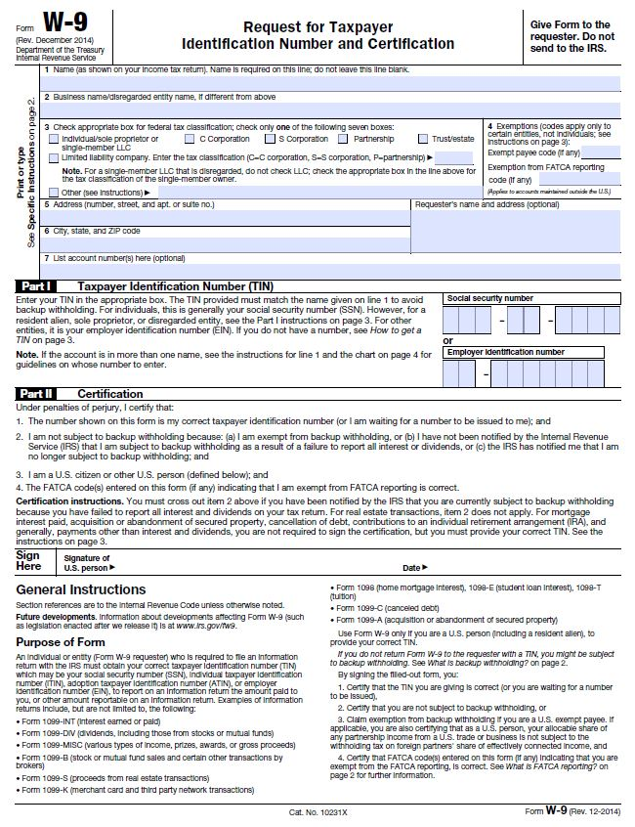

Pre-Award Audit Questionnaire for LEAs and State Agencies
Visit the SCDE’s Office of Auditing Services website to access the Pre-Award Audit Questionnaire for LEAs and State Agencies.
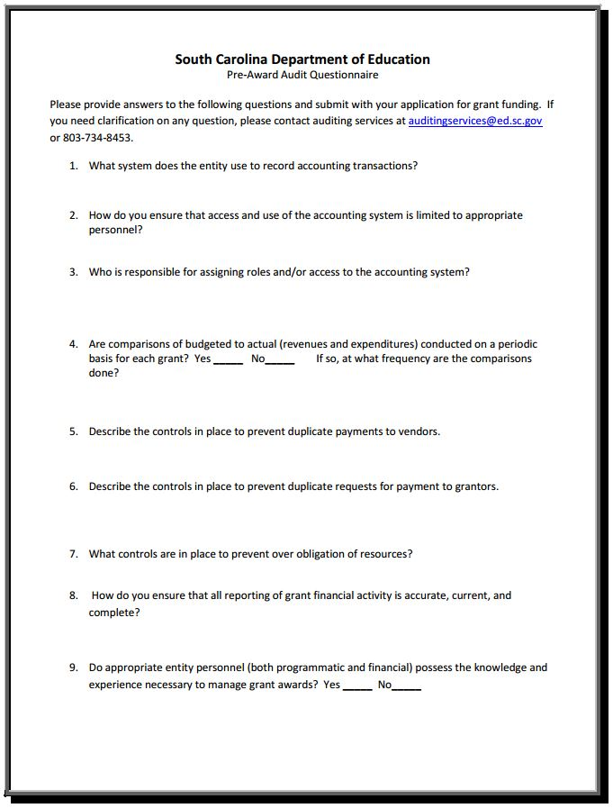
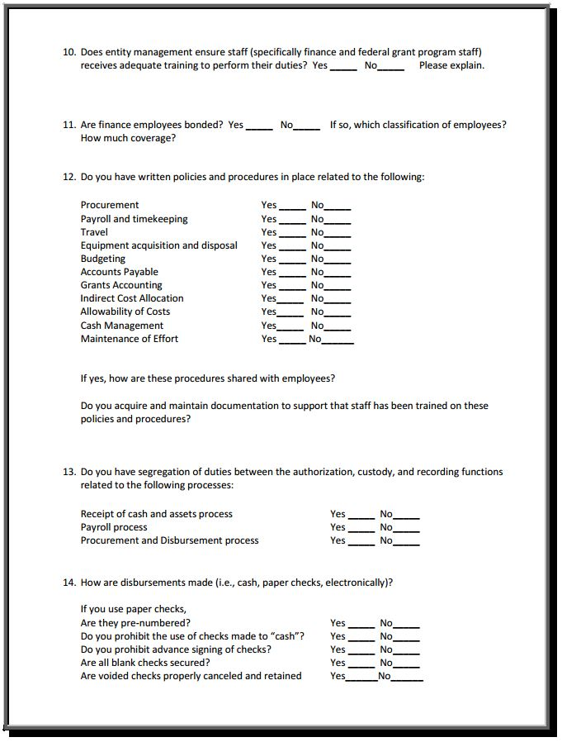
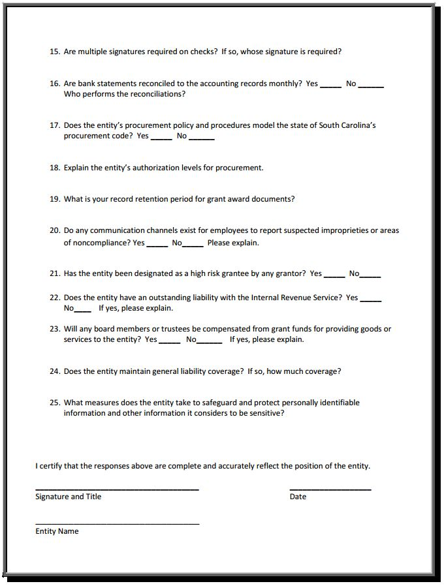
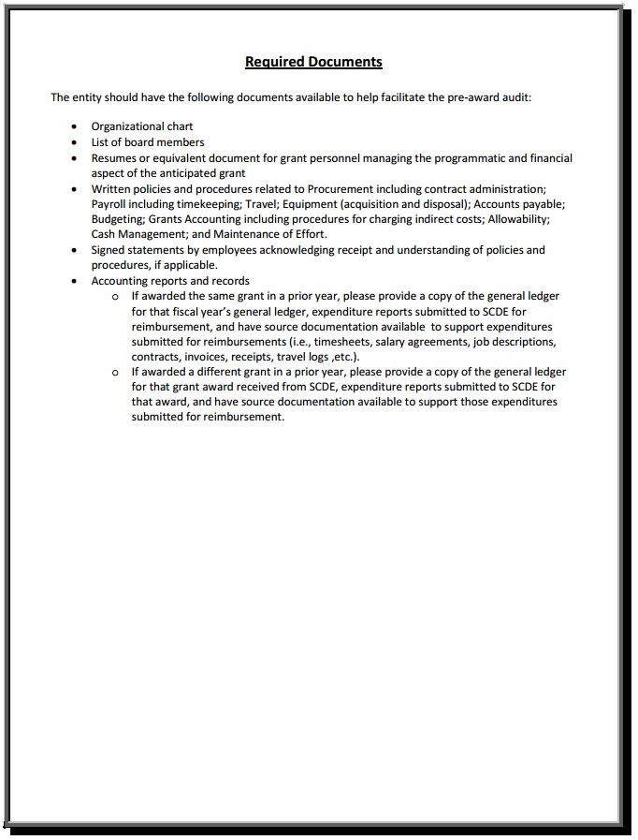
Pre-Award Audit Questionnaire for Non-LEAs
Visit the SCDE’s Office of Auditing Services website to access the Pre-Award Audit Questionnaire for Non-LEAs.
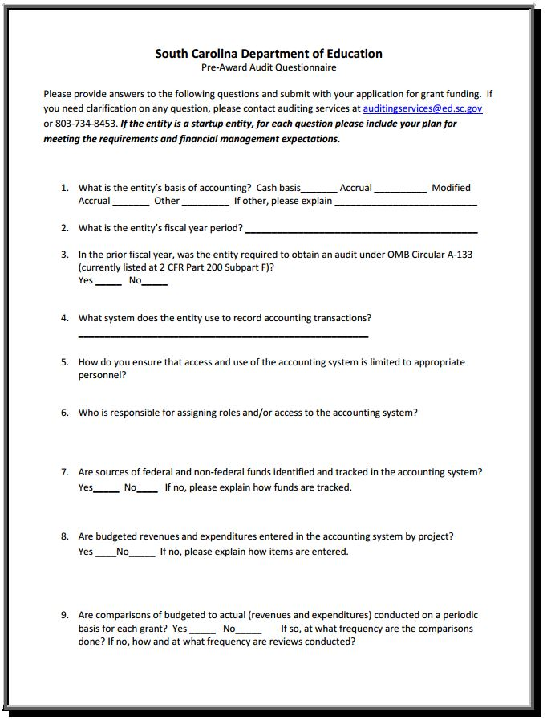

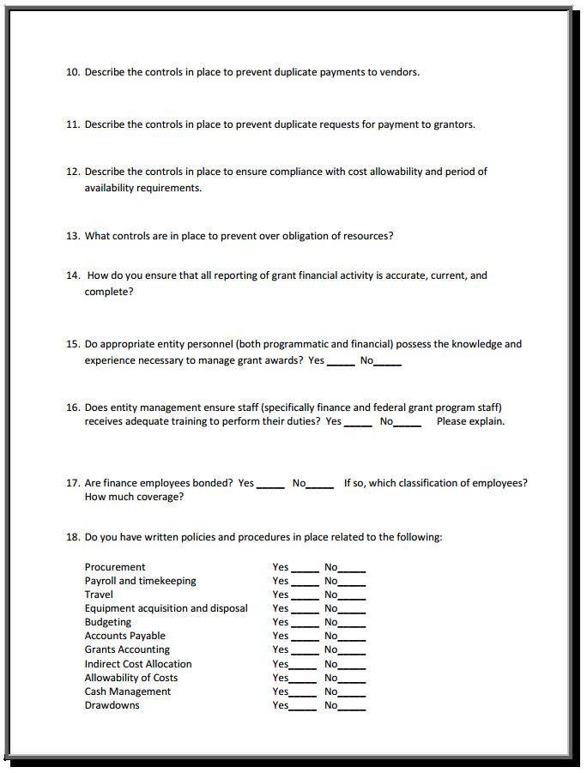
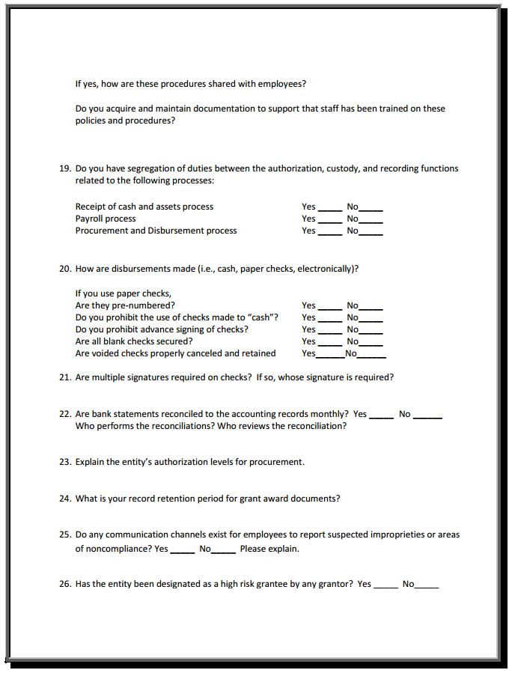
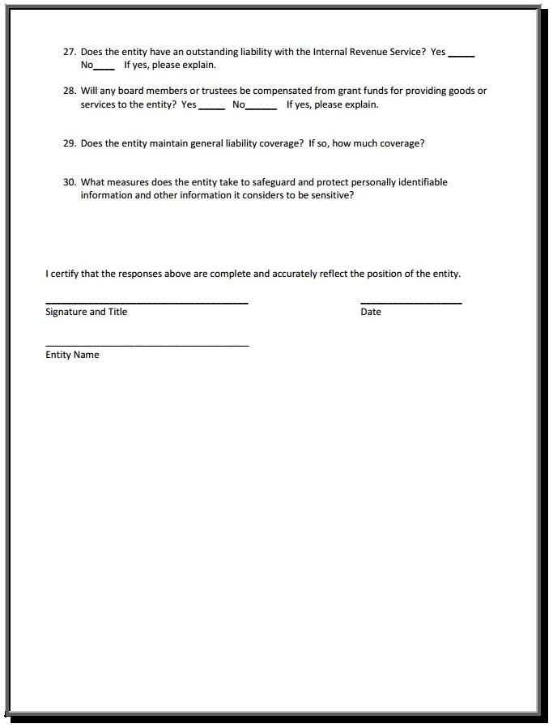
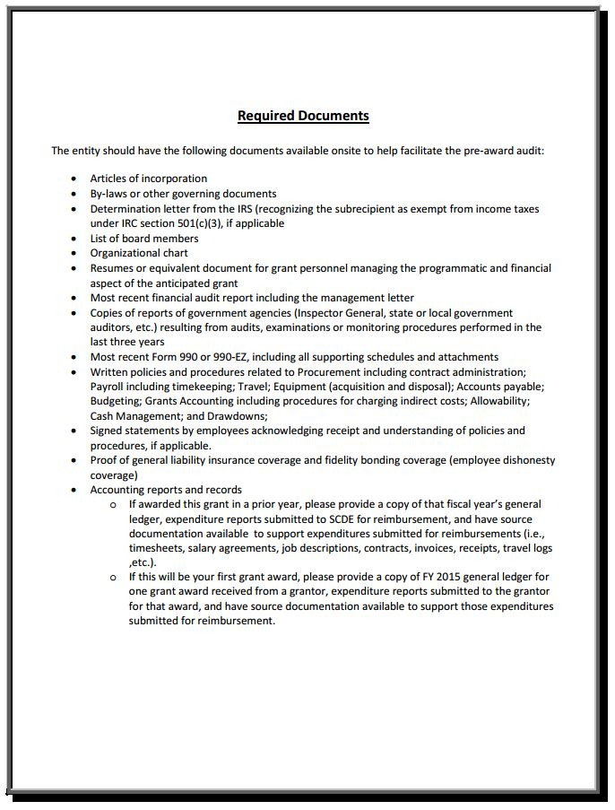

Recruitment and Retention Action Plan—Year 1

Complete Recruitment and Retention Action Plan for the proposed IEL/CE program. Guidance on completing the Action Plan follows below.

Program Name: List the name of the program.
County(ies) to be Served: List the county or counties that will be served by your program.
Total Anticipated Number of Participants in Year 1: Indicate the total number of program participants you anticipate serving in Year 1 of the subgrant.
Target Group/Area & Target Enrollment Number:
- Indicate the target group or area in which recruitment efforts will be focused. For example, the target group may be young adults or individuals with advanced degrees from their home country. A target area may be broad scale (e.g., county-wide) or in a specific locale (e.g., a neighborhood or school).
- The target enrollment number should reflect how many students you anticipant enrolling from that target group or area. Your target enrollment may change per period depending on how many “new” students your program can accommodate.
- In the table, use a separate row for each target group/area to outline the timeframe, recruitment activities, retention strategies, and lead person for that particular group/area.
Timeframe: List the timeframe in which the recruitment activities and retention strategies will be implemented.
Recruitment Activities: Outline specific recruitment activities that your program will conduct to attract and enroll students. Outline how you will stay visible and promote your program. Indicate the who, what, when, where and how for your activities.
Retention Strategies: Retention strategies should be centered around student barriers and interest. Once you get the students, how will you get them to persist? Indicate who, what, when, where and how for strategies.
Person(s) Responsible: Recruitment and retention will often be neglected or occur haphazardly if not assigned to a specific person or group. Assign one or more staff to lead recruitment efforts.

Program Name: |  |  |  | County(ies) to be Served:
Program Type: Integrated English Literacy/Civics Education
Total Anticipated Number of Participants in Year 1:
Target Group/Area & Target Enrollment Number | Recruitment Activities |  |  |  | Retention Strategies
Target Group/Area & Target Enrollment Number | Timeframe | Activities | Person(s) Responsible |  | Timeframe | Activities | Person(s) Responsible

Past Effectiveness Chart

For Consideration 3. Past Effectiveness, the SCDE will consider past effectiveness of the applicant/eligible provider in improving the literacy of eligible individuals, to meet state-adjusted levels of performance for the primary indicators of performance described in WIOA section 116, especially with respect to eligible individuals who have low levels of literacy.

For this consideration, applicants have the option of including a table to reflect two consecutive years of performance data as a part of the narrative response or completing the appropriate Past Effectiveness Chart (see the following pages).

If applicable, complete the Past Effectiveness Chart, reference the chart in your narrative response to consideration 3, and include it as an appendix item in the application.

Applicant _____________________________________________________________
Past Effectiveness Chart for the IEL/CE Program
Educational Functioning Level Outcomes  (or Grade Level Equivalent) | Two Consecutive Years
 | Number Enrolled |  | Number Completing Level |  | Percentage Completing Level
 | 20__ - 20_ | 20__ - 20_ | 20__ - 20_ | 20__ - 20_ | 20__ - 20_ | 20__ - 20_
ABE Beginning Literacy (0–1)
ABE Beginning Basic Education (2–3)
ABE Intermediate Low (4–5)
ABE Intermediate High (6–8)
ASE Low (9–10)
ASE High (11–12)
ESL Beginning Literacy
ESL Beginning Low
ESL Beginning High
ESL Intermediate Low
ESL Intermediate High
ESL Advanced
TOTAL (ESL + ABE/ASE)
High School Credential Outcomes | Number Enrolled |  | Number Earning Certificate |  | Percentage Earning Certificate
High School Credential Outcomes | 20__ - 20_ | 20__ - 20_ | 20__ - 20_ | 20__ - 20_ | 20__ - 20_ | 20__ - 20_
High School Diploma
High School Equivalency Diploma
TOTAL Obtaining a HS Credential
Transition Outcomes | Number Enrolled |  | Number Transitioned |  | Percentage Transitioned
Transition Outcomes | 20__ - 20_ | 20__ - 20_ | 20__ - 20_ | 20__ - 20_ | 20__ - 20_ | 20__ - 20_
Transition to Postsecondary Education
Transition to Workforce

IEL/CE Program Budget Planning Form and Budget Narrative Template Guidance

Use the Excel budget file located on the IEL/CE Grant Opportunity Web page to complete the Program Budget Planning Form and Budget Narrative for the first year of the proposed AEFLA Program. Insert rows in the budget spreadsheet as needed.
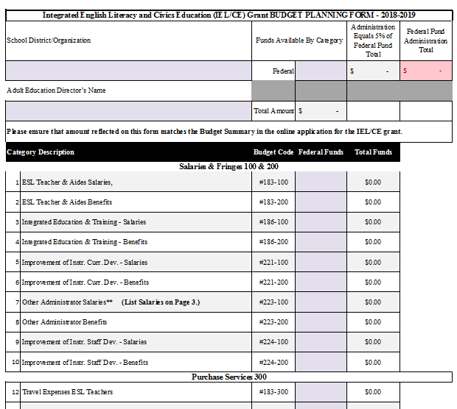

IEL/CE Partners and Partnership Coordination

The IEL/CE Partners and Partnership Coordination table applies to Considerations 4 and 10 & 11. In the table on the next page, outline and describe any partnerships and collaborative efforts that have been established or will be established for the benefit of the students and program.
Guidance on completing the Adult Education Partners and Partnership Coordination table follows below.
Program Name: List the name of the program.

County(ies) to be Served: List the counties that will be served by your program.

Partner: List the name of the organization, entity, and/or agency with which your program will partner.

Partner Type: There are various partners within the workforce and education system. Indicate the partner type as one of the following: Core, One-Stop, or Other.

Activities and/or Support Services: List the activities (e.g., conducting a workshop) and/or support services (transportation, etc.) the partner will offer adult education students.

Service Coordination/Partnership Agreement: Describe how services will be coordinated between your organization and the partner and what services the partner will provide or briefly describe the agreement or partnership arrangement.

Referral Process: Outline the referral process, to and from, the partner. Indicate your contact person and/or person responsible for all or parts of the referral process.

Program Name: |  |  |  | County(ies) to be Served:
Program Type: Integrated English Literacy and Civics Education (IEL/CE)
Partner | Partner Type | Activities and/or  Support Service(s) | Service Coordination/  Partnership Agreement |  | Referral Process
Transport X  EXAMPLE | Other | Transportation | Transport X will provide bus passes at a reduced rate to AE students with an adult ed ID. |  | Students receive a voucher from the AE receptionist and provide that to the bus driver. Vouchers are reconciled on a monthly basis.
Transport X  EXAMPLE | Other | Job Shadowing | Students with an interest in truck driving can shadow a bus driver for a 2-3 day period. The bus driver receives an evaluation form to assess the student. The student receives a self-reflection form to help assess continued interest in the field. |  | Once students complete 20 hours, they can sign-up with the CCN to shadow a bus driver. The CCN coordinates with the HR manager a time for the student to shadow a bus driver.

Weekly Schedule (applies to Considerations 5. & 6.b. and 10. & 11.a.)
Program Name:
Program Type: Integrated English Literacy and Civics Education (IEL/CE)
Location |  | Teacher/Teaching Assistant | Course/Level | Day(s) | Time | Number of Weeks

Certification Signature Page

Certification
I hereby certify that, to the best of my knowledge, the information and data contained in this application are true and correct. The applicant’s governing body has duly authorized this application and documentation, and the applicant will comply with the SCDE Assurances and Terms and Conditions if the subgrant is awarded. The applicant is registered and current (active) on the federal System for Award Management (SAM).

Authorized Official (CEO/executive director of organization or school district superintendent)
Name:
Position: | Email:
Telephone: | Fax:

Signature of Authorized Official:

Date Signed:

Financial Official
Name:
Signature of Financial Official:

Date Signed:

IEL/CE Lead Contact Person
Name:
Signature of Program Director or Coordinator/Designee:

Date Signed:
Please complete, print, and obtain signatures prior to submission. Include the signed, scanned form in the required appendices as indicated on page 31.

Assurances and Terms and Conditions for Federal Subawards

For informational purposes only
The applicant certifies to abide by the SCDE Assurances and Terms and Conditions by signing and submitting the Certification Signature Page.

Assurances

I certify that this applicant:
- Has the legal authority to apply for federal assistance and the institutional, managerial, and financial capability (including funds sufficient to pay the nonstate share of project costs) to ensure proper planning, management, and completion of the project described in this application.
- Will give the South Carolina Department of Education (SCDE) access to and the right to examine all records, books, papers, or documents related to this award and will establish a proper accounting system in accordance with generally accepted accounting principles (GAAP) or agency directives.
- Has an accounting system with sufficient internal controls, a clear audit trail, and written cost-allocation procedures as necessary. The financial management systems are capable of distinguishing expenditures that are attributable to this grant from those that are not attributable to this grant. This system is able to identify costs by programmatic year and by budget line item and to differentiate among direct, indirect, and administrative costs. In addition, the applicant will maintain adequate supporting documents for the expenditures (federal and nonfederal) and in-kind contributions, if any, that it makes under this grant. Costs are shown in books or records (e.g., disbursements ledger, journal, payroll register) and are supported by a source document such as a receipt, travel voucher, invoice, bill, or in-kind voucher.
- Will also comply with the Office of Management and Budget 2 CFR Part 200 Subpart E-Cost Principles related to the allowability, reasonableness, and allocability of costs consistent with the approved budget and also by maintaining required support for salaries and wages. Required support includes certifications and/or personnel activity records depending upon the amount of time spent on cost objectives.
- Will approve all expenditures, document receipt of goods and services, and record payments on the applicant’s accounting records prior to submission of reimbursement claims to the SCDE for costs related to this grant.
- Will initiate and complete work within the applicable time frame after receipt of approval by the SCDE.
- Will not discriminate against any employee or applicant for employment because of race, color, religion, age, sex, national origin, or disability and comply with Title VI of the Civil Rights Act of 1964, Section 504 of the Rehabilitation Act of 1973, Title IX of the Education Amendments of 1972, the Age Discrimination Act of 1975, and Titles I, II, and III of the Americans with Disabilities Act of 1990 (ADA). The grantee will take affirmative action to ensure that applicants for employment and the employees during the period of their employment are treated without regard to their race, color, religion, age, sex, national origin, or disability.
- Has no policy that prevents, or otherwise denies, participation in constitutionally protected prayer in public schools as set forth in the Guidance on Constitutionally Protected Prayer in Public Education (20 U.S.C. § 7904).
- Will comply with the Family Educational Rights and Privacy Act. (20 U.S.C. §1232g; 34 CFR Part 99).
- Will comply with the Ethics, Government Accountability, and Campaign Reform Act (S.C. Code Ann. § 2-17-10 et seq. and § 8-13-100 et seq. (Supp. 2017)).
- Will comply with the South Carolina Drug Free Workplace Act (S.C. Code Ann. § 44-107-10 et seq. (Supp. 2017) if the amount of this award is $50,000 or more and the federal Drug Free Workplace Act of 1988 (41 USC 702).
- Will provide information to the SCDE, as requested, regarding the reporting requirements of the Federal Funding Accountability and Transparency Act (FFATA), which requires the SCDE to file a FFATA subaward report by the end of the month following the month in which it awards any subgrant equal to or greater than $25,000.
- Will comply with 2 CFR Part 25 and register and receive a unique entity identifier, fulfill the requirement for the System for Award Management, maintain the currency of the registration throughout the full grant term, and allow access by the granting agency to ensure compliance.
- Will comply with 2 CFR Part 200.112 and disclose in writing any potential conflict of interest to the SCDE.
- Will comply with 2 CFR Part 200.113 and disclose in writing to the SCDE all violations of federal criminal law involving fraud, bribery, or gratuity violations potentially affecting the federal award.
- Will comply with conditions under Executive Order 13513 “Federal Leadership on Reducing Text Messaging While Driving” (October 1, 2009) by refraining from text messaging while driving during official grant business.

Terms and Conditions

- Completeness of Proposal. All proposals should be complete and carefully worded and must contain all of the information requested by the South Carolina Department of Education (SCDE). If you do not believe a section applies to your proposal, please indicate that fact.
- Non-awards/Termination. The SCDE reserves the right to reject any and all applications and to refuse to grant monies under this solicitation. If the SCDE rejects an application, the applicant has a right to request a hearing, as provided by 2 CFR Part 200.341 and 34 CFR Part 76.401, if it alleges the SCDE’s actions violate a state or federal statute or regulation by (1) disapproving of or failing to approve the application or project, in whole or in part, or (2) failing to provide funds in amounts in accordance with the requirements of statutes and regulations.
After it has been awarded, the SCDE may terminate a grant by giving the grantee written notice of termination. In the event of a termination after award, the SCDE shall reimburse the grantee for allowable expenses incurred up to the notification of termination. In addition, this grant may be terminated by the SCDE if the grantee fails to perform as promised in its proposal. Federal grants will be terminated in accordance with 2 CFR Part 200.339 and 200.340.
In the event that this grant is terminated, the grantee shall have a right to a hearing as set forth in 34 CFR Part 76.783. The grantee must notify the SCDE of its request for a hearing within 30 days of receiving written notice of the termination. If a hearing is requested, the SCDE will conduct the hearing in accordance with the procedures outlined in 34 CFR Part 76.401(d)(2)–(7).
- Reduction in Budgets and Negotiations. The SCDE reserves the right to negotiate budgets with applicants. The SCDE may, at its sole discretion, determine that a proposed budget is excessive and may negotiate a lower budget with the applicant. The applicant may at that time negotiate or withdraw its proposal. In addition, the SCDE may desire to fund a project but not at the level proposed. In that case, the SCDE shall notify the applicant of the amount that can be funded, and the applicant and the SCDE shall negotiate a modification to the proposal to accommodate the lower budget. All final decisions are that of the SCDE.
- Amendments to Grants. Amendments are permitted generally for budgets, grant end date, and management upon the mutual agreement of the parties involved and will become effective when specified in writing and signed by both parties. However, amendments to scope of work that significantly alter the original application proposal may trigger partial or full termination consistent with 2 CFR Part 200.339 and 200.340.
- Use of Grant Funds. Funds awarded are to be expended only for purposes and activities covered by the approved project plan and approved budget and budget narrative.
- Submission of Expenditure Reports. Claims for reimbursement must be made at least quarterly and consistent with calendar quarters (e.g., an expenditure report claim for costs for January 1 through March 30 must be filed by May 15).
- Obligation of Grant Funds. Grant funds may not be obligated prior to the effective date or subsequent to the end or termination date of the grant period. No obligations are allowed after the end of the grant period. The final request for expenditure report claims must be submitted no later than thirty (30) days after the end of the grant period.
- Deobligation of Funds. After a final expenditure report claim has been submitted to the SCDE, the grantee will go through the official deobligation process with the SCDE.
- Documentation. The grantee must provide for accurate and timely recording of receipts and expenditures. The grantee’s accounting system should distinguish receipts and expenditures attributable to each grant. The grantee must review the memo regarding “Guidelines for Retaining Documentation to Support Expenditure Claims.”
- Travel Costs. Travel costs, if allowed under this solicitation, must not exceed limits noted in the United States General Services Administration regulations for lodging. Meals and incidentals are limited by the state budget proviso, currently not to exceed $25 per day for in-state travel and $32 for out-of-state travel (see page 91 of the State of South Carolina Statewide Disbursement Regulations). Mileage reimbursement must follow the current Office of Comptroller General instructions, which is consistent with the published IRS rates.
- Honoraria. Amounts paid in honoraria, if allowed under this grant, must be consistent with SCDE policies. Applicants should check with the program office before budgeting for honoraria.
- Reports. The grantee shall submit, as required or instructed by the awarding program office, all reports (programmatic, financial, or evaluation) within the specified period or date and in the prescribed format. An expenditure claim report must be filed by August 15 for all expenditures incurred by June 30 in order to comply with the generally accepted accounting principles (GAAP) and the production of the State's Comprehensive Annual Financial Report.
- Copyright. The grantee is free to copyright any books, publications, or other copyrightable materials developed in the course of this grant. However, the SCDE reserves a royalty-free, nonexclusive, and irrevocable license to reproduce, publish, or otherwise use, and to authorize others to use, the copyrighted work developed under this grant.
- Certification Regarding Lobbying, Suspension, and Debarment. By submitting an application, the applicant certifies, to the best of its knowledge and belief, that the
- Applicant and/or any of its principals, subgrantees, or subcontractors
  - Have not paid or will not pay to any person any federally appropriated funds for the purpose of influencing or attempting to influence an officer or employee of any agency, a Member of Congress, an officer or employee of Congress, or any employee of a Member of Congress in connection with making any federal grant and the extension continuation, renewal, amendment, or modification of any federal grant, as defined at 34 CFR Part 82.105 and 82.110. If any funds other than federally appropriated funds have been paid or will be paid to any person for influencing or attempting to influence an officer or employee of any agency, a Member of Congress, an officer or employee of Congress, or any employee of a Member of Congress in connection with this federal grant, the undersigned shall complete and submit Standard Form LLL, “Disclosure of Lobbying Activities,” in accordance with its instructions.
  - Are not presently debarred, suspended, proposed for debarment, or declared ineligible for the award of contracts by any state or federal agency as stated at 2 CFR Part 180 or 2 CFR Part 3485.
  - Have not, within a three-year period preceding this application, been convicted of or had a civil judgment rendered against them for commission of fraud or a criminal offense in connection with obtaining, attempting to obtain, or performing a public (federal, state, or local) contract or subcontract; violated federal or state antitrust statutes relating to the submission of offers; or committed embezzlement, theft, forgery, bribery, falsification or destruction of records, making false statements, tax evasion, or receiving stolen property.
  - Are not presently indicted for, or otherwise criminally or civilly charged by a governmental entity with, commission of any of the offenses enumerated above.
- Applicant has not, within a three-year period preceding this application, had one or more contracts terminated for default by any public (federal, state, or local) entity.
- Audits.
- Entities expending $750,000 or more in federal awards:
Entities that expend $750,000 or more in federal awards during the fiscal year are required to have an audit performed in accordance with the provisions of 2 CFR Part 200.501, et seq. Except for the provisions for biennial audits provided in 2 CFR Part 200.504 (a) and (b), audits must be performed annually as stated at 2 CFR Part 200.504. A grantee that passes through funds to subrecipients has the responsibility of ensuring that federal awards are used for authorized purposes in compliance with federal program laws, federal and state regulations, and grant agreements. The director of the OMB, who will review this amount every two years, has the option of revising the threshold upward.
- Entities expending less than $750,000 in federal awards:
Entities that expend less than $750,000 in a fiscal year in federal awards are exempt from the audit requirements in 2 CFR Part 200.504. However, such entities are not exempt from other federal requirements (including those to maintain records) concerning federal awards provided to the entity. The entity’s records must be available for review or audit by the SCDE and appropriate officials of federal agencies, pass-through entities, and the General Accounting Office (GAO).
- Records. The grantee shall retain federal grant records, including financial records and supporting documentation, for a minimum of six (6) years after the end date of the grant when the final expenditure report claim for reimbursement and all final reports have been submitted, unless informed otherwise or in the case of litigation.
- Electronic Signature Agreement. I agree that my electronic signature is the legally binding equivalent to my handwritten signature.

GEPA: Notice to All Applicants
The purpose of this enclosure is to inform you about a new provision in the Department of Education's General Education Provisions Act (GEPA) that applies to applicants for new grant awards under Department programs. This provision is Section 427 of GEPA, enacted as part of the Improving America's Schools Act of 1994 (Public Law (P.L.) 103-382).

To Whom Does This Provision Apply?
Section 427 of GEPA affects applicants for new grant awards under this program. ALL APPLICANTS FOR NEW AWARDS MUST INCLUDE INFORMATION IN THEIR APPLICATIONS TO ADDRESS THIS NEW PROVISION IN ORDER TO RECEIVE FUNDING UNDER THIS PROGRAM.

What Does This Provision Require?
Section 427 requires each applicant for funds (other than an individual person) to include in its application a description of the steps the applicant proposes to take to ensure equitable access to, and participation in, its federally assisted program for students, teachers, and other program beneficiaries with special needs. This provision allows applicants discretion in developing the required description. The statute highlights six types of barriers that can impede equitable access or participation: gender, race, national origin, color, disability, or age. Based on local circumstances, you should determine whether these or other barriers may prevent your students, teachers, etc. from such access or participation in the federally funded project or activity. The description in your application of steps to be taken to overcome these barriers need not be lengthy; you may provide a clear and succinct description of how you plan to address those barriers that are applicable to your circumstances. In addition, the information may be provided in a single narrative, or, if appropriate, may be discussed in connection with related topics in the application.

Section 427 is not intended to duplicate the requirements of civil rights statutes, but rather to ensure that, in designing their projects, applicants for federal funds address equity concerns that may affect the ability of certain potential beneficiaries to fully participate in the project and to achieve to high standards. Consistent with program requirements and its approved application, an applicant may use the federal funds awarded to it to eliminate barriers it identifies.

What are Examples of How an Applicant Might Satisfy the Requirement of This Provision?
The following examples may help illustrate how an applicant may comply with Section 427.
- An applicant that proposes to carry out an adult literacy project serving, among others, adults with limited English proficiency might describe in its application how it intends to distribute a brochure about the proposed project to such potential participants in their native language.
- An applicant that proposes to develop instructional materials for classroom use might describe how it will make the materials available on audio tape or in Braille for students who are blind.
- An applicant that proposes to carry out a model science program for secondary students and is concerned that girls may be less likely than boys to enroll in the course might indicate how it intends to conduct "outreach" efforts to girls to encourage their enrollment.
- An applicant that proposes a project to increase school safety might describe the special efforts it will take to address concern of lesbian, gay, bisexual, and transgender students, and efforts to reach out to and involve the families of LGBT students.

We recognize that many applicants may already be implementing effective steps to ensure equity of access and participation in their grant programs, and we appreciate your cooperation in responding to the requirements of this provision.
Estimated Burden Statement for GEPA Requirements
According to the Paperwork Reduction Act of 1995, no persons are required to respond to a collection of information unless such collection displays a valid OMB control number. Public reporting burden for this collection of information is estimated to average 1.5 hours per response, including time for reviewing instructions, searching existing data sources, gathering and maintaining the data needed, and completing and reviewing the collection of information. The obligation to respond to this collection is required to obtain or retain benefit (Public Law 103-382. Send comments regarding the burden estimate or any other aspect of this collection of information, including suggestions for reducing this burden, to the U.S. Department of Education, 400 Maryland Ave., SW, Washington, DC 20210-4537 or email ICDocketMgr@ed.gov and reference the OMB Control Number 1894-0005.

Partner Identification and Funding Request Form

Partner Identification Form

As applicable, include a Partnership Identification Form for each partner institution/organization that your organization will contract with to enhance adult education and literacy services and/or activities funded by IEL/CE.

Name of Applicant:
Program Type:
Name of Partner Institution
Type of Institution/Organization
Primary Contact Information
Name
Title
Complete Address
Telephone |  |  | Fax
Email
Describe the services/activities to be provided by the partner

List only the funding the partner organization will receive from the IEL/CE program.
Anticipated Direct Cost Requested from Partner | YEAR 1 | YEAR 2 | YEAR 3 | TOTAL
1. Salaries & Wages
(Professional and Clerical)
2. Employee Benefits
3. Travel in State
4. Travel Out of State
5. Materials and Supplies
6. Consultants and Contracts
7. Teacher Stipends
8. Equipment (Purchase)
9. Other (Equipment rental, printing, etc.)
Total Funding from Partner to Adult Education Program

By signing below, I authorize my organization/agency’s participation in this subgrant program, and I certify that my organization/agency is committed to completing the services described above and will apply the funds outlined in the budget above to these services.

____________________________________________ _______________
Signature of Authorized Official Date

____________________________________________
Printed Name of Authorized Official

Program Personnel Schedule

Use the Program Personnel Schedule located on the IEL/CE Grant Opportunity Web page to document all personnel associated with the IEL/CE program.
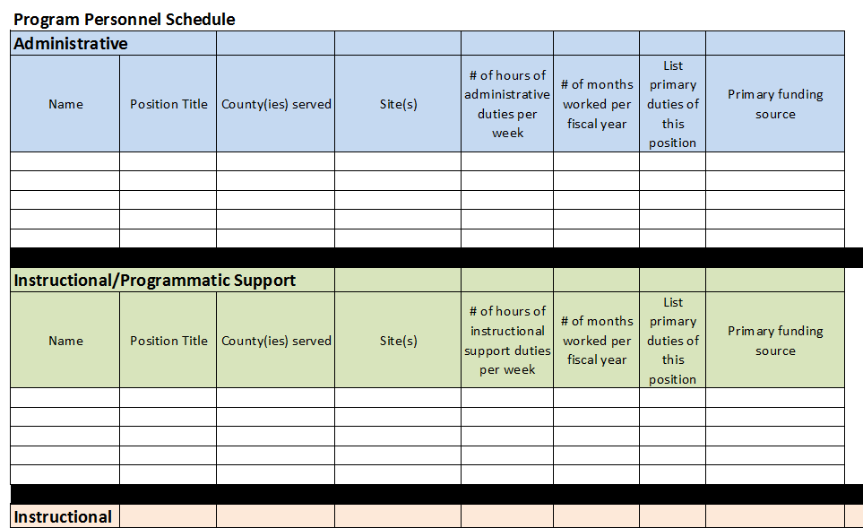

South Carolina: Languages Spoken by
Limited English Proficient (LEP) Individuals Statewide and by County*

County | Total Population | Total LEP Population
South Carolina | 4,333,300 | 130,800
Abbeville County | 23,900 | 300
Aiken County | 148,500 | 3,400
Allendale County | 9,900 | 100
Anderson County | 173,800 | 3,000
Bamberg County | 15,100 | 100
Barnwell County | 21,200 | 400
Beaufort County | 148,500 | 9,700
Berkeley County | 161,900 | 5,900
Calhoun County | 14,300 | 200
Charleston County | 324,200 | 9,800
Cherokee County | 51,500 | 1,000
Chester County | 31,100 | 100
Chesterfield County | 43,500 | 800
Clarendon County | 32,700 | 300
Colleton County | 36,300 | 800
Darlington County | 64,200 | 900
Dillon County | 29,300 | 500
Dorchester County | 124,200 | 2,900
Edgefield County | 25,400 | 800
Fairfield County | 22,500 | 100
Florence County | 126,700 | 1,800
Georgetown County | 56,900 | 1,100
Greenville County | 414,700 | 22,300
Greenwood County | 64,600 | 2,000
Hampton County | 19,700 | 500
Horry County | 250,000 | 11,000
Jasper County | 22,300 | 1,600
Kershaw County | 56,900 | 1,300
Lancaster County | 69,500 | 1,400
Laurens County | 62,600 | 1,300
Lee County | 18,300 | 300
Lexington County | 240,600 | 8,100
McCormick County | 9,800 | 100
Marion County | 31,100 | 500
Marlboro County | 27,300 | 400

Newberry County |  | 34,900 | 1,400
Oconee County |  | 69,500 | 1,400
Orangeburg County |  | 86,200 | 1,200
Pickens County |  | 112,100 | 2,400
Richland County |  | 354,700 | 10,700
Saluda County |  | 18,300 | 1,300
Spartanburg County |  | 262,800 | 11,300
Sumter County |  | 99,000 | 1,900
Union County |  | 27,200 | 200
Williamsburg County |  | 32,600 | 400
York County |  | 206,100 | 5,000
 | Reference: Batalova, J., & Whatley, M. (2013, July 25). Limited English Proficient Population of the United States. Migration Policy Institute. Retrieved October 6, 2017.
 | *Migration Policy Institute uses the term Limited English Proficient (LEP). LEP refers to any person age five (5) and older who reported speaking English “less than very well,” as classified by the US Census Bureau. Population estimates are for individuals age 5 and older.

