Request for Proposals (RFP)
Application Package

2026 Advanced Placement® (AP) Teacher Institutes
Competitive Grant and Teacher Endorsement Authority

The 2026 AP Teacher Institute is a grant program authorized by the
Education Improvement Act (EIA) of 1984, funded by the South Carolina General Assembly through the General Appropriations Act, Proviso 1A.22, and administered by
the South Carolina Department of Education.

Deadline for Receipt of Applications: January 23, 2026, at 5:00 p.m.

Technical Assistance for Applicants: December 17, 2025, at 9:30 a.m.

For questions about the Advanced Placement Grant Program contact:
Jennifer Holliday, Education Associate for Advanced Programs
803-734-0163; jnholliday@ed.sc.gov

For reporting, fiscal/budget, and RFP-specific questions, contact:
Stephen Stokes, Education Associate for Grants, Awards, Scholarships
803-734-3461; sstokes@ed.sc.gov

Issued by:
South Carolina Department of Education
Office of Assessment and Standards
849 Learning Lane
West Columbia, SC 29172-3171
TABLE OF CONTENTS

PART I: General Information 2
A. Introduction and Purpose 2
B. Eligible Applicants 3
C. Absolute and/or Competitive Priorities 3
D. Timeline of Granting Process 3
E. Technical Assistance Sessions for Applicants 3
F. Statutory, State-Level, and Other Requirements 3
G. Authorized Activities 5
H. Unauthorized Activities 5
I. Program Accountability and Monitoring 5
J. Fiscal Operations 8
K. Supplement, Not Supplant 9
L. Review and Selection Process 9
M. Appeals Process 10

PART II: Application Overview, Content, and Instructions 11
A. Application Overview 11
B. Application Narrative Format 11
C. Online Application Submission 12
D. Project Summary 12
E. Project Narrative Content 12
1. Project Description 13
2. Management and Personnel 13
3. Evaluation Design 13
F. Proposed AP Teacher Institute Details and Budget 13
1. AP Institute Narrative 14
1. Evaluation 14
2. Budget Narrative 14
3. AP Teacher Institute Syllabus 17
4. Curriculum Vitae of Professor, Master Teacher, and/or Consultant 17
G. Attachments 17
H. Deadline and Submission Procedures 18
I. Screenshots of Online Application Submission Forms 18

Appendix A: Definitions of Terms Used 26

Appendix B: Selection Criteria and Reviewers’ Scoring Rubric 27

Appendix C: Required SCDE Forms 35
Certification Signature Page 35
Assurances and Terms and Conditions for State Awards 36
Budget Narrative Template 40

PART I: General Information

Introduction and Purpose

The South Carolina General Assembly annually allocates funds to the South Carolina Department of Education (SCDE) to provide Advanced Placement® (AP) teacher training courses as authorized by the Education Improvement Act (EIA) of 1984, Division II, Subdivision A, Subpart 4, § 1. Funding for the 2026 AP Teacher Institutes is appropriated by the General Appropriations Act, Proviso 1A.22 (SDE-EIA: Professional Development).

The purpose of the AP Teacher Institutes is to provide South Carolina public school teachers with the special endorsement to teach an AP course as required in S.C. Code Ann. Reg. 43-258.1 (2017). Teachers who successfully complete an AP Teacher Institute will be awarded special AP endorsement in the specific AP content area.

Applicants must propose providing AP Teacher Institutes in subject areas outlined by the College Board to provide initial training for newly assigned AP teachers. The institute should prepare teachers to implement the AP class effectively according to College Board requirements, provide a depth of content knowledge in the specific subject area, and provide effective instructional strategies for teaching AP students.

For this funding round, the SCDE will consider funding College Board Advanced Placement Courses.

Approximately $190,000 will be available for new grants in this 2026 funding cycle. The SCDE anticipates awarding approximately ten grants. Award amounts will be determined based on the quality of applications received and total funding requested. Final budgets may be negotiated based on demonstrated needs.

The 2026 grant period is March 1, 2026, through June 30, 2026. The grantee may obligate funds upon receipt of the grant award notice. However, no funds will be disbursed until after March 1, 2026, and no expenditures incurred prior to that date are allowable. Funds will be disbursed within 30 days upon the receipt of the signed Grant Award Notification (GAN).

The College Board has agreed to endorse grantees following the process outlined in this RFP for AP Teacher Institutes. To be considered a College Board–endorsed AP Teacher Institute, all courses must be taught by College Board–endorsed consultants independently or collaboratively with a professor. Non-College Board–endorsed institutes will be prohibited from (1) purchasing College Board AP Teacher Institute materials and (2) advertising or listing the institute as College Board–endorsed.

Contact Libby Brown (libbrown@collegeboard.org) at the College Board Southern Regional Office for preparation guidance to meet the criteria for the College Board endorsement. The endorsement allows entities to purchase College Board–created materials to use as resources for the institute and advertise the institute via the College Board website.

Eligible Applicants

Any of South Carolina’s public or private institutions of higher education (IHEs) and any school district (or a consortium of districts) working in collaboration with a state public or private IHE are eligible to apply. For a school district to be eligible, the district must have a fully executed letter of agreement or memorandum of understanding (MOU) with an IHE to offer the institute and must include a copy of the agreement as an attachment to their application.

To be eligible, the IHE, district(s), or consortium must obtain College Board endorsement for the proposed institute(s) prior to submitting an application. The SCDE will verify the endorsement prior to making grant awards.

Absolute and/or Competitive Priorities

Competitive priority is not applicable to this grant.

Timeline of Granting Process

Date | Activity/Action
December 17, 2025 | Pre-application technical assistance session(s)
January 23, 2026 | Deadline for receipt of application
March 2026 | Notification of awards
March 2026 | New grantee technical assistance session
March 1, 2026 | Funding period begins; projects can begin
June 30, 2026 | Funding period ends; projects must end
August 17, 2026 | Final report(s) due to the SCDE

Technical Assistance Sessions for Applicants

The Office of Assessment and Standards will offer a pre-application technical assistance session via Adobe Connect on December 17, 2025, from 9:30 a.m. until 10:30 a.m. No password is required to join the session. Participants should enter their full names when logging in to the session. Participants will be able to log in 30 minutes prior to the start of the session to test their equipment’s audio settings and to download/print handouts. While participation is not mandatory in order to submit an application, it is highly recommended.

Statutory, State-Level, and Other Requirements

State Board Regulation 43-258.1 states, in part:

The South Carolina Department of Education (SCDE) will fund and coordinate AP teacher training courses. Each teacher of an AP course shall have added the specialized AP course endorsement. The specialized AP course endorsement may be earned by:
- successful completion of the three-semester hours graduate training program or other training program approved by the SCDE, or
- successful completion of at least thirty hours of training by a College Board endorsed provider, or
- documentation of a Ph.D. or other terminal degree in the course subject area.

Newly assigned teachers of AP courses will have one calendar year to meet the AP course training requirements.

The SCDE has established the following requirements for this grant program:
  - Either the professor, master teacher, or consultant must have experience with, and detailed knowledge of, the program and/or service for which they are applying—such experience may include, but is not limited to, service as a Test Development Committee member or an Academic Advisory Committee member.
  - Both a professor and a master teacher may teach each AP Teacher Institute and either the professor or the master teacher must have served as an AP Consultant.
  - The master teacher or professor must have access to current College Board materials.
  - The master teacher must have completed the AP Course Audit in their subject.
  - College Board-endorsed consultants may teach independently or collaboratively with a professor to award the College Board endorsement.
  - College Board-endorsed consultants must teach redesigned, revised, and updated AP courses.
  - Grantees must administer an AP Teacher Institute participant evaluation instrument that is subject to approval by the SCDE and includes questions for
- evaluating the professor/master teacher/consultant and the institute,
- assessing the effect of the institute on how prepared the participating teachers feel to teach the AP course, and
- gathering suggestions for improving the course curriculum and instruction.
  - Participants will complete the evaluation instrument at the conclusion of the institute.
  - Each institute will meet the minimum requirement of at least 30 contact hours.
  - Institutes are encouraged to offer a supplement to each course that will allow teachers to earn three graduate credit hours.
  - Once the institute has been announced to school districts, the grantee will coordinate all paperwork pertaining to registration. Priority for registration must be given to teachers currently teaching AP courses or those assigned to teach AP courses.

Universal Entity Identifier (UEI) and System of Award Management—2 CFR Part 25
All grant applicants must obtain a unique entity identifier (UEI) by registering in the federal System for Award Management (SAM). The applicant must include a valid UEI in the online application. Contact your finance office for assistance with your entity’s UEI. Please note that the SCDE will not make an award to an applicant until the applicant has complied with the requirements to provide a valid UEI.

Applicants should review the Assurances and Terms and Conditions for State Awards (on pages 36–39) to ensure that, if awarded a grant, they are capable of full compliance, especially with all the referenced state laws in order to enter into an agreement with the SCDE for this program. Pursuant to S.C. Code Ann. § 8-13-700, the applicant must disclose any potential conflict of interest to the SCDE in accordance with the SC Ethics Reform Act conflict of interest policy. A signed Certification Signature Page (page 35) is required with the application and legally binds the applicant to the Assurances and Terms and Conditions for State Awards.

Authorized Activities

Funds may be used to provide an institute for the initial training of South Carolina public-school AP teachers to prepare them to implement the AP class effectively according to College Board requirements, provide a depth of content knowledge in the specific subject area, and provide effective instructional strategies for teaching AP students.

Allowable activities include:
- Supplies and materials,
- Professor/Master Teacher instructor fees to include salary and fringe, and
- Non-participant travel (subject to approval by the SCDE).

Unauthorized Activities

Funds must not be used for:
- participant travel, including room and board;
- participant fees, including medical, recreation, and parking;
- application fees;
- fees associated with master teacher and professor not pre-approved by SCDE;
- fees associated with a current SC master teacher or professor who will not maintain the designation throughout the period of performance; and
- equipment and supplies totaling more than $5,000 per unit.

Program Accountability and Monitoring

The SCDE is responsible for monitoring AP Teacher Institute grant implementation to provide South Carolina public school teachers with the special endorsement to teach AP courses as required in S.C. Code Ann. Reg. 43-258.1 (2017) in accordance with the following program accountability requirements:
- Each recipient receiving funds through this RFP meets the eligibility requirements for the grant described herein, and the applicant has provided all required assurances that it will comply with all program implementation and reporting requirements established through this RFP.
- Each recipient receiving funds through this RFP appropriately uses these funds as described in this application package.
- Each recipient implements activities funded through this application within the timeline in which the funds provided are to be used.

Applicants may be subjected to an evaluation of their financial system, internal controls processes, and policies and procedures by the SCDE’s Office of Audit Services before a grant award is issued or during the grant term. Visit the Office of Audit Services to access the review process and procedures.

Applicants awarded grant funds must satisfy periodic reporting and accountability requirements throughout the term of the grant. These requirements address: (1) program accountability; (2) performance reporting; (3) annual budget; (4) monitoring; (5) program evaluation; and (6) technical assistance.

    - Program Accountability
Each grantee is responsible for carrying out its responsibilities in accordance with S.C. Code Ann. Reg. 43-258.1 (2017); all applicable statutes, regulations, and programmatic guidance; and its approved grant application and work plan. Grantees are also required to submit periodic reports to the SCDE to report on the use of grant funds and the progress of grant activities.

    - Performance Reporting
Performance reporting requirements include those for both programmatic reporting and fiscal reporting. The grantee is responsible for ensuring that all required performance reports are accurate, complete, and submitted on time. Achievement of grant goals and objectives will be reviewed through the final report process.

Programmatic Reporting Requirements
The final performance report must be submitted to the SCDE no later than August 17, 2026, via the online submission link provided by the SCDE prior to the deadline. Progress toward achieving grant goals and objectives will be monitored through the annual performance report process.

The following is required of all grant recipients, and these requirements are to be reported in the final performance report in the period the activity occurred:
- A list of all institute participants to include the following for each participant:
  - school and home address,
  - email address,
  - South Carolina teaching certificate number, and
  - final grade or credit status.
- An end-of-course evaluation form completed by each institute participant. The evaluation instrument used is subject to approval by the SCDE.
- A brief narrative that discusses the outcome, effectiveness, and impact of the overall project to provide AP Teacher Institutes; summarizes the participants’ evaluation responses for the specific institute(s) conducted; and discusses the implications for subsequent institutes.
- A table that lists each AP Teacher Institute conducted and provides summary information on enrollment, attendance rates, grades, and withdrawals. (A template for this table will be provided to grantees.)

Following the conclusion of the AP Teacher Institute, the grantee also will submit to the SCDE the required documentation for the College Board; this requirement will be discussed during the post-award grantee meeting.

Fiscal Reporting Requirements
Grant funds will be disbursed within 30 days upon the receipt of a signed GAN. The grantee is responsible for ensuring that all expenditures are aligned to the approved budget for authorized activities (see Section F) and for retaining accurate and complete documentation and records of all expenditures. The grantee must submit a final fiscal and programmatic report that covers the full performance period of the grant (March 1, 2026, through June 30, 2026) to the SCDE by August 17, 2026. Reports are subject to verification. The SCDE reserves the right to recover any funds used for expenditures that are determined to be unauthorized for the project, including funds not expended according to the approved budget.

    - Project Budget
A project budget of projected expenditures to be funded by the grant must be submitted with the application. Upon receipt of the signed GAN, each grantee will receive their disbursement of funds within 30 days. Expenditures must align with the final approved budget and must be for authorized activities.

    - Monitoring
The SCDE will monitor grantees by reviewing and approving the final fiscal and programmatic reports. All information in monitoring reports is subject to verification.

The SCDE may conduct programmatic and financial monitoring site visits. Grantees must agree to site visits conducted by SCDE or state program representatives. The purpose of site visits is to validate information provided in fiscal and program reports and to gather more detailed information on implementation efforts and challenges from interviews and observations for monitoring and evaluation purposes. The College Board may also conduct site visits to monitor institute content and activities.

The SCDE may require additional information from the grantee, verify information with the authorizing agency, or require the submission of additional documentation including, but not limited to, invoices, receipts, and personnel time and effort reports. Prior to a site visit, the grantee may be required to submit additional relevant information that will allow the SCDE to conduct a useful, efficient, and effective visit. The SCDE may require electronic submission of documents instead of a paper-copy submission.

SCDE staff will verify the contents of documentation submitted. Grantee may be asked to revise reports when
- non-allowable expenses are found;
- reports are confusing or difficult to understand; or
- there are unexplained discrepancies between the proposed use of grant funds, as provided in the project budget, and actual expenditures found in the submitted documentation.

    - Program Evaluation
Grantee Project Monitoring and Evaluation
Grantees are required to conduct ongoing monitoring and evaluation to ensure project goals are achieved. While hiring an external monitoring and evaluation contractor is not required, it is also not prohibited. Progress toward meeting project goals is to be reported through the final reporting process.

A final project performance report is to be completed by August 17, 2026. The final report must address project success toward each goal stated in the application. If a grantee fails to conduct the final project evaluation report before the deadline, or if any of the performance requirements in section I.2 are not completed, the SCDE may consider the grantee a high risk and elect to discontinue funding or disqualify the grantee from future funding opportunities.

    - Technical Assistance to Grantees
Grantees are required to participate in any technical assistance that the SCDE may conduct for the AP Teacher Institute grant. Delivery of such technical assistance may include in-person meetings, webinars, and conference calls.

Fiscal Operations

Grantees must use grant funds for allowable grant expenditures during the grant period. Subject to financial risk analysis, the SCDE will disburse funds upon receipt of a signed GAN for the entire grant period and require documentation of allowable expenditures made under that allocation. Documentation of allowable expenditures must be received by August 17, 2026. The SCDE will de-obligate any unspent funds remaining at the end of the grant period or funds expended on unallowable activities. Indirect costs are not allowed.

The SCDE reserves the right to withdraw or recoup funding pursuant to the grant agreement, and the grantee must agree to pay a refund if the SCDE determines that the AP Teacher Institute grant funds were not expended in accordance with allowable activities in the approved grant application, the grant agreement, and assurances.

Allowable Costs
Grant funds must be used in accordance with the statutory and state requirements stated in Section F. Grant funds must be used to support the activities stated in Section G.
- Supplies and materials may not exceed $400 per participant enrolled.
- The professor’s/instructor’s salary and fringe should not exceed $6,500—including those who have served as a reader or consultant for the College Board.
- The College Board endorsed master teacher’s salary and fringe should not exceed $4,000.
- Travel expenditures for the professor/master teacher or the College Board Consultant.

Unallowable Costs
Grantees may not use AP Teacher Institute grant funds for any costs that provide for any unauthorized activities described in Section H. The AP Teacher Institute grant does not provide indirect costs or funds for administrative charges. Grant funds may not be used for new construction; travel or room and board for participants; college or university application fees; medical, recreation, parking, or other fees; equipment and supplies totaling more than $5,000 per unit; and purchases that do not directly support the approved work plan. Individual budget items may not exceed the limits specified in “allowable costs” above.

Supplement, Not Supplant

AP Teacher Institute grant funds must supplement, not supplant, existing services and may not be used to supplant federal, state, local, or non-federal funds. Institutes may not use grant funds to pay for existing levels of services funded from any other services.

Review and Selection Process

Only those grant applications that are received by the deadline and deemed complete will be forwarded for review and funding consideration. All required materials including forms and attachments must be submitted for the application to be considered complete and eligible for review. Program staff will conduct an initial review of applications for completeness and compliance with the RFP instructions. No incomplete applications will be forwarded to the selected reviewers or considered for funding.

Three reviewers from diverse backgrounds without a vested interest in any applicant being funded will evaluate each application based on the quality of the proposed activities and the capability of the applicant to implement the proposed project. The review team will be comprised of experienced grant readers from various professions and entities, including the SCDE.

Reviewers will use the scoring rubric on pages 27–34 to read and score each application independently. After the three reviewers have individually rated each application, the scores will be averaged. An application can earn up to 100 points for an average score. Applications that earn an average score of 80 or higher will receive first consideration for funding.

Applications will be reviewed and scored using a dual-tiered rating system. The first tier will rate the overall project narrative to determine the institution’s capacity to successfully implement and manage the AP Teacher Institute grant. The second tier will rate each proposed institute separately for the quality of the course and the personnel who will be instructing the institute. The score assigned to the overall project narrative will be added to the course quality and personnel quality scores to determine the total score for each individual institute. A total of 100 points is available for each proposed institute.

Applications will be rank ordered by averaged scores. Subject to the SCDE’s final approval, the availability of state funds, geographic equity, and the inclusion of priority programming, grant awards will be made starting with applications that earned an average score of 80 points or higher. To the extent practical, the SCDE will award grants equitably among geographic regions within the state to include rural and urban communities. If funds remain following these awards, the SCDE will consider funding remaining applications that earned an average score within the adequate/meets range until all funds are allocated.

Prior to making awards, the SCDE’s Office of Audit Services will conduct a pre-award risk assessment. Based upon the results of this assessment, special conditions may be applied to the award that may include, but are not limited to, requirements for more frequent programmatic or financial reporting, increased monitoring of grant activities, and the provision of additional technical assistance. The SCDE reserves the right to interview applicants recommended for funding, request additional documentation, and make a site visit as appropriate to ensure compliance with state requirements.

The SCDE reserves the right to negotiate final budgets and to disqualify costs associated with any line items that are unallowable, unallocable, unreasonable, or inconsistent with the program’s goals or the proposed project’s activities and strategies.

Grant awards are not final until an SCDE GAN is fully executed. Notification of funding will be sent by March 2026 to the authorized official listed on the Certification Signature Page. After the notification of awards, copies of the reviewers’ comments and score sheets can be sent to the project director upon request.

Appeals Process

An applicant who has submitted a proposal that the SCDE does not fund has 30 calendar days after receiving notification that the proposal is not funded to request a review of the process. Scores may not be appealed; the SCDE will not rescore applications. An unfunded applicant may inquire as to whether or not the application process was followed. The request for review must be directed to the State Superintendent of Education and must state the reasons for the request. The Superintendent may delegate to a deputy superintendent the authority to conduct a review. The deputy superintendent will issue a decision after the review of the information submitted by the applicant and the program office. This decision will be the final decision of the agency. The applicant may appeal the agency’s decision to the Administrative Law Court under the terms of the Administrative Procedures Act.

PART II: Application Overview, Content, and Instructions

Read all guidelines and criteria carefully before preparing your application. Adhere to font, format, page limit, and organizational requirements. Only applications that include all sections and attachments and fully adhere to these guidelines will be reviewed and considered for funding. Incomplete applications will not be reviewed.

Application Overview

Applicants are encouraged to prepare all of the following elements of the application before beginning the online submission process. Do not wait until the last minute before the deadline to submit an application. Use the following overview as a checklist to ensure that the application is complete with items labeled accordingly and presented in the order outlined below. Verify that all narrative components and information are included prior to uploading attachments.

The AP Teacher Institute grant online application is organized into the following sections (also see the screenshots on pages 18–25):
- Online Forms
- Applicant Information
- Project Director Contact Information
- Funding Information
- Budget Summary
- Proposed AP Teacher Institute Courses
  - Individual Course Information
  - Professor Information
  - Master Teacher Information
  - AP Teacher Institute Details and Budget Attachments
    - AP Institute Narrative
    - Evaluation
    - Budget Narrative
    - AP Teacher Institute Syllabus
    - Curriculum Vitae of Professor, Master Teacher, and/or Consultant
- Attachments Section
  - Project Summary
  - Project Narrative
  - Certification Signature Page
  - Agreement between School District and IHE (if applicable)

Application Narrative Format

Length of Narrative: | Maximum of four pages for the overall project narrative only, excluding the table of contents. The institute narrative is limited to a maximum of two pages per AP Teacher Institute proposed.
Required Font/Size: | Times New Roman/12 or Arial/12.
Margins: | 1” on all sides.
Page Numbers: | Bottom right-hand corner.
Spacing: | Double-spacing throughout narrative. Charts and tables may be single-spaced.
Final File Format: | PDF document.

Each section must be clearly identified. Sections may not be combined. Reviewers will not consider information requested in one section that is provided in another section. Incomplete proposals will not be considered.

Online Application Submission

Proposals must be submitted using the online application form. The online submission is organized into three sections—Online Forms, Proposed AP Teacher Institute Courses, and Attachments Section.

Provide the primary applicant’s 12-character alphanumeric UEI and Taxpayer Identification Number (TIN) in the application form. Applicants should contact their organization’s finance office if they need assistance with these items.

Use the following instructions to compile and complete all proposal attachments prior to submitting your application. Verify that all components of the narrative and information are included prior to uploading attachments. Follow the directions in each section for saving the documents and refer to the screenshot on page 23 for upload locations.

Project Summary

In one page, concisely describe the overall project to provide one or more AP Teacher Institutes. Include the number of institutes proposed, the number of teachers to be served, the applicant’s name, the amount requested, and a list of applicable partners (IHEs or school districts).

When completed, save the abstract as a single PDF document to be uploaded as an attachment in the online application.

Project Narrative Content

Use the following directions to write the overall narrative and organize it into sections following the sequence presented below. Include a table of contents as the first page of the narrative (not included in the page limit). Do not combine sections. Required components must be located in their designated sections in order to be scored.

When complete, save the entire narrative as a single PDF document to be uploaded into the online application where indicated in the proposal attachments section.

Note: Applicants are also required to provide an institute-specific narrative, budget, and other required documents for each proposed AP Teacher Institute as detailed in Section F below.

      - Project Description (maximum of 10 points available)

- Provide a detailed description of the overall project to provide one or more AP Teacher Institutes. Include the project’s goals and objectives. Objectives must be specific, measurable, achievable, relevant, and time-specific (SMART). Describe the primary target audience and the number of teachers to be served.
- Discuss the scope of the project. List the institute(s) that will be offered during the project term to meet the goals and objectives. Indicate the format for each institute (face-to-face, virtual, or hybrid model).

      - Management and Personnel (maximum of 10 points available)

Describe the plan to manage the overall project to provide one or more AP Teacher Institutes. Include details about the IHE’s and the district’s (if applicable) experience in providing AP Teacher Institutes, including the types of institutes provided, the number of years the institutes have been provided, and the delivery method(s). List the professors, master teachers, and consultants, who will provide the AP Teacher Institute(s), indicate their rank, whether they are College Board endorsed, and discuss briefly the professor’s master teacher’s, and consultant’s prior experience, both with the College Board and with providing AP Teacher Institutes.

      - Evaluation Design (maximum of 10 points available)

Explain the techniques, methods, and/or instruments used for determining the outcomes, effectiveness, impact, and changes resulting from the overall project to provide AP Teacher Institutes and the specific institute(s) conducted. Include a plan to collect and report both quantitative and qualitative data for the programmatic final report as detailed in Part I, Section I.2 of this RFP. Include how the data will be collected and assessed (when and by whom).

Discuss how the applicant will use the participants’ evaluation responses to assess the effectiveness of the proposed institute(s) and to plan for subsequent institutes.

Proposed AP Teacher Institute Details and Budget

For each proposed institute, provide the following items: (1) AP Teacher Institute Narrative,
(2) evaluation, (3) budget narrative, (4) AP Teacher Institute syllabus, and (5) curriculum vitae of professor, master teacher, and/or consultant. Save the compiled components as a single PDF document for each institute and upload them separately into the online application where indicated (see the screenshot on page 23).

Structure the file name to include the three-letter IHE abbreviation, topic of the institute, the term (F for fall, S for Spring, and SU for Summer), and two-digit year. For example, a course offered by Spartanburg University for AP Calculus in Spring 2026 would be SPU_APCALS26.

AP Institute Narrative (maximum of 20 points available)
- Describe in detail the instructional approach for the proposed institute and the materials to be used. Explain how this approach is intended to meet the institute objectives stated in the syllabus. Explain the goal and purpose of the proposed institute and describe the roles of the professor, master teacher, and/or consultant.
- Explain how content will be aligned with approved state curriculum standards as well as the College Board’s standards, including the use of AP Central and AP Potential, and the AP course audit. Describe the appropriate strategies and activities and detail how they are intended to advance teacher and student learning and achieve the institute objectives stated in the syllabus.
- List all materials and publications that participants will receive as support materials in the institute and describe how these materials will be used. Support materials must include the following:
    - AP course description book appropriate for the institute,
    - AP teacher’s guide appropriate for the institute, and
    - free-response question booklet appropriate for the institute.

Evaluation (maximum of 10 points available)
Describe the instrument to be used including the components to be evaluated. If an IHE uses its own course evaluation instrument it must, at a minimum, include a description of
- the techniques, methods, and/or instruments for determining the institute outcomes, effectiveness, impact, and changes resulting from this institute and how they relate to the institute objectives stated in the syllabus;
- how participants will be evaluated and the basis for awarding credit; and
- how participants will evaluate the professor/master teacher/consultant and the delivery of the AP Teacher Institute.

Include the course evaluation instrument to be used for the proposed institute(s). The evaluation instrument is subject to approval by the SCDE.

Budget Narrative (limited to two pages; 0 points)
The application budget consists of the project budget summary that includes all grant-related expenditures for the funding period March 1, 2026, through June 30, 2026, and individual institute budget narrative(s) for the proposed institute(s) that include(s) only those expenses necessary for the specific institute(s). All proposed expenditures for the entire grant period must be included in the budget summary and itemized in the individual budget narrative(s). Ensure the totals in the budget summary equal the combined total of all institute budget narratives. The budget summary is entered in the Project Budget Summary section of the online application (see page 21).

The institute budget narrative should provide clear evidence that the expenditures are adequate, reasonable, appropriate, and justified to support the activities in the proposed institute. In either a narrative or a spreadsheet, structure a budget narrative to parallel the sections of the Budget Summary (online form). A budget template is available on the SCDE’s Grant Opportunities web page for AP Teacher Institutes for applicants to use in developing the institute budget narrative (see page 40). Expenditures should be reasonable and adequate to complete the project and must directly connect to the institute details.

While it is assigned zero (0) points, the budget remains a critical component of the entire application. No institute with an incomplete budget or a budget that is not itemized- to include the quantity, cost per item, and other formulas used to derive at total figures- will be reviewed or funded.

The following describes the line items that should be budgeted in each category.

Salaries/Stipends (100)
This category includes pay for salaries for staff members and substitutes and stipends for teachers. The total percentage of time charged to the grant and to non-grant funds cannot exceed 100 percent of the total time worked by any staff member.

Employee Benefits (200)
FICA, workers’ compensation, health insurance, and other employee benefits costs should be included here. These costs will represent a percentage of the total in Salaries/Stipends (100).

Purchased Services (300)
Expenses such as consultant fees, travel/transportation costs, telephone costs, and other purchased services will be included here. This includes amounts paid for personal services rendered by personnel who are not on the payroll and for other specialized services purchased by the organization. While a product may or may not result from the transaction, the primary reason for the purchase is the service provided. Note: Salaries for direct teachers and project staff should be recorded in Salaries/Stipends (100) and not in this section.

For a grantee to pay a vendor, a contract must be in place. At a minimum, the contract should include the scope of services, the duration of the contract, and the method and amount of payment; both parties must execute the contract. Consulting/service contracts must be procured in accordance with South Carolina Procurement Law.

Supplies and Materials (400)
Include the amounts paid for material items of an expendable nature. It is recommended that applicants group items into categories to avoid listing every item; however, make sure that such expenditures are aligned with relevant project characteristics (objectives, number of participants, frequency of activity, etc.). Allow for maintenance, repair, and replacement costs over the grant life cycle of the proposed project for any equipment that totals $5,000 and below.

Capital Outlay/Equipment (500)
Equipment and supplies totaling more than $5,000 per unit are not allowable (see Part I, section H). Itemize furniture, fixtures and equipment that total $5,000 and below per unit under Supplies and Materials.

Other Objects (600)
This category includes expenditures such as postage, liability insurance fees, and copyright fees that do not neatly fit into the other categories.

Indirect Costs (700)
Indirect costs are not allowed.

The SCDE reserves the right to disqualify, disallow, and negotiate costs associated with any line item proposed in the budget. If any line-item cost is determined to be excessive, given the nature and scope of the entire project or of a particular activity, the SCDE can request the applicant reduce the cost of the line item or ask the applicant to assume a portion of the cost before the budget is approved and funds are awarded.

Use the following guidelines when creating the institute budget narrative:
- Carefully allocate appropriate personnel and other resources for the tasks and activities described in the application narrative. Applicants should ensure that the budget will adequately cover program expenses.
- Estimate a maximum of 25 participants or provide justification for a lower enrollment.
- Provide a detailed breakdown (hourly rate, cost per item, cost per student, etc.) for each expense including all materials and supplies. Include the formulas used to calculate the costs for each line item. For example: Program Manager will provide [insert name of textbook] to each participant. Each book costs $100 per participant. The total cost for this institute is $16,450 which includes books ($100 x 25 participants = $2,500), master teacher’s salary ($88 x 45 hours = $3,960), and professor’s salary ($222 x 45 hours = $9,990).
- Ensure proposed expenditures are within allowable limits.
  - If the professor has served as a reader or consultant for the College Board, the contract course rate (purchased services), which includes the professor’s/instructor’s salary and fringe, should not exceed $6,500.
  - If the master teacher has served as a reader or consultant for the College Board, use a maximum of $4,000 for the sum of the master teacher's salary and fringe.
  - Supplies and materials may not exceed $400 per participant enrolled. A detailed breakdown and justification of supply and material costs must be provided.
  - All applicable travel-related expenses must adhere to the state travel proviso (see Section J. Travel Costs of the Terms and Conditions beginning on page 37).
- Do not include non-allowable expenditures, including travel for participants, professors, and or master teachers; room and board for participants; college/university application fees; or medical, recreational, parking, or other fees (see part I, section H).

AP Teacher Institute Syllabus (maximum of 25 points available)
Include a daily syllabus that summarizes the content, participant activities, and requirements for the proposed AP Teacher Institute. The syllabus must include all of the following:
- the course components, including the course name/title and number, number of graduate credits awarded, the meeting dates and items to reflect adequate course duration and frequency of instructional activities (i.e., instructional time and the number of times the course will meet);
- the specific performance standards for the institute;
- how the course readings, assignments, and assessments will ensure competency with the specific AP standards;
- clearly defined SMART objectives for the institute;
- the content to be addressed in each class meeting and participant activities and requirements;
- core content related to the discipline; and
- instructional strategies for teaching the AP course, and the preparation of K–12 students to successfully complete the course of study and write the four-page AP examination.

Curriculum Vitae of Professor, Master Teacher, and/or Consultant (maximum of 15 points available)
Include curriculum vitae (CV) for the professor, master teacher, and/or consultant for the proposed institute (maximum of two pages per person). The CV must address their unique qualifications and experience regarding AP education and courses; it must include evidence that the person has the required experience and qualifications for the proposed institute (see Part I, Section F).

If a CV is applicable to more than one institute being proposed in this funding round, indicate all institute titles at the top of the CV. Only one CV is required per professor, master teacher, or consultant.

Attachments

Each attachment must be saved as individual PDF documents and uploaded into the online application where indicated on page 23. The attachments consist of the Project Summary, Project Narrative, Certification Signature Page, and Agreement Between School District and IHE (if applicable).

Certification Signature Page
Print the Certification Signature Page (see page 35) and obtain the appropriate signatures. This form includes the certification of the SCDE’s Assurances and Terms and Conditions for State Awards and any applicable program-related conditions conveyed in this RFP. Those documents are not required to be included in the applicant’s proposal submission. However, retain the copy included in this RFP for your records and ensure that the signatories and partner organizations have copies of each document.

By signing the Certification Signature Page, the signatories assure that they will comply with all the assurance and terms and conditions for the project. All signatories must understand that they are signing a document that is legally binding in the event a grant is awarded. All signatories should retain a copy of the Assurances and Terms and Conditions for State Awards and the signed Certification Signature Page for their records. Save the signed form into a PDF document to be uploaded in the online application where indicated. Applications that do not include the signed Certification Signature Page will not be reviewed or considered for funding.

Agreement between School District and IHE (if applicable)
A school district applicant must include their fully executed letter of agreement or MOU with an IHE to offer the institute. Save the agreement or MOU as a PDF document to be uploaded in the online application where indicated (see the screenshot on page 23).

Deadline and Submission Procedures

- Applications must be submitted online before 5:00 p.m. on January 23, 2026. Applications received after the deadline will not be considered.
- Only applications that adhere to all of the guidelines and directions set forth in this RFP will be reviewed and considered for funding.
- No hard copy applications will be accepted. Applications delivered by hand, postal mail, email, or fax will not be accepted.
- Applications must originate from the applicant. Applications that are plagiarized from the Internet, other grants, or other resources will not be considered for funding.
- Do not attach or submit any additional materials other than what is specifically required. Any additional materials will be disposed of without review.
- Applications will not be returned. Keep a copy of the entire application for your records.

Screenshots of Online Application Submission Forms

The following screenshots are for informational purposes only and to assist applicants in compiling all items needed to complete the online submission. Complete the attachments for the online application as directed in the preceding instructions. The SCDE encourages applicants to prepare all items of the application prior to beginning the online submission process.

Make sure all information submitted is accurate, including formal and official names of contacts and the organization, and that spelling is correct. Do not use abbreviations or acronyms. All fields marked with a red asterisk are required; you will not be able to proceed to the next screen of the application without entering all required information.

If necessary, you may save your progress in the online application and return to the form later. Note: You do not need to save your application in order to submit your application. Only use the save feature if you must leave a partially completed application. Click on the “Save and Resume Later” link to save your progress. You will save your form or enter an email address to have the link emailed to you. Be sure to enter the email address correctly, as SCDE personnel cannot access the link or the incomplete application. Use the link to access the application from any computer within thirty days to complete the online submission. Without the link and password or after thirty days, the data previously entered cannot be retrieved, and you will have to begin a new application. A saved application is not a submitted application. You must follow the steps described on pages 23–25 to complete the submission process.

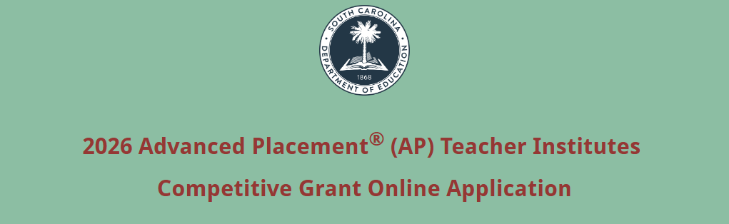

Enter the official name of the applicant organization and select the applicant type. Enter the applicant organization’s physical address with the 10-digit ZIP Code (ZIP+4 Code), UEI, and TIN (tax identification number). Provide a descriptive title of the project.
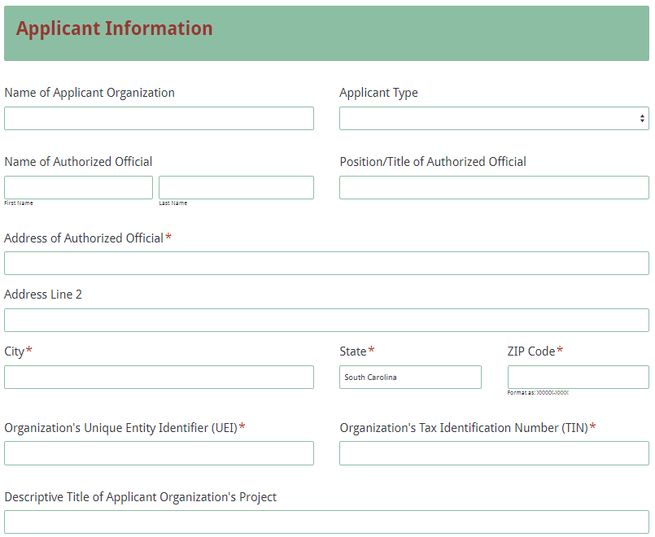
Enter the contact information for the project director. The name entered in the online application must match the project director’s name on the Certification Signature Page. The project director’s email is a required field. The project director will receive the confirmation email upon submission of the application. Reenter the email address to confirm that it is correct.
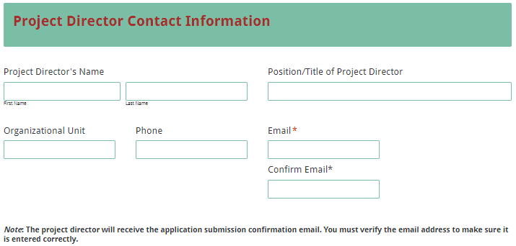

Enter amounts in the Funding Information and Budget Summary using whole dollars (no cents—round to the nearest dollar). Complete all fields and enter 0 (zero) for line items that are not applicable to the proposed project. In the Funding Information section, provide the total amount of funds requested for all AP Teacher Institutes combined for the period from March 1, 2026, through June 30, 2026.
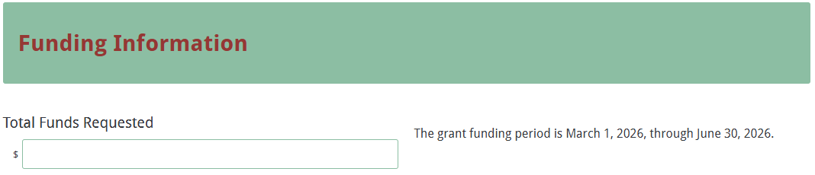

In the Budget Summary section, enter the line item totals for the funds requested. The Total Costs (Funds Requested) field will automatically calculate. This amount must match the total funds requested under the Funding Information section and the combined totals of the individual budget narratives for each proposed institute.

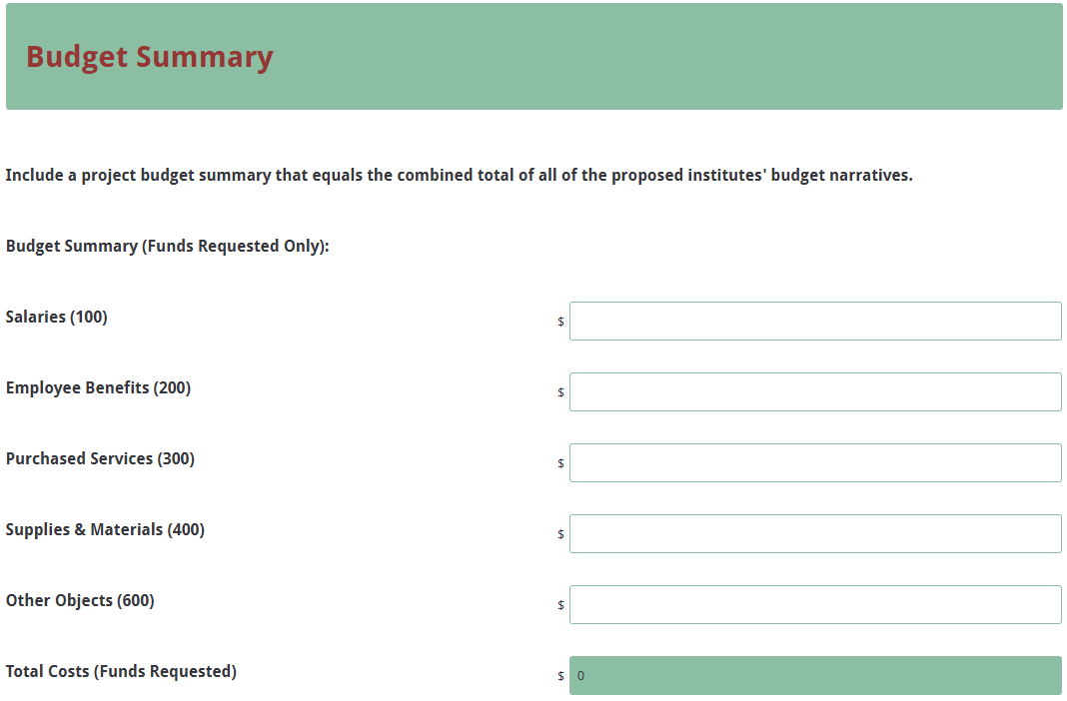

Select the number of proposed institutes from the dropdown box (up to twelve). Separate screens will be displayed based on the number of institutes selected to allow you to provide details and budgets for each proposed institute. If the number of institutes selected is incorrect, select the correct number from the dropdown menu.
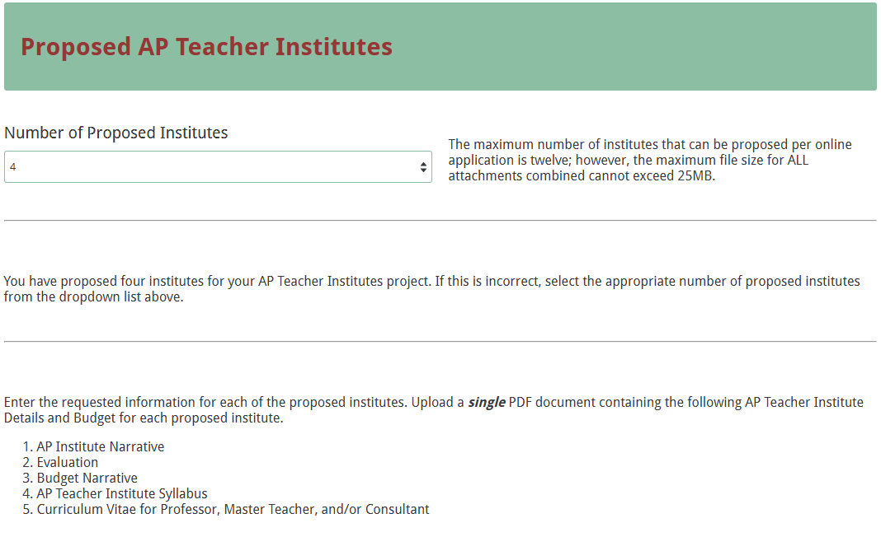

For each institute, enter the name of the AP subject area, the institute number and title, the total graduate hours to be awarded, the meeting dates, and the class time(s).
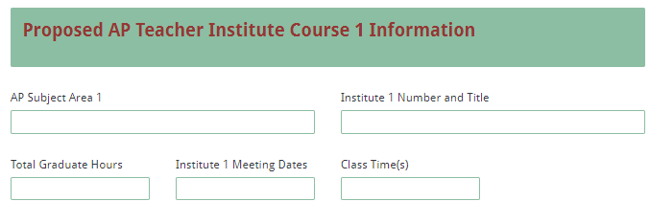

Provide the requested information for the professor. Indicate whether or not the curriculum vitae (CV) is included in the attachments for this institute (only one CV is required per person; see section F.4. on page 17).
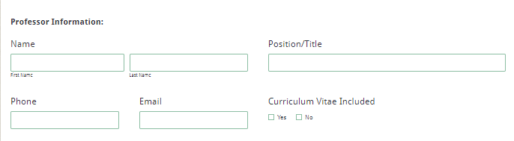

Provide the requested information for the master teacher. Indicate whether their CV is included in the attachments for this institute (respond “No” to indicate that the CV is included in the attachments for a previously entered institute). Indicate the most recent year that the master teacher taught an AP course and the most recent year they served as an AP reader.

Upload the PDF documents containing the AP Teacher Institute details and budget narrative for the individual institute.
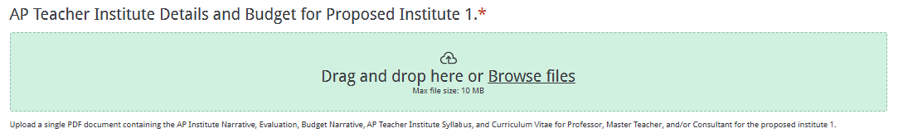

In the Attachments section, upload the Project Summary, Project Narrative, Certification Signature Page, and, if applicable, a copy of the signed agreement between the school district and the IHE in the appropriate format following the instructions.
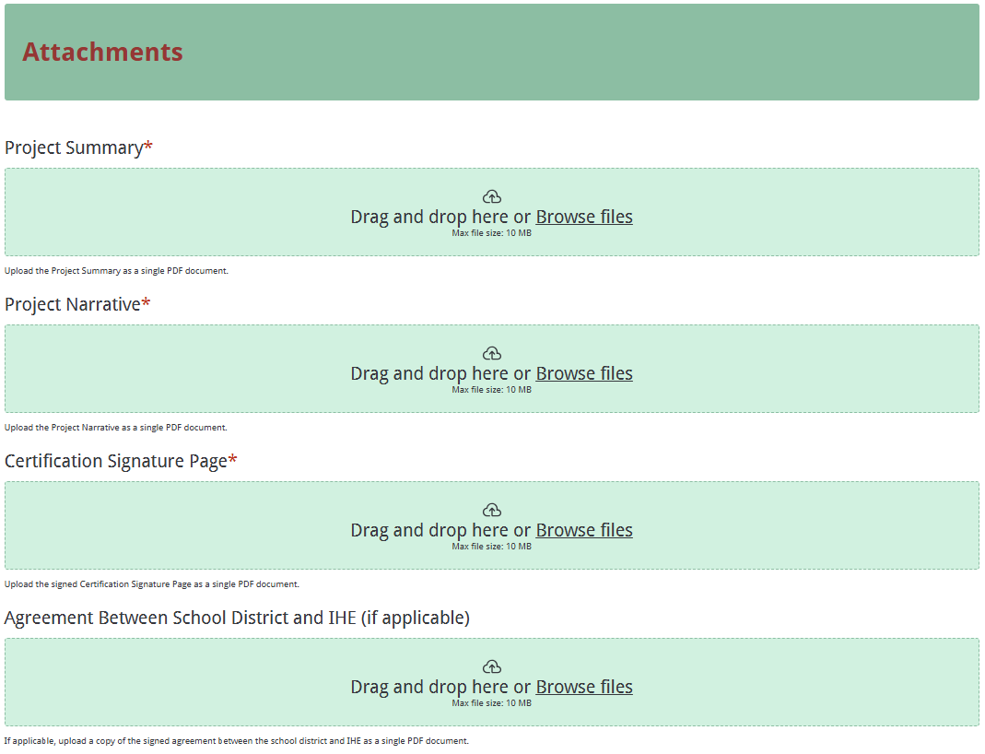

Before submitting the application, thoroughly review all information on the Data Review and Confirmation Page to verify that it has been entered correctly in the online application. You will not be able to access the application form after it has been submitted.
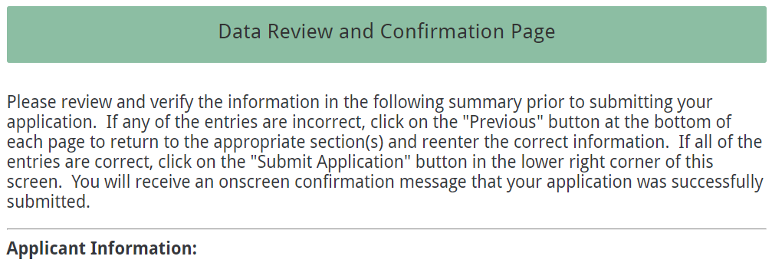

If any entries are incorrect, click on the "Previous" button at the bottom of each page to return to the appropriate section(s) and reenter the correct information. If all of the entries are correct, click on the “Submit Form” button in the lower right corner of this screen to complete the submission process.

Once the application is submitted, the following message will be displayed on the screen, and a submission confirmation will be sent to the email address entered for the project director.
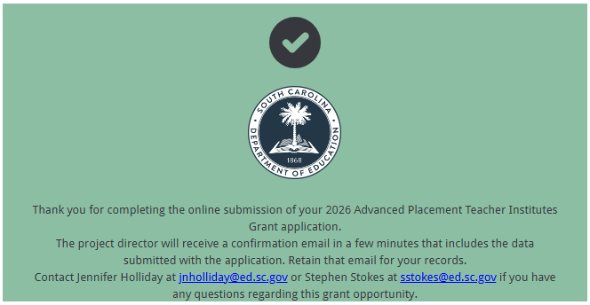

The following confirmation email will go to the email address entered for the project director (see page 20). If the project director does not receive a confirmation email, then the application did not submit successfully. You must resubmit the entire online form, including all attachments, in order for the application to be considered for funding.
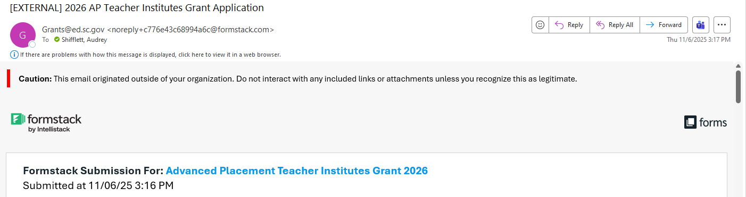

An email confirmation that your application was successfully uploaded and submitted does not account for the quality of the upload or its completeness. The confirmation email only notifies you that your online application has been submitted. Successfully uploaded grant narratives and attachments do not necessarily mean that the attachments are complete and that your application will be reviewed or considered for funding.

If you have concerns regarding the upload of any documents following submission, you may resubmit the entire online form prior to the application deadline. Only the most recently submitted, complete application will be reviewed.

Appendix A: Definitions of Terms Used

The Advanced Placement® (AP) Program offers students the opportunity to take college-level courses while in high school.

AP Central is the official online home for any professional interested in or involved with the AP program or Pre-AP strategies.

AP Potential is a free, web-based tool that allows schools to generate rosters of students who are likely to score a 3 or higher on a given AP® Exam based on their performance on the Preliminary Scholastic Assessment Test (PSAT)/National Merit Scholarship Qualifying Test (NMSQT®), PSAT™ 8/9, PSAT™ 10, or Scholastic Aptitude Test (SAT®). AP Potential is rooted in a long line of research showing moderate to strong correlations between PSAT/NMSQT® scores and AP Exam results, and that PSAT/NMSQT scores are stronger predictors of students’ AP Exam scores than the more traditional factors such as high school grades and grades in same-discipline course work. AP Potential is designed to help you increase access to AP and to ensure that no student who has the chance of succeeding in AP is overlooked.

The College Board is a mission-driven not-for-profit organization that connects students to college success and opportunity. Founded in 1900, the College Board was created to expand access to higher education. Today, the membership association is made up of more than 6,000 of the world’s leading educational institutions and is dedicated to promoting excellence and equity in education. Each year, the College Board helps more than seven million students prepare for a successful transition to college through programs and services in college readiness and college success—including the SAT and the AP Program. The organization also serves the education community through research and advocacy on behalf of students, educators and schools.

De-obligation—the downward adjustment of the obligations recorded in a grant award document. It is caused by factors such as (1) termination of part of the project, (2) reduction in material prices, (3) cost savings, or (4) correction of recorded amounts.

Appendix B: Selection Criteria and Reviewers’ Scoring Rubric

Selection Criteria

A total of 100 points is available to applications that meet the maximum score for each selection criteria. While the budget is assigned zero (0) points, the budget remains a critical component of the entire application. An application with an incomplete budget will not be funded.

The point values for each section of the application are as follows:
Narrative Sections | Points Available
Overall Project Narrative  Includes Project Description, Management and Personnel, and Evaluation Design | 30
Proposed AP Teacher Institute Details and Budget (per proposed institute)  Includes AP Institute Narrative; Evaluation; Budget Narrative; AP Teacher Institute Syllabus; and Curriculum Vitae of Professor, Master Teacher, and/or Consultant | 70
Budget (Summary and Narrative) | 0
TOTAL | 100

Scoring Rubric

Project Summary: The applicant must provide a one-page, concise description of the overall project to provide one or more AP Teacher Institutes and includes:
  - the number of institutes proposed
  - the number of teachers to be served,
  - the applicant’s name,
  - the amount requested, and
  - a list of applicable partners (IHEs or school districts).
Acceptable
Adequate/Meets—0 points
Applicant provides a narrative that fully addresses all required items.
Not Acceptable
Inadequate—0 points
Applicant provides a narrative that does not adequately address all required items.
Score
☐ Adequate/Meets ☐ Inadequate
Reviewer’s Comments

1.a. Project Narrative Content—Project Description: The applicant must provide a narrative that is a detailed description of all the following:
- the overall project to provide one or more AP Teacher Institutes;
- project goals and SMART objectives;
- the primary target audience; and
- the number of teachers to be served.
Acceptable
Fully Meets—4–5 points
Applicant provides a narrative that fully describes all required items.
Adequate/Meets—2–3 points
Applicant provides a narrative that moderately describes all required items.
Not Acceptable
Limited/Approaches—1 point
Applicant provides a narrative that is limited or unclear in describing all required items.
Inadequate—0 points
Applicant provides a narrative that does not adequately describe all required items.
Score
Reviewer’s Comments

1.b. Project Narrative Content—Project Description: The applicant provides a narrative that
- discusses the scope of the project;
- lists of the institute(s) that will be offered during the project term to meet the goals and objectives; and
- indicates the format for each institute (face-to-face, virtual, or hybrid model).
Acceptable
Fully Meets—4–5 points
Applicant provides a narrative that fully discusses all required items.
Adequate/Meets—2–3 points
Applicant provides a narrative that moderately discusses all required items.
Not Acceptable
Limited/Approaches—1 point
Applicant provides a narrative that is limited or unclear in discussing all required items.
Inadequate—0 points
Applicant provides a narrative that does not adequately discuss all required items.
Score

Reviewer’s Comments

2. Project Narrative Content—Management and Personnel: The applicant must provide a narrative that
- describes the plan to manage the overall project to provide one or more AP Teacher Institutes;
- includes details about the IHE’s and the district’s (as applicable) experience in providing AP Teacher Institutes including the types of institutes provided, number of years the institutes have been provided, and the delivery methods;
- lists the professors, master teachers, and consultants who will provide the AP Teacher Institutes, indicating their rank and whether they are College Board–endorsed; and
- discusses briefly the professor’s, master teacher’s, and consultant’s prior experience with the College Board and with providing AP Teacher Institutes.
Acceptable
Fully Meets—7–10 points
Applicant provides a narrative that fully describes all required items.
Adequate/Meets—4–6 points
Applicant provides a narrative that moderately describes all required items.
Not Acceptable
Limited/Approaches—2–3 points
Applicant provides a narrative that is limited or unclear in describing all required items.
Inadequate—0–1 point
Applicant provides a narrative that does not adequately describe all required items.
Score
Reviewer’s Comments

3. Project Narrative Content—Evaluation Design: The applicant must provide a narrative that
- explains the techniques, methods, and/or instruments used for determining the outcomes, effectiveness, impact, and changes resulting from the overall project to provide AP Teacher Institutes and the specific institute(s) conducted;
- Includes a plan to collect and report both quantitative and qualitative data for the programmatic final report;
- includes how the data will be collected and assessed (when and by whom); and
- discusses how they will use the participants’ evaluation responses to assess effectiveness of the proposed institute(s) and plan for subsequent institutes.
Acceptable
Fully Meets—7–10 points
Applicant provides a narrative that fully describes all required items.
Adequate/Meets—4–6 points
Applicant provides a narrative that moderately describes all required items.
Not Acceptable
Limited/Approaches—2–3 points
Applicant provides a narrative that is limited or unclear in describing all required items.
Inadequate—0–1 point
Applicant provides a narrative that does not adequately describe all required items.
Score
Reviewer’s Comments

1.a. Proposed AP Teacher Institute Details and Budget—AP Teacher Institute Narrative: The applicant must provide a narrative that
- describes in detail the instructional approach for the proposed institute;
- describes the materials to be used;
- explains how this approach is intended to meet the institute objectives stated in the syllabus;
- explains the goal and purpose of the proposed institute; and
- describes the roles of the professor, master teacher, and/or consultant.
Acceptable
Fully Meets—4–5 points
Applicant provides a narrative that fully details all required items.
Adequate/Meets—2–3 points
Applicant provides a narrative that moderately details all required items.
Not Acceptable
Limited/Approaches—1 point
Applicant provides a narrative that is limited or unclear in detailing all required items.
Inadequate—0 points
Applicant provides a narrative that does not adequately detail all the required items.
Score
Reviewer’s Comments

1.b. Proposed AP Teacher Institute Details and Budget—AP Teacher Institute Narrative: The applicant must provide a narrative that
- explains how content will be aligned with approved state curriculum standards as well as the College Board’s standards, including the use of AP Central and AP Potential, and the AP course audit; and
- describes the appropriate strategies and activities and details how they are intended to advance teacher and student learning and achieve the course objectives stated in the syllabus.
Acceptable
Fully Meets—7–10 points
Applicant provides a narrative that fully describes all required items.
Adequate/Meets—4–6 points
Applicant provides a narrative that moderately describes all required items.
Not Acceptable
Limited/Approaches—2–3 points
Applicant provides a narrative that is limited or unclear in describing all required items.
Inadequate—0–1 point
Applicant provides a narrative that does not adequately describe all required items.
Score
Reviewer’s Comments

1.c. Proposed AP Teacher Institute Details and Budget—AP Teacher Institute Narrative: The applicant must provide a narrative that
- lists all materials and publications that participants will receive as support materials in the institute;
- describes how these materials will be used; and
- includes all of the following support materials:
  - AP course description book appropriate for the institute,
  - AP teacher’s guide appropriate for the institute, and
  - free-response question booklet appropriate for the institute.
Acceptable
Fully Meets—4–5 points
Applicant provides a narrative that fully states and details all required items.
Adequate/Meets—2–3 points
Applicant provides a narrative that moderately states and details all required items.
Not Acceptable
Limited/Approaches—1 point
Applicant provides a narrative that is limited or unclear in stating and detailing all required items.
Inadequate—0 points
Applicant provides a narrative that does not adequately state and/or detail all required items.
Score
Reviewer’s Comments

2. Proposed AP Teacher Institute Details and Budget—Evaluation: The applicant must provide a narrative that describes the evaluation instrument to be used and the components to be evaluated and must include a copy of the course evaluation instrument to be used for the proposed institute.

An IHE that plans to use its own course evaluation instrument must provide a narrative that describes the following three items:
- the techniques, methods, and/or instruments for determining the institute outcomes, effectiveness, impact, and changes resulting from how they relate to the institute objectives stated in the syllabus;
- how participants will be evaluated and the basis for awarding credit; and
- how participants will evaluate the professor/master teacher/consultant and the delivery of the AP Teacher Institute.

Acceptable
Fully Meets—7–10 points
Applicant provides a narrative that fully describes and includes all required items.
Adequate/Meets—4–6 points
Applicant provides a narrative that moderately describes and includes all required items.
Not Acceptable
Limited/Approaches—2–3 points
Applicant provides a narrative that is limited or unclear in describing and including all required items.
Inadequate—0–1 point
Applicant provides a narrative that does not adequately describe and include all required items.
Score
Reviewer’s Comments

3. Proposed AP Teacher Institute Details and Budget—Budget Narrative: The applicant must provide a detailed budget narrative that includes
- clear evidence that the expenditures are adequate, reasonable, appropriate, and justified to support the activities in the proposed institute; and
- the formulas used to calculate the cost for each line item.
Acceptable
Adequate/Meets—0 points
Applicant provides a budget narrative that includes all required items.
Not Acceptable
Inadequate—0 points
Applicant provides a budget narrative that did not include all required items.
Score
☒ Adequate/Meets ☐ Inadequate
Reviewer’s Comments

4. Proposed AP Teacher Institute Details and Budget—AP Teacher Institute Syllabus: The applicant must provide a daily syllabus that summarizes the content, participant activities, and requirements for the proposed AP Teacher Institute, and must include
- the course components, including the course name/title and number, number of graduate credits awarded, the meeting dates and items to reflect adequate course duration and frequency of instructional activities (i.e., instructional time and the number of times the course will meet);
- the specific performance standards for the institute:
- how the course readings, assignments, and assessments will ensure competency with the specific AP standards;
- clearly defined SMART objectives for the institute;
- the content to be addressed in each class meeting and the participant activities and requirements;
- core content related to the discipline; and
- instructional strategies for teaching the AP course, and the preparation of K–12 students to successfully complete the course of study and write the four-page AP examination.
Acceptable
Fully Meets—18–25 points
Applicant provides a syllabus that fully summarizes all required items.
Adequate/Meets—12–17 points
Applicant provides a syllabus that moderately summarizes all required items.
Not Acceptable
Limited/Approaches—6–11 points
Applicant provides a syllabus that is limited or incomplete in summarizing all required items.
Inadequate—0–5 points
Applicant provides a syllabus that does not adequately summarize all required items.
Score
Reviewer’s Comments

5. Proposed AP Teacher Institute Details and Budget—Curriculum Vitae of Professor, Master Teacher, and/or Consultant: The applicant must include a curriculum vitae (CV) for the professor, master teacher, and/or consultant for the proposed institute that addresses
- their unique qualifications and experience regarding AP education and courses; and
- evidence that the person has the required experience and qualifications for the proposed institute.

If a CV is applicable to more than one institute being proposed, the applicant indicates all institute titles at the top of the CV.
Acceptable
Fully Meets—12–15 points
Applicant provides a CV that fully addresses all required items.
Adequate/Meets—8–11 points
Applicant provides a CV that moderately addresses all required items.
Not Acceptable
Limited/Approaches—4–7 points
Applicant provides a CV that is limited or incomplete in addressing all required items.
Inadequate—0–3 points
Applicant provides a CV that does not adequately address all required items.
Score
Reviewer’s Comments

Appendix C: Required SCDE Forms

Certification Signature Page

Certification
I hereby certify that, to the best of my knowledge, the information and data contained in this application are true and correct. The applicant’s governing body has duly authorized this application and documentation, and the applicant will comply with the Program Specific Assurances (if applicable) and the SCDE Assurances and Terms and Conditions if the grant is awarded. The applicant has a unique entity identifier (UEI) issued by the federal System for Award Management (SAM). I certify to the best of my knowledge and belief that the information provided herein is true, complete, and accurate. I am aware that the provision of false, fictitious, or fraudulent information, or the omission of any material fact, may subject me to criminal, civil, or administrative consequences including, but not limited to violations of U.S. Code Title 18, Sections 2, 1001, 1343 and Title 31, Sections 3729-3730 and 3801-3812.

Authorized Official
Name:
Position: | Email:
Telephone: | Fax:

Signature of Authorized Official: | Typed name of Authorized Official:
Date Signed:
Signature of Financial Official (if not authorized official): | Typed Name of Financial Official:
Date Signed:
Project Director: | Typed Name of Project Director:
Date Signed:

Please complete, print, and obtain signatures prior to submission. Include the signed, scanned form in the required attachments as indicated on page 17.

Assurances and Terms and Conditions for State Awards

Assurances
I certify that this applicant
- Has the legal authority to apply for state assistance and the institutional, managerial, and financial capability (including funds sufficient to pay the nonstate share of project costs) to ensure proper planning, management, and completion of the project described in this application.
- Will give the South Carolina Department of Education (SCDE) access to and the right to examine all records, books, papers, or documents related to this award and will establish a proper accounting system in accordance with generally accepted accounting principles (GAAP) or agency directives.
- Has an accounting system that includes sufficient internal controls, a clear audit trail, and written cost-allocation procedures as necessary. The financial management systems are capable of distinguishing expenditures that are attributable to this grant from those that are not attributable to this grant. This system is able to identify costs by programmatic year and by budget line item and to differentiate among direct, indirect, and administrative costs. In addition, the applicant will maintain adequate supporting documents for the expenditures and in-kind contributions, regardless of the type of funds, if any, that it makes under this grant. Costs are shown in books or records (e.g., disbursements ledger, journal, payroll register) and are supported by a source document such as a receipt, travel voucher, invoice, bill, or in-kind voucher.
- Will also comply with GAAP as it relates to budgets, budget amendments, and expenditure claim submissions.
- Will approve all expenditures, document receipt of goods and services, and record payments on the applicant’s accounting records prior to submission of reimbursement claims to the SCDE for costs related to this grant.
- Will initiate and complete work within the applicable time frame after receipt of approval by the SCDE.
- Will not discriminate against any employee or applicant for employment because of race, color, religion, age, sex, national origin, or disability. The applicant will take affirmative action to ensure that applicants for employment and the employees during the period of their employment are treated without regard to their race, color, religion, age, sex, national origin, or disability.
- Will comply with the Ethics, Government Accountability, and Campaign Reform Act (S.C. Code Ann. § 2-17-10 et seq. and § 8-13-100 et seq. (Supp. 2024)).
- Will comply with the Drug Free Workplace Act (S.C. Code Ann. § 44-107-10 et seq. (Supp. 2024)) if the amount of this award is $50,000 or more.
- Will comply with the requirements of Proviso 1.78, H. 4025, 126th Leg., 2nd Reg. Sess. (S.C. 2025), available at https://www.scstatehouse.gov/sess126_2025-2026/appropriations2025/crp1b.pdfhttps://www.sc.statehouse.gov/sess125_2023-2024/appropriations2024/gab5100.php.
- Will not use grant funds in a manner inconsistent with the South Carolina Department of Education (SCDE) guidance to districts and staff on federal education policy changes and terminology and data collection practices. Those documents are available at https://ed.sc.gov/newsroom/school-district-memoranda-archive/update-on-federal-education-policy-changes/update-on-federal-education-policy-changes-memo/ and https://ed.sc.gov/newsroom/guidance-regarding-terminology-and-data-collection-practices/.
- Will not use grant funds in a manner inconsistent with state regulations including Regulation 43-170. Guidance is available at https://ed.sc.gov/state-board/state-board-of-education/uniform-procedure-for-selection-or-reconsideration-of-instructional-materials/.

Terms and Conditions

- Completeness of Proposal. All proposals should be complete and carefully worded and must contain all of the information requested by the South Carolina Department of Education (SCDE). If you do not believe a section applies to your proposal, please indicate that fact.
- Non-awards/Termination. The SCDE reserves the right to reject any and all applications and to refuse to grant monies under this solicitation. If the SCDE rejects an application, the applicant has a right to request a review of the process consistent with the appeals process presented in the Request for Proposals (RFP).
After it has been awarded, the SCDE may terminate a grant by giving the grantee written notice of termination. In the event of a termination after award, the SCDE shall reimburse the grantee for expenses incurred up to the notification of termination. In addition, this grant may be terminated by the SCDE if the grantee fails to perform as promised in its proposal.
Upon the termination of a grant, the grantee shall have the right to a review process. The grantee must notify the SCDE of its request within 30 days of receiving written notice of the termination.
- Reduction in Budgets and Negotiations. The SCDE reserves the right to negotiate budgets with potential grantees. The SCDE may, at its sole discretion, determine that a proposed budget is excessive and may negotiate a lower budget with the applicant. The applicant may at that time negotiate or withdraw its proposal. In addition, the SCDE may desire to fund a project but not at the level proposed. In that case, the SCDE shall notify the applicant of the amount that can be funded, and the applicant and the SCDE shall negotiate a modification to the proposal to accommodate the lower budget. All final decisions are that of the SCDE.
- Amendments to Grants. Amendments are permitted upon the mutual agreement of the parties and will become effective when specified in writing and signed by both parties.
- Use of Grant Funds. Funds awarded are to be expended only for purposes and activities covered by the approved project plan, budget, and budget narrative.
- Submission of Expenditure Reports. Claims for reimbursement must be made at least quarterly and consistent with calendar quarters (e.g., an expenditure report claim for costs for January 1 through March 30 must be filed by May 15).
- Obligation of Grant Funds. Grant funds may not be obligated prior to the effective date or subsequent to the end or termination date of the grant period. No obligations are allowed after the end of the grant period. The final request for expenditure report claims must be submitted no later than forty-five (45) days after the end of the grant period unless the scope of work for the grant states a shorter reporting period.
- Deobligation of Funds. After a final expenditure claim has been submitted to the SCDE, the grantee will go through the official deobligation process with the SCDE.
- Documentation. The grantee must provide for accurate and timely recording of receipts and expenditures. The grantee’s accounting system should distinguish receipts and expenditures attributable to each grant. The grantee must review the memo regarding “Guidelines for Retaining Documentation to Support Expenditure Claims.”
- Travel Costs. Travel costs, if allowed under this solicitation, must not exceed limits noted in the United States General Services Administration (GSA) per diem rates for lodging, except in the case of conference lodging required for program-required training. In the case that conference-related lodging exceeds the GSA per diem rate, the grantee shall follow their entity’s written procedure for obtaining prior approval to exceed a GSA rate for a conference hotel. Meals and incidentals are limited by the state budget proviso, currently not to exceed $35 per day for in-state travel and $50 for out-of-state travel (see page 81 of the State of South Carolina Statewide Disbursement Regulations). Mileage reimbursement must follow the current Office of Comptroller General instructions, which is consistent with the published IRS rates.
- Honoraria. Amounts paid in honoraria, if allowed under this grant, must be consistent with SCDE policies. Applicants should check with the program office before budgeting for honoraria.
- Reports. The grantee shall submit, as required or instructed by the awarding program office, all reports (programmatic, financial, or evaluation) within the specified period or date and in the prescribed format. An expenditure claim report must be filed by July 5 for all expenditures incurred by June 30 in order to comply with the generally accepted accounting principles (GAAP) and the production of the State's Annual Comprehensive Financial Report.
- Copyright. The grantee is free to copyright any books, publications, or other copyrightable materials developed in the course of this grant. However, the SCDE reserves a royalty-free, nonexclusive, and irrevocable license to reproduce, publish, or otherwise use, and to authorize others to use, the copyrighted work developed under this grant.
- Certification Regarding Suspension and Debarment. By submitting an application, the applicant certifies, to the best of its knowledge and belief, that the
- Applicant and/or any of its principals, subgrantees, or subcontractors
  - are not presently debarred, suspended, proposed for debarment, or declared ineligible for the award of contracts by any state or federal agency; have not, within a three-year period preceding this application, been convicted of or had a civil judgment rendered against them for commission of fraud or a criminal offense in connection with obtaining, attempting to obtain, or performing a public (federal, state, or local) contract or subcontract; violation of federal or state antitrust statutes relating to the submission of offers; or commission of embezzlement, theft, forgery, bribery, falsification or destruction of records, making false statements, tax evasion, or receiving stolen property; and
  - are not presently indicted for, or otherwise criminally or civilly charged by a governmental entity with, commission of any of the offenses enumerated above.
- Applicant has not, within a three-year period preceding this application, had one or more contracts terminated for default by any public (federal, state, or local) entity.
- Audits. Although this Assurances, Terms, and Conditions document is for a state award, federal audit requirements apply as follows:
- Entities expending $1,000,000 or more in federal awards:
Entities that expend $1,000,000 or more in federal awards during the fiscal year are required to have an audit performed in accordance with the provisions of 2 CFR Part 200.501, et seq. Except for the provisions for biennial audits provided in 2 CFR Part 200.504 (a) and (b), audits must be performed annually as stated at 2 CFR Part 200.504. A grantee that passes through funds to subrecipients has the responsibility of ensuring that federal awards are used for authorized purposes in compliance with federal program laws, federal and state regulations, and grant agreements. The director of the OMB, who will review this amount every two years, has the option of revising the threshold upward. Audits must be conducted in accordance with Government Auditing Standards (Yellow Book).
- Entities expending less than $1,000,000 in federal awards:
Entities that expend less than $1,000,000 in a fiscal year in federal awards are exempt from the audit requirements in 2 CFR Part 200.504. However, such entities are not exempt from other federal requirements (including those to maintain records) concerning federal awards provided to the entity. The entity’s records must be available for review or audit by the SCDE and appropriate officials of federal agencies, pass-through entities, and the General Accounting Office (GAO). Audits must be conducted in accordance with Government Auditing Standards (Yellow Book).
- Records. The grantee shall retain grant records, including financial records and supporting documentation, for a minimum of six (6) years after the end date of the grant when the final expenditure report claim for reimbursement and all final reports have been submitted, unless informed otherwise or in case of litigation.
- Electronic Signature Agreement. I agree that my electronic signature is the legally binding equivalent to my handwritten signature.

Budget Narrative Template

For informational purposes only.
Go to the AP Teacher Institute SCDE Grant Opportunity page to obtain the Excel Spreadsheet. Modify the headings to fit the grant term.

