Memorandum

TO: District Superintendents
District School Food Service Directors/Supervisors
Elementary School Principals

FROM: Ellen Mason
Interim Director, Office of Health and Nutrition

DATE: April 15, 2025

RE: 2025–26 Fresh Fruit and Vegetable Subgrant Program

Funding for the Fresh Fruit and Vegetable Program (FFVP) is available for the 2025–26 school year through Section 19 of the Richard B. Russell National School Lunch Act. The purpose of the FFVP is to provide students in participating schools with a variety of free fresh fruit and vegetables as healthy snack options throughout the school day (at times other than at breakfast, lunch, or in an afterschool program).

The FFVP targets elementary schools with the highest percentage of students eligible for free and reduced-price meals (at least 50 percent or higher). Schools will be selected based on the highest percentage of eligible students using the October 2024 Meal Count Data by Site (SNP Lunch) data collected in the South Carolina Automated Payment System (SCAPS).

The SCDE will offer a pre-application technical assistance webinar via Adobe Connect on April 28, 2025, from 10:00 a.m. until 11:30 a.m. Participants may log in up to 30 minutes in advance of the session to test their equipment and download handouts. For repeat participants, while participation is not mandatory in order to submit an application, it is highly recommended. For first-time applicants, it is mandatory to attend this session.

Eligible public schools (current participants and new applicants) must submit an application online no later than 11:59 p.m. on Monday, May 19, 2025, to the South Carolina Department of Education’s (SCDE’s) Office of Health and Nutrition. The Application Submission Instructions (below) provide directions on how to properly complete and submit the application. Additional information is available on SCDE’s FFVP Grant Opportunities Web site. Applications received after the deadline will not be considered for funding. If you have any questions or require assistance, please contact FFVP@ed.sc.gov, Diane D. Gillie at 803-734-8193 or Imani Wilson-Peterkin at 803-734-4586.

We hope that you will consider participating in the FFVP as another way to help your students develop lifelong healthy eating habits.

South Carolina Department of Education
Fresh Fruit and Vegetable Program

2025–26 Application Submission Instructions

Funding Authorization
The Fresh Fruit and Vegetable Program (FFVP) is authorized under Section 19 (42 U.S.C. 1769a) of the Richard B. Russell National School Lunch Act. The U.S. Department of Agriculture (USDA) allocates federal funds to enable the SCDE to manage and monitor this subgrant program (Assistance Listings #10.582).

Program Purpose
The purpose of the FFVP is for elementary schools to provide free fresh fruits and vegetables to students throughout the school day. It is an effective and creative way to introduce fresh fruits and vegetables as healthy snack options. The FFVP also encourages schools to develop partnerships at the state and local levels to support implementing and operating the program.

The goals of the FFVP are to create healthier school environments by providing healthier food choices to
- expand the variety of fruits and vegetables children experience,
- increase children’s fruit and vegetable consumption, and
- make a difference in children’s diets to impact their present and future health.

The FFVP introduces school children to a variety of produce that they otherwise might not have the opportunity to sample.

Eligibility and Selection Criteria
Eligible schools, including residential childcare centers and private, parochial, and charter schools, must submit an application to the SCDE’s Office of Health and Nutrition based on this guidance and the USDA. Section 19 of the National School Lunch Act requires the following selection criteria for participating schools:
- Only elementary schools may participate. An eligible elementary school (as defined in section 9101 of the Elementary and Secondary Education Act of 1965 (20 U.S.C. 7801)) is a nonprofit institutional day or residential school, including a public elementary charter school, which provides elementary education, as determined under state law. Section 59-1-150 of the Code of Laws of South Carolina defines an elementary school as “any public school which contains grades no lower than kindergarten and no higher than eighth.”
- Selected schools must also operate the National School Lunch Program.
- Each interested school must submit an application for participation in the FFVP.
- Each selected school must have 50 percent or more of its students eligible for free and reduced-price meals. Schools electing to participate in the Community Eligibility Provision (CEP) are eligible to participate in the FFVP. The product of the Identified Student Percentage (ISP) multiplied by 1.6 will be used for the purpose of awarding FFVP funds because the 1.6 multiplier is intended to provide an estimate of the total number of students eligible for free and reduced-price meals in eligible schools. Schools in districts electing CEP for the entire district or as part of a group of schools electing CEP with a shared ISP will be subject to the individual school CEP percentage when FFVP awards are determined.
- Highest priority must be given to schools with the highest percentages of low-income students.
- The total enrollment of all schools receiving a subaward must result in a per-student allocation of at least $50 per year.

Residential childcare centers and private, parochial, and charter schools that want to apply to participate in the FFVP for the first time must have a site visit by the SCDE’s Office of Health and Nutrition prior to receiving a subgrant award; this site visit is to confirm sufficient logistics are in place to support successful FFVP implementation.

Applicants may be subjected to an evaluation of their financial system, internal controls, and policies and procedures by the SCDE’s Office of Auditing Services before a subgrant is issued or during the subgrant term. Review the Pre-Award Audit Resources to access the review process and procedures.

Technical Assistance Session
The Office of Health and Nutrition will offer a pre-award technical assistance session via Adobe Connect on April 28, 2025, from 10:00 a.m. until 11:30 a.m. No password is required to join the session. Participants should enter their full names when logging into the session. Participants will be able to log in 30 minutes prior to the start of the session to test their equipment’s audio settings and to download/print handouts. While participation is not mandatory to submit an application, it is highly recommended.

Applicable Federal and State Regulations
Applicants should review the following federal regulations, accessible at the electronic Code of Federal Regulations (e-CFR) Web site that are applicable to the FFVP program. Applicants are reminded that, if funded, their programs must comply with these regulations.
- 2 CFR Part 25—Universal Identifier and System for Award Management
- 2 CFR Part 170—Reporting Subaward and Executive Compensation Information
- 2 CFR Part 175—Award Term for Trafficking in Persons
- 2 CFR Part 180—OMB Guidelines to Agencies on Government-wide Debarment and Suspension (Non-Procurement) as adopted at 2 CFR Part 417
- 2 CFR Part 200—Uniform Administrative Requirements, Cost Principles, and Audit Requirements for Federal Awards as adopted at 2 CFR Part 400
- 2 CFR Part 415—USDA General Program Administrative Regulations
- 2 CFR Part 416—USDA General Program Administrative Regulations for Grants and Cooperative Agreements to State and Local Governments
- 2 CFR Part 418—USDA New Restrictions on Lobbying
- 2 CFR Part 421—Requirements for Drug Free Workplace (Financial Assistance)
- 7 CFR Part 15—Nondiscrimination
- 7 CFR Part 210—National School Lunch Program
- 41 U.S.C. Section 22—Interest of Member of Congress
- Duncan Hunter National Defense Authorization Act of FY 2009 (Pub. L. No. 110-417)
- Sections 738 and 739 of the Agriculture, Rural Development, Food and Drug Administration, and Related Agencies Appropriation Act, 2012 (Pub. L. No. 112-55)
- Federal Funding Accountability and Transparency Act (FFATA), September 26, 2006
- Freedom of Information Act (FOIA)—Public access to Federal Financial Assistance records shall not be limited, except when such records must be kept confidential and would have been excepted from disclosure pursuant to the “Freedom of Information” regulation (5 U.S.C. 552).

USDA Nondiscrimination Statement
In accordance with Federal civil rights law and U.S. Department of Agriculture (USDA) civil rights regulations and policies, the USDA, its Agencies, offices, and employees, and institutions participating in or administering USDA programs are prohibited from discriminating based on race, color, national origin, religion, sex, disability, age, marital status, family/parental status, income derived from a public assistance program, political beliefs, or reprisal or retaliation for prior civil rights activity, in any program or activity conducted or funded by USDA (not all bases apply to all programs). Remedies and complaint filing deadlines vary by program or incident.

Persons with disabilities who require alternative means of communication for program information (e.g., Braille, large print, audiotape, American Sign Language, etc.) should contact the State or local Agency that administers the program or contact USDA through the Telecommunications Relay Service at 711 (voice and TTY). Additionally, program information may be made available in languages other than English.

To file a program discrimination complaint, complete the USDA Program Discrimination Complaint Form, AD-3027, found online at How to File a Program Discrimination Complaint and at any USDA office or write a letter addressed to USDA and provide in the letter all of the information requested in the form. To request a copy of the complaint form, call (866) 632-9992. Submit your completed form or letter to USDA by:

- mail: U.S. Department of Agriculture
Office of the Assistant Secretary for Civil Rights
1400 Independence Avenue, SW,
Mail Stop 9410,
Washington, D.C. 20250-9410;

- fax: (202) 690-7442; or

- email: program.intake@usda.gov.

USDA is an equal opportunity provider and employer.

Unique Entity Identifier and System for Award Management—2 CFR Part 25
All applicants must obtain a unique entity identifier (UEI) from the federal System for Award Management (SAM). The applicant must include a valid UEI in the online application. The SCDE will not make a subaward of federal funds to an applicant that does not comply with the requirements described in 2 CFR 25 to provide a valid UEI. For assistance and more information, see the Federal Service Desk frequently asked questions.

Note that for an organization to receive a direct grant from the federal government, the organization must be registered and maintain an active registration in SAM prior to and throughout the application and award process. To receive a subaward from the SCDE, only the valid UEI is required.

Applicants and all signatories should review the Assurances and Terms and Conditions for USDA Subawards (on pages 19–22) to ensure that, if awarded a subgrant, they are capable of full compliance, especially with all the referenced federal regulations and state laws, in order to enter into an agreement with the SCDE for this program. For example, in compliance with 2 CFR Part 200.112, applicants must disclose in writing any potential conflict of interest to the SCDE in accordance with the conflict-of-interest policy of the USDA. Districts/schools must oversee all contractors in compliance with 2 CFR Part 200.318. A signed Certification Signature Page (page 23) is required with the application and legally binds the applicant to the agency’s assurance and terms and conditions.

Allowable Use of Funds
Contingent upon funding from the USDA, approximately $3.5 million will be available for new subgrants in this 2025–26 funding cycle. The FFVP funding period is July 1, 2025, through June 30, 2026. The level of funding provided to any selected school will be $50 per student. The total amount of funds each school will receive will be based on the October 2024 Eligibility Report—Meal Count Data by Site (SNP Lunch) data in SCAPS. Applicants must confirm with the district school food service director/supervisor that the correct free and reduced-price percentage is entered in the application for the school.

Funds must be used primarily to purchase fresh fruits and vegetables to be made available at no charge to all students. No more than 10 percent of subgrant funds may be used for administrative costs, such as labor costs for planning the program, managing the paperwork, obtaining the equipment needed, and all other aspects of FFVP that are not related to the preparation and service of fruits and vegetables. The program should be structured so that the maximum amount of funds can be spent on fruits and vegetables for student consumption.

Costs reported by the school for reimbursement must be allowable, actual costs and fully documented. Schools must report labor costs in a manner that clearly identifies the actual time allocated to the FFVP.

Schools that contract with food service management companies (FSMC) must ensure that the FSMC is aware of all FFVP policies and rules and must carefully assess all contractual provisions allowing the FSMC to charge costs other than actual costs of fresh fruits and vegetables.

Expectations of Participating Schools
Participating schools must make free fresh fruits and vegetables available to all enrolled students at times other than at meal service periods (i.e., breakfast, lunch, or in an afterschool program). Participating elementary schools will provide information about participation, purchasing, and program costs to the SCDE’s Office of Health and Nutrition through the district’s School Food Authority (SFA). Schools and districts must comply with all requests made by the SCDE and the USDA.

Monitoring of each school’s budget is critical in the success of the program; therefore, schools will develop and maintain a budget at the school level. Schools are expected to exercise due diligence in spending their entire allocation. Funds are distributed on a reimbursement basis. Monthly claims will be submitted and processed through the SCAPS by the district’s SFA.

Schools are required to submit a semi-annual and an end-of-year report to the Office of Health and Nutrition that reflects the elementary school’s participation in the FFVP for 2025–26. The semi-annual report will include the school’s FFVP activities from the project start date through December 31, 2025, and will be due by January 31, 2026. The end-of-year report will reflect the activities from January 1, 202, through June 30, 2026, and will be due by August 15, 2026. The Office of Health and Nutrition will provide more information to subgrantees. Information to be reported may include
- when and where the FFVP snacks were distributed,
- which fruits and vegetables were the most and least successful,
- what type of nutrition education was provided,
- which community partners were involved and how,
- what lead to increased fruit and vegetable consumption in school meals, and
- what challenges have been confronted.

How to Apply
To participate in the program, a school must submit the FFVP application online by 11:59 p.m., Monday, May 19, 2025. The FFVP school team should coordinate with the district’s school food service director to successfully complete the application for submission by the deadline.

While the application form will be active and open until 11:59 p.m. Eastern Time on May 19, 2025, technical support is not available to help with a submission or to answer questions between 5:01 p.m. and 11:59 p.m. We strongly encourage you to start early with your application and secure all necessary signatures well before the deadline date. A submitted application is not complete without the Certification Signature Page with all required signatures and will not be considered for a subaward.

Applicants must complete the information requested online and submit an application that includes the School Proposal Narrative and signed Certification Signature Page. Follow the order below to ensure all information is collected, prepared, and saved as directed prior to completing the online submission.
- Prepare the School Proposal Narrative based on your school’s plan to implement the FFVP program and following the directions starting on page 10.
- Obtain all signatures on the Certification Signature Page and save it as a PDF document.
- Compile the information to be entered online using the screenshots below.

Application Content Information
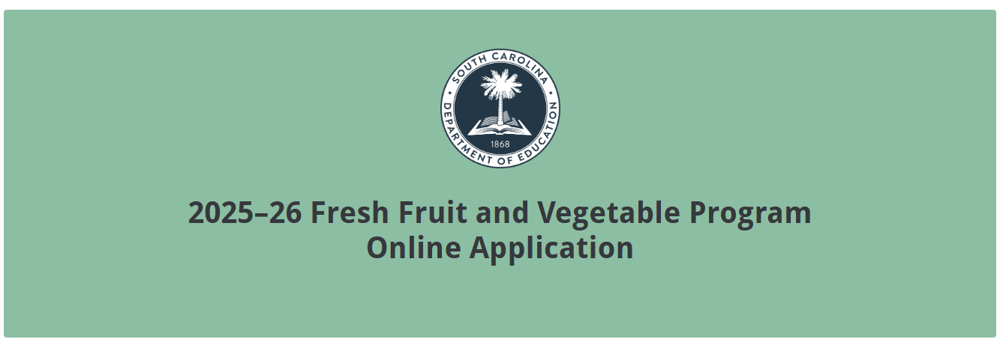
Applicant Information
Indicate if your school received funding in 2024-25. Provide the formal name of the school and the school district. Include the applicant’s 10-digit ZIP code (ZIP + 4). Enter the district’s UEI and tax identification number (TIN).
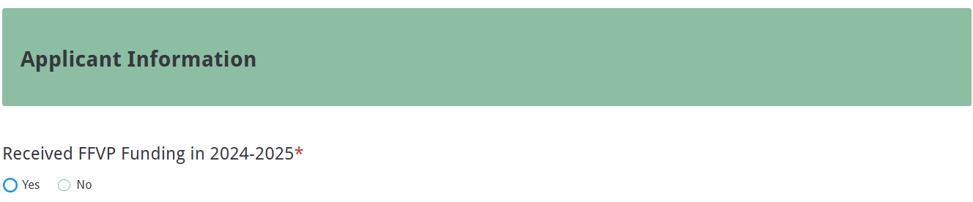
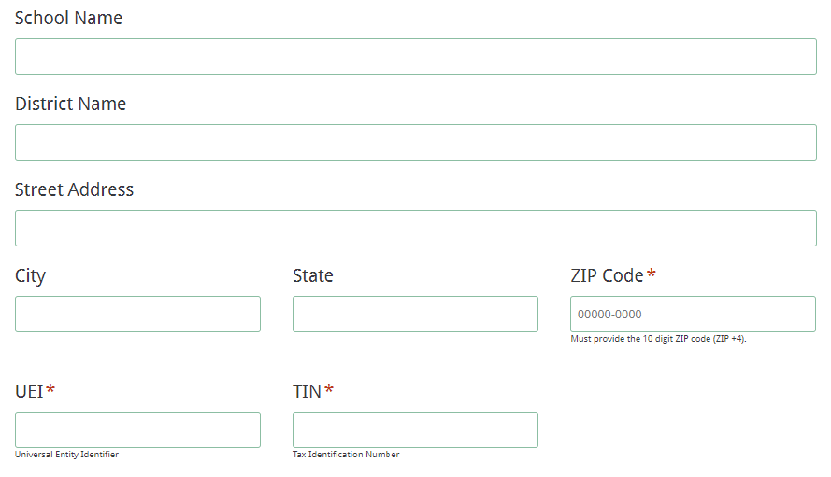
School-Level Contact Information
Provide the requested information including a valid email address for the school-level contact person who will be the FFVP team leader at the school. This person will receive the application submission confirmation email.
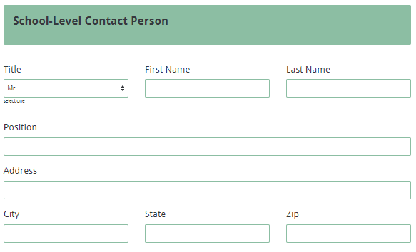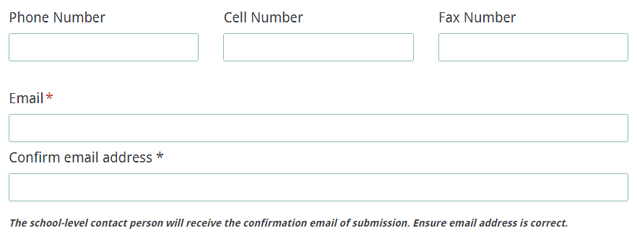

Summer Contact Information
Provide the requested information including a valid email address for the summer contact person. The summer contact person will be the FFVP secondary contact for summer if the school-level contact is not available for summer session.

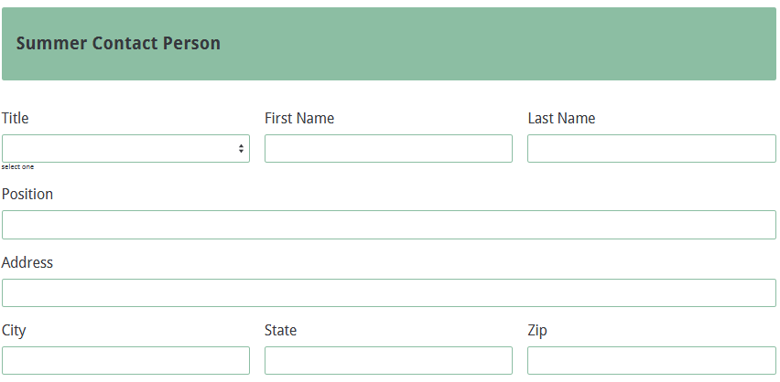
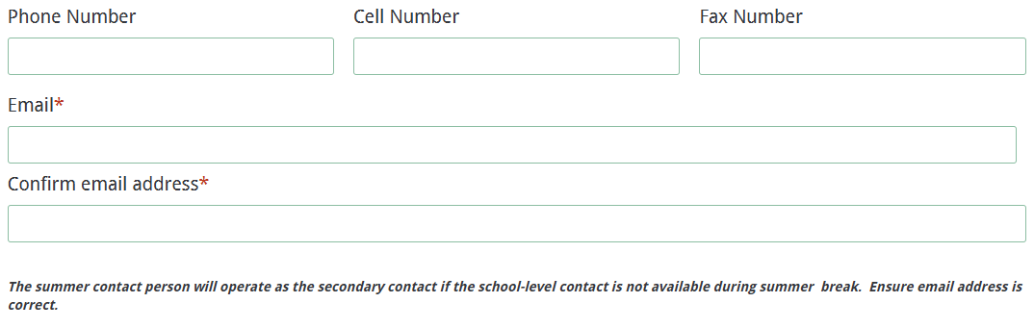

School Data
Provide the data requested below. Indicate the school location and meals offered. Enter the ADM from the October 2024 report in SCAPS, including only the membership for eligible grades (K–8). Confirm with the district’s school food service director/supervisor the correct free and reduced-price percentage for your school.

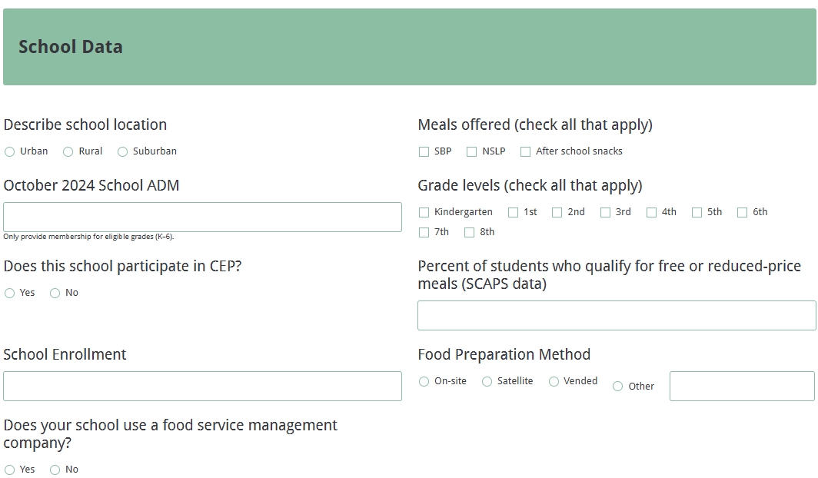

School Proposal Narrative
Prepare the School Proposal Narrative based on your school’s plan to implement the FFVP.
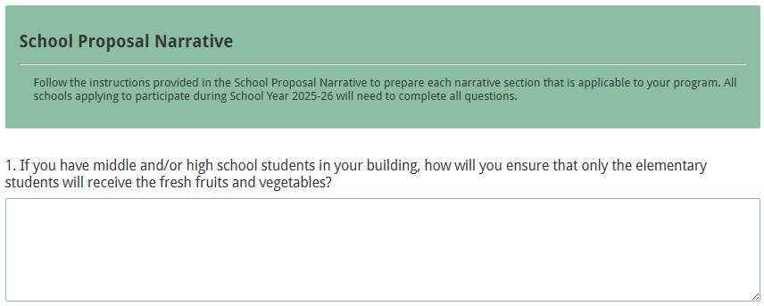
All schools applying to participate in the 2025-26 FFVP must complete the entire proposal narrative as outlined below. Draft responses for each item in a Word document. Once the proposal narrative is complete, cut and paste the response to each item into the online application where appropriate (see the screenshots below).

- If you have middle and/or high school students in your building, how will you ensure that only the elementary students will receive the fresh fruits and vegetables?
- Identify two or three reasons why this school should be chosen to participate in this Program.
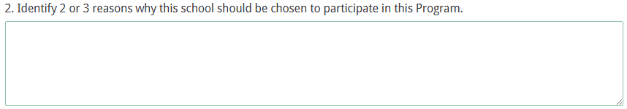

- Describe the level of support and commitment of the School Administration and Staff for this Program.
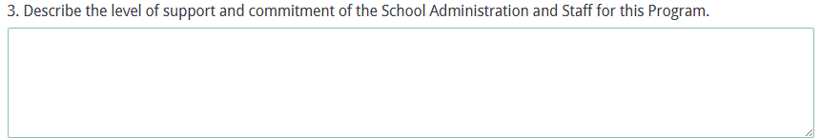Describe the plan you have for distributing the fresh fruit and vegetable snacks to students to include the involvement of volunteers, students, teachers, parents, and community partners who may be assisting.
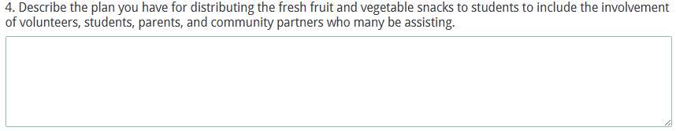

- Identify when and where distribution of the produce for the FFVP snack is planned to maximize opportunities for all students.
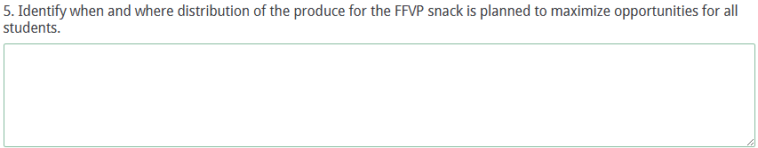

- How many days per week will the FFVP snack be served?
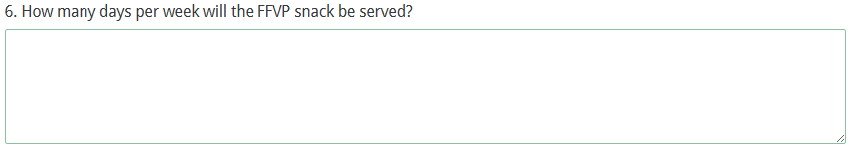

- How many days will the fresh fruits and vegetables be served during the months of July, August, and September (using the first allocation)?
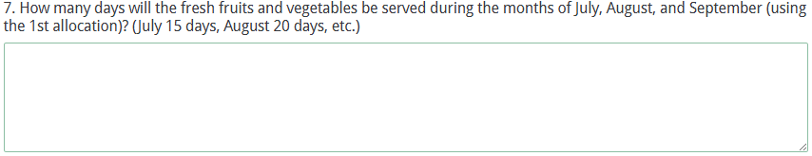

- How will the fresh fruits and vegetables be purchased and prepared?
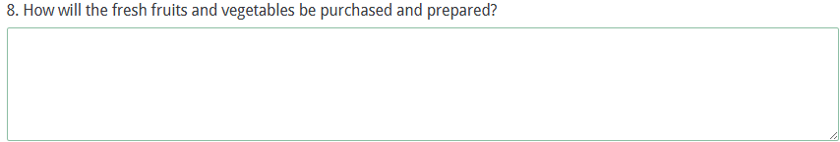
- How will the FFVP purchases (fruits, vegetables, small supplies, equipment, etc.) and labor be kept separate from those of other school meals programs?
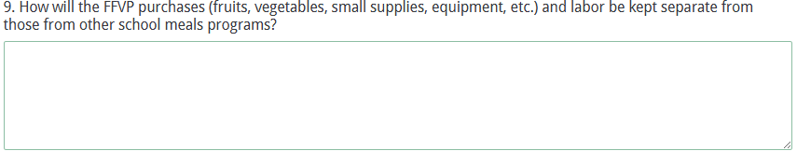

- How will the FFVP award be tracked for remaining balance, spending rate, and administrative costs?
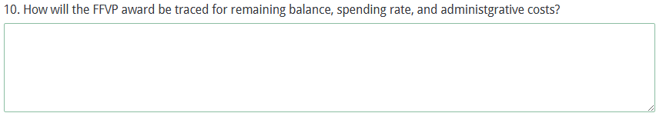

- Describe how internal (school) partners have agreed to collaborate in committing to make this Program and other important nutrition and/or physical activity-related projects successful if the school is selected.
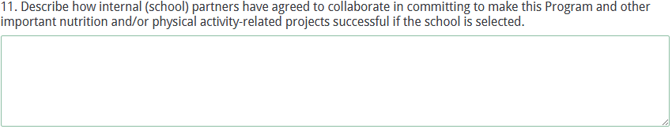

- Describe how external (community) partners have agreed to collaborate in committing to make this Program and other important nutrition and/or physical activity-related projects successful if the school is selected.
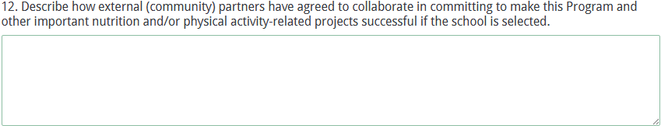

- Describe your plan for creative and effective marketing/promoting of the USDA FFVP and of fresh fruits and vegetables within the school (with students, teachers, administration, etc.).
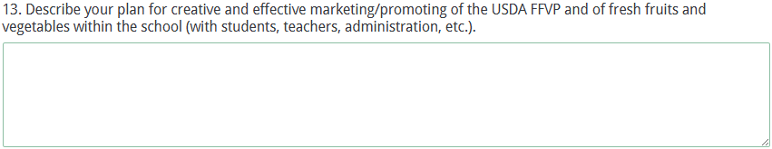

- Describe how families of the students and the community will initially be notified of this Program and the process for on-going promotion/marketing of fresh fruit and vegetables.
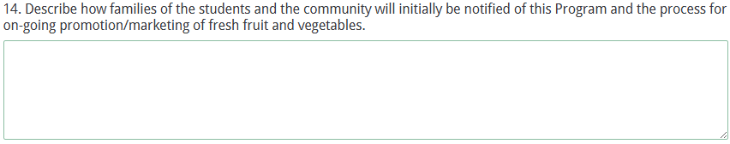

- Describe any nutrition education activities that are planned in the classroom and/or school-wide to coordinate with fresh fruits and vegetables served to students participating in the FFVP.
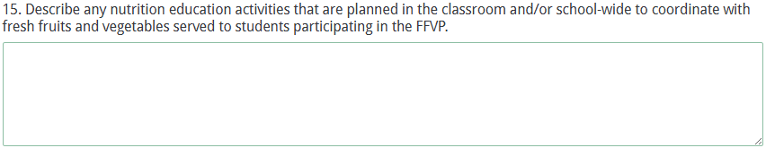

- Briefly describe any existing Buy Local – Buy Fresh and/or Farm-to-School efforts and any future plans to purchase local grown fruits and vegetables to use as part of the FFVP.
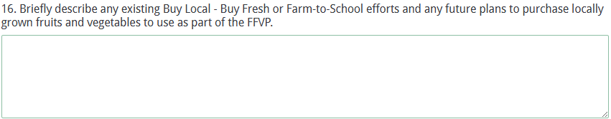

Certification
Applicants must attest to the information they are providing by completing the information requested online and by printing and acquiring signatures on the Certification Signature Page (see page 23). Scan the document as a PDF and attach where indicated online (see screenshot below).

The Certification Signature Page includes certification of the SCDE’s Assurances and Terms and Conditions for USDA Subawards (located on pages 19–22); therefore, an applicant is not required to include those forms in their submitted application. However, please retain the copy included in these instructions for your records and ensure that each signatory has a copy of each document. Use the screenshots below to compile the information for each signatory.
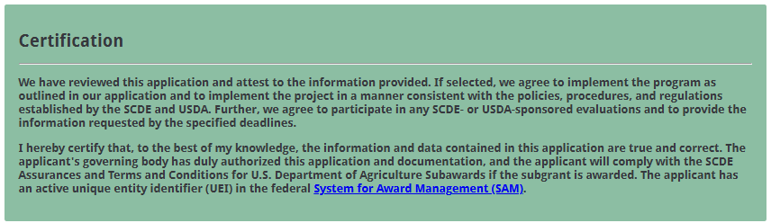
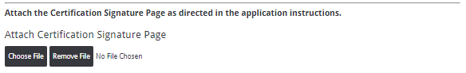

By signing the Certification Signature Page, the signatories assure that they will comply with all assurances and terms and conditions for the project. All signatories must understand that they are signing a document that is legally binding in the event a subgrant is awarded. Applications that do not include the signed Certification Signature Page will not be reviewed or considered for funding.

In the online form, enter the contact information for the School Principal, Child Nutrition Manager, District Child Nutrition Director, Financial Officer, and District Superintendent.
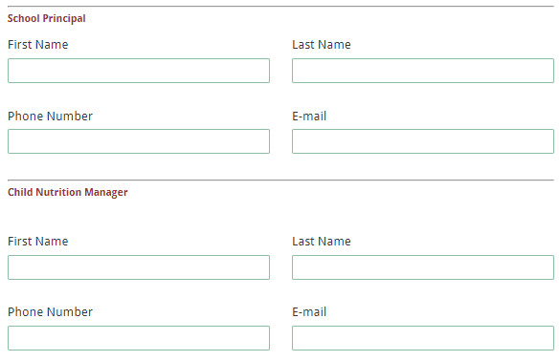
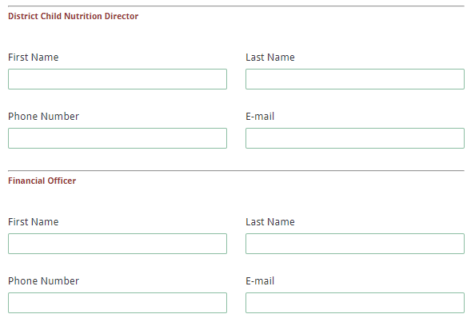
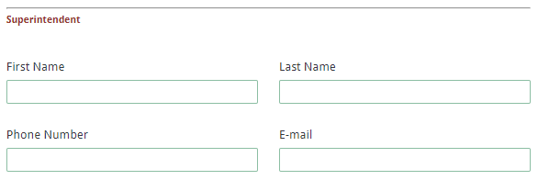
If the school uses a food service management company, provide the company name and contact information for the authorized representative.
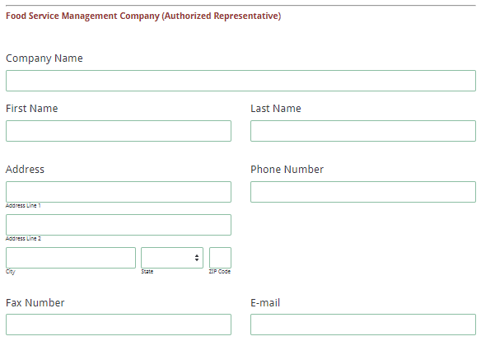

Saving Progress
Applicants have the option to save their progress while entering the application online, which allows applicants to save work in progress and return to an incomplete application. Please note that you do not have to save your form in order to submit an application. Only use this feature if you must stop entering your information before you can submit it. Follow the directions below to save an incomplete application.

Click the “Save and Resume Later” button located at the bottom of any page to save your progress. You will receive a message asking if you want to proceed. Click the “Save and get link” button to continue.



You will then be given two options for obtaining and saving the hyperlink to the partially completed application:
- copy the hyperlink and save it in a secure location, or
- have an email containing the hyperlink sent to you.

Make sure you have received the email before closing the browser. The SCDE does not have access to saved applications that have not been submitted.
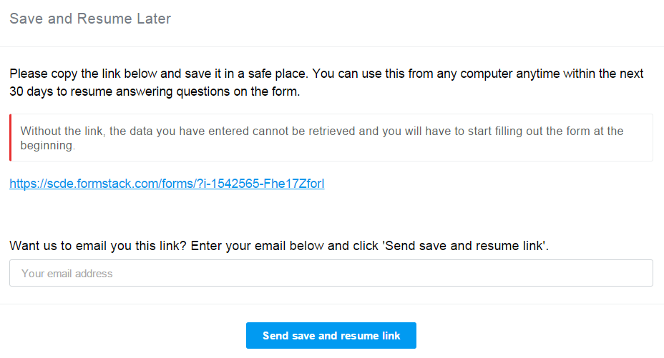
Note: A saved application is not a submitted application. You must use the hyperlink to return to the incomplete application and continue to complete the application.

Data Review, Submission, and Confirmation
Click the Next button once everything is entered into the online form and the required certification form is attached. You will be directed to the Data Review Prior to Submitting page. Thoroughly review all information entered and attached before submitting the application.
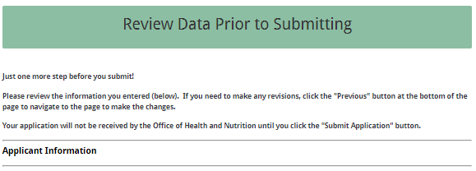
If any of the entries are incorrect, click on the "Previous" button at the bottom of each screen to return to the appropriate section(s) and reenter the correct information.

Note: You will not be able to access the completed application form after it has been submitted. If you need to make changes after the application has been submitted, you must start another application submission and enter the information again.

Once the application has been verified, click on the “Submit Application” button to submit the completed application. Remember, a saved application is not a submitted application.

Once the submission is complete, you will receive the following confirmation message.
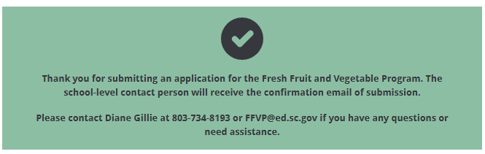
The school-level contact person will receive a confirmation email of the submission that contains the data entered in the online form. Save this email along with these instructions, the Assurances and Terms and Conditions, and the Certification Signature Page for your records.

If the contact person does not receive a confirmation email, then the application did not successfully submit. You must go back and resubmit the entire online form, including all attachments, in order for your application to be considered for funding. Only the last complete application submitted will be reviewed.

An email confirmation that the application was successfully submitted does not account for the quality of the uploaded documents or the completeness of the online form. The confirmation email only notifies you that the online application has been submitted. Applicants are responsible for ensuring that the information entered in the online form, including all attachments, is accurate and complete in order for the application to be reviewed and considered for funding.

Assurances and Terms and Conditions for U.S. Department of Agriculture Subawards

Assurances
I certify that this applicant
- Has the legal authority to apply for federal assistance and the institutional, managerial, and financial capability (including funds sufficient to pay the nonstate share of project costs) to ensure proper planning, management, and completion of the project described in this application.
- Will give the South Carolina Department of Education (SCDE) access to and the right to examine all records, books, papers, or documents related to this award and will establish a proper accounting system in accordance with generally accepted accounting principles (GAAP) or agency directives.
- Has an accounting system with sufficient internal controls, a clear audit trail, and written cost-allocation procedures as necessary. The financial management systems are capable of distinguishing expenditures that are attributable to this grant from those that are not attributable to this grant. This system is able to identify costs by programmatic year and by budget line item and to differentiate among direct, indirect, and administrative costs. In addition, the applicant will maintain adequate supporting documents for the expenditures (federal and nonfederal) and in-kind contributions, if any, that it makes under this grant. Costs are shown in books or records (e.g., disbursements ledger, journal, payroll register) and are supported by a source document such as a receipt, travel voucher, invoice, bill, or in-kind voucher.
- Will also comply with the Office of Management and Budget 2 CFR Part 200 Subpart E-Cost Principles related to the allowability, reasonableness, and allocability of costs consistent with the approved budget and also by maintaining required support for salaries and wages. Required support includes certifications and/or personnel activity records depending upon the amount of time spent on cost objectives.
- Will approve all expenditures, document receipt of goods and services, and record payments on the applicant’s accounting records prior to submission of reimbursement claims to the SCDE for costs related to this grant.
- Will initiate and complete work within the applicable time frame after receipt of approval by the SCDE.
- Will not discriminate against any employee or applicant for employment because of race, color, religion, age, sex, national origin, or disability and comply with Title VI of the Civil Rights Act of 1964, Section 504 of the Rehabilitation Act of 1973, Title IX of the Education Amendments of 1972, the Age Discrimination Act of 1975, and Titles I, II, and III of the Americans with Disabilities Act of 1990 (ADA). The grantee will take affirmative action to ensure that applicants for employment and the employees during the period of their employment are treated without regard to their race, color, religion, age, sex, national origin, or disability.
- Has no policy that prevents, or otherwise denies, participation in constitutionally protected prayer in public schools as set forth in the Guidance on Constitutionally Protected Prayer in Public Education (20 U.S.C. § 7904).
- Will comply with the Family Educational Rights and Privacy Act. (20 U.S.C. §1232g; 34 CFR Part 99).
- Will comply with the Ethics, Government Accountability, and Campaign Reform Act (S.C. Code Ann. § 2-17-10 et seq. and § 8-13-100 et seq. (Supp. 2024)).
- Will comply with the South Carolina Drug Free Workplace Act (S.C. Code Ann. § 44-107-10 et seq. (Supp. 2024) if the amount of this award is $50,000 or more and the federal Drug Free Workplace Act of 1988 (41 USC 702).
- Will provide information to the SCDE, as requested, regarding the reporting requirements of the Federal Funding Accountability and Transparency Act (FFATA), which requires the SCDE to file a FFATA subaward report by the end of the month following the month in which it awards any subgrant equal to or greater than $25,000.
- Will comply with 2 CFR Part 25 and receive a unique entity identifier (UEI), and provide the UEI anytime requested by the SCDE.
- Will comply with 2 CFR Part 200.112 and disclose in writing any potential conflict of interest to the SCDE.
- Will comply with 2 CFR Part 200.113 and disclose in writing to the SCDE whenever the applicant has credible evidence of the commission of a violation of federal criminal law involving fraud, conflict of interest, bribery, or gratuity violations found in Title 18 of the United States Code or a violation of the civil False Claims Act (31 U.S.C. 3729-3733) that potentially affect the federal award.
- Will comply with conditions under Executive Order 13513 “Federal Leadership on Reducing Text Messaging While Driving” (October 1, 2009) by refraining from text messaging while driving during official grant business. Relatedly, the applicant will refrain from emailing while driving during official grant business.

Terms and Conditions
- Completeness of Proposal. All proposals should be complete and carefully worded and must contain all of the information requested by the South Carolina Department of Education (SCDE). If you do not believe a section applies to your proposal, please indicate that fact.
- Non-awards/Termination. The SCDE reserves the right to reject any and all applications and to refuse to grant monies under this solicitation. If the SCDE rejects an application, the applicant has a right to request a hearing, as provided by the SCDE Hearing Procedures, if it alleges the SCDE’s actions violate a state or federal statute or regulation by (1) disapproving of or failing to approve the application or project, in whole or in part, or (2) failing to provide funds in amounts in accordance with the requirements of statutes and regulations.
After it has been awarded, the SCDE may terminate a grant by giving the grantee written notice of termination. In the event of a termination after award, the SCDE shall reimburse the grantee for allowable expenses incurred up to the notification of termination. In addition, this grant may be terminated by the SCDE if the grantee fails to perform as promised in its proposal.
In the event that this grant is terminated, the grantee shall have a right to a hearing as set forth in the SCDE Hearing Procedures. The grantee must notify the SCDE of its request for a hearing within 30 days of receiving written notice of the termination. If a hearing is requested, the SCDE will conduct the hearing in accordance with the procedures outlined in the SCDE Hearing Procedures.
- Reduction in Budgets and Negotiations. The SCDE reserves the right to negotiate budgets with applicants. The SCDE may, at its sole discretion, determine that a proposed budget is excessive and may negotiate a lower budget with the applicant. The applicant may at that time negotiate or withdraw its proposal. In addition, the SCDE may desire to fund a project but not at the level proposed. In that case, the SCDE shall notify the applicant of the amount that can be funded, and the applicant and the SCDE shall negotiate a modification to the proposal to accommodate the lower budget. All final decisions are that of the SCDE.
- Amendments to Grants. Amendments are permitted generally for budgets, grant end date, and management upon the mutual agreement of the parties involved and will become effective when specified in writing and signed by both parties. However, amendments to scope of work that significantly alter the original application proposal may trigger partial or full termination.
- Use of Grant Funds. Funds awarded are to be expended only for purposes and activities covered by the approved project plan and approved budget and budget narrative.
- Submission of Expenditure Reports. Claims for reimbursement must be made at least quarterly and consistent with calendar quarters (e.g., an expenditure report claim for costs for January 1 through March 30 must be filed by May 15).
- Obligation of Grant Funds. Grant funds may not be obligated prior to the effective date or subsequent to the end or termination date of the grant period. No obligations are allowed after the end of the grant period. The final request for expenditure report claims must be submitted no later than ninety (90) days after the end of the grant period unless the scope of work for the grant states a shorter reporting period.
- Deobligation of Funds. After a final expenditure report claim has been submitted to the SCDE, the grantee will go through the official deobligation process with the SCDE.
- Documentation. The grantee must provide for accurate and timely recording of receipts and expenditures. The grantee’s accounting system should distinguish receipts and expenditures attributable to each grant. The grantee must review the memo regarding “Guidelines for Retaining Documentation to Support Expenditure Claims.”
- Travel Costs. Travel costs, if allowed under this solicitation, must not exceed limits noted in the United States General Services Administration (GSA) per diem rates for lodging, except in the case of conference lodging required for program-required training. In the case that conference-related lodging exceeds the GSA per diem rate, the grantee shall follow their entity’s written procedure for obtaining prior approval to exceed a GSA rate for a conference hotel. Meals and incidentals are limited by the state budget proviso, currently not to exceed $35 per day for in-state travel and $50 for out-of-state travel (see page 81 of the State of South Carolina Statewide Disbursement Regulations). Mileage reimbursement must follow the current Office of Comptroller General instructions, which is consistent with the published IRS rates.
- Honoraria. Amounts paid in honoraria, if allowed under this grant, must be consistent with SCDE policies. Applicants should check with the program office before budgeting for honoraria.
- Reports. The grantee shall submit, as required or instructed by the awarding program office, all reports (programmatic, financial, or evaluation) within the specified period or date and in the prescribed format. An expenditure claim report must be filed by August 15 for all expenditures incurred by June 30 in order to comply with the generally accepted accounting principles (GAAP) and the production of the State's Annual Comprehensive Financial Report.
- Copyright. The grantee is free to copyright any books, publications, or other copyrightable materials developed in the course of this grant. However, the SCDE reserves a royalty-free, nonexclusive, and irrevocable license to reproduce, publish, or otherwise use, and to authorize others to use, the copyrighted work developed under this grant.
- Certification Regarding Lobbying, Suspension, and Debarment. By submitting an application, the applicant certifies, to the best of its knowledge and belief, that the
- Applicant and/or any of its principals, subgrantees, or subcontractors
  - Have not paid or will not pay to any person any federally appropriated funds for the purpose of influencing or attempting to influence an officer or employee of any agency, a Member of Congress, an officer or employee of Congress, or any employee of a Member of Congress in connection with making any federal grant and the extension continuation, renewal, amendment, or modification of any federal grant, as stated at 2 CFR Part 418 and 34 CFR Part 82. If any funds other than federally appropriated funds have been paid or will be paid to any person for influencing or attempting to influence an officer or employee of any agency, a Member of Congress, an officer or employee of Congress, or any employee of a Member of Congress in connection with this federal grant, the undersigned shall complete and submit Standard Form LLL, “Disclosure of Lobbying Activities,” in accordance with its instructions.
  - Are not presently debarred, suspended, proposed for debarment, or declared ineligible for the award of contracts by any state or federal agency as stated at 2 CFR Part 417.
  - Have not, within a three-year period preceding this application, been convicted of or had a civil judgment rendered against them for commission of fraud or a criminal offense in connection with obtaining, attempting to obtain, or performing a public (federal, state, or local) contract or subcontract; violated federal or state antitrust statutes relating to the submission of offers; or committed embezzlement, theft, forgery, bribery, falsification or destruction of records, making false statements, tax evasion, or receiving stolen property.
  - Are not presently indicted for, or otherwise criminally or civilly charged by a governmental entity with, commission of any of the offenses enumerated above.
- Applicant has not, within a three-year period preceding this application, had one or more contracts terminated for default by any public (federal, state, or local) entity.
- Audits.
- Entities expending $1,000,000 or more in federal awards:
Entities that expend $1,000,000 or more in federal awards during the fiscal year are required to have an audit performed in accordance with the provisions of 2 CFR Part 200.501, et seq. Except for the provisions for biennial audits provided in 2 CFR Part 200.504 (a) and (b), audits must be performed annually as stated at 2 CFR Part 200.504. A grantee that passes through funds to subrecipients has the responsibility of ensuring that federal awards are used for authorized purposes in compliance with federal program laws, federal and state regulations, and grant agreements. The director of the OMB, who will review this amount every two years, has the option of revising the threshold upward. Audits must be conducted in accordance with Government Auditing Standards (Yellow Book).
- Entities expending less than $1,000,000 in federal awards:
Entities that expend less than $1,000,000 in a fiscal year in federal awards are exempt from the audit requirements in 2 CFR Part 200.504. However, such entities are not exempt from other federal requirements (including those to maintain records) concerning federal awards provided to the entity. The entity’s records must be available for review or audit by the SCDE and appropriate officials of federal agencies, pass-through entities, and the General Accounting Office (GAO). Audits must be conducted in accordance with Government Auditing Standards (Yellow Book).
- Records. The grantee shall retain federal grant records, including financial records and supporting documentation, for a minimum of six (6) years after the end date of the grant when the final expenditure report claim for reimbursement and all final reports have been submitted, unless informed otherwise or in the case of litigation.
- Electronic Signature Agreement. I agree that my electronic signature is the legally binding equivalent to my handwritten signature.

Certification Signature Page
(This form must be signed by the individual from each proposed district, school, or organization who holds the title listed below.)

Certification
I hereby certify that, to the best of my knowledge, the information and data contained in this application are true and correct. The applicant’s governing body has duly authorized this application and documentation, and the applicant will comply with the Program Specific Assurances (if applicable) and the South Carolina Department of Education (SCDE) Assurances and Terms and Conditions for U.S. Department of Agriculture (USDA) Subawards if the grant is awarded. The applicant has an active unique entity identifier (UEI) in the federal System for Award Management (SAM).

If selected, we agree to implement the program as outlined in the information provided and to implement the project in a manner consistent with the policies and procedures established by the SCDE and the USDA. Further, we agree to participate in any SCDE- or USDA-sponsored evaluations and to provide the information requested by the specified deadlines.

District: | School:
Authorized Official: School District Superintendent
Name: | Position:
Telephone: |  | Email:
Signature: |  | Date Signed:
Signature of Financial Official: | Typed name of Financial Official:
Date Signed:
Signature of Child Nutrition Director: | Typed Name of Child Nutrition Director:
Date Signed:
Signature of School Cafeteria Manager: | Typed Name of School Cafeteria Manager:
Date Signed:
Signature of Principal: | Typed Name of Principal:
Date Signed:
Food Service Management Company Rep.: | Typed Name of FSMC Representative:
Date Signed:
Please complete, print, and obtain signatures prior to submission. Include the signed, scanned form where indicated online (see page 14).

